Patrick Boyde
$include(title-layout-b.in)

Titian: The Studiolo of Duke Alfonso
In this lecture, we will be looking at two cycles of paintings, both of them done for Ferrara, which—as you can see on the map, lies about fifty miles from Venice, on the South side of the Po, and about forty miles from Mantua.
In many ways Ferrara is like Mantua. It had about 25–30,000 inhabitants at this time, its buildings are largely of brick, and it is dominated by a huge brick castle built in the late fourteenth century. It was the seat of a Marquisate that became a Duchy. In the late fifteenth and early sixteenth centuries, the Duke of Ferrara ruled over a vast tract of land (shown in purple on the map), extending right across the peninsula, controlling all the main routes from the North to the South.
Like Mantua, too, the city and the contado had been ruled throughout the fourteenth and fifteenth centuries by members of a single family—the Estes (in Italian, Estensi).
$include(column-break.in) $include(figure-slice-vertical.in)
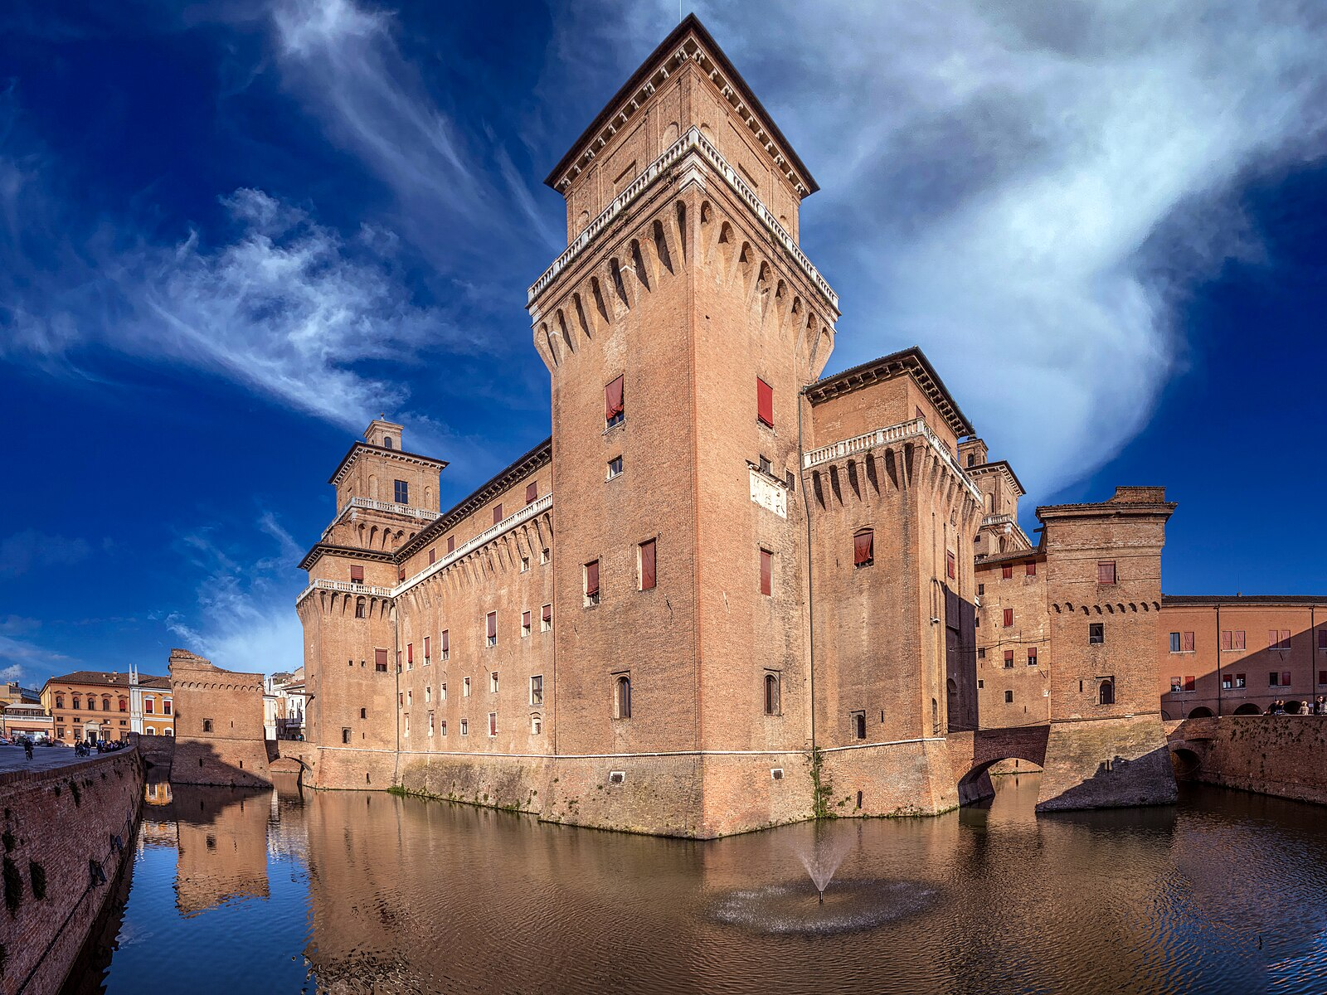
(V4_1) Castello Estense, Ferrara
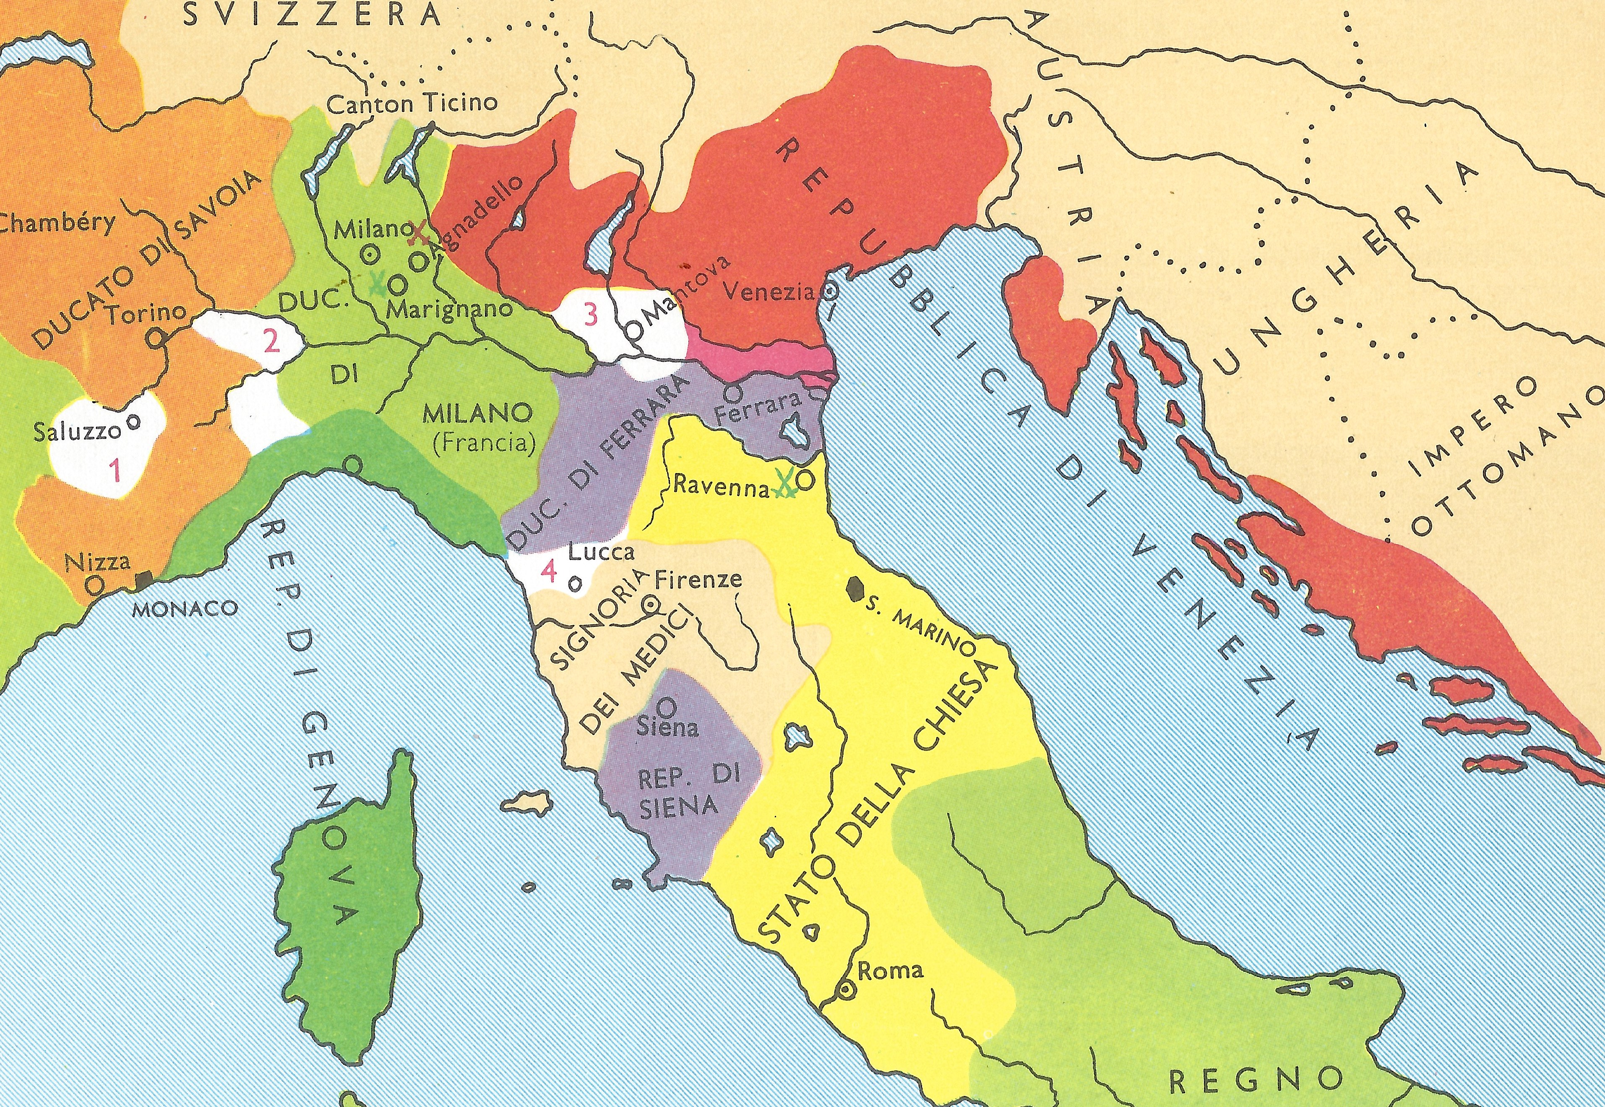
(V4_1a) Political Map of Italy, c. 1510
$include(figure-slice-vertical-end.in) $include(layout-b-end.in) $include(sheet.in) $include(layout-b.in)
The sons of the ruling families in Ferrara and Mantua (the Estes and the Gonzagas) were among the first to be sent to one of the new humanist educators—men like Vittorino da Feltre and Guarino—and they were to become important patrons of the Arts.
$include(column-break.in) $include(figure-slice-vertical.in)
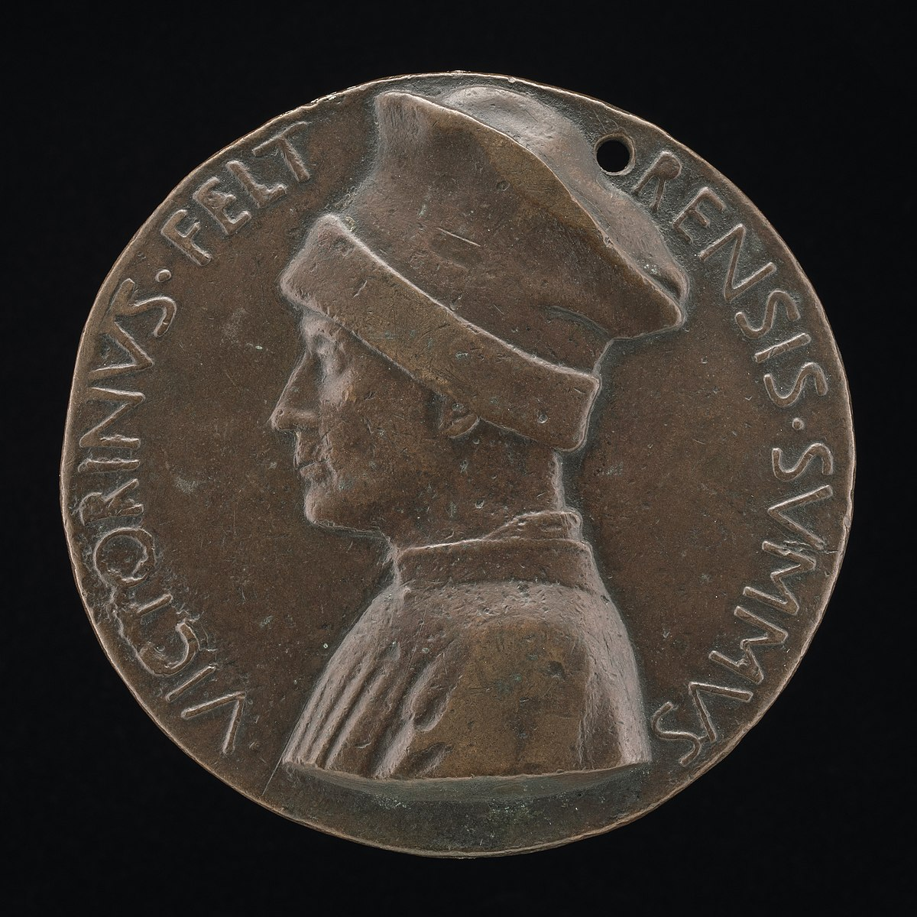
(V4_2) Pisanello, Portrait medal of Vittorino da Feltre, National Gallery of Art
$include(figure-slice-vertical-end.in) $include(layout-b-end.in) $include(sheet.in) $include(layout-b.in)
He was born on the wrong side of the blanket, but succeeded his father in the 1440s, when he called in artists such as Roger Van der Weyden, Jacopo Bellini and Pisanello.
In 1450, he was succeeded by his brother, Borso, also illegitimate, who ruled until 1471.
$include(column-break.in) $include(figure-slice-vertical.in)
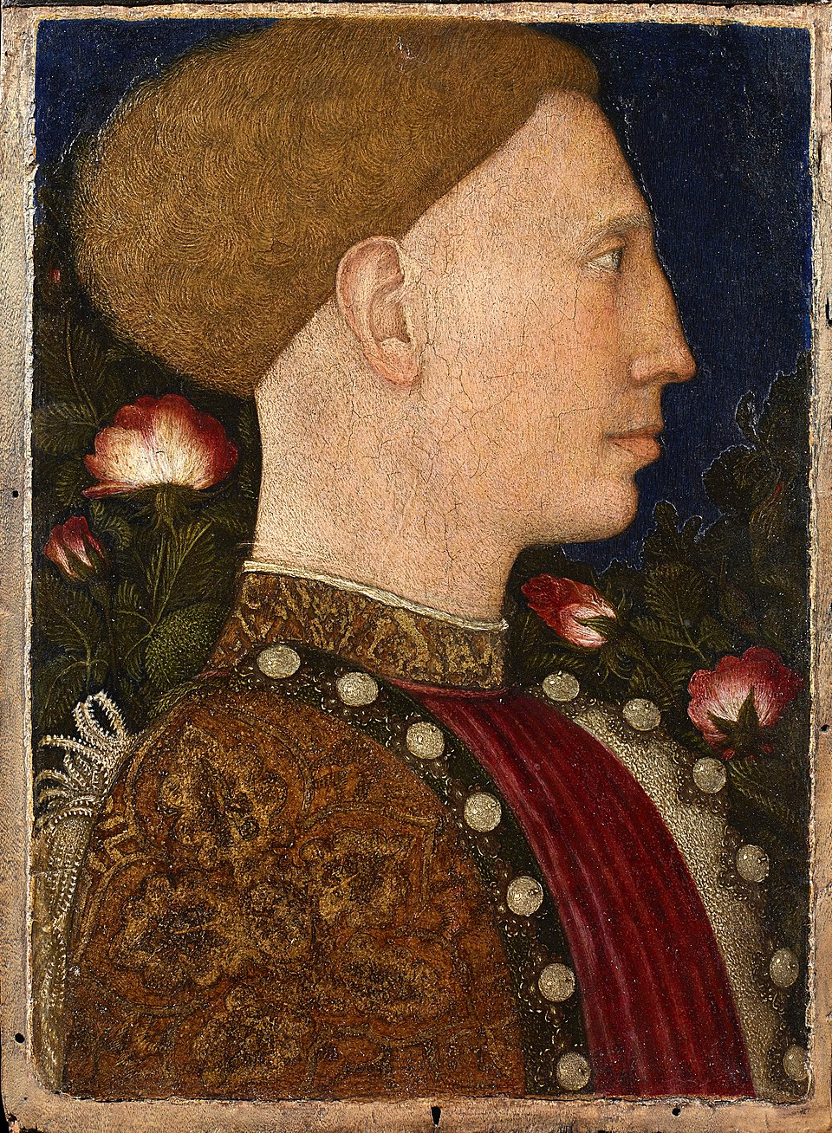
(V4_2a) Pisanello, Portrait of Lionello d’Este, Accademia Carrara
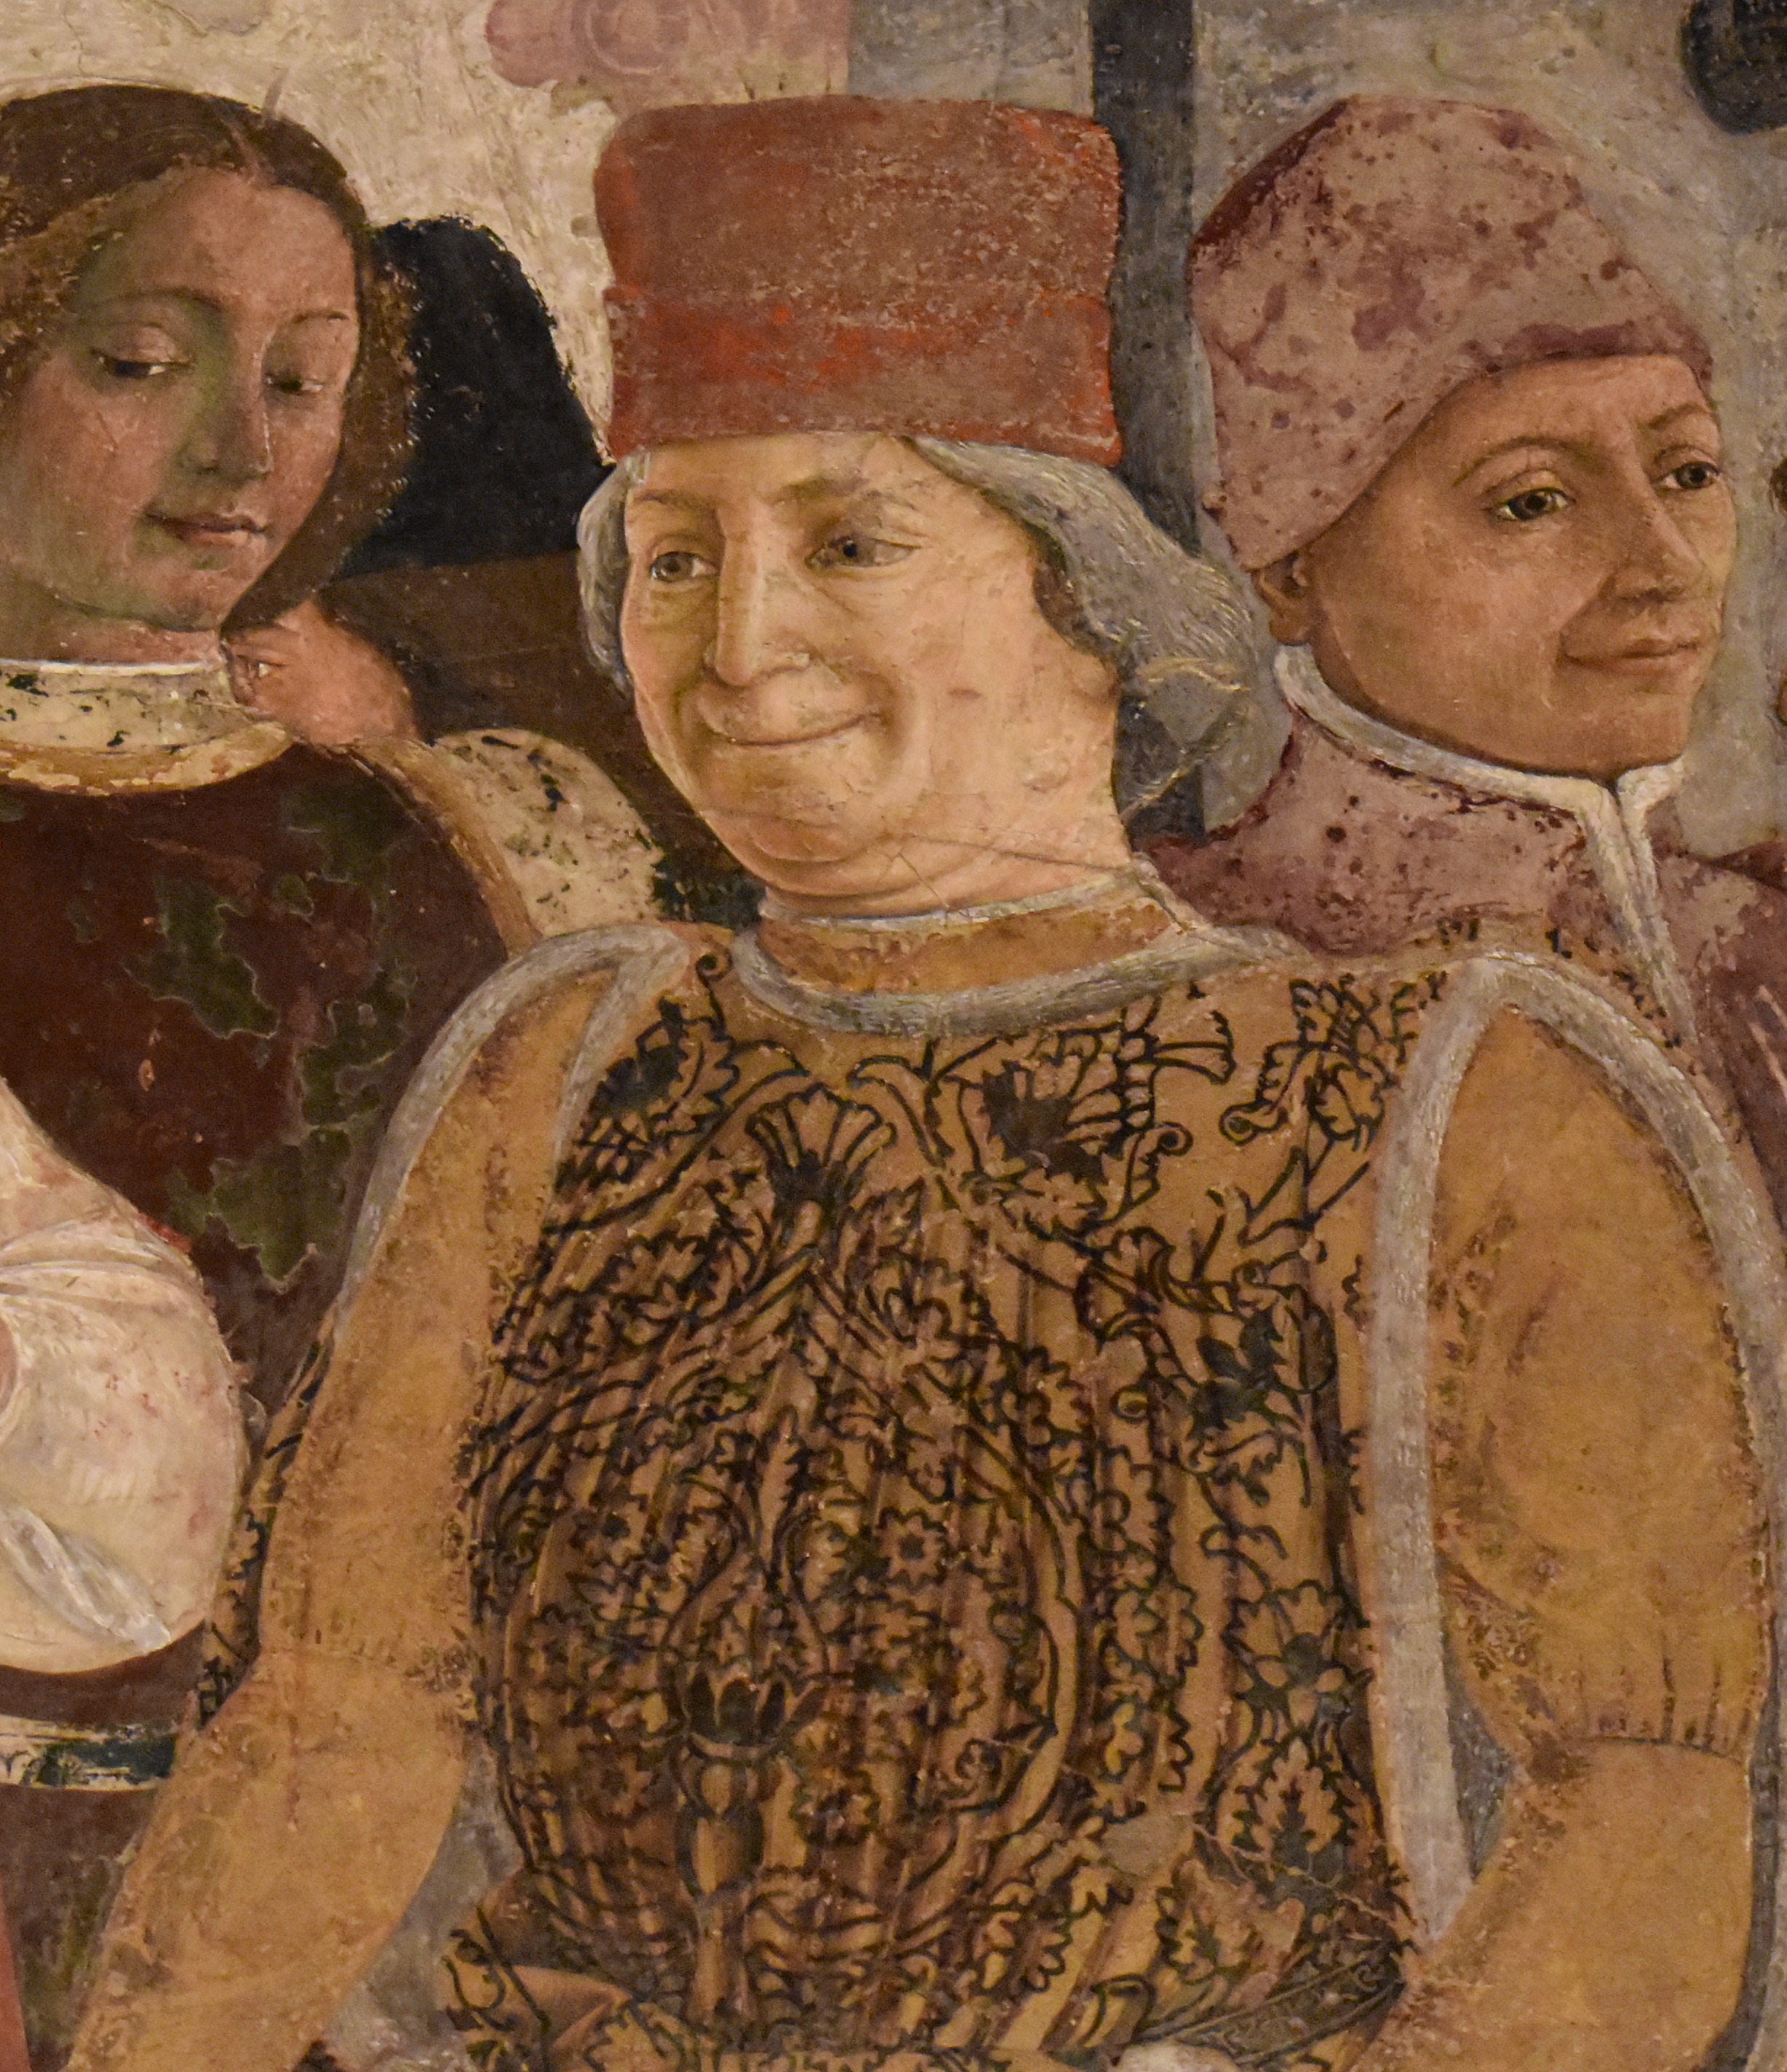
(V4_3) Francesco del Cossa, Portrait of Borso d’Este, Palazzo Schifanoia
$include(figure-slice-vertical-end.in) $include(layout-b-end.in) $include(sheet.in) $include(layout-a.in)
The climax of Borso’s rule came in the year 1469 (about the time when Mantegna was at work on the Camera degli Sposi), when he was granted the title of Duke and completed a second palace within the city not far from the castle, which he called ‘Banish Dull Care’—Palazzo Schifanoia.
It is rather a grim looking building on the outside, but as the name suggests, it was intended as a pleasure palace; and in the 1470s, the main room on the first floor was decorated with a superb set of frescos by local painters—that is, Ferrarese painters—led by Francesco del Cossa.
The frescos have suffered severely from damp and neglect, but I am going to spend a bit of time on this earlier cycle, because it introduces many of the themes of Titian’s paintings while offering a wonderful foil to his style, and also because, even in its damaged state, the room is still well worth a visit for its own sake.
$include(column-break.in) $include(figure-slice-vertical.in)
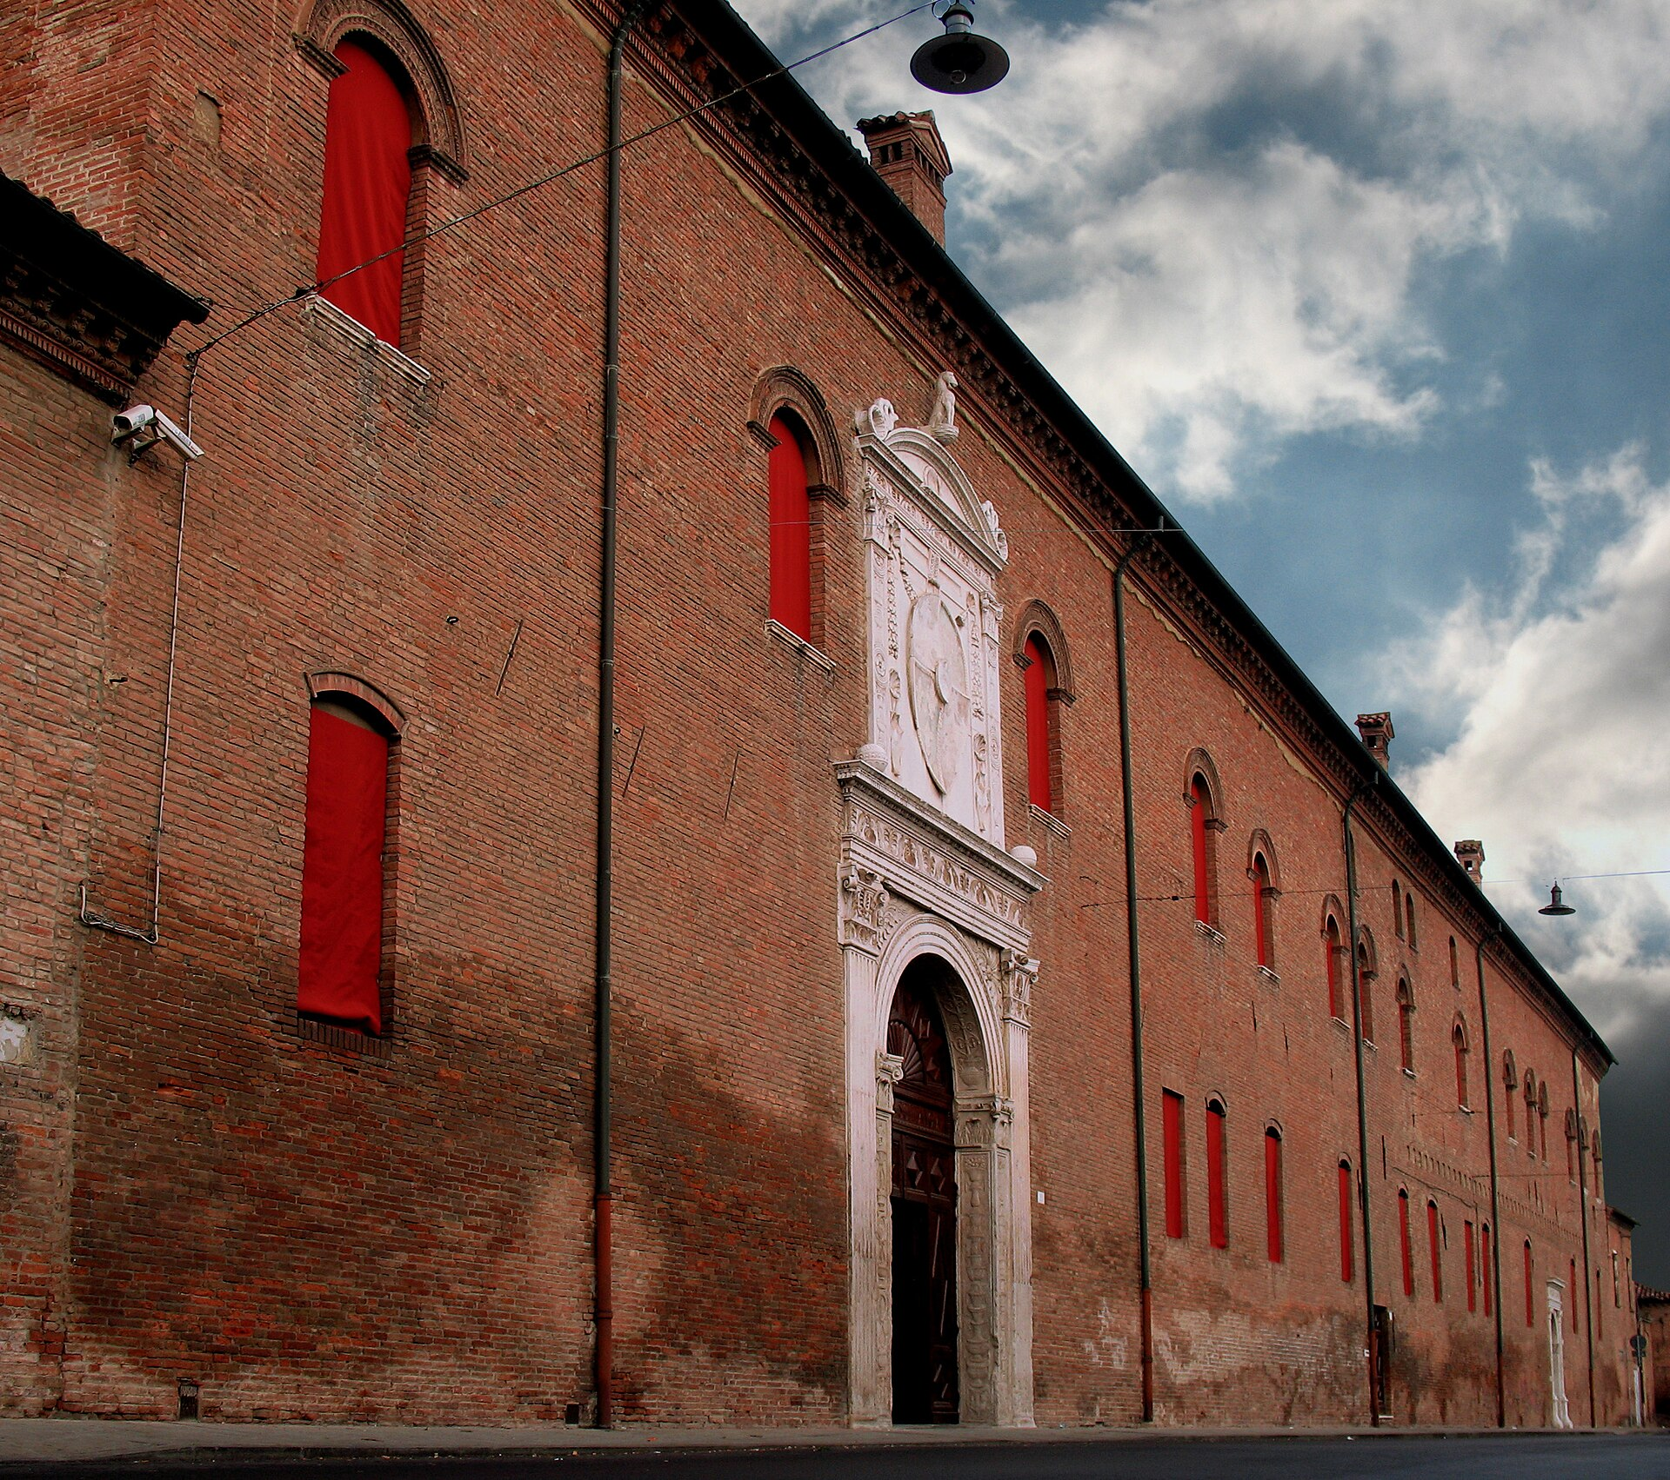
(V4_4) Palazzo Schifanoia, Ferrara
$include(figure-slice-vertical-end.in) $include(layout-a-end.in) $include(sheet.in) $include(layout-a-50.in)
After you have gone through the handsome portal, you come up the stairs into a large oblong room, about eighty feet by thirty-six, whose shape is suggested by the diagram.
$include(column-break.in) $include(figure-slice-vertical.in)
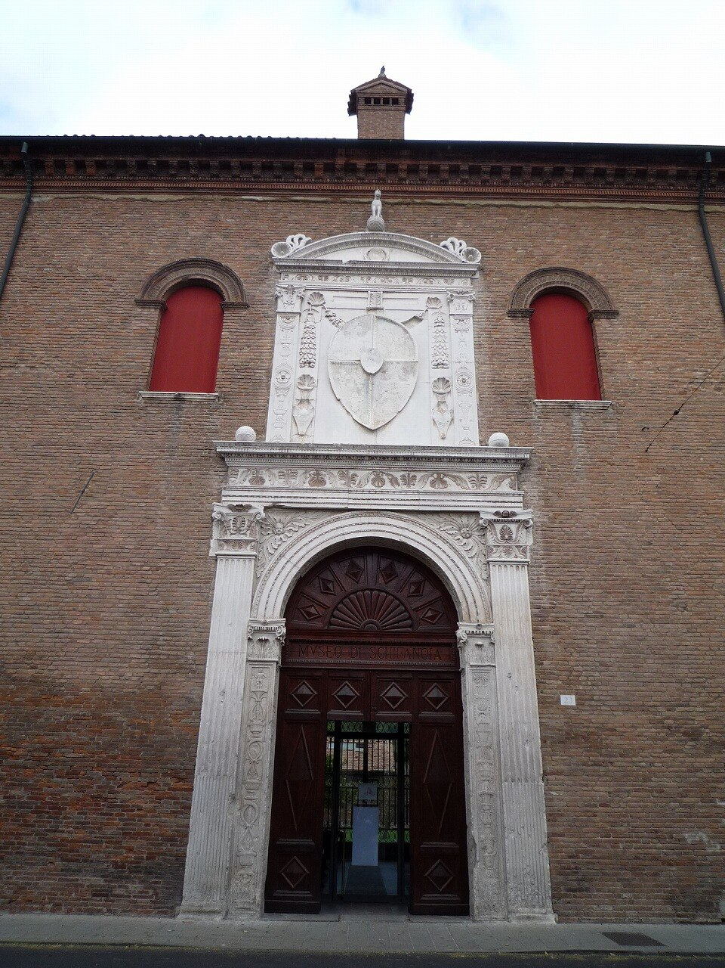
(V4_5) Main door, Palazzo Schifanoia
$include(figure-slice-vertical-end.in) $include(layout-a-end.in) $include(layout-c-50.in) $include(figure-slice.in)
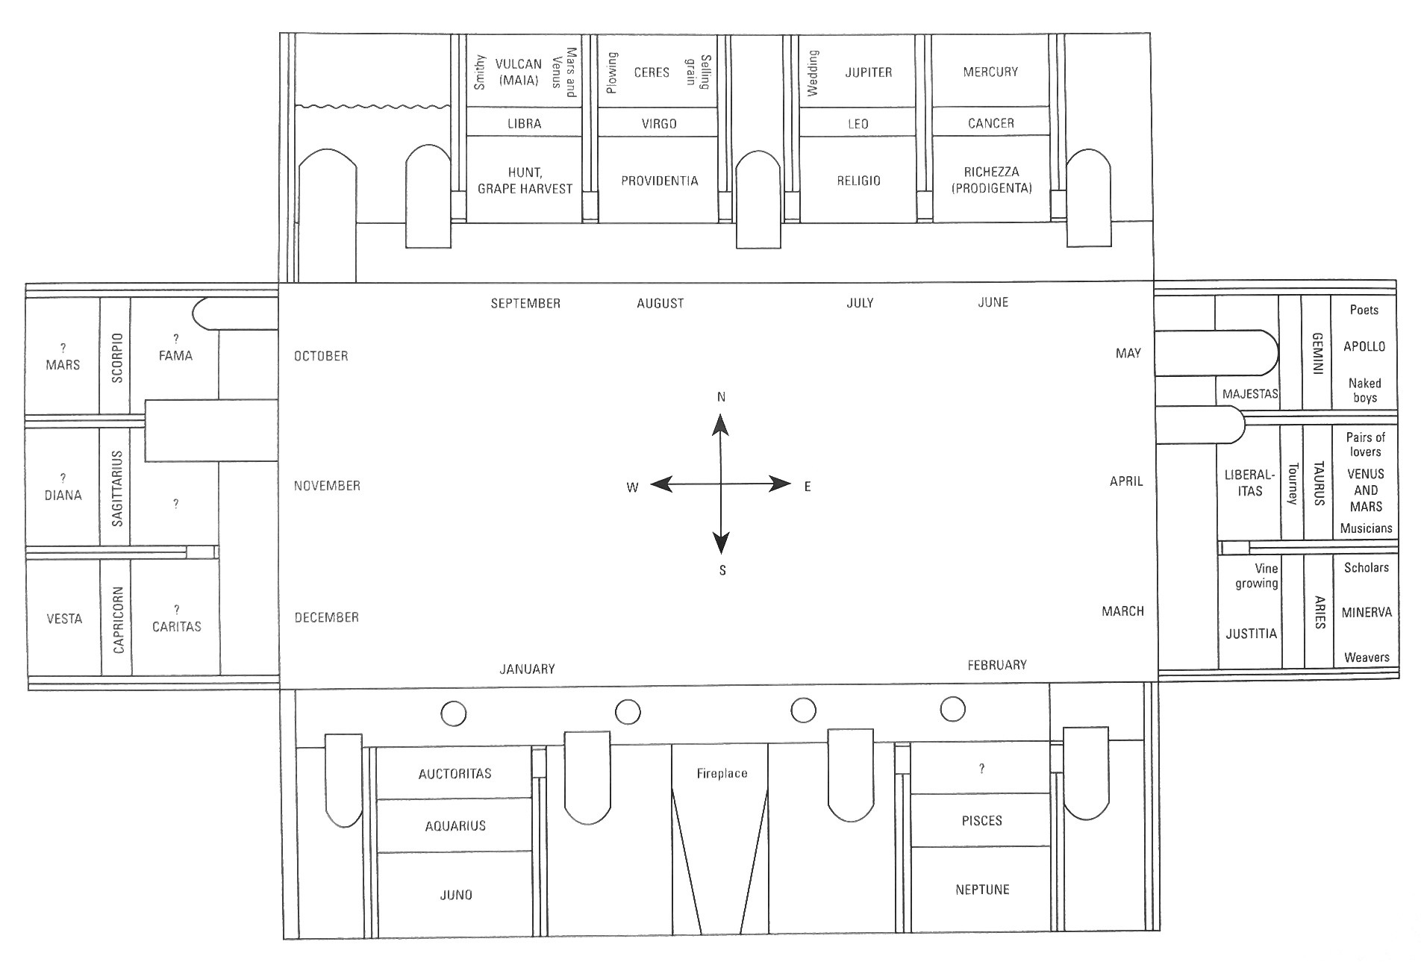
(V4_6) Layout of the Hall of the Months, Palazzo Schifanoia
$include(figure-slice-end.in) $include(layout-c-50-end.in) $include(sheet.in) $include(layout-c.in) $include(one-column-text.in)
As the diagram shows, the frescos you have come to see are laid out in twelve ‘zones’, two on the South wall, three on each of the shorter walls, and four on the North wall, which is the one illustrated here.
$include(one-column-text-end.in) $include(figure-slice.in)
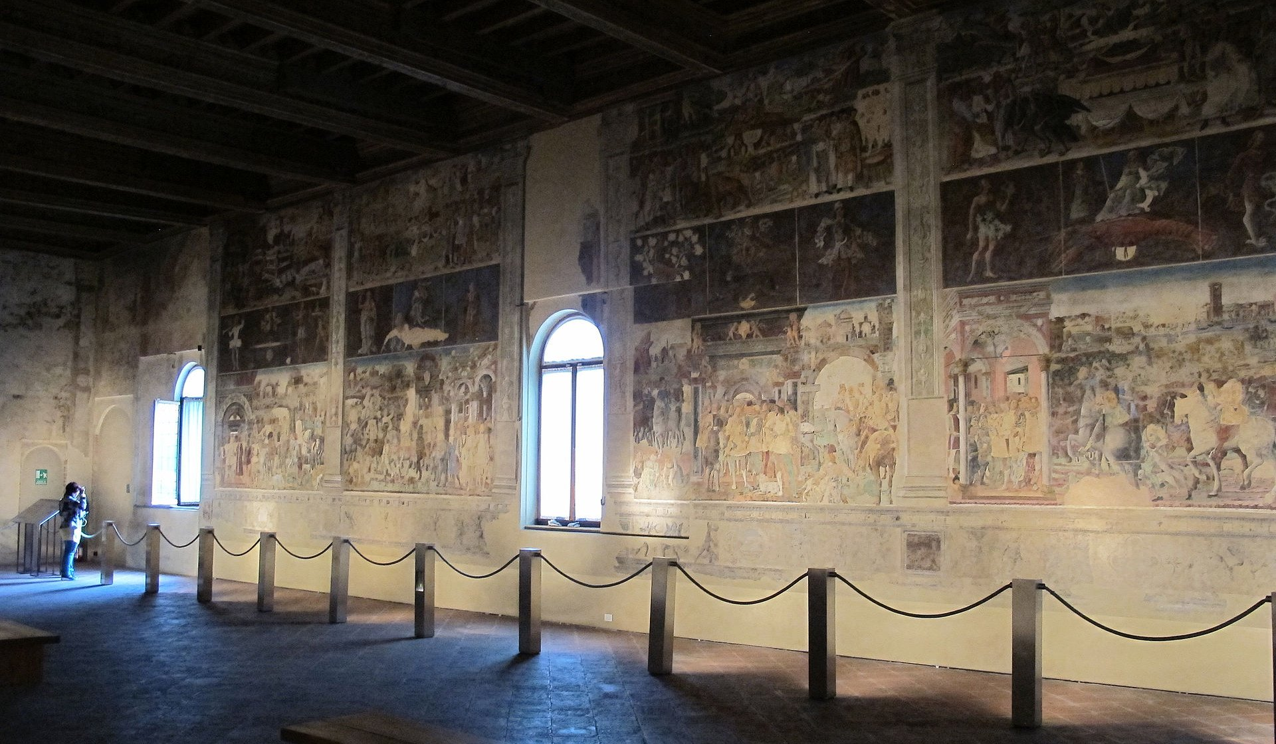
(V4_7a) North wall, Hall of Months
$include(figure-slice-end.in) $include(layout-c-end.in) $include(sheet.in) $include(layout-a.in)
Each of the twelve zones is divided into three horizontal bands (light, dark, light); and each zone is dedicated to one of the twelve months in the year.
To be more precise, each zone is dedicated to one of the twelve signs of the Zodiac; and the figure representing the ‘sign’ itself is always represented in the very centre of the central zone.
$include(column-break.in) $include(figure-slice-vertical.in)
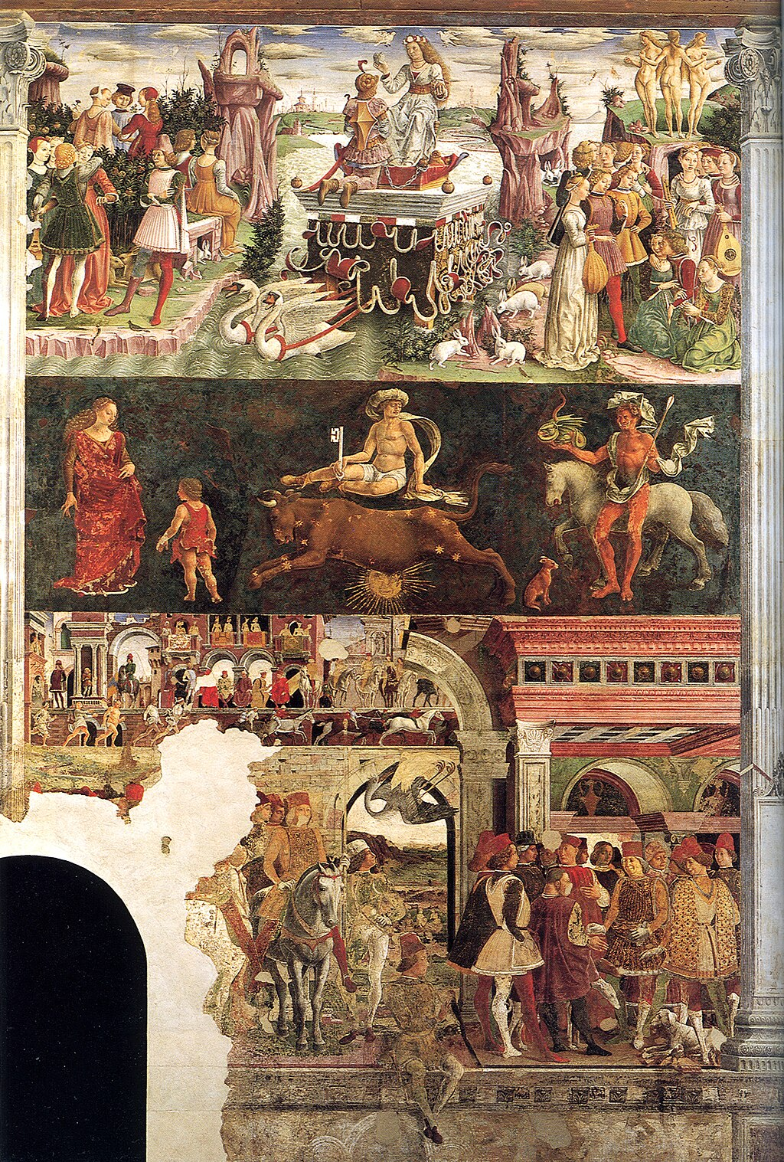
(V4_7) Francesco del Cossa, Allegory of Taurus (April), Hall of the Months
$include(figure-slice-vertical-end.in) $include(layout-a-end.in) $include(sheet.in) $include(layout-c.in) $include(two-column-text.in)
This is why the cycle begins with Aries the Ram (that is, with the Spring equinox), which is represented on the East wall. And this is why the sequence unfolds from right to left, in the order Taurus, Gemini, Cancer etc. (since the observer in the Northern hemisphere will always see Taurus to the left of Aries, Leo to the left of Cancer etc.).
In Palazzo Schifanoia, the twelve ‘signs’ are linked to twelve of the classical gods and goddesses, in a conceptual scheme whose origins can be traced right back to the early first century AD. Hence the deities who had early been identified with the seven planets—Diana (the moon) Mercury, Venus, Apollo (the sun), Mars, Jupiter and Saturn—are here joined by Ceres, Vulcan and others.
Each of the Signs of the Zodiac, as you will probably know, is said to be ‘dominant’ for the thirty days during in which it is ‘in conjunction’ with the Sun. From ‘dominance’, it was easy to arrive at the idea of ‘triumph’, and then to give ‘triumph’ the limited sense that it has in the Triumph of Caesar at Mantua (discussed in the first lecture in this series).
So, the upper band of the frescos in Schifanoia always represents an appropriate Olympian deity riding on a triumphal chariot, drawn by appropriate animals and accompanied by an appropriate retinue.
What you see here (in the upper band of Aries), is the goddess Minerva, drawn by white steeds; and, to the left, scholars, soberly dressed, their noses buried in books; and to the right, women weaving at a loom and embroidering (although there are allusions to the Three Fates in the group in the foreground).
$include(two-column-text-end.in) $include(figure-slice-vertical.in)
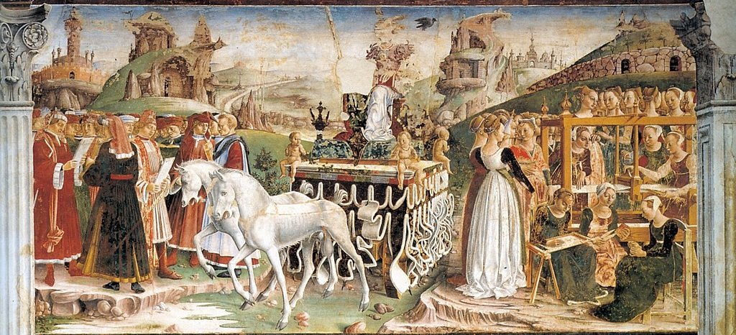
(V4_7c) Detail from Francesco del Cossa, Allegory of Aries (March), Hall of the Months
$include(figure-slice-vertical-end.in) $include(layout-c-end.in) $include(sheet.in) $include(layout-c.in) $include(one-column-text.in)
There is no space here to explain the ‘decans’ who accompany the Signs in the middle band of the wall, nor is there time to do more than remind you of the obvious fact that the whole point of the ‘science’ of Astrology was that the stars and planets were believed to ‘rain down’ influences—influences, which were either ‘benign’ or ‘malignant’, which varied with the different conjunctions of the heavenly bodies, and which did a great deal (though how much was always in dispute) to affect or to determine our temperament, our health and our inclinations.
$include(one-column-text-end.in) $include(figure-slice-vertical.in)
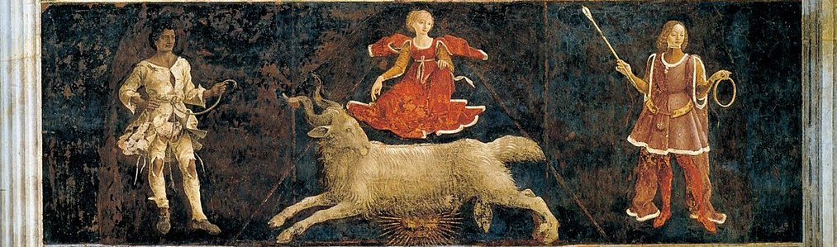
(V4_7d) Detail from Francesco del Cossa, Middle band showing the Allegory of Aries (March and two decans), Hall of the Months
$include(figure-slice-vertical-end.in) $include(layout-c-end.in) $include(sheet.in) $include(layout-a-50.in)
The lowest of the three bands—what you see here is Taurus again—shows typical human activities on Earth as influenced for good or ill by the heavens; and in the particular case of Palazzo Schifanoia, this band shows some of the activities of Duke Borso himself.
Notice that he is represented in the same way as Lodovico Gonzaga was portrayed in those same years at Mantua—in a group portrait with members of his court. (This group is the source of the detail from which I take his smiling portrait.)
On the right, Borso is giving a coin to the Court Jester; and you will recognise him again, on the left, riding on a splendid white horse, watching while a falcon brings down a heron.
$include(column-break.in) $include(figure-slice-vertical.in)
(V4_3_bis_altcaption) Francesco del Cossa, Portrait of Borso d’Este
$include(figure-slice-vertical-end.in) $include(layout-a-end.in) $include(layout-c-50.in) $include(figure-slice.in)
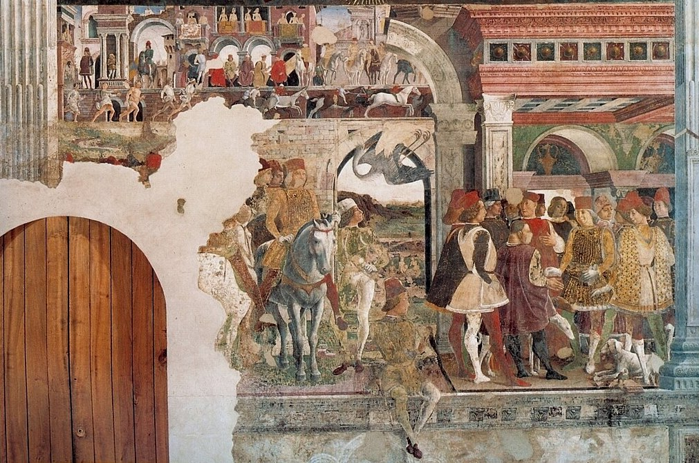
(V4_8) Detail from Francesco del Cossa, Allegory of April, Hall of the Months
$include(figure-slice-end.in) $include(layout-c-50-end.in) $include(sheet.in) $include(layout-c.in) $include(one-column-text.in)
The small oblong area at the top of the middle zone (found in some months but not all) also deals with contemporary human life; and the one in Taurus is absolutely fascinating, since it shows the Palio at Ferrara, in its dual aspect of a horse-race (as at Siena), and what was called a ‘humilation’ race—a race on foot, between vagabonds, prostitutes and Jews, run for the amusement of the nobles and their ladies, seated above.
$include(one-column-text-end.in) $include(figure-slice.in)
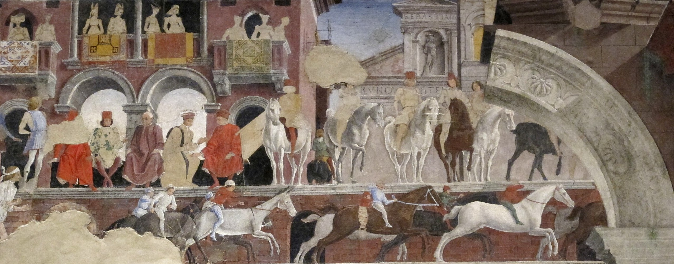
(V4_8a) Detail from Francesco del Cossa, Allegory of April
$include(figure-slice-end.in) $include(layout-c-end.in) $include(sheet.in) $include(layout-c.in) $include(two-column-text.in)
Let us climb the wall now (still in the same fresco), up past the Sign of Taurus to its ‘Triumph’ scene, which in this case is the Triumph of Venus.
She is represented as throned on a state barge, drawn by swans, while her attendants and followers assemble on both banks of the central stream.
$include(two-column-text-end.in) $include(figure-slice-vertical.in)
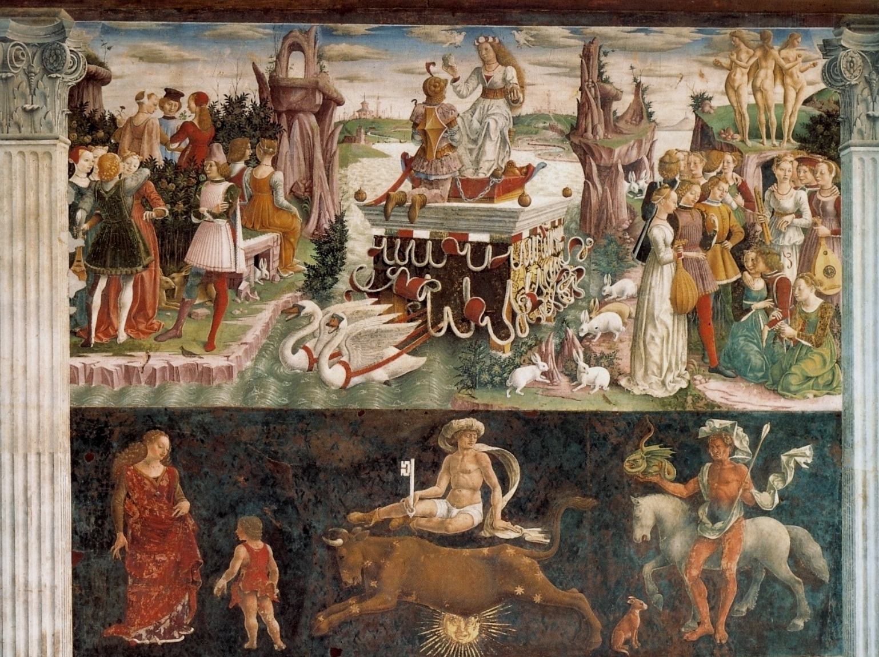
(V4_8b) Detail from Francesco del Cossa, Allegory of April
$include(figure-slice-vertical-end.in) $include(layout-c-end.in) $include(sheet.in) $include(layout-a.in)
These attendants give the artist, Francesco del Cossa, a wonderful chance to show fifteenth-century Ferrarese art at its most characteristic, and as being everything that Titian’s art is not: naive, light in tonality, sharp in outline, anxious to record every lacquered curl, and every pleat in the contemporary costumes.
$include(column-break.in) $include(figure-slice.in)
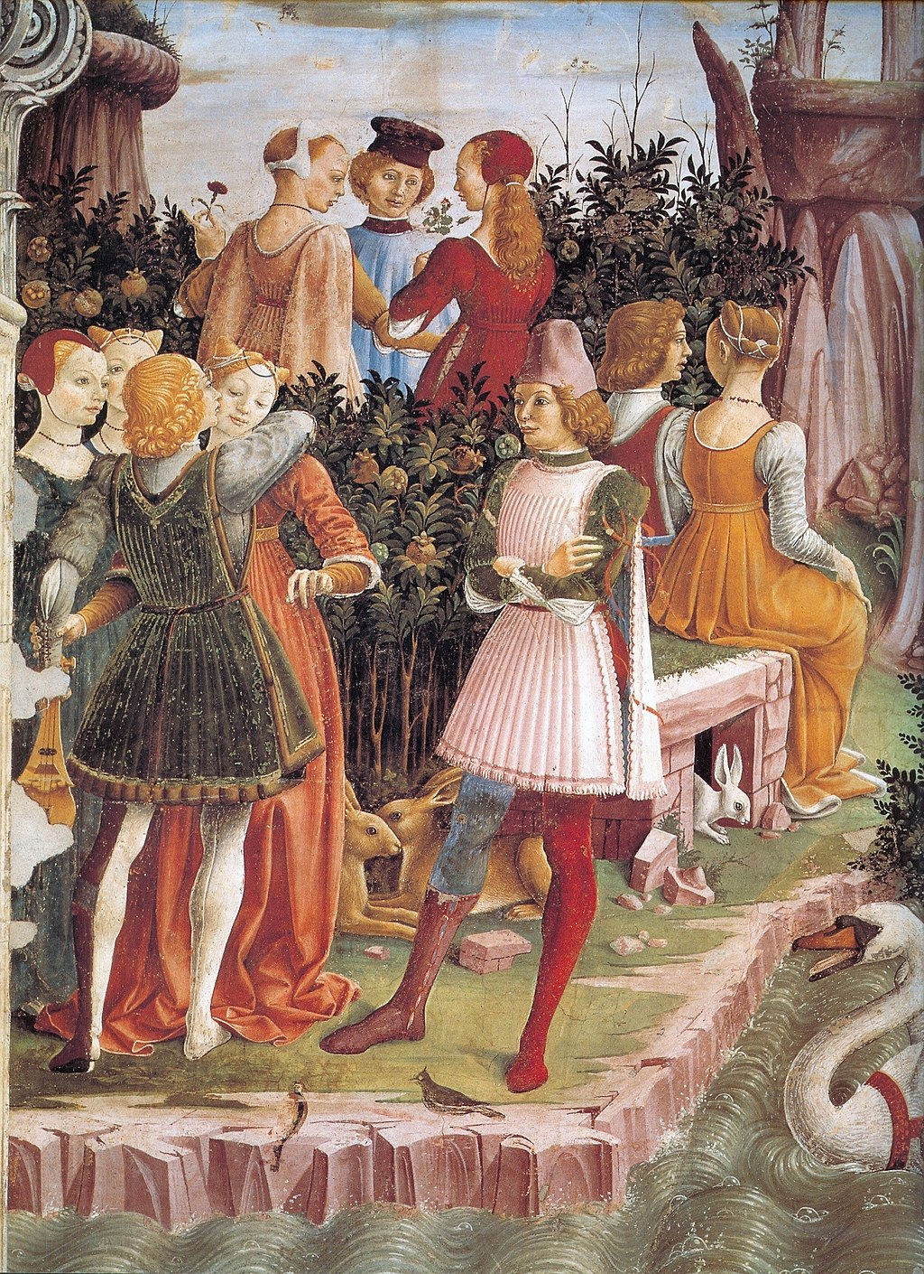
(V4_8c) Detail from Francesco del Cossa, Allegory of April
$include(figure-slice-end.in) $include(layout-a-end.in) $include(sheet.in) $include(layout-b.in)
So let us go in closer with these two details. The first (unrestored) shows a demure lover’s kiss; while the second (on the other bank of the stream) shows the three Graces, and some slender young women with lutes and recorders—music being the ‘food of love’, and the humble recorder being closely associated with the ‘act of love’.
$include(column-break.in) $include(figure-slice-vertical.in)
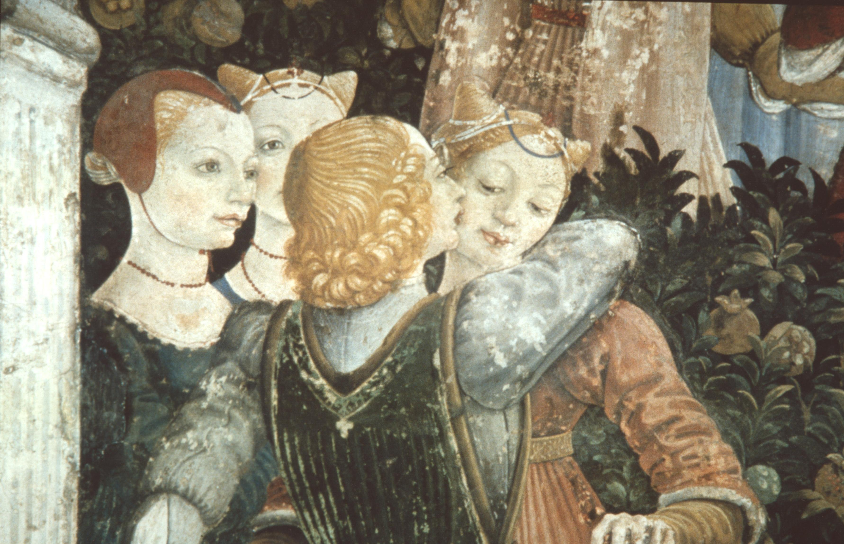
(V4_11) Detail from Francesco del Cossa, Allegory of April
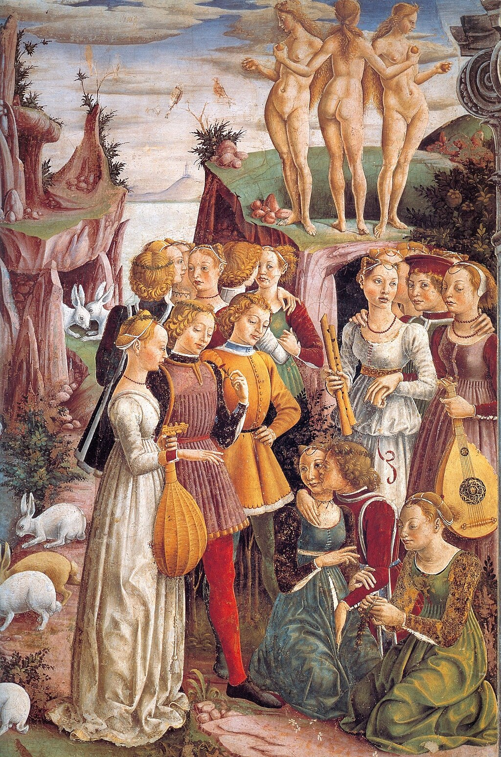
(V4_8d) Detail from Francesco del Cossa, Allegory of April
$include(figure-slice-vertical-end.in) $include(layout-b-end.in) $include(sheet.in) $include(layout-a.in)
You will notice, on the ground, rabbits and hares—famous respectively for their fecundity and for their madness in the mating session.
Nor should we forget the Goddess herself, decorously clothed in the costume of a fifteenth-century court beauty, with Mars kneeling before her, in full armour, but chained, ‘in her thrall’.
For reasons of space and internal economy, I must renounce the pleasure of showing you more details from other Signs in the room, but I hope you have seen enough to make you want to go to Ferrara and ‘banish dull care’ for a couple of hours in Palazzo Schifanoia.
$include(column-break.in) $include(figure-slice-vertical.in)
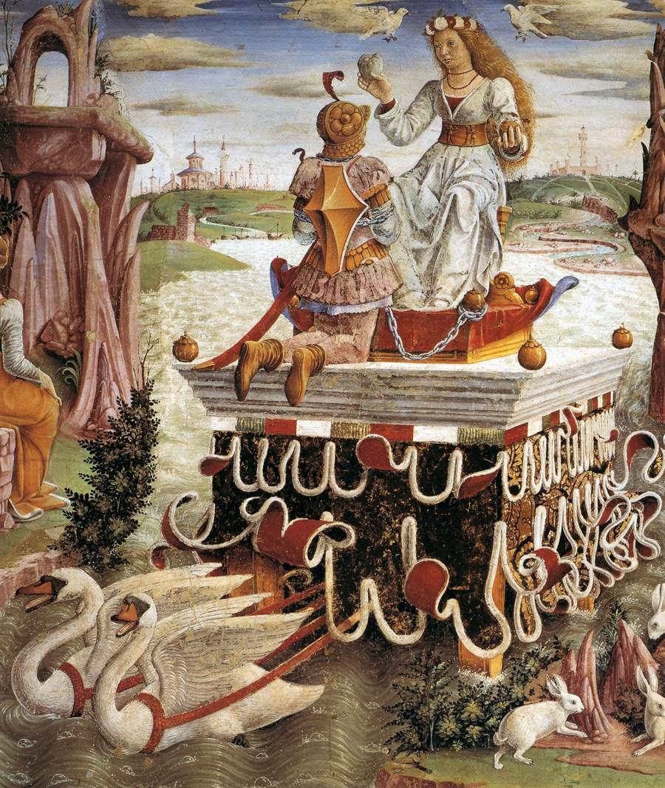
(V4_13) Detail from Francesco del Cossa, Allegory of April
$include(figure-slice-vertical-end.in) $include(layout-a-end.in) $include(sheet.in) $include(layout-b.in) $include(text-with-image.in)
As you can read in this genealogical table, Duke Borso died in 1471; and for the second time running, a ruler of Ferrara was succeeded by his brother—a much younger half-brother called Hercules, or Ercole, who ruled as Duke of Ferrara until his death in 1505.
You see him here in a posthumous portrait by Dosso Dossi.
$include(text-with-image-end-text.in)
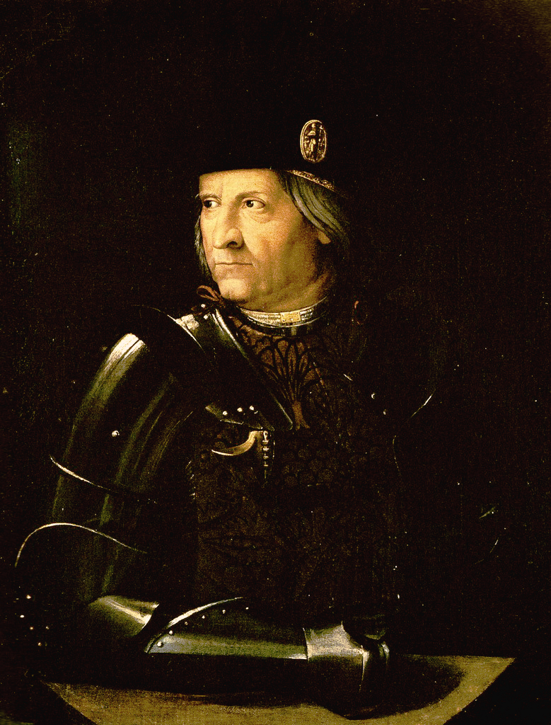
(V4_15) Dosso Dossi, Portrait of Ercole d’Este, Galleria Estense
$include(text-with-image-end.in) $include(column-break.in) $include(figure-slice-vertical.in)
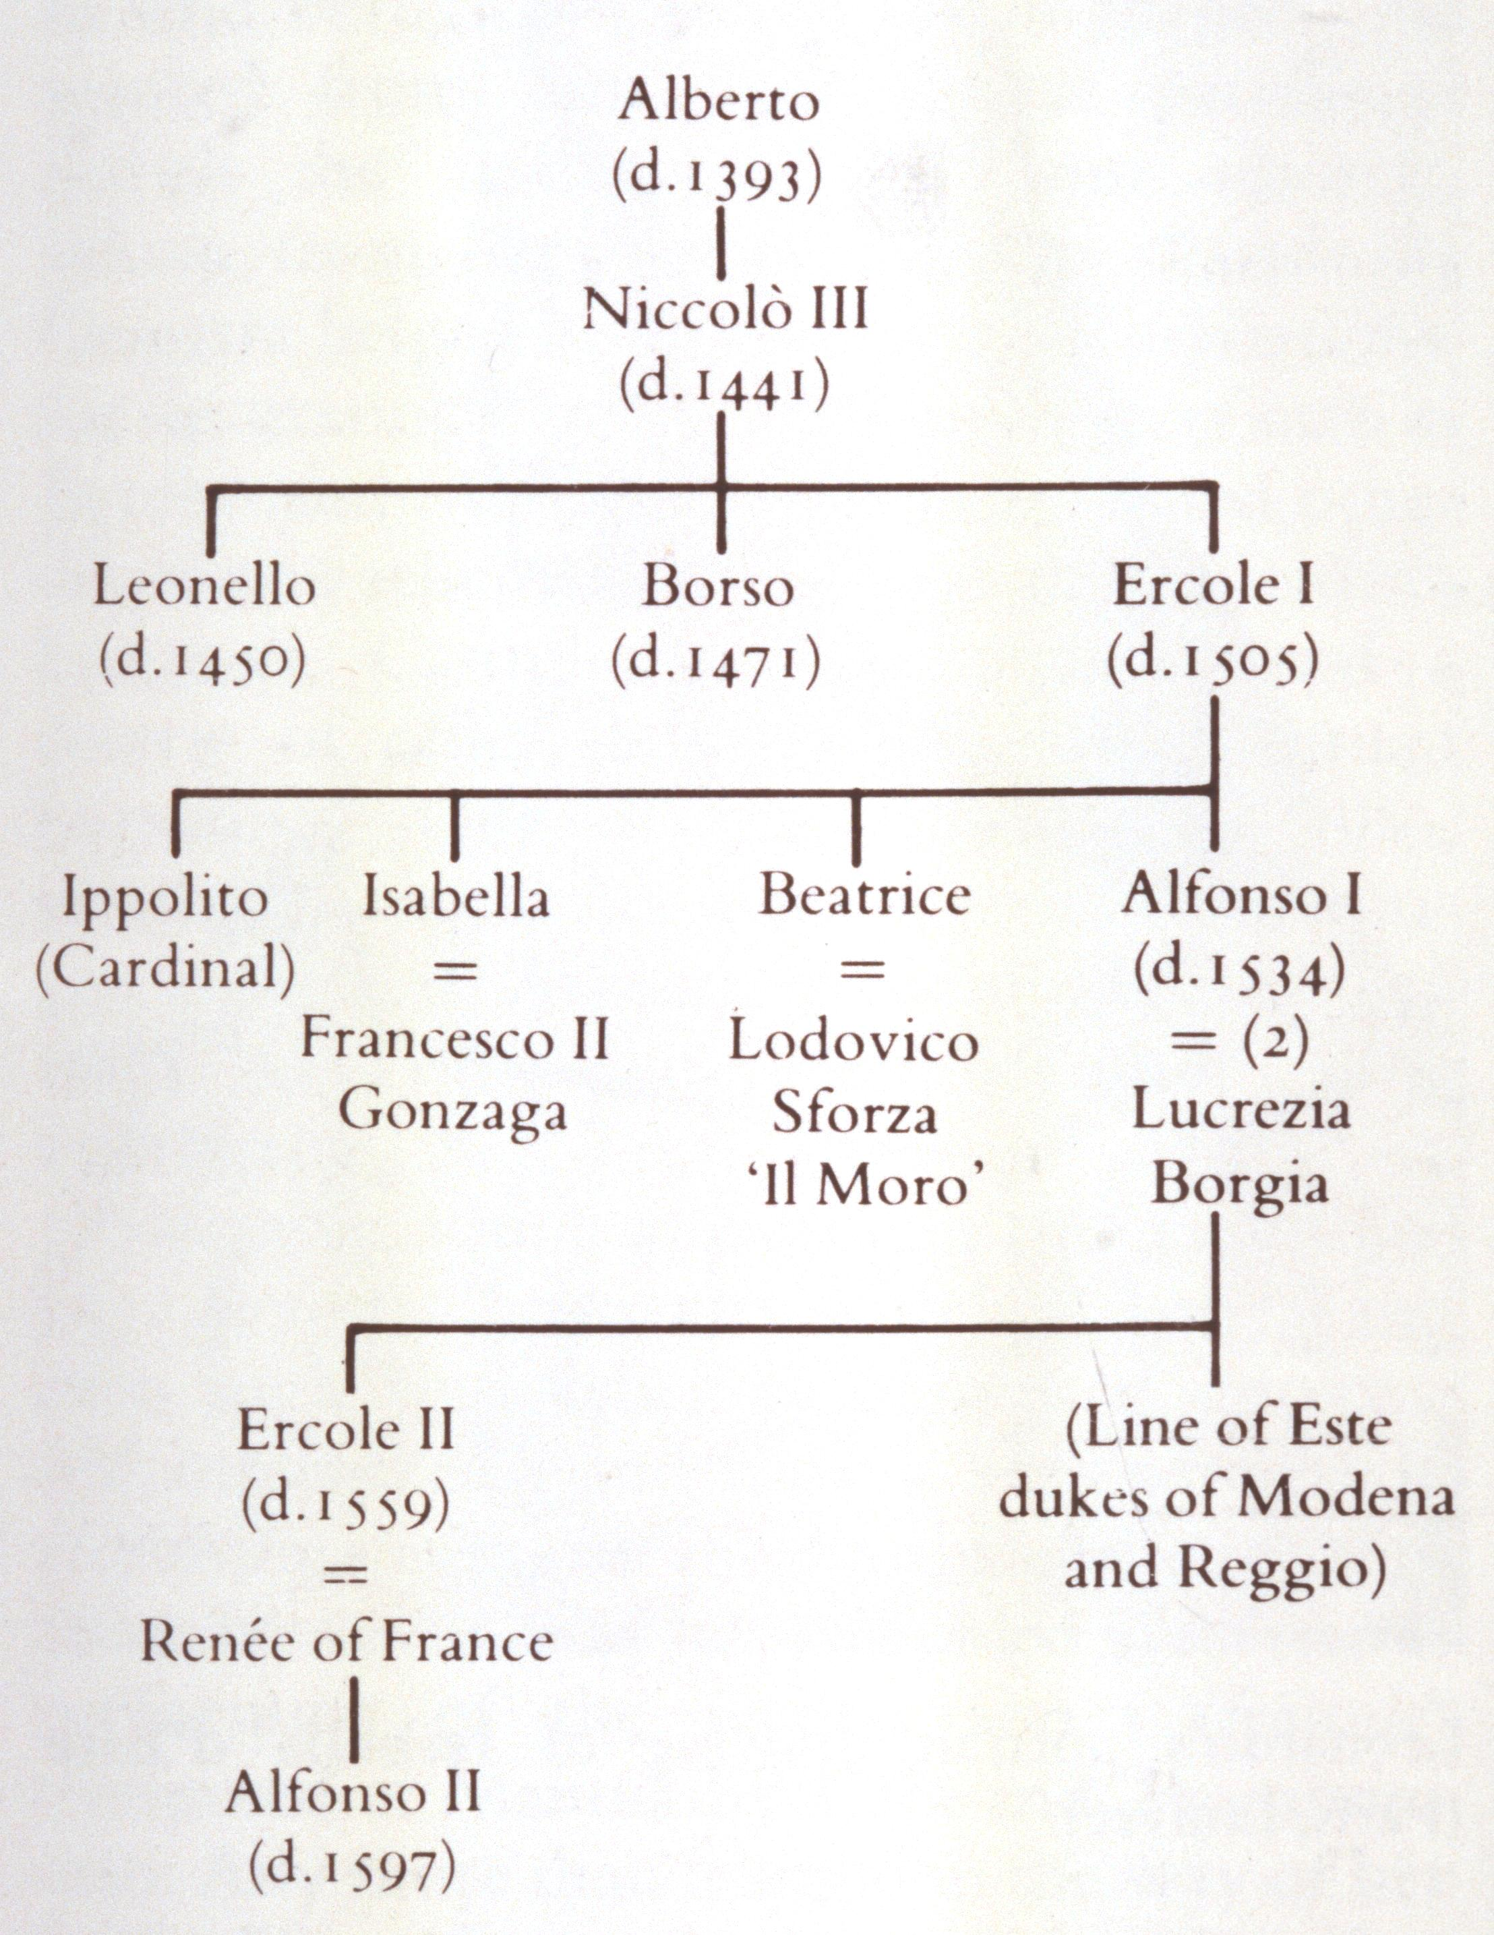
(V4_14) Genealogy of the Dukes of Ferrara
$include(figure-slice-vertical-end.in) $include(layout-b-end.in) $include(sheet.in) $include(layout-a.in)
Ercole was much admired by Machiavelli for the way in which he survived a major war against Venice in 1482–84 (hence the armour); and in the last fifteen years of his regime he was the moving force behind an extremely ambitious programme of building, such that the new city walls would include three times the previous area, and the new streets would be laid out according to the most advanced ‘town planning’ of his day.
Apart from stimulating architecture, he was a notable patron of the Arts—he had Josquin as a court composer for two years—and he had considerable success in ‘placing’ his very well educated, art-loving daughters.
Beatrice married the Duke of Milan, who was the patron of Leonardo da Vinci in the 1480s.
Isabella (whom you see here in a drawing by Leonardo) married the Duke of Mantua, and together they became the last patrons of Andrea Mantegna, as we saw in his Triumph of Caesar.
$include(column-break.in) $include(figure-slice-vertical.in)
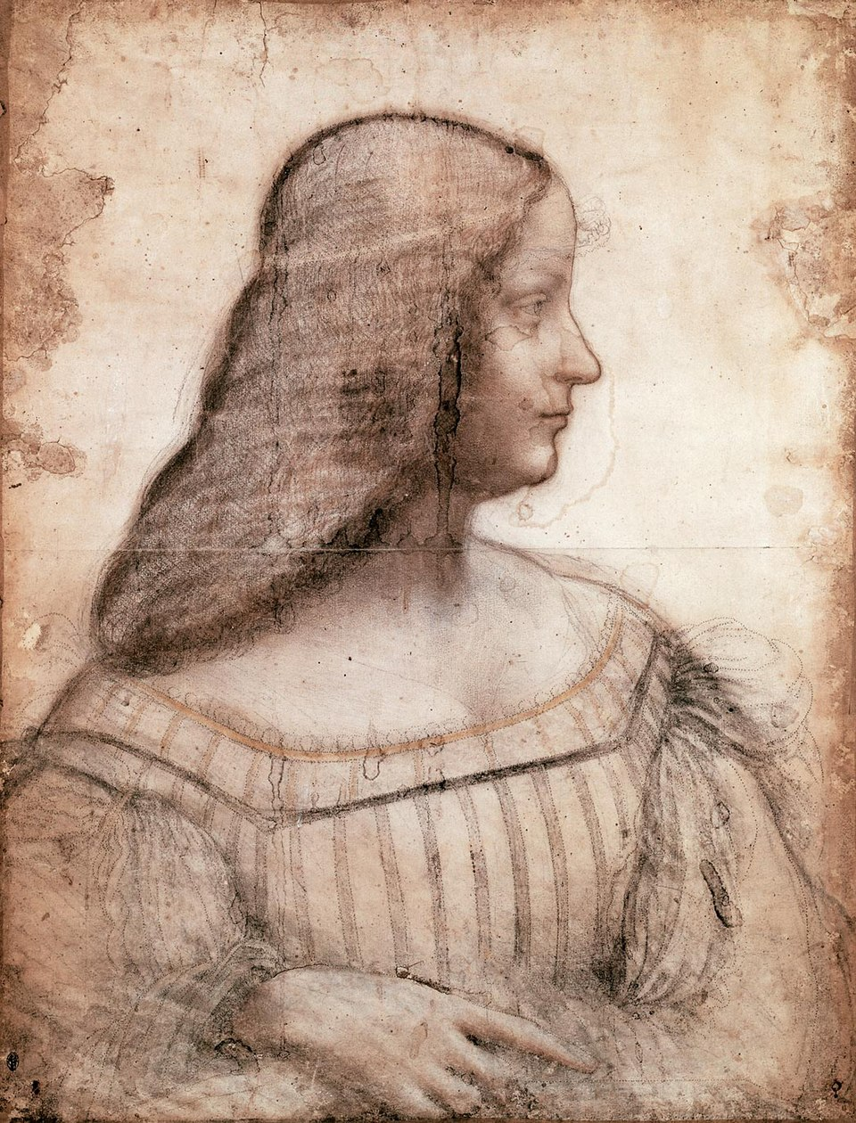
(V4_16) Leonardo da Vinci, Portrait of Isabella d’Este, Musée du Louvre
$include(figure-slice-vertical-end.in) $include(layout-a-end.in) $include(sheet.in) $include(layout-b.in)
His son and heir, Alfonso, was married, first, to a daughter to the Duke of Milan, and then to Lucrezia Borgia, the daughter of Pope Alexander VI.
$include(column-break.in) $include(figure-slice-vertical.in)
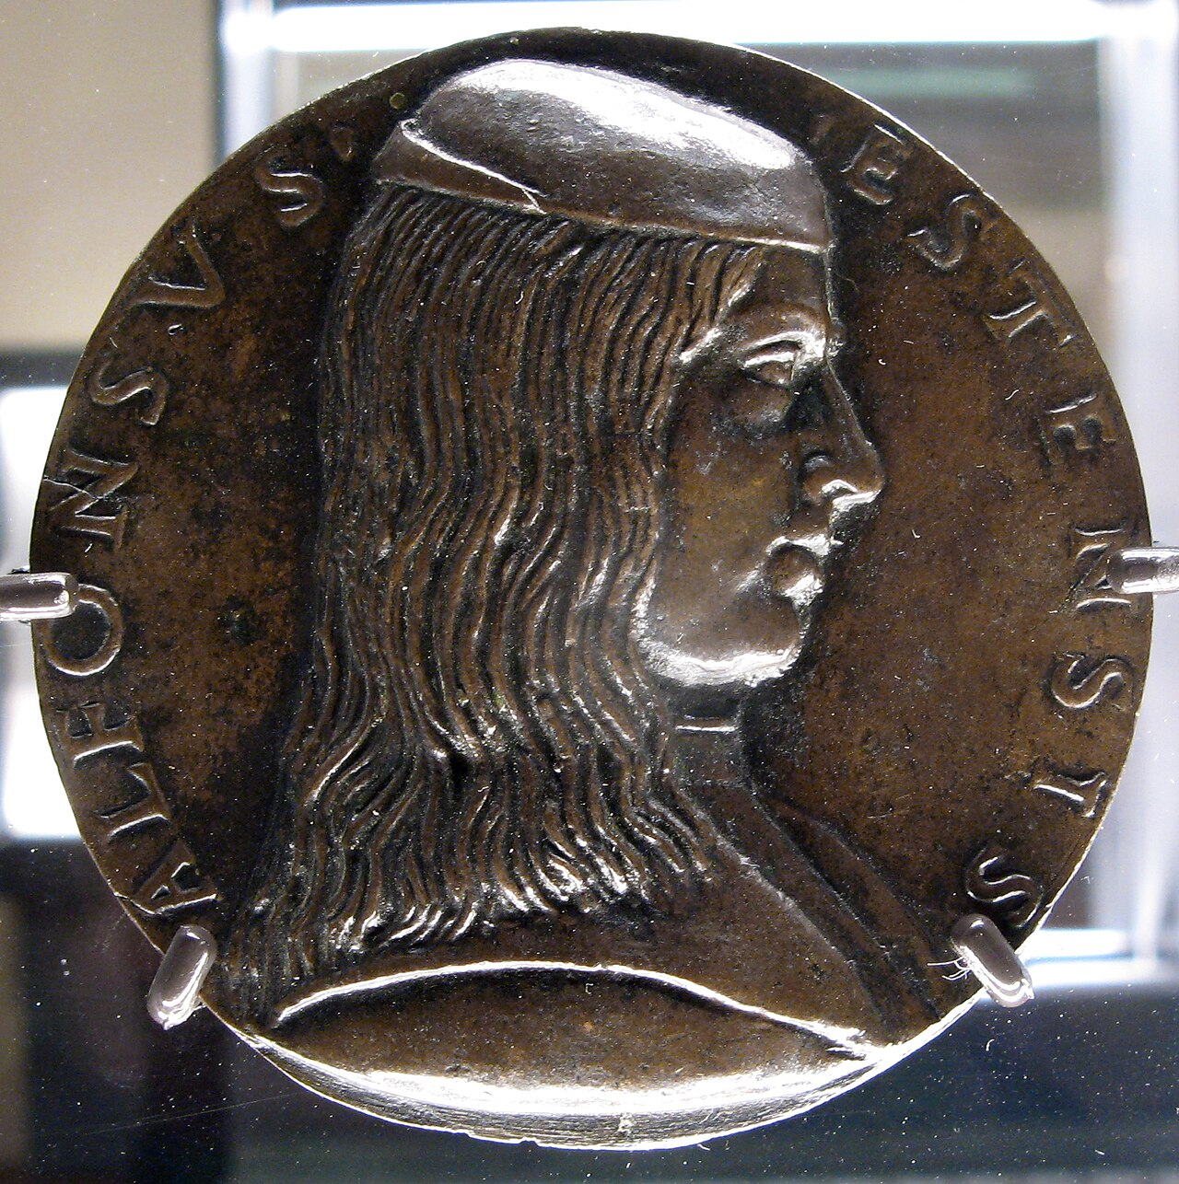
(V4_17) Niccolò di Forzore Spinelli, Portrait medal of Alfonso d’Este, 1492, Bargello Museum
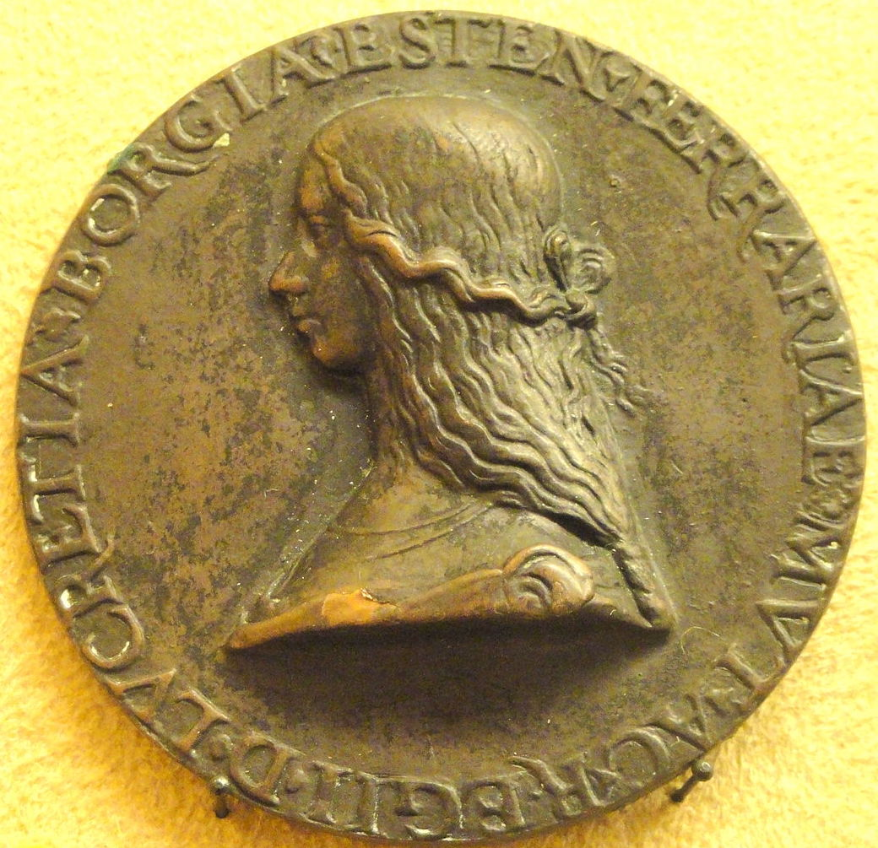
(V4_17a) Anonymous, Portrait medal of Lucrezia Borgia, c. 1503, National Museum of Finland
$include(figure-slice-vertical-end.in) $include(layout-b-end.in) $include(sheet.in) $include(layout-b.in)
Lucrezia presided over a brillant, small court at Ferrara until her death in 1519; and perhaps this is the moment to add that the greatest Italian poet of the Renaissance, Ariosto, was in the service of the Este family, and that the first edition of his chivalrous epic, Orlando furioso, was published in 1516, by which year Alfonso had acquired the greying beard, short hair and broad forehead appropriate for a commander-in-chief.
$include(column-break.in) $include(figure-slice-vertical.in)
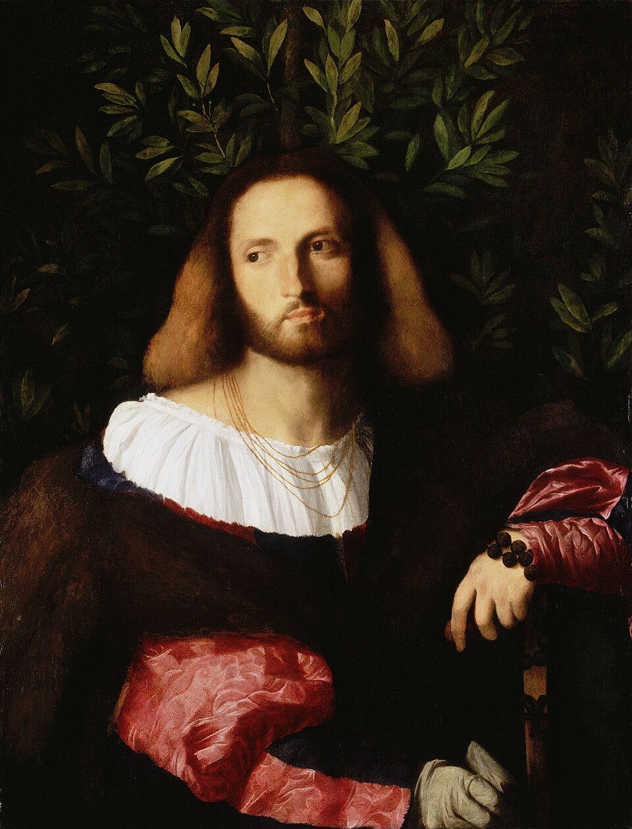
(V4_18) Palma Vecchio, Portrait of Ariosto , National Gallery
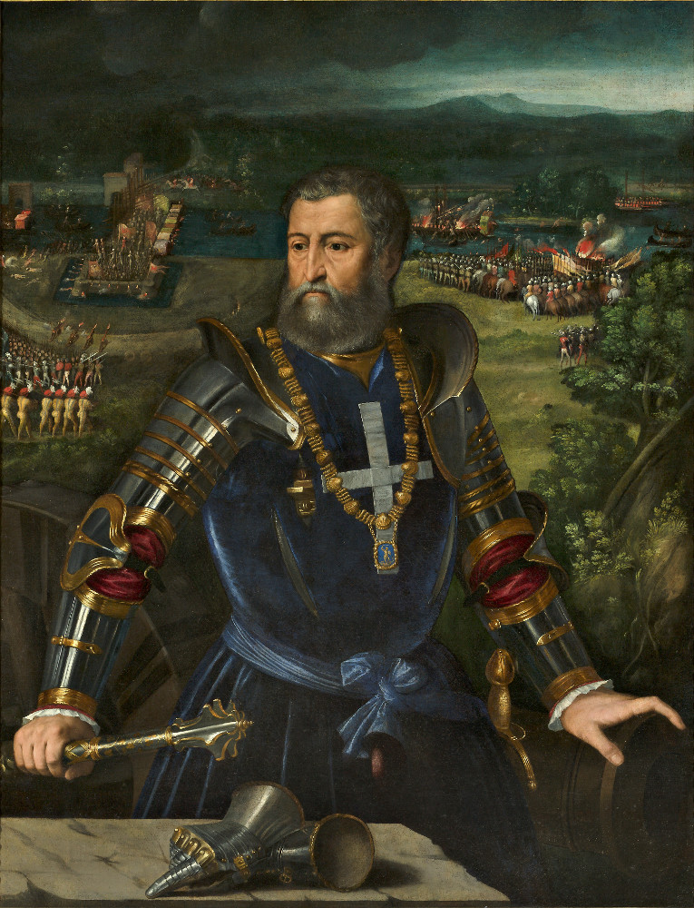
(V4_18a) Battista Dossi, Portrait of Alfonso d’Este, Galleria Estense
$include(figure-slice-vertical-end.in) $include(layout-b-end.in) $include(sheet.in) $include(layout-b.in)
In 1518, not long before Lucrezia died, Alfonso decided to rebuild a wing linking the palace to the main castle, and to create (at the level indicated by the marble balcony in the second photograph),some private apartments which would include a bedroom and a study, uno studiolo.
$include(column-break.in) $include(figure-slice-vertical.in)
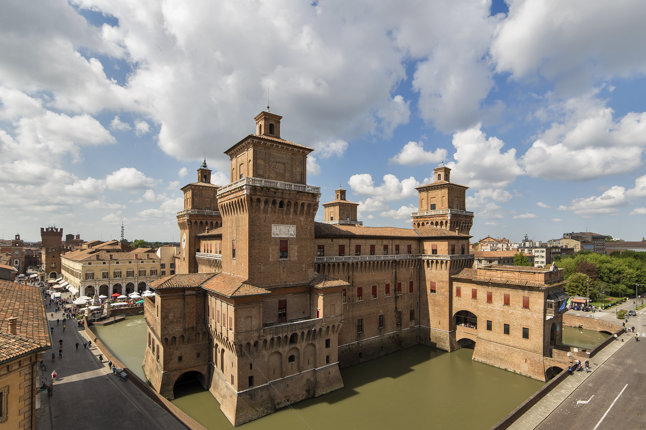
(V4_19) Aerial view of Castello Estense
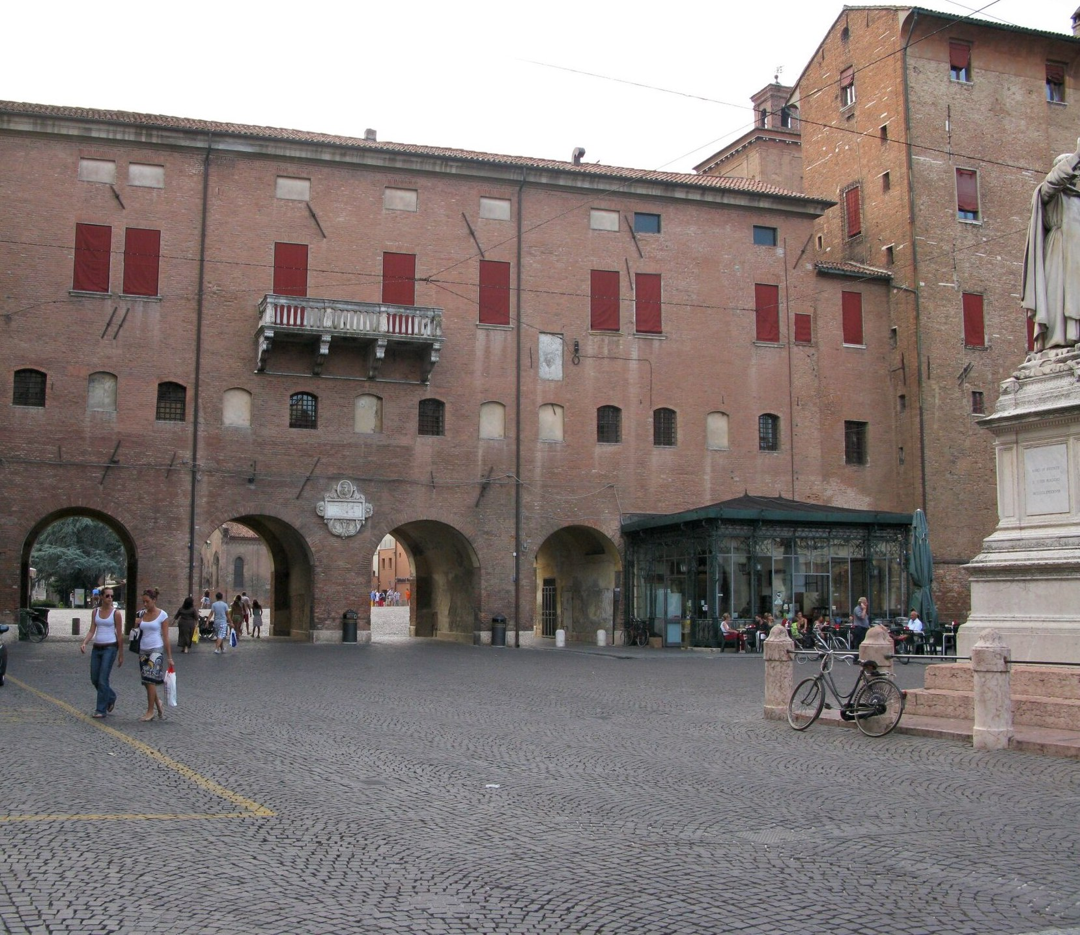
(V4_19a) View of Via Coperta, Ferrara
$include(figure-slice-vertical-end.in) $include(layout-b-end.in) $include(sheet.in) $include(layout-a.in)
It had become something of a fashion for a prince to have a splendid private room, decorated perhaps with illusionistic marquetry, as at Urbino, or with a set of paintings done by great artists, as was to be in the case with Alfonso’s sister at Mantua, who commissioned solemn and learned allegories of the virtues from artists such as Mantegna and Perugino.
$include(column-break.in) $include(figure-slice-vertical.in)
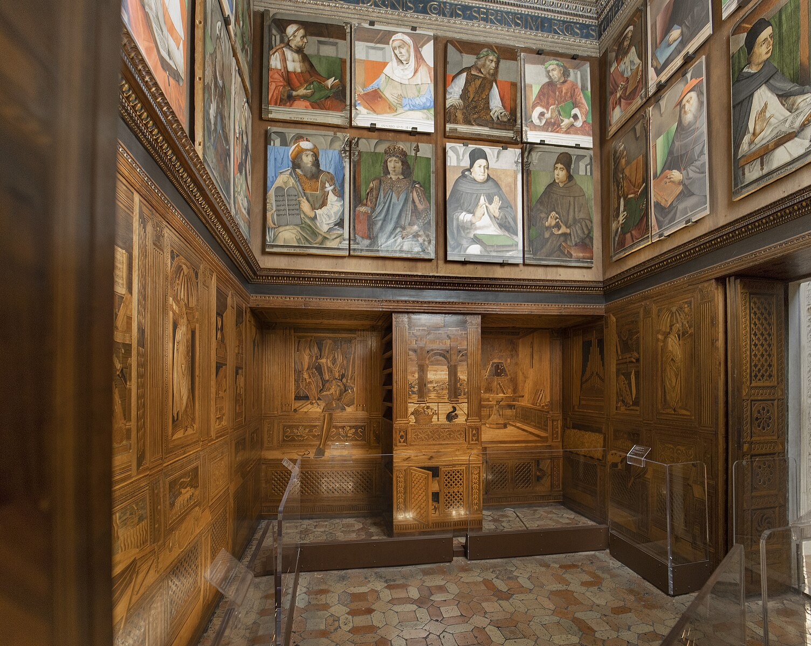
(V4_20) Studiolo of Federico da Montefeltro, Palazzo Ducale, Urbino
$include(figure-slice-vertical-end.in) $include(layout-a-end.in) $include(sheet.in) $include(layout-a.in)
Alfonso was an earthier man than his sister, but he was a man of his time. He wanted the paintings in his private room to celebrate the pleasures of good wine and sex rather than the moral virtues, but he chose to dignify these pleasures by associating them with classical deities—with Bacchus and Venus. He therefore demanded that his paintings should consist of detailed illustrations of passages in classical literature.
By 1514 he had already persuaded Giovanni Bellini to illustrate a passage from Ovid. He then tried very hard to obtain a Bacchus from Raphael, and a Venus from Fra Bartolomeo (whose detailed drawing was never executed, but would not be without influence, as we shall see later).
$include(column-break.in) $include(figure-slice-vertical.in)
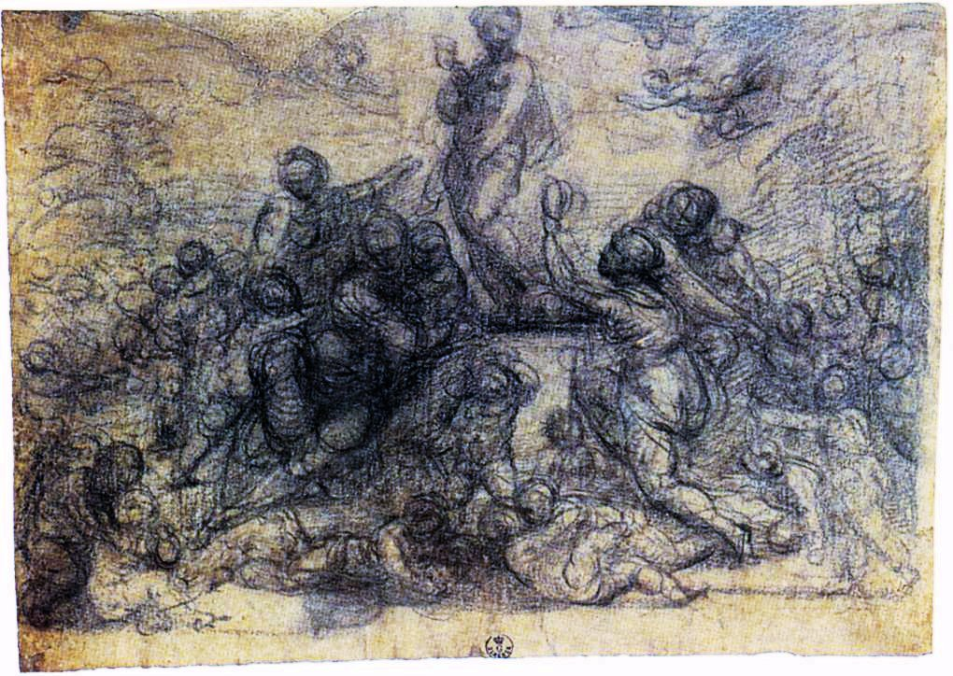
(V4_21) Fra Bartolomeo, Worship of Venus, Uffizi
$include(figure-slice-vertical-end.in) $include(layout-a-end.in) $include(sheet.in) $include(layout-a.in)
Both artists died (respectively, in 1520 and 1517) before delivering the goods, so Alfonso turned to a Venetian painter in his thirties called Vecellio, Tiziano Vecellio—known to us simply as Titian.
From him, Alfonso commissioned three canvassses which were to be of the same size as the existing Bellini. The first would illustrate another passage from Ovid. The other two would attempt to recreate lost classical paintings representing Bacchus and Venus, as described by an ancient Greek rhetorician. To these, he would add a fifth painting by his own court painter, Dosso Dossi.
The fifth painting is lost (or unidentified); and I shall say no more about it. The other four canvasses are now dispersed in Washington, London and Madrid. But I am going to reassemble them for you, so that we may view them as a cycle— because the relationship between pictures and narrative texts is one of the most interesting I have had the pleasure of examining in these lectures, and because Alfonso’s camerino, as it is also called, must have been the most beautiful ‘small room’ anywhere in Italy at this time.
Before we come to the main item of business, however, I must remind you that the art of painting had evolved almost out of all recognition between 1470 (the date of the frescos in Palazzo Schifanoia) and 1520 (the time when Titian began his oil paintings for the studiolo. This sensitive portrait of a young man, inconceivable in the fifteenth century, dates from this period in his long career).
$include(column-break.in) $include(figure-slice-vertical.in)
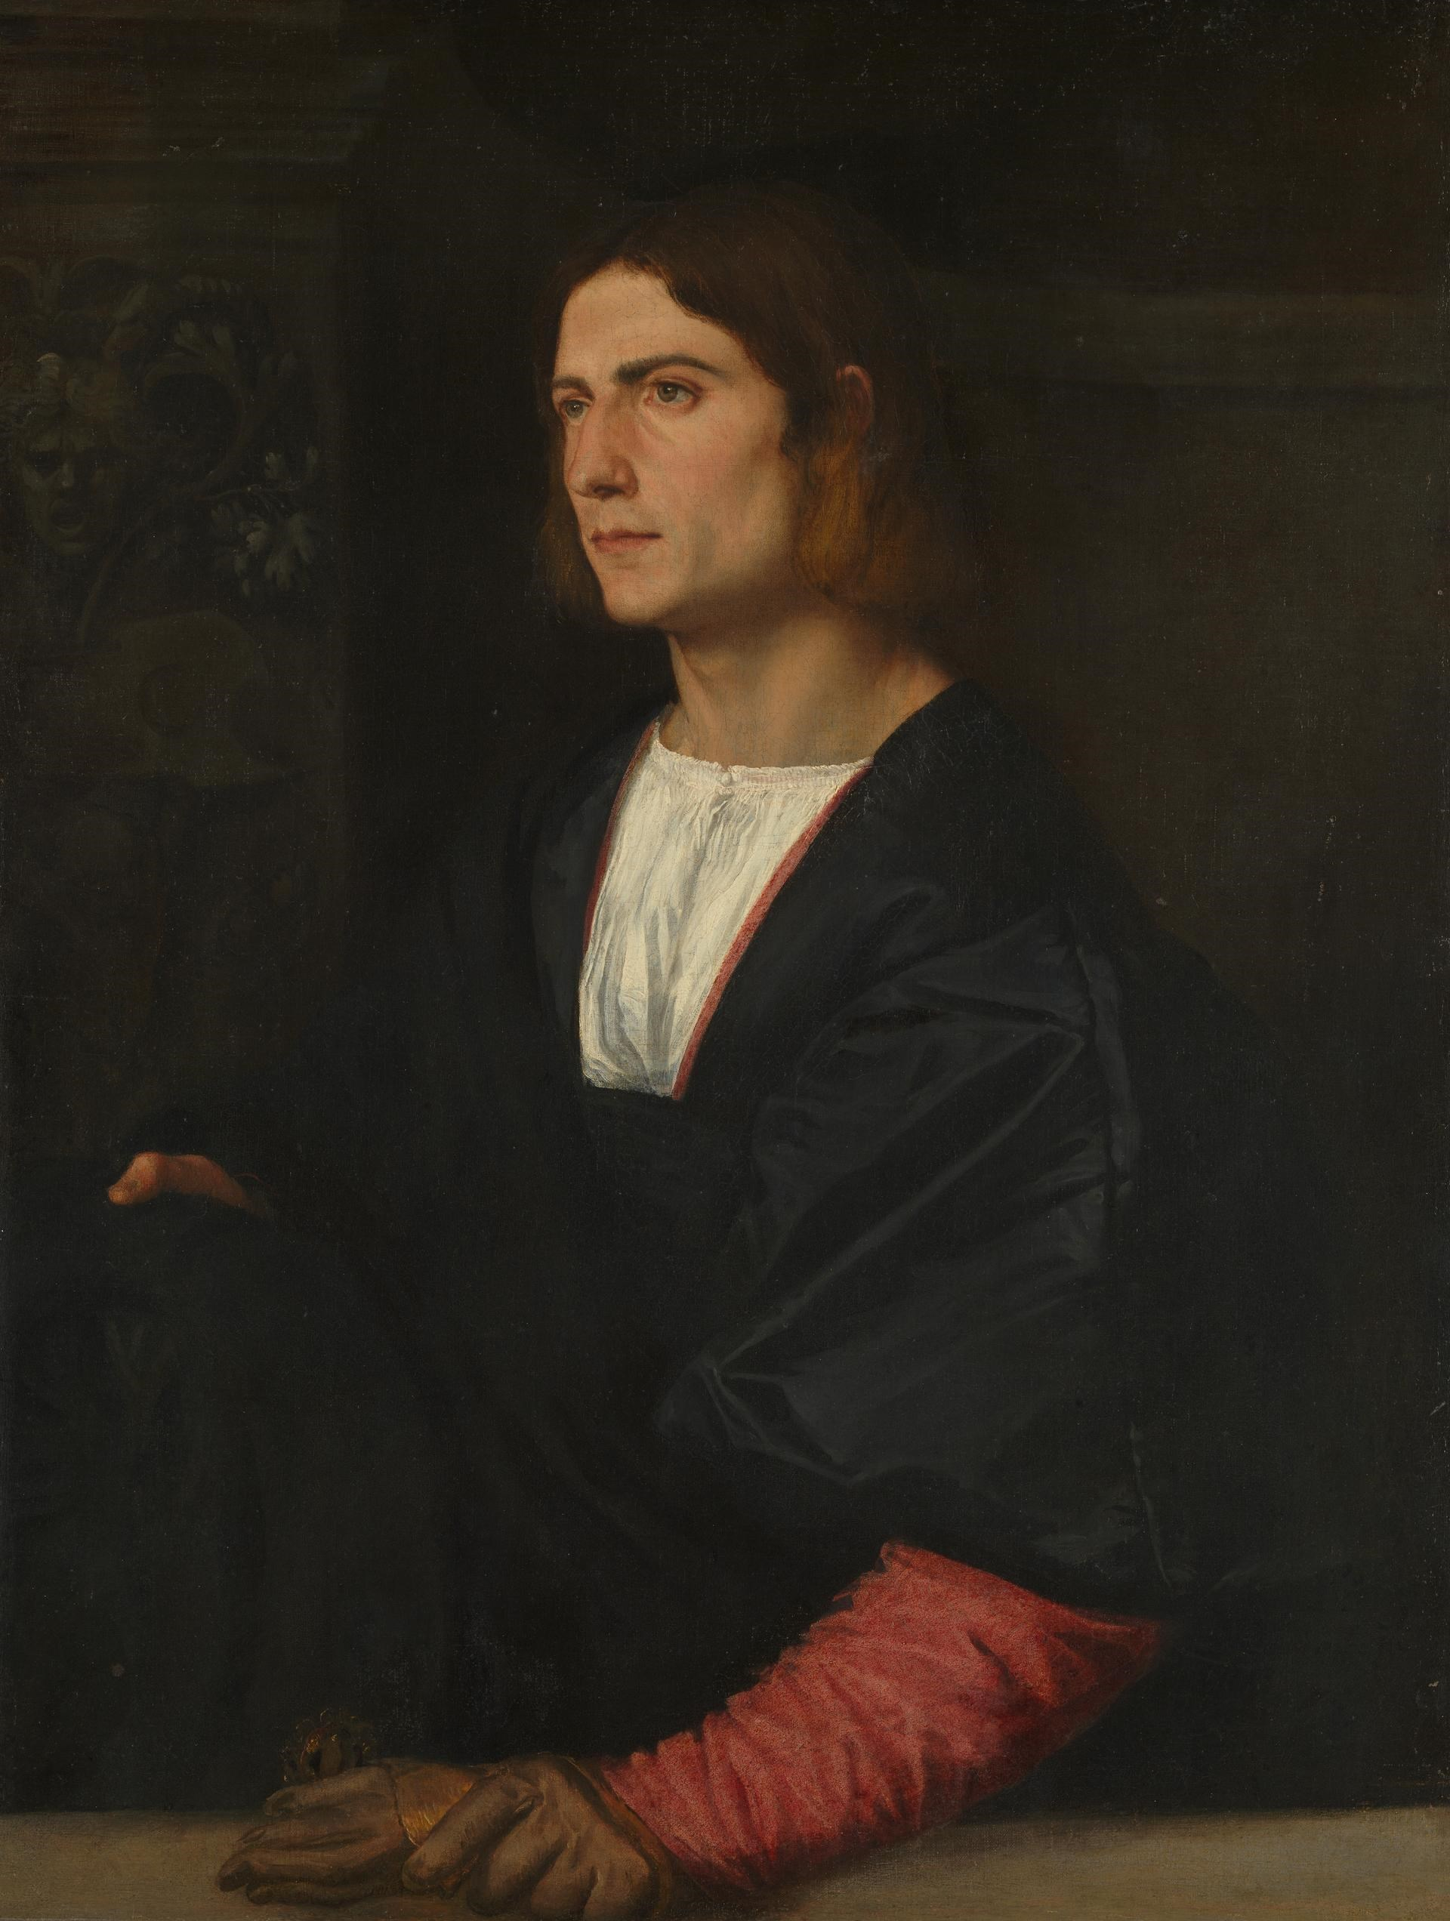
(V4_21a) Titian, Portrait of a Young Man, c. 1515–20, National Gallery
$include(figure-slice-vertical-end.in) $include(layout-a-end.in) $include(sheet.in) $include(layout-a.in)
In central Italy, Raphael—who had been Alfonso’s first choice—had been inspired by the extraordinary figure-compositions of Leonardo and Michelangelo and had then developed their procedures in his own way, as in his jaw-dropping Transfiguration of 1517, which stands fully thirteen feet high.
$include(column-break.in) $include(figure-slice-vertical.in)
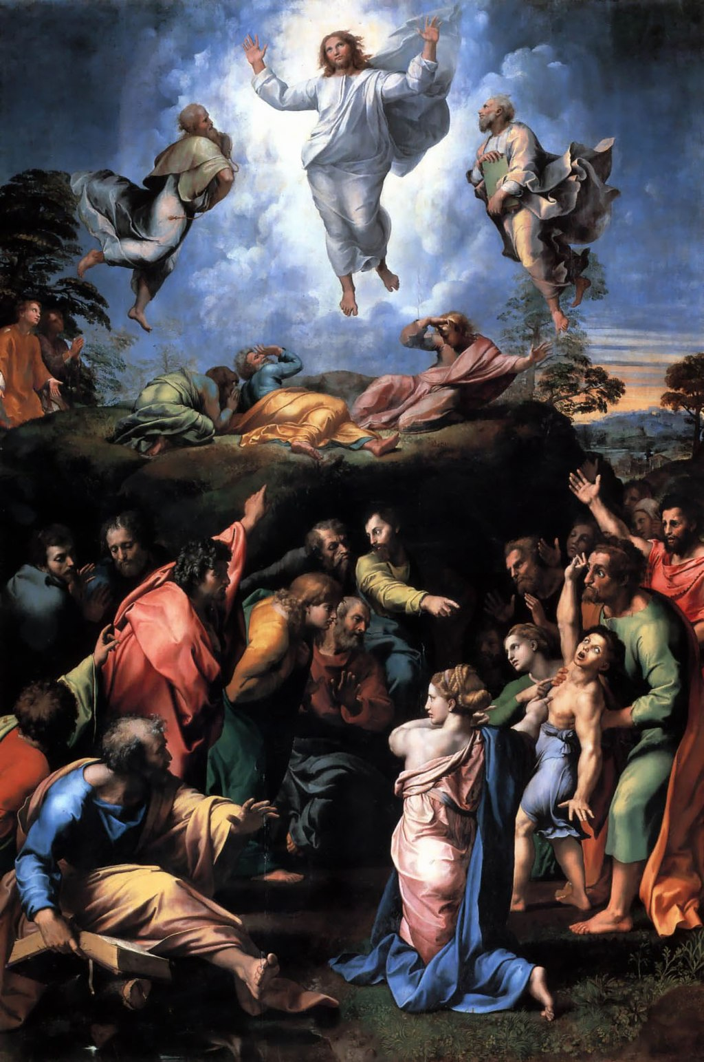
(V4_22) Raphael, Transfiguration, Pinacoteca Vaticana
$include(figure-slice-vertical-end.in) $include(layout-a-end.in) $include(sheet.in) $include(layout-a.in)
In Venice, Titian had already executed an even bigger painting of the Assumption of the Virgin, fully twenty feet high, which also dates from the years 1516 to 1517.
$include(column-break.in) $include(figure-slice-vertical.in)
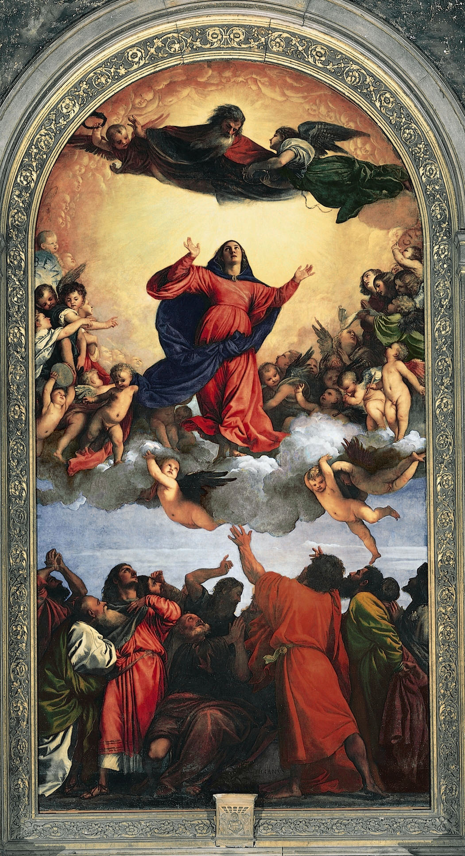
(V4_23) Titian, Assumption of the Virgin, Basilica di Santa Maria Gloriosa dei Frari
$include(figure-slice-vertical-end.in) $include(layout-a-end.in) $include(sheet.in) $include(layout-a.in)
Today, we think of the feeling of upward movement and the extraordinarily complex ‘choreography’ of the Assumption of the Virgin as being somehow generically ‘Italian High Renaissance’, but the warmth of colour and the softness of outline owe a very great deal to a quieter revolution, which had been taking place more exclusively in Venice, and which we owe to the extraordinary ‘late summer’ of Giovanni Bellini.
$include(column-break.in) $include(figure-slice-vertical.in)
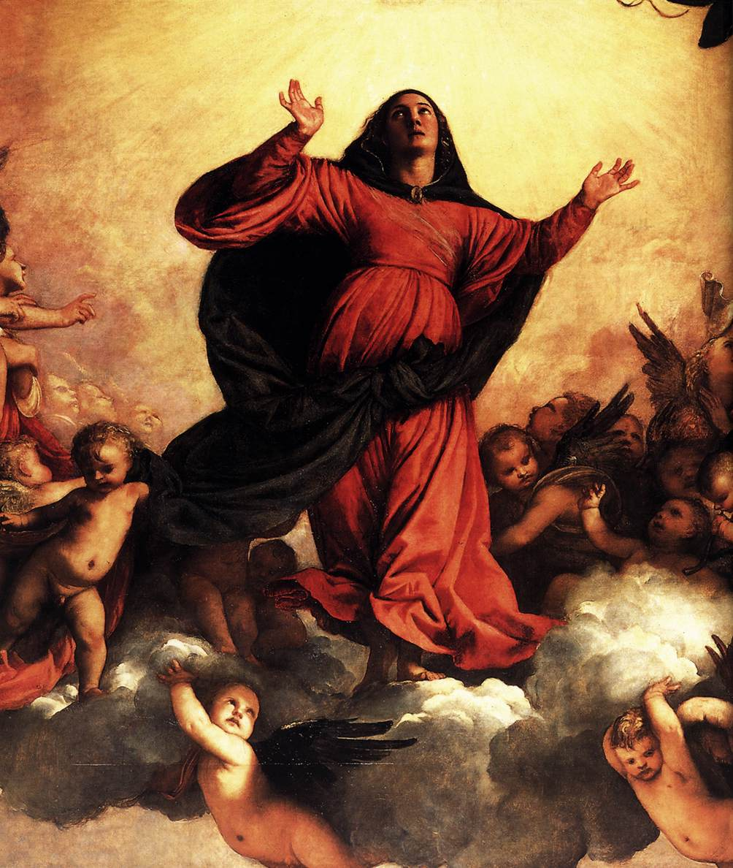
(V4_24) Detail from Titian, Assumption of the Virgin
$include(figure-slice-vertical-end.in) $include(layout-a-end.in) $include(sheet.in) $include(layout-a-50.in)
Just two examples.
Look at the head of St John the Baptist on the left of an altarpiece which Bellini painted in his ‘Indian summer’, when he was 80 years old, in 1510.
$include(column-break.in) $include(figure-slice-vertical.in)
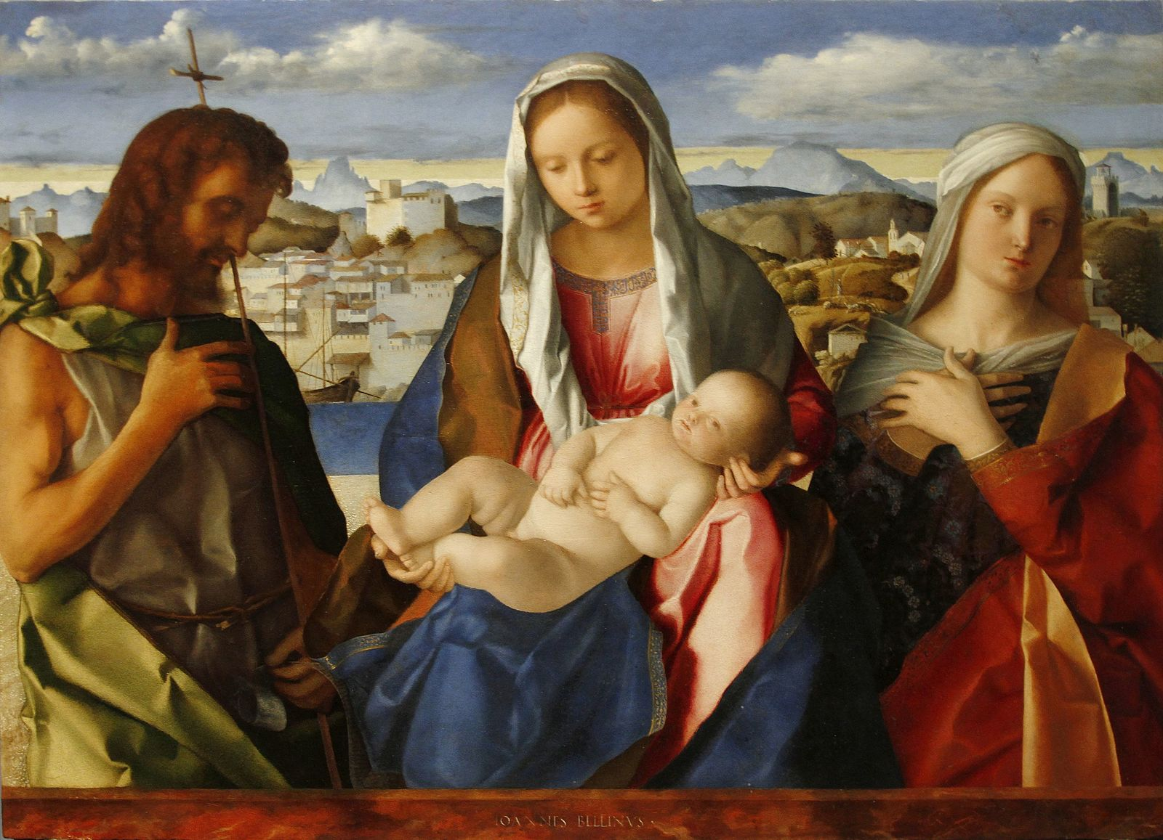
(V4_25) Gentile Bellini, Virgin and child with John the Baptist and an unknown Saint, Gallerie dell’Accademia
$include(figure-slice-vertical-end.in) $include(layout-a-end.in) $include(layout-a-50.in)
And look at the no less extraordinary ‘spring’ of that mysterious genius, Giorgione, who died of the plague in the year 1510, when he could not have been more than thirty.
Take your time.
$include(column-break.in) $include(figure-slice-vertical.in)
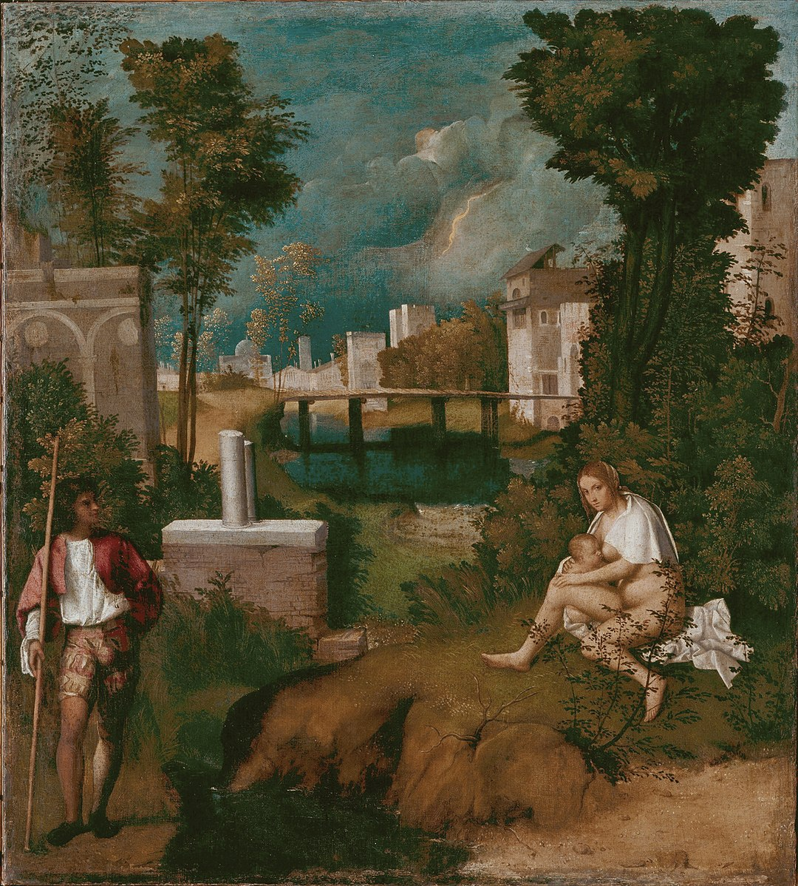
(V4_26) Giorgione, The Tempest, Gallerie dell’Accademia
$include(figure-slice-vertical-end.in) $include(layout-a-end.in) $include(sheet.in) $include(layout-b.in)
At this point, it had been my intention to pinpoint, in my own words, what it is that makes Giorgione’s figures, his landscapes and his skies so startlingly new; why it is that his contemporaries called La tempesta a ‘poem’, una poesia; and what were the features that the young Titian took over from him.
I soon realised, however, that a proper answer to these questions would be totally disproportionate in a lecture about Titian as a painter of narratives, so I shall limit myself to offering you just three more images, which you can treat as ‘test-cards’, so to speak, in order to give you time to ‘adjust your sets’ to the signals coming from this new ‘channel’.
The first of these is from the National Gallery in London. It is much earlier than La tempesta and is only twelve inches high. Look particularly closely at the detail (an area of about two square inches), so that you can register the soft, ‘smoky’ ‘sfumato’ outlines, the shadows, the warmth of the flesh tones, the simplification of the heads, and a certain feeling of inwardness.
$include(column-break.in) $include(figure-slice-vertical.in)
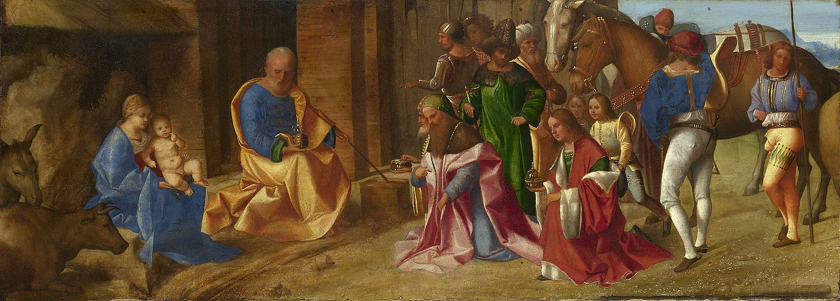
(V4_27) Giorgione, The Adoration of the Kings, National Gallery
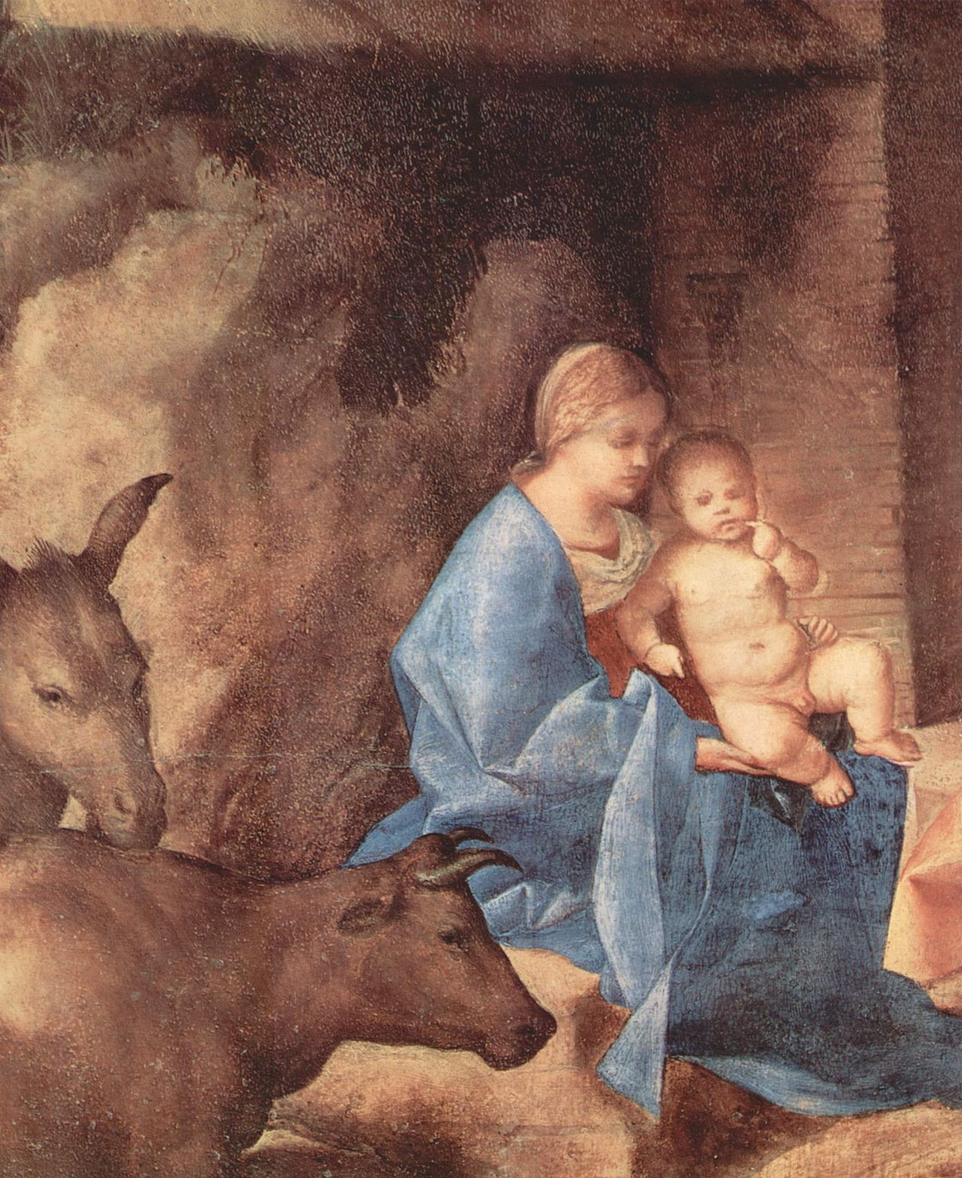
(V4_28) Detail from Giorgione, The Adoration of the Kings
$include(figure-slice-vertical-end.in) $include(layout-b-end.in) $include(sheet.in) $include(layout-c.in) $include(one-column-text.in)
Next—and more directly relevant to the mythologies painted at Ferrara—I show Giorgione’s famous Reclining Venus, which was to be the prototype of all sixteenth-century reclining Venuses.
$include(one-column-text-end.in) $include(figure-slice-vertical.in)
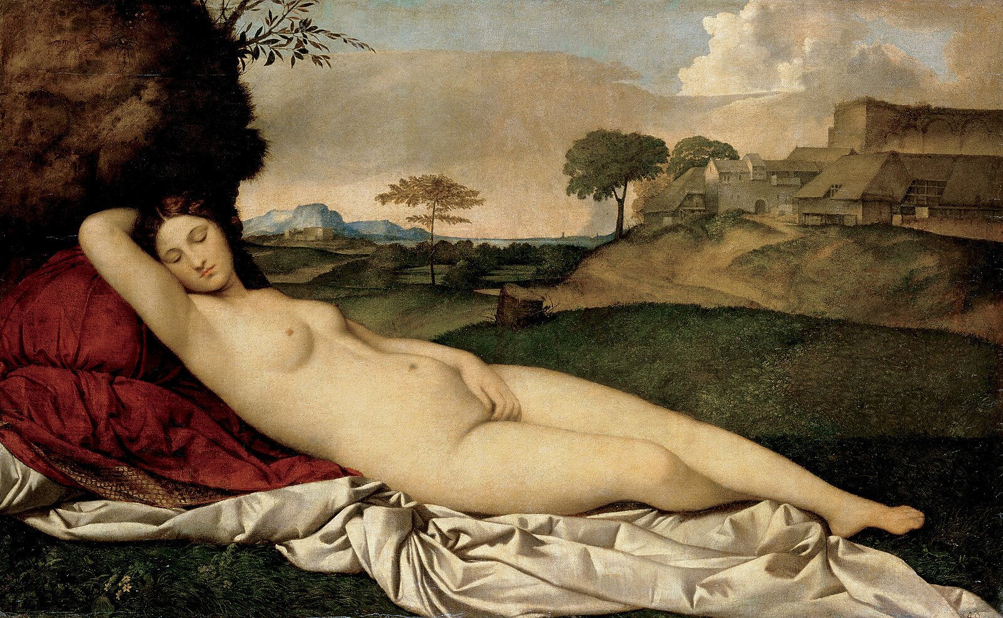
(V4_29) Giorgione, Sleeping Venus, Gemäldegalerie Alte Meister
$include(figure-slice-vertical-end.in) $include(layout-c-end.in) $include(sheet.in) $include(layout-a.in)
In this case, experts suggest that the goddess herself was painted by Giorgione, but that the landscape was completed by Titian, shortly after Giorgione’s death in the plague of 1510.
With the economy of a true professional, Titian used the same hill and the same building in his own Noli me tangere—again from about 1510, and now in our National Gallery):
It is a splendid anticipation of what we shall find at Ferrara in its varying impressionistic treatment of the rocks, the broad-leaved foliage lit by the rising sun, the blue ‘aerial perspective’ of the distant hills and the delicate gradations of colour in the clouds of the dawn sky.
$include(column-break.in) $include(figure-slice-vertical.in)
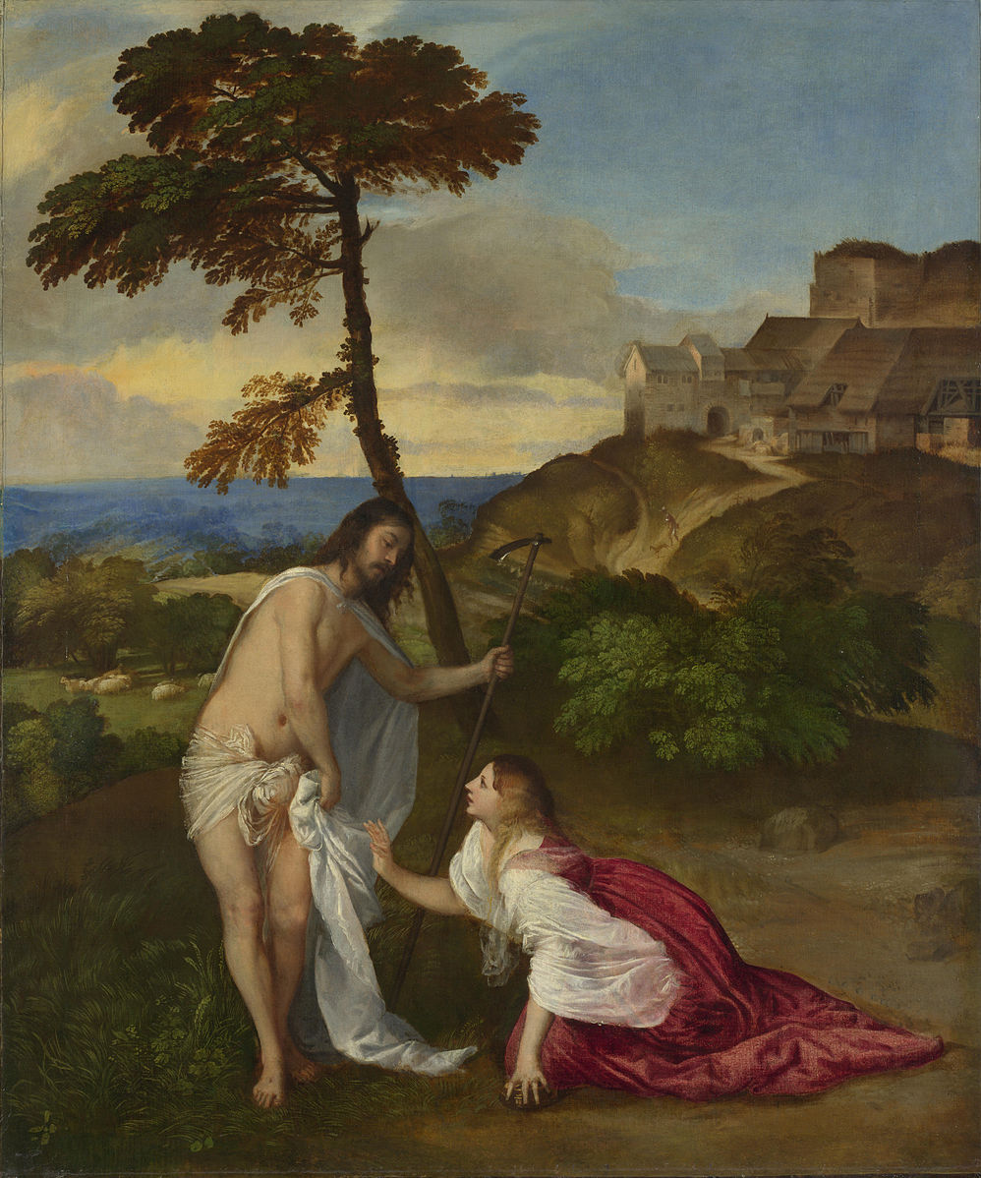
(V4_30) Titian, Noli me tangere, National Gallery
$include(figure-slice-vertical-end.in) $include(layout-a-end.in) $include(sheet.in) $include(layout-c.in) $include(two-column-text.in)
Back now to our ‘advertised programme’; that is, back to Alfonso’s camerino or studiolo, the pictures devoted to Bacchus and Venus, and the texts which they illustrate.
There have been some major articles in recent years which attempt to reconstruct the layout of the main apartment(s) in the castle wing, to deduce which works of art were displayed in which compartments or distinct rooms, and specifically, to establish the intended sequence of the five paintings which concern us in this lecture.
Dana Goodgal, for example, concluded that there were two rooms; and she argued that the pictures were intended to hang relatively high on the walls—above the doors, just as we saw in the previous lecture about Carpaccio’s canvasses for the School of St George.
Charles Hope (in his first examination of the evidence) deduced that the single long apartment had distinct ‘bay’s (as you see in his diagram—the numbers refer to the presumed position of the five canvasses, of which the lost Dosso Dossi would have been no. 4).
$include(two-column-text-end.in) $include(figure-slice-vertical.in)
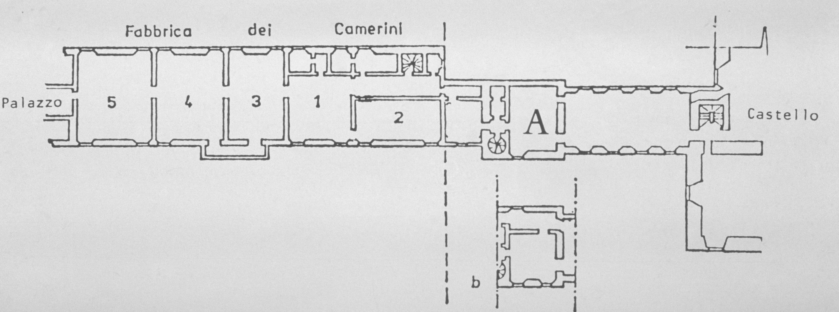
(V4_31) Plan of Alfonso I d’Este’s camerino by Charles Hope
$include(figure-slice-vertical-end.in) $include(layout-c-end.in) $include(sheet.in) $include(layout-c.in) $include(two-column-text.in)
For our purposes, however, it will be enough if you keep in mind that the apartment was tiny—the longer wall measuring not more than twenty feet— and if you retain an impression of this photomontage of the surviving canvases, in which the visitor to an exhibition could see (proceeding from right to left) the existing Bellini (now in Washington) in the centre of a long wall, lying between the two lesser-known Titians (now in the Prado), before being hit between the eyes, on the short wall, by the drama of Titian’s Bacchus and Ariadne (now in the National Gallery).
$include(two-column-text-end.in) $include(figure-slice-vertical.in)
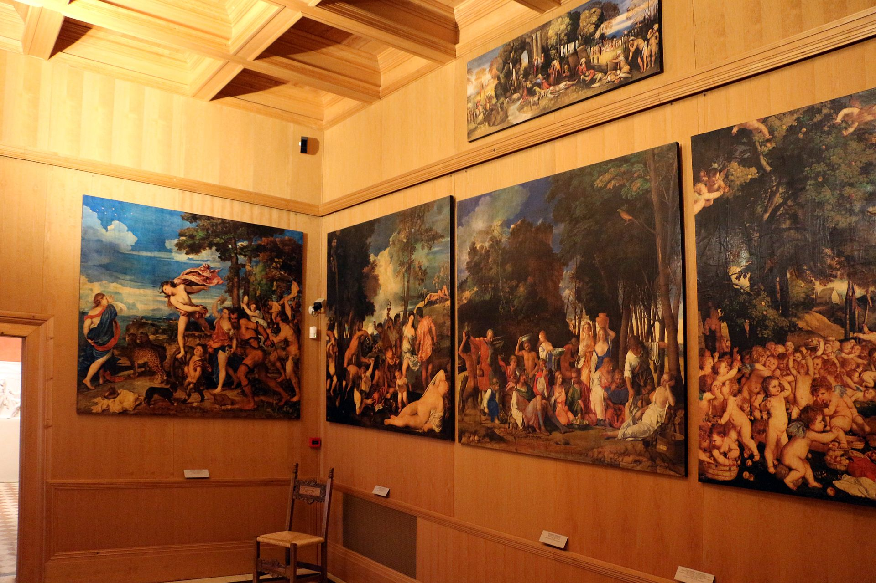
(V4_32) Mock-up of the layout of Alfonso I d’Este’s camerino, 2013
$include(figure-slice-vertical-end.in) $include(layout-c-end.in) $include(sheet.in) $include(layout-a.in)
Let us begin by looking at the so-called Feast of the Gods which has now found its way to Washington. It measures five and a half feet by six. The figures and the foreground were painted by Giovanni Bellini (it is firmly dated to 1514, when the artist would have been eighty-four years old). But the trees on the left and the rocky crag were repainted by Titian, some ten years later.
The underlying story comes from Ovid’s unfinished poem on the festivals of the Roman calendar, Fasti, which we can think of as a pagan Golden Legend.
The episode in question is a kind of ‘Just-so story for adults’, which purports to explain why it is that donkeys are sacrificed to Priapus, the god of procreation or fertility. (You will probably know that wooden statues of him, usually shown with an enormous erection, were used by the Romans in their gardens as scarecrows.)
It is not a very ‘proper’ story; and Ovid, indeed, asks himself whether he ought to tell it or leave it out. In the event, however, he finds it so entertaining that he tells it twice, with a different heroine each time: once in connection with the Ides of January, and then again in connection with the Ides of June.
It is the time of the biennial feast of Bacchus (if we follow Ovid’s first version) or of the feast of Cybele (if we follow the second). In our painting we see both the infant Bacchus, who is crouching to draw wine from a barrel, and Cybele, dressed in pink, holding a quince taken from the fruit bowl on the ground.
$include(column-break.in) $include(figure-slice-vertical.in)
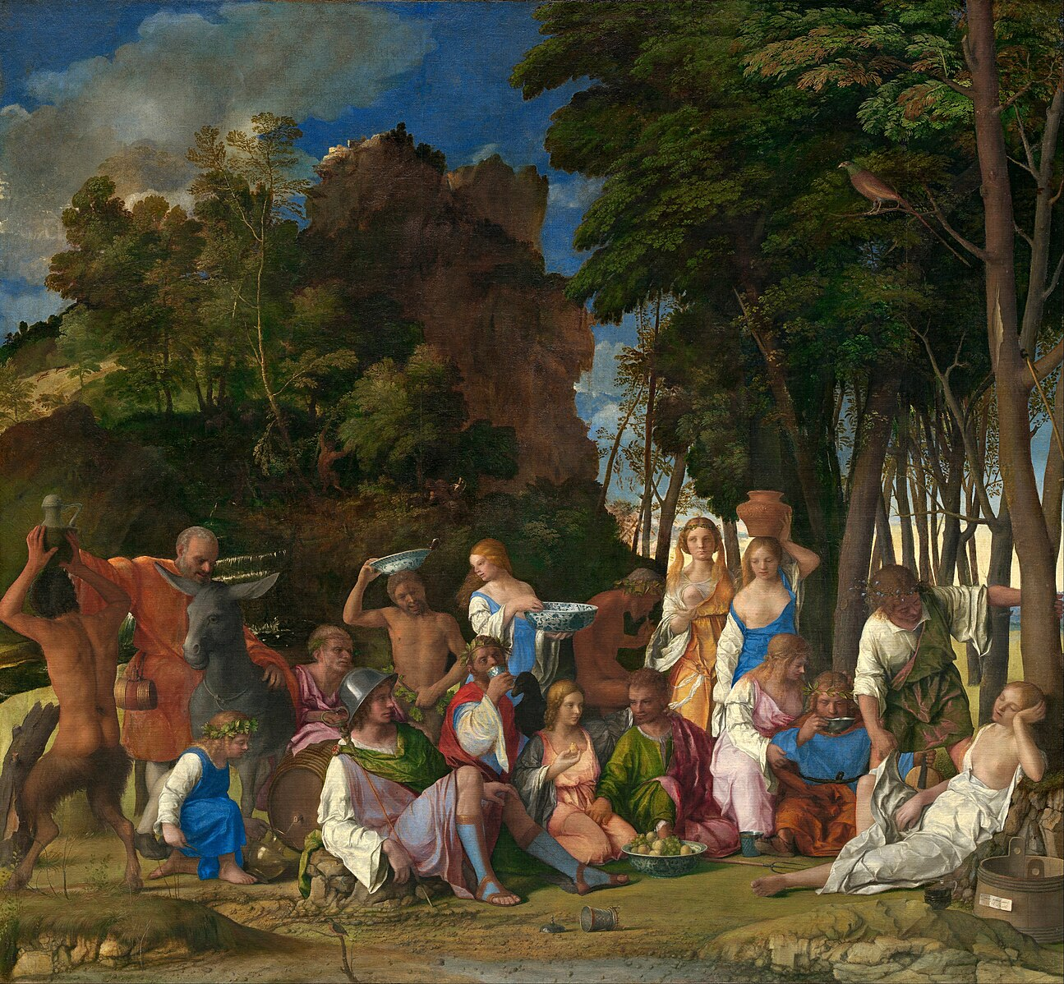
(V4_35) Giovanni Bellini, The Feast of the Gods, National Gallery of Art
$include(figure-slice-vertical-end.in) $include(layout-a-end.in) $include(sheet.in) $include(layout-a.in)
The eternal gods have come together for a glorified picnic, with ‘Pans, lascivious Satyrs, and the Nymphs or goddesses of the countryside’.
There are three Satyrs (two of them stripped to the waist), one of whom must be Pan.
The Nymphs are placed to the right; while the seated (or reclining) gods in the foreground are clearly the guests of honour, the Olympians.
$include(column-break.in) $include(figure-slice-vertical.in)
(V4_35_bis) Giovanni Bellini, The Feast of the Gods, National Gallery of Art
$include(figure-slice-vertical-end.in) $include(layout-a-end.in) $include(sheet.in) $include(layout-b.in) $include(text-with-image.in)
Ovid, in fact, does not name the gods, but they are identifiable by their attributes (just like the saints in a Christian altarpiece).
In these details, you can pick out: Mercury (helmeted and holding his caduceus); Jupiter (drinking, with a bedraggled eagle on his shoulder); Neptune , his trident lying on the ground); and Apollo (who is drinking from a flat dish and holding in his left hand the neck of a primitive member of the viol family).
$include(text-with-image-end-text.in)
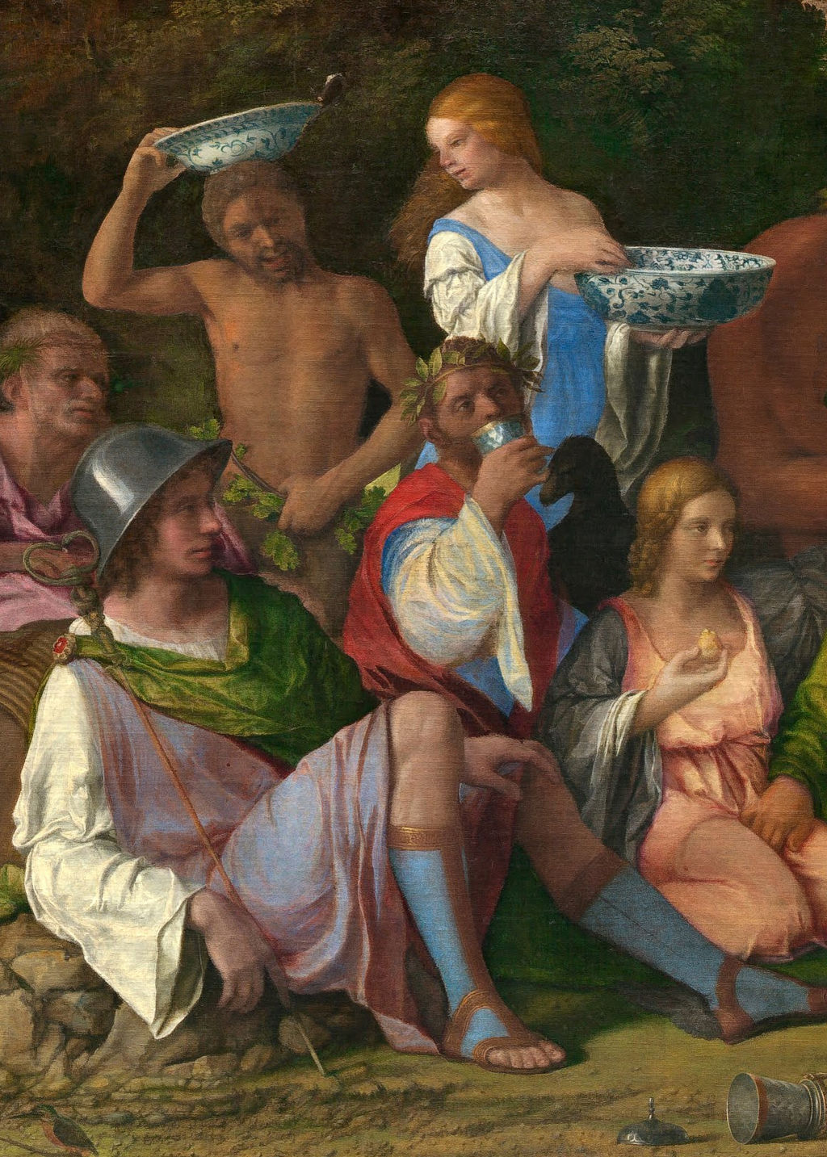
(V4_36) Detail from Giovanni Bellini, The Feast of the Gods
$include(text-with-image-end.in) $include(column-break.in) $include(figure-slice-vertical.in)
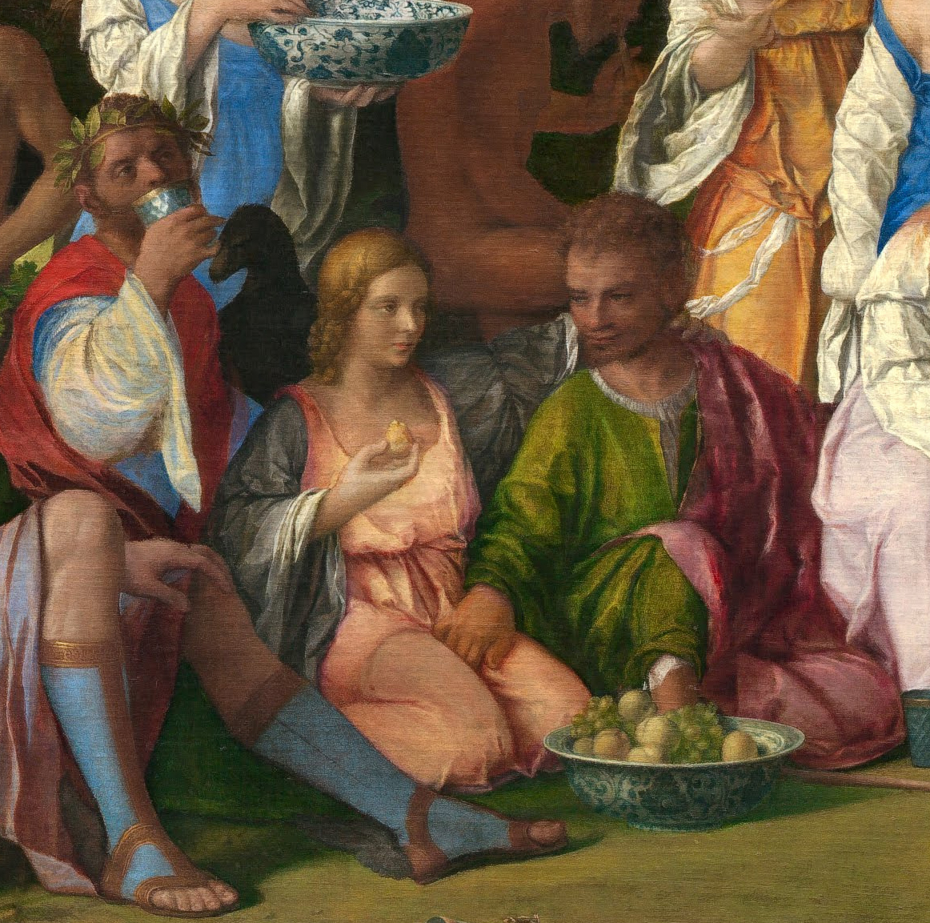
(V4_37) Detail from Giovanni Bellini, The Feast of the Gods
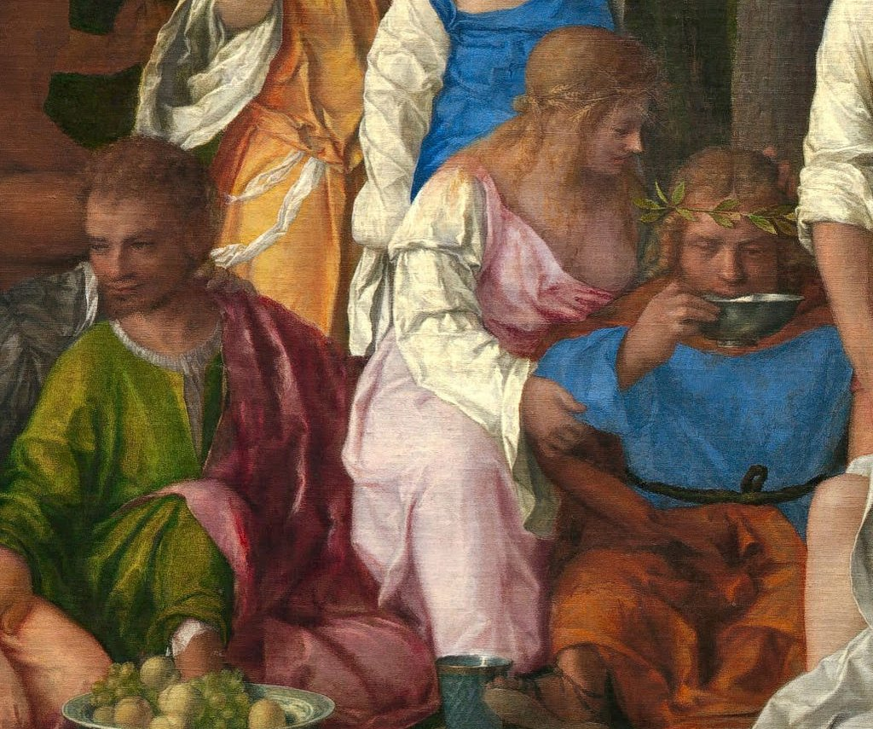
(V4_37a) Detail from Giovanni Bellini, The Feast of the Gods
$include(figure-slice-vertical-end.in) $include(layout-b-end.in) $include(sheet.in) $include(layout-c.in) $include(two-column-text.in)
The key figures in the story, however, are old Silenus on the left (standing next to his donkey), and young Priapus on the right.
We are told that Bacchus poured the wine; and Ovid specifies that some of the nymphs had their hair neatly combed, while others had let their hair down. We are also told that the nymphs were all barefoot, and that these facts combined to excite (to borrow a phrase from Dr Johnson) the ‘amorous propensities’ of the Satyrs, Silenus and Priapus.
What Bellini shows in the main group is the earlier, more decorous phase of the party—although the nymphs are clearly beginning to display their charms; and, as the wine runs free, their shoulders and bosoms have begun to appear.
$include(two-column-text-end.in) $include(figure-slice-vertical.in)
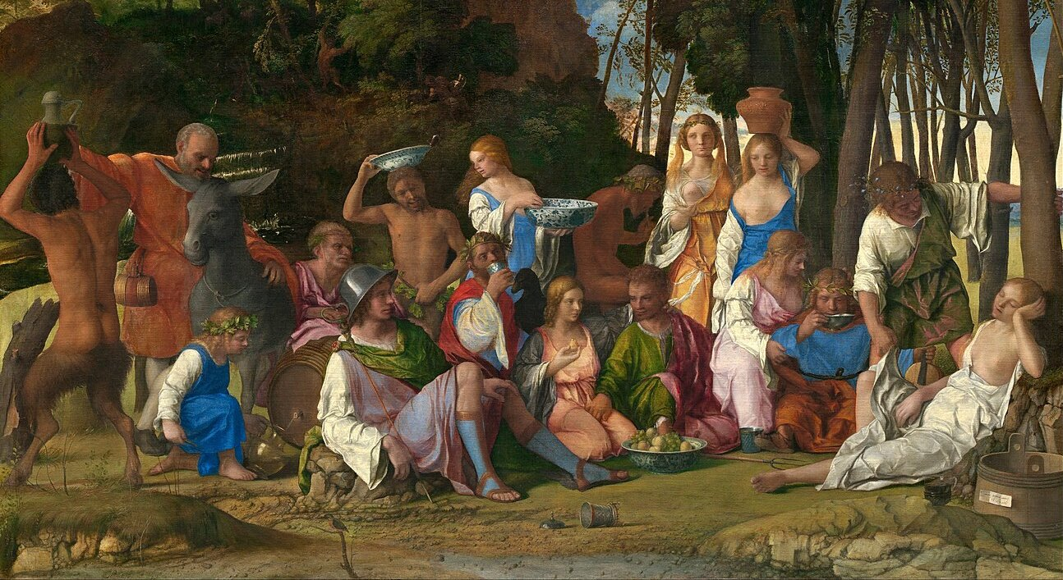
(V4_35a) Detail from Giovanni Bellini, The Feast of the Gods
$include(figure-slice-vertical-end.in) $include(layout-c-end.in) $include(sheet.in) $include(layout-c.in) $include(two-column-text.in)
Priapus is strongly attracted by a nymph called Lotis (in the first version), or Vesta (in the second version), but she rejects his sighs and his gestures. Night comes on, and the revellers ‘crash out’ on the grass, having been overpowered by the wine.
Lotis falls asleep, under a maple tree, ‘apart from the others’. Priapus notices her and tiptoes across, holding his breath, until he is standing close by. She is full of sleep (plena soporis) and she does not stir.
He lifts the dress that covered her feet (a pedibus tracto velamine), but, just when he is sure he can have his will, the donkey, old Silenus’s mount, utters a raucous and ill-timed bray (intempestivos edidit…sonos…. rauco…ore), with the result that Lotis awakes and escapes, and the gods mock Priapus and the all too evident indicator of his lust.
This, ‘O best beloved’, is why Priapus has demanded the sacrifice of donkeys ever since that day.
$include(two-column-text-end.in) $include(figure-slice.in)
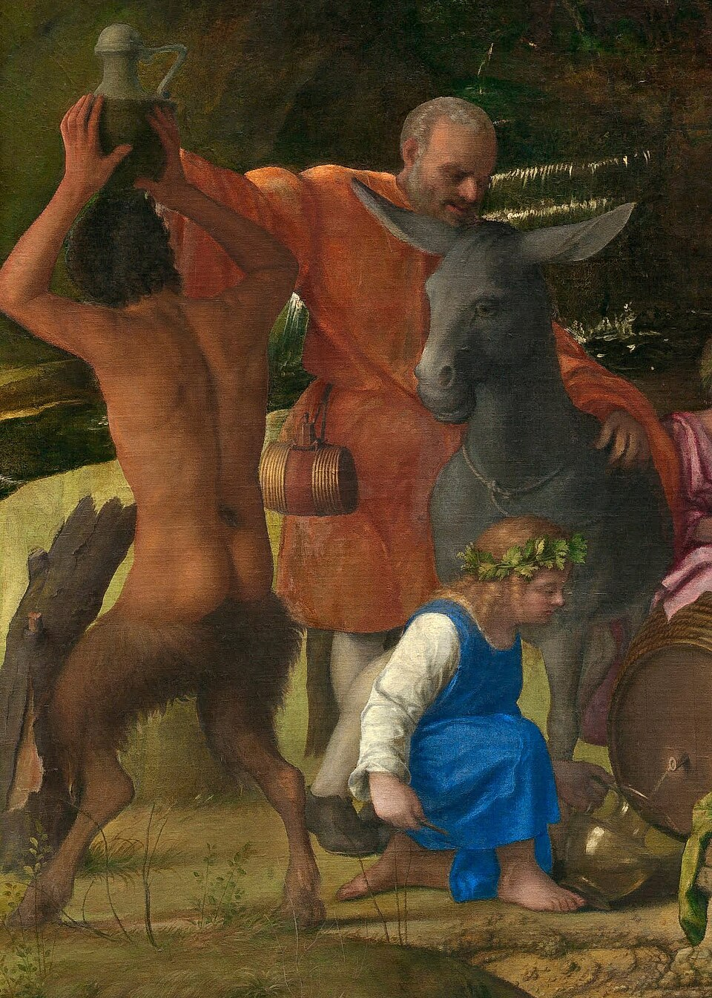
(V4_35b) Detail from Giovanni Bellini, The Feast of the Gods
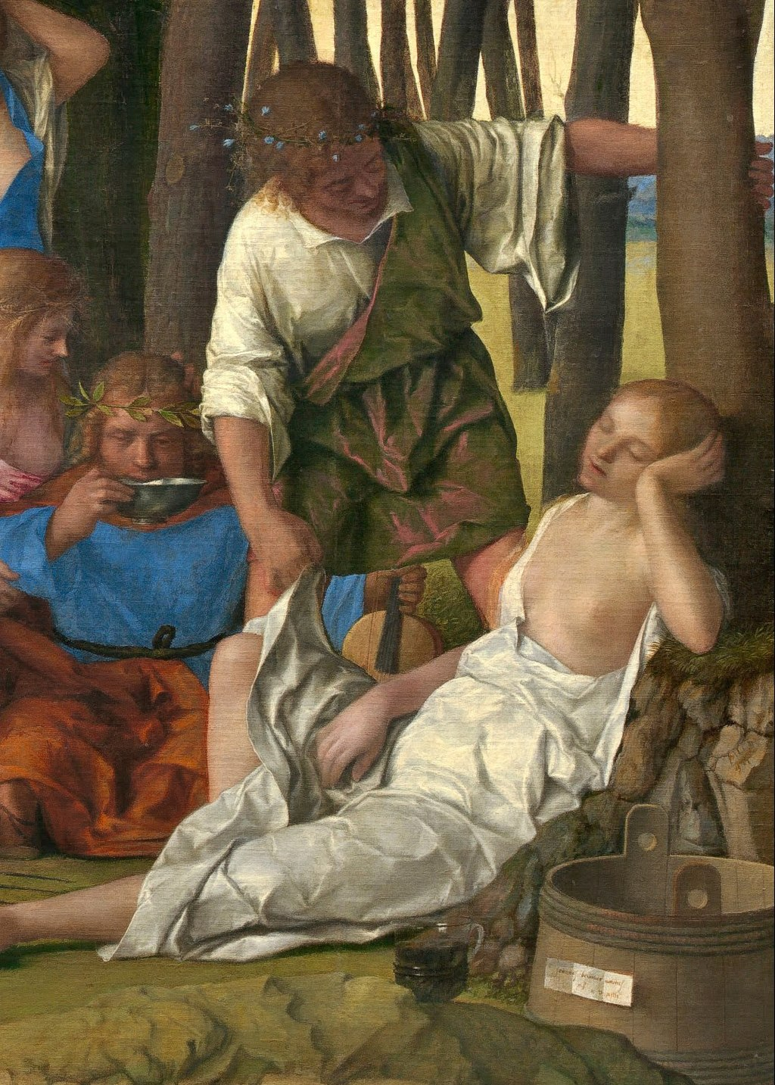
(V4_38) Detail from Giovanni Bellini, The Feast of the Gods
$include(figure-slice-end.in) $include(layout-c-end.in) $include(sheet.in) $include(layout-a.in)
The stony foreground and the slender tree-trunks on the right, I remind you, were painted by Giovanni Bellini, who was born way back in 1430. So, too, were all the deities and the donkey. And although the grouping is relatively sophisticated, it is still totally innocent of Florentine choreography and artifice of the kind we saw in Raphael’s Transfiguration and Titian’s Assumption of the Virgin.
By contrast, the landscape on the left is an early sixteenth-century poesia. The trees on the mound, the precipitous crag with a diminutive sunlit fortress on its crest, and the radiant clouds are the work of Titian, who was clearly charged with the task of either completing a canvas left unfinished (as he had done with Giorgione’s Reclining Venus), or repainting this area in order to harmonise its colours and proportions with his own Andrians, which would hang to its left.
$include(column-break.in) $include(figure-slice-vertical.in)
(V4_35_bis_bis) Giovanni Bellini, The Feast of the Gods, National Gallery of Art
$include(figure-slice-vertical-end.in) $include(layout-a-end.in) $include(sheet.in) $include(layout-a.in)
But before we come to The Andrians, let us examine the painting that was intended to hang on the other side of the Bellini, and take note of Titian’s debt to the lightning study which Fra Bartolommeo had produced in response to a very precise brief from Duke Alfonso.
Taking it in rapidly with an innocent eye, you will register a semi-clad Venus—seemingly alive but posed like a statue on a pedestal—who is being actively adored by a throng of worshippers who are grouped to form a pyramid of which the goddess forms the apex. But the drawing has a dynamic impact, produced by the impressionistic swirl of naked children, huddling close to one another, playing boisterously on the ground, or flying through the air.
Fra Bartolommeo was a Florentine who has been studying the revolutionary art of Leonardo and Michelangelo in the first decade of the new century. Titian, it will become clear, was commissioned by Duke Alfonso to paint a canvas representing this same subject, in the same spirit; and he was not in the least averse to borrowing and adapting from the sketch of his fellow artist.
But I am running ahead of myself…
$include(column-break.in) $include(figure-slice-vertical.in)
(V4_21_bis) Fra Bartolomeo, Worship of Venus, Uffizi
$include(figure-slice-vertical-end.in) $include(layout-a-end.in) $include(sheet.in) $include(layout-a.in)
The conventional or received title of Titian’s painting is the Worship of Venus, but, as we shall see, there is absolutely no doubt that its real title should be Cupids; or, in Latin, Cupidines.
Look first at the sky, the hint of dark blue hills with the campanile, the farm building with its chimney, and the broad masses of the trees that occupy about a quarter of the canvas, because these all come from a ‘repertory’ of standard backgrounds that Titian had built up through his contact with Giorgione in the early years of his career (by this point, he would have been in his mid-thirties).
But almost everything else in the picture comes (via Bartolommeo) from the classical text which Duke Alfonso had required him to illustrate—or rather, to recreate.
Because this the first of the two ‘recreations’ of lost or imaginary classical paintings that had been described in Greek prose by a rhetorician called Philostratos in the early third century AD, in a work called, in Greek, Icons, and, in the Latin translation that Alfonso had borrowed from his sister Isabella, Imagines.
This fascinating work consists of sixty-four ‘vivid descriptions’ (the technical term in the manuals of rhetoric was ekphrases), preceded by an introduction in which Philostratos explains that they are intended to help the young ‘to interpret paintings and to appreciate why they are valued’.
They are cast in the form of little talks given to the ten-year-old son of his host while the author was staying at a splendid country villa which had many panelled pictures. Hence, the very first descriptio begins: ‘Have you noticed, my boy, that the painting here is based on Homer?’. And the first words of the sixth description, entitled Erotes (in Latin, Cupidines), are: ‘Look, Cupids are gathering apples, and do not be surprised that there are so many of them’.
$include(column-break.in) $include(figure-slice-vertical.in)
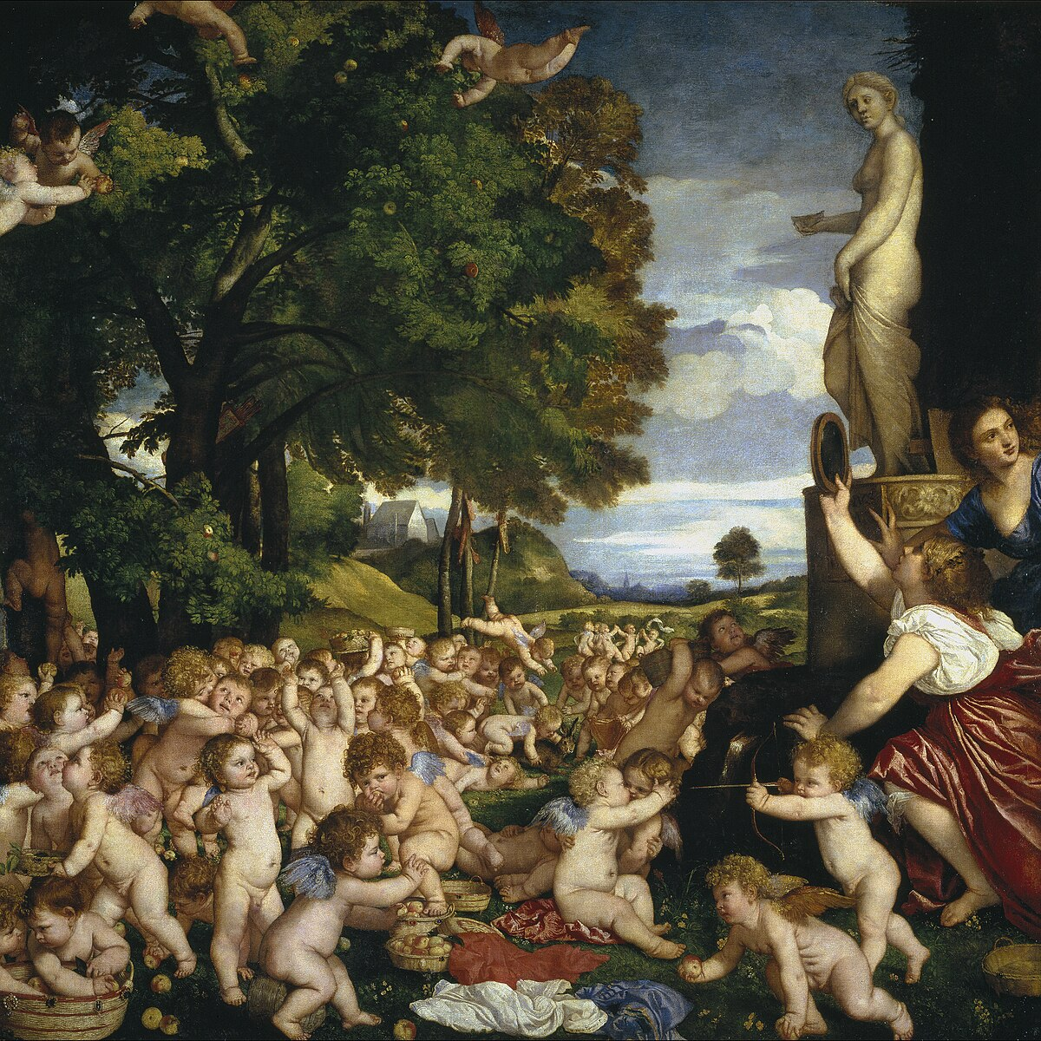
(V4_40) Titian, The Worship of Venus, Prado Museum
$include(figure-slice-vertical-end.in) $include(layout-a-end.in) $include(sheet.in) $include(layout-a.in)
As you are about to see, Titian is following his written source very closely indeed and all the features I am going to point out derive from Philostratos.
‘Cupids are gathering apples’, which grow ‘red and gold on the ends of the branches’ of trees, which run in ‘straight rows’, with ‘space left free between them to walk in’ and with ‘tender grass fit to be a couch’.
The cupids have blue wings; they are not wearing their crowns, as their hair suffices; and they are untrammelled by their gold-studded quivers, which they have hung on the trees (Titian has made the quivers far too big, so that we are able to see them).
They do not need ladders, because they fly to where the apples hang; the baskets they use to gather the apples are encrusted with jewels. (Titian gives them prominence, but his apples are more functional and more ‘vernacular’.) Their embroidered mantles lie on the ground, and countless are the colours thereof’. ‘Some of the Cupids are sleeping, while others are engaged in wrestling’. ‘Let not the hare yonder escape us, the hare which possesses the gift of Aphrodite to an unusual degree, and has been hunted, without arrows, and caught by the Cupids as an offering to Aphrodite’.
$include(column-break.in) $include(figure-slice-vertical.in)
(V4_40_bis) Titian, The Worship of Venus, Prado Museum
$include(figure-slice-vertical-end.in) $include(layout-a-end.in) $include(sheet.in) $include(layout-a.in)
Philostratos continues (I quote from the Loeb translation):
Do look, please, at Aphrodite.
But where is she, and in what part of the orchard yonder? Do you see the overarching rock? With the spring?…Be sure she is there…where the nymphs have established a shrine to her, because she has made them mothers of Cupids.
That silver mirror is not there without a purpose.…And the Cupids bring first fruits of the apples and pray that their orchard may prosper.
$include(column-break.in) $include(figure-slice-vertical.in)
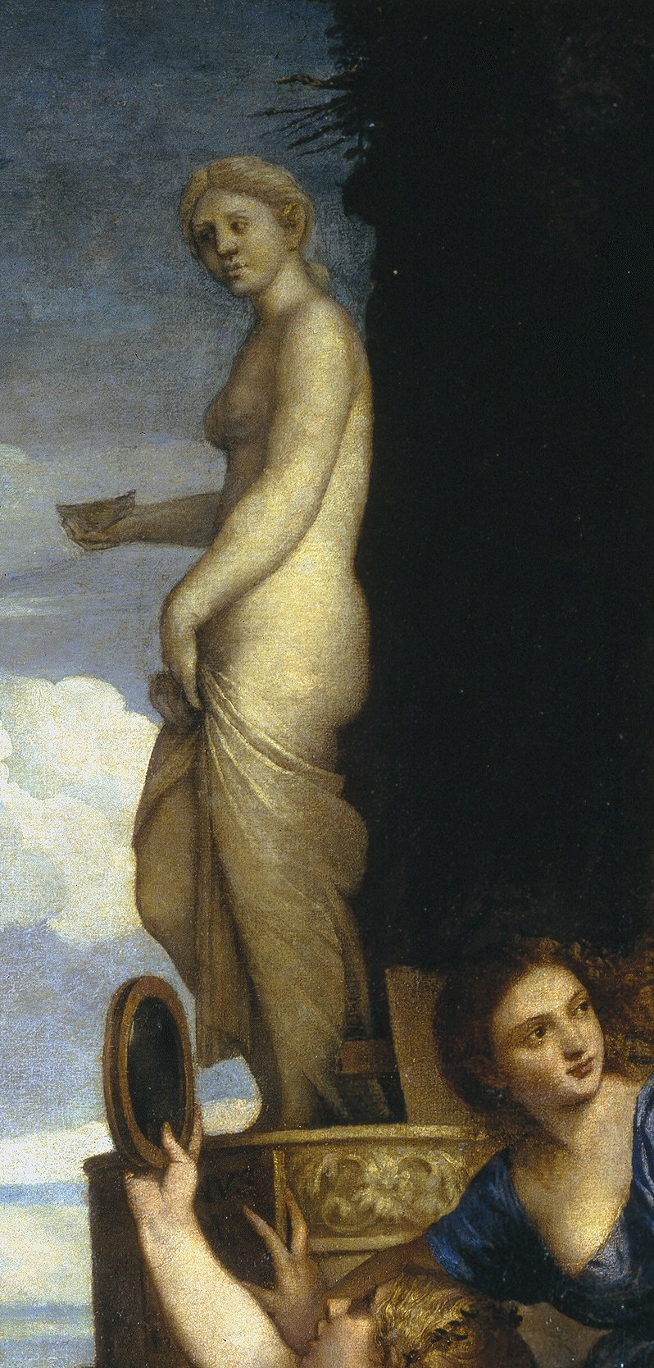
(V4_41) Detail from Titian, The Worship of Venus
$include(figure-slice-vertical-end.in) $include(layout-a-end.in) $include(sheet.in) $include(layout-c.in) $include(two-column-text.in)
I have left to the end, though, the most important paragraph of all which relates to the special group of Cupids in the foreground. (I shall quote in full once again, because Loeb English is not without its charms.)
What is the meaning of these others? For here are four of them, the most beautiful of all, withdrawn from the rest. Two of them are throwing an apple back and forth; the second pair are engaged in archery, each shooting at his companion. Nor is there any trace of hostility in their faces; rather, they offer their breasts to each other, in order that the missiles may pierce them there.
It is a beautiful riddle. Come, let us see perchance if I can guess the painter’s meaning.
The meaning of the ‘riddle’ turns out to be that the first pair are beginning to fall in love (the kissing of the apple before throwing is mentioned in the text). Whereas the second pair, the archers, are ‘shooting arrows that they may not cease from desire’.
$include(two-column-text-end.in) $include(figure-slice.in)
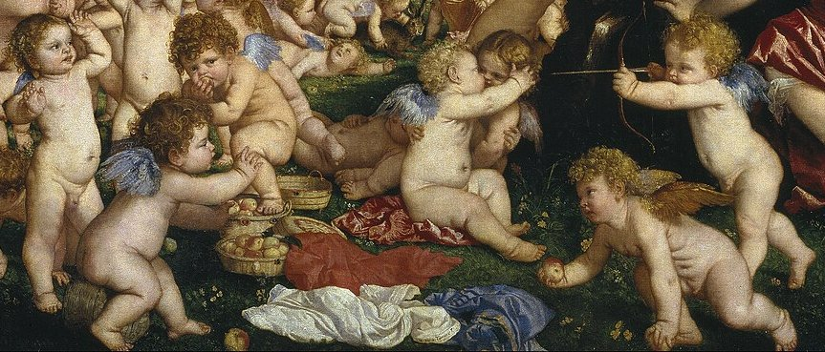
(V4_41a) Detail from Titian, The Worship of Venus
$include(figure-slice-end.in) $include(layout-c-end.in) $include(sheet.in) $include(layout-a.in)
Now, I am well aware that English Protestant taste ‘stumbles’ over Madonnas, and positively ‘sticks’ at Cupids or putti; and I know also that the appreciation of Titian’s painting only begins with the recognition that he was attempting to recreate all those details described in the classical text. But ‘there are cupids and cupids’, as I remind you with a new detail from the frescos in Palazzo Schifanoia.
It is enough to take one quick look at the closely-packed figures of Francesco del Cossa to recognise the wealth of invention in Titian, his extraordinary power to suggest human flesh, his insight into the sexuality of children—all the qualities that ought to make you give this picture an extra five minutes attention next time you are in Madrid, because that is where you will have to go if you want to see the original.
$include(column-break.in) $include(figure-slice-vertical.in)
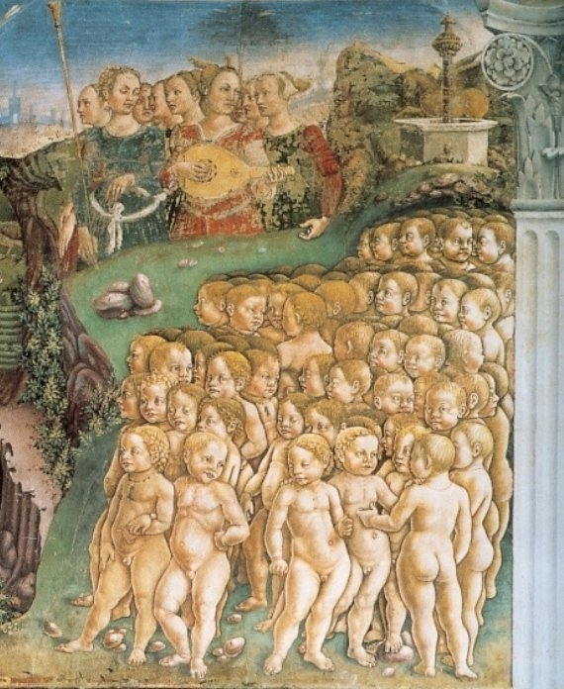
(V4_43a) Francesco Cossa, Detail from fresco of the Allegory of May, Hall of the Months, Palazzo Schifanoia
$include(figure-slice-vertical-end.in) $include(layout-a-end.in) $include(sheet.in) $include(layout-c.in) $include(two-column-text.in)
(Before you set out for Spain, you could learn a great deal about Titian’s art by doing a little ‘comparative homework’ on your own.
Make a careful ‘audit’, starting with Fra Bartolommeo’s sketch. Take into account all the capital which Titian borrowed, and rejoice in the immense profits he earned, through which he repaid the loan with superabundant interest.)
$include(two-column-text-end.in) $include(figure-slice.in)
(V4_21_bis_bis) Fra Bartolomeo, Worship of Venus, Uffizi
(V4_40_bis_bis) Titian, The Worship of Venus, Prado Museum
$include(figure-slice-end.in) $include(layout-c-end.in) $include(sheet.in) $include(layout-a.in)
From a shrine of Venus, in a teetotal orchard, we pass in imagination to the other side of the Bellini to the last two Titians, which are closely connected thematically, and deal with a river of wine, Dionysiac revels, and the love of Bacchus for Ariadne.
This is the first of them—it is the same size as the Cupids, and it is also in Madrid. While thinking about its relationship to Bellini’s Feast of the Gods, notice how the paintings are linked by the colour and the scale of the trees (they occupy about a quarter of the painted surface here), although clearly this particular ‘rhyme’ did not exist before Titian repainted the Bellini.
The argument is once again taken from Philostratos’s Imagines, mostly from the twenty-fifth chapter, entitled ‘Andrians’ (or ‘Dwellers on the Island of Andros’). But there are two very important additions, taken from Chapter 15, which establish a link with the previous painting; and in due course we will take note all the features that Titian derives from his written sources.
Chapter 25 begins like this:
The subject of this painting is the River of Wine on the island of Andros, and the Andrians, who have got tipsy by drinking the river.
For thanks to Dionysus [who, of course, is the Greek counterpart of Bacchus], the earth of Andros is so steeped in wine that it bursts forth as a great river—not ‘great’ in respect of volume, but in the transcendent quality of the wine. It is superior to the River Nile, since this river makes men rich, influential, handsome, and seven feet tall—at least in their imaginations. It is never muddied by the feet of cattle…but is drunk unpolluted, flowing for men alone.
$include(column-break.in) $include(figure-slice-vertical.in)
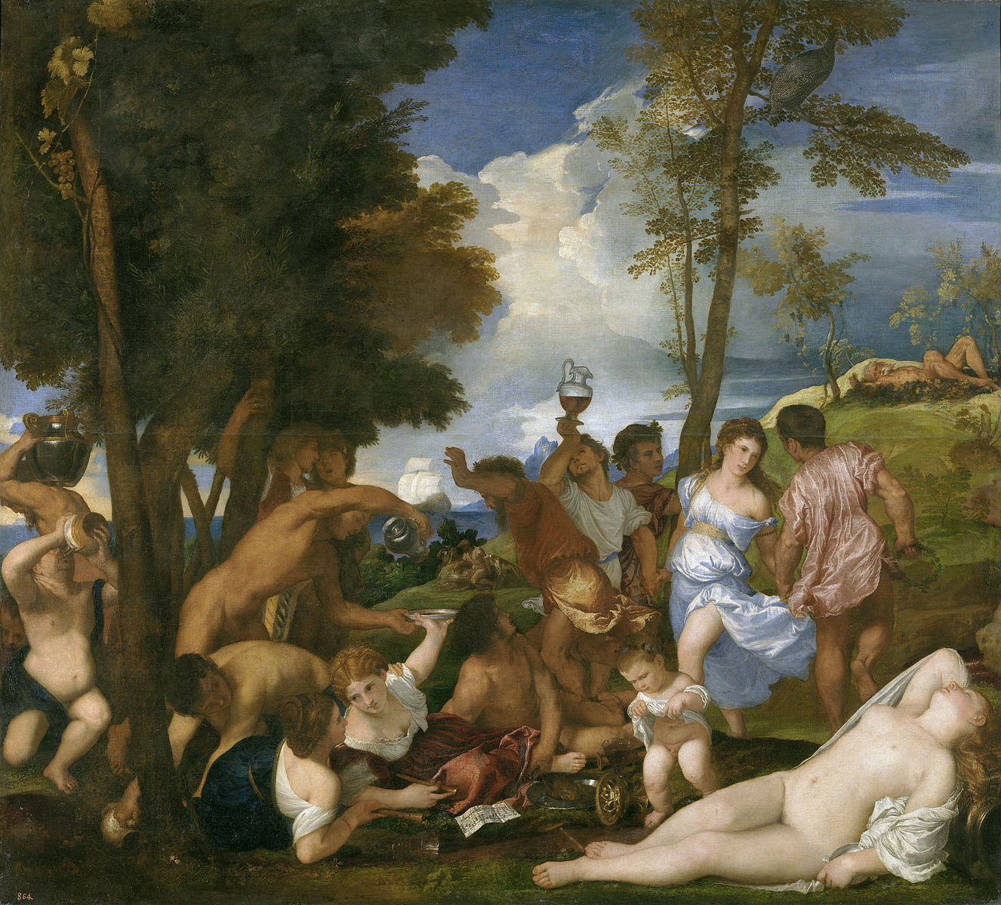
(V4_44) Titian, The Andrians, Prado Museum
$include(figure-slice-vertical-end.in) $include(layout-a-end.in) $include(sheet.in) $include(layout-b.in) $include(text-with-image.in)
The old man who is sprawling on the hillock in the background may be interpreted as the source of the miraculous river, because his position echoes that of statues of classical river gods. So, perhaps it is his weight which causes the saturated earth to ooze and flow with wine.
Philostratos tells us that the Andrians draw their wine directly from the stream; and Titian shows them scooping up, pouring out, swilling down, carrying away, and balancing decanters on their noses in a wonderfully choreographed interaction of bodies, which are growing like shoots from the foot of the tree.
$include(text-with-image-end-text.in)
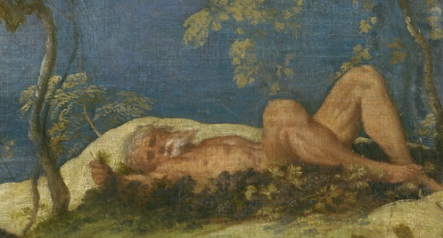
(V4_45) Detail from Titian, The Andrians
$include(text-with-image-end.in) $include(column-break.in) $include(figure-slice-vertical.in)
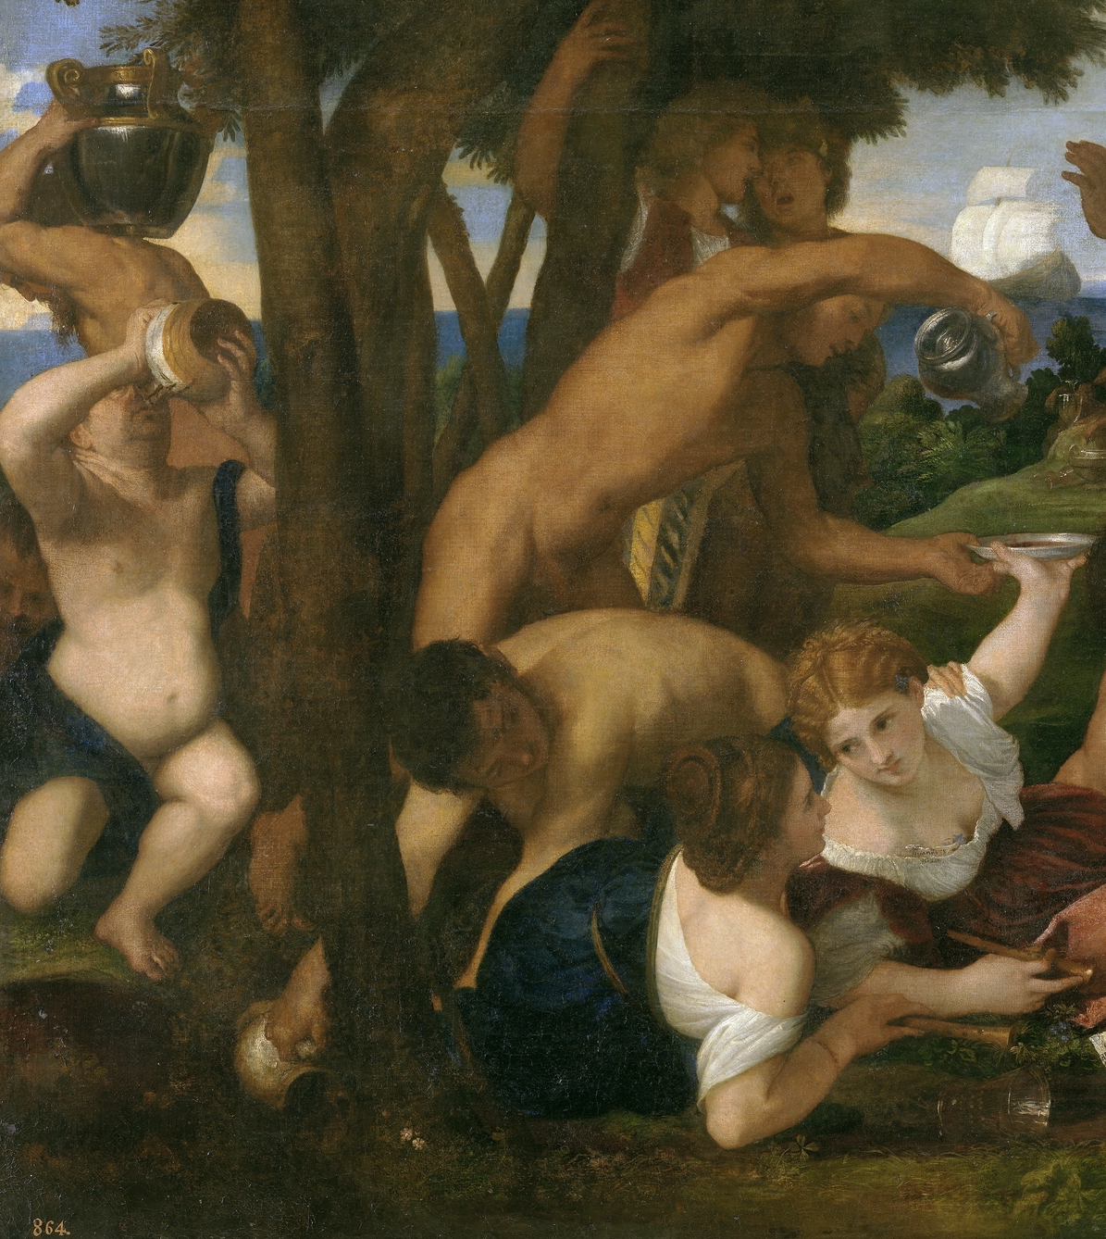
(V4_46) Detail from Titian, The Andrians
$include(figure-slice-vertical-end.in) $include(layout-b-end.in) $include(sheet.in) $include(layout-a.in)
Philostratos specifies that women and children also participate (although he does not say that the children lift their smocks for a wee); and that some of the women are dancing, and others reclining, while the men are singing the praises of the river.
There is not much that Titian can do about the singing, although he does give each of the foreground girls a recorder (you will remember the symbolism) and a sheet of music to play. The notation is easy to read and the piece turns out to be tiny ‘catch’ or ‘glee’ (that is, a ‘round’), probably composed by the contemporary composer Adrian Willaert, setting a very brief French text in praise of drinking.
Qui boit, et ne reboit,
il ne sait que boire soit.
To drink, and not to call for more,
is not to know what drinking’s for.
$include(column-break.in) $include(figure-slice-vertical.in)
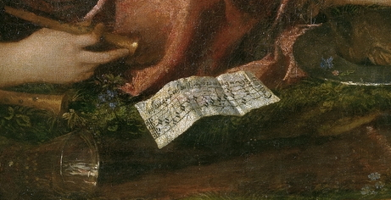
(V4_47) Detail from Titian, The Andrians
$include(figure-slice-vertical-end.in) $include(layout-a-end.in) $include(sheet.in) $include(layout-a.in)
What Titian can do, on other hand, is to evoke the movement and spirit of the dance. He is in top form. We know that the couple are circling round each other, their eyes meeting, their shoulders lowered, pivoting round their clasped hands, the thighs raised in the identical way, suggesting that they are moving to the rhythm of the music—and moving with sufficient speed to lift his doublet and to set her skirt swirling.
$include(column-break.in) $include(figure-slice-vertical.in)
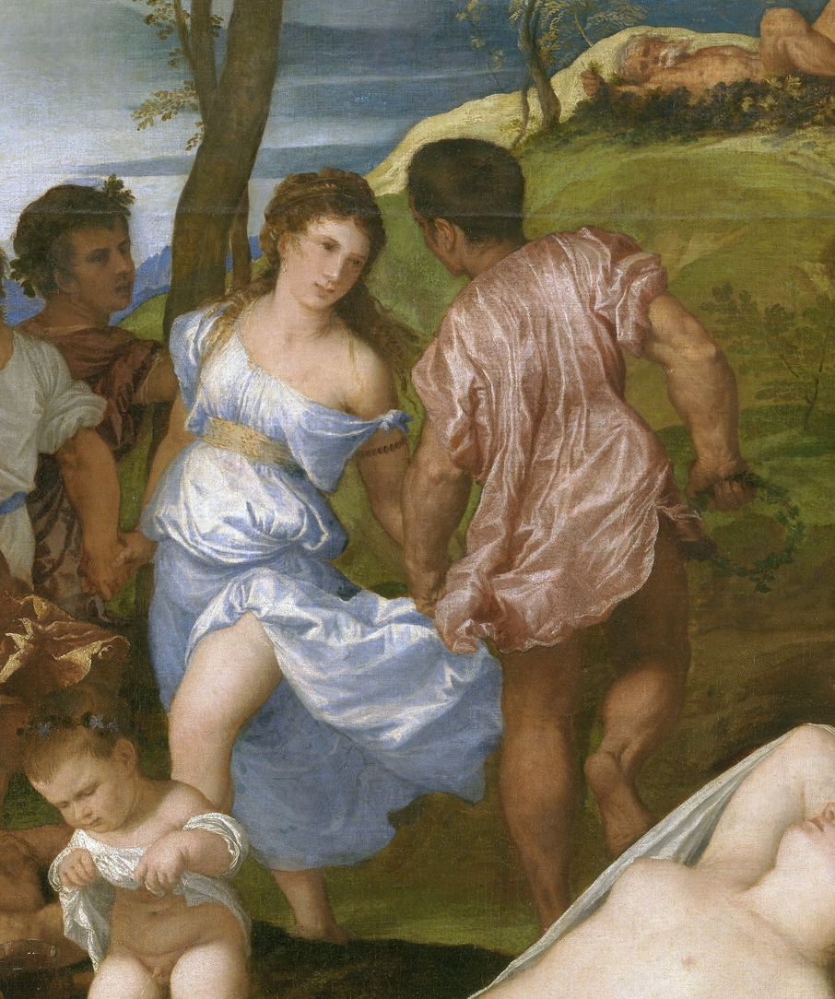
(V4_48) Detail from Titian, The Andrians
$include(figure-slice-vertical-end.in) $include(layout-a-end.in) $include(sheet.in) $include(layout-a-50.in)
Nevertheless, despite the splendid ‘choreography’ of moving bodies, I suspect many people may think that the reclining figures are the most memorable of all—the figures that look back to Giorgione, rather than to Raphael.
The two recorder players are leaning on their elbows. The first, who is reaching back to have her flat bowl refilled with wine, has violets tucked into her corsage (hence the not improbable deduction that this is a portrait of Titian’s mistress Violante: indeed, the violets carry Titian’s signature).
Above all, we remember the girl who is overpowered by sleep (a link to the story of Lotis), with her head thrown back, and her loose hair spreading over the pitcher.
$include(column-break.in) $include(figure-slice-vertical.in)
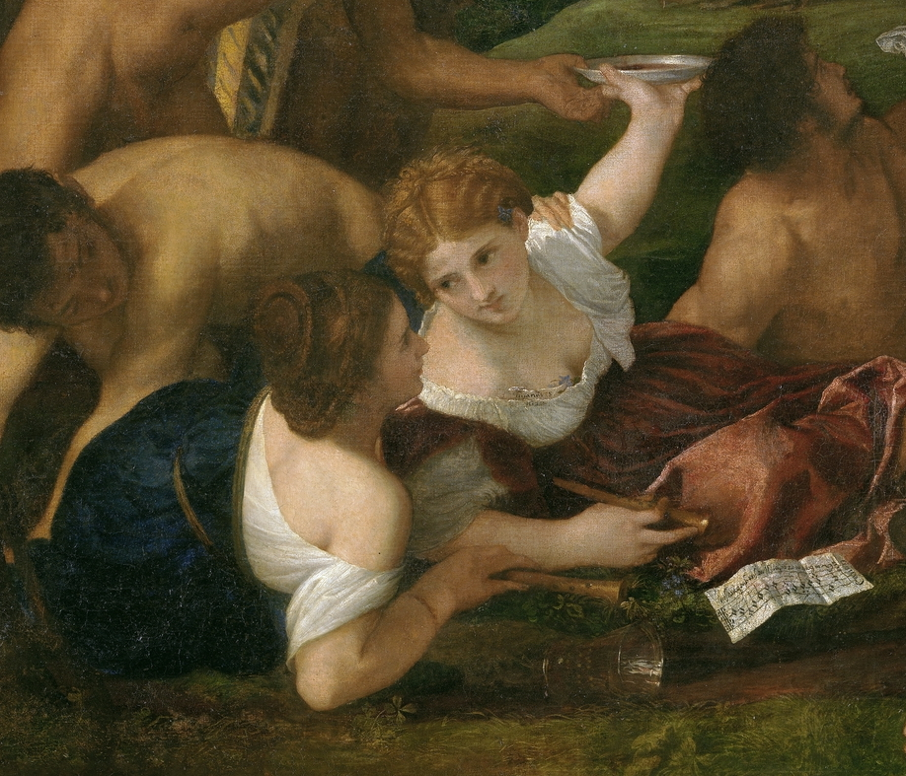
(V4_49) Detail from Titian, The Andrians
$include(figure-slice-vertical-end.in) $include(layout-a-end.in) $include(layout-c-50.in) $include(figure-slice.in)
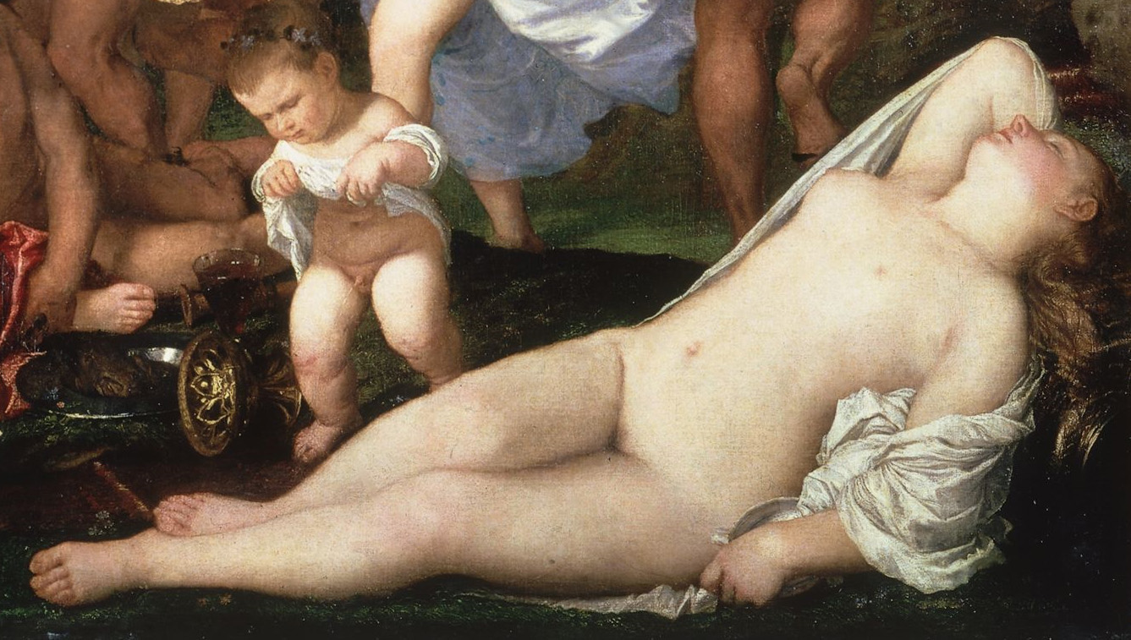
(V4_52_bis) Detail from Titian, The Andrians
$include(figure-slice-end.in) $include(layout-c-50-end.in) $include(sheet.in) $include(layout-b.in)
Even Titian never painted young, soft, and desirable female flesh with quite this lyrical abandon again; and while art historians remind us of a pictorial source in the ancient world, we might perhaps take this image as the anticipation of a modern myth, seeing the qualities of voluptuous innocence that a local photographer once intuited in a girl called Norma Jeane Baker, whom Hollywood would transform into Marilyn Monroe.
$include(column-break.in) $include(figure-slice-vertical.in)
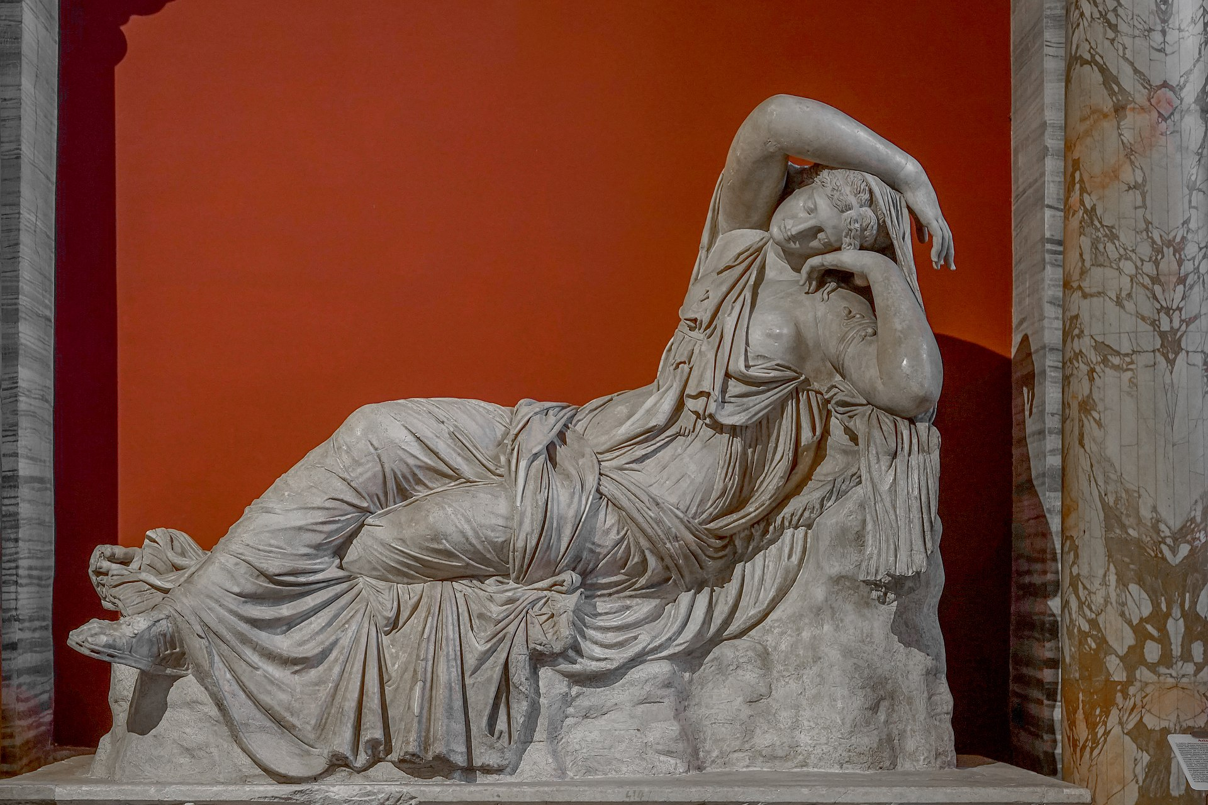
(V4_51) Sleeping Ariadne, Vatican Museums
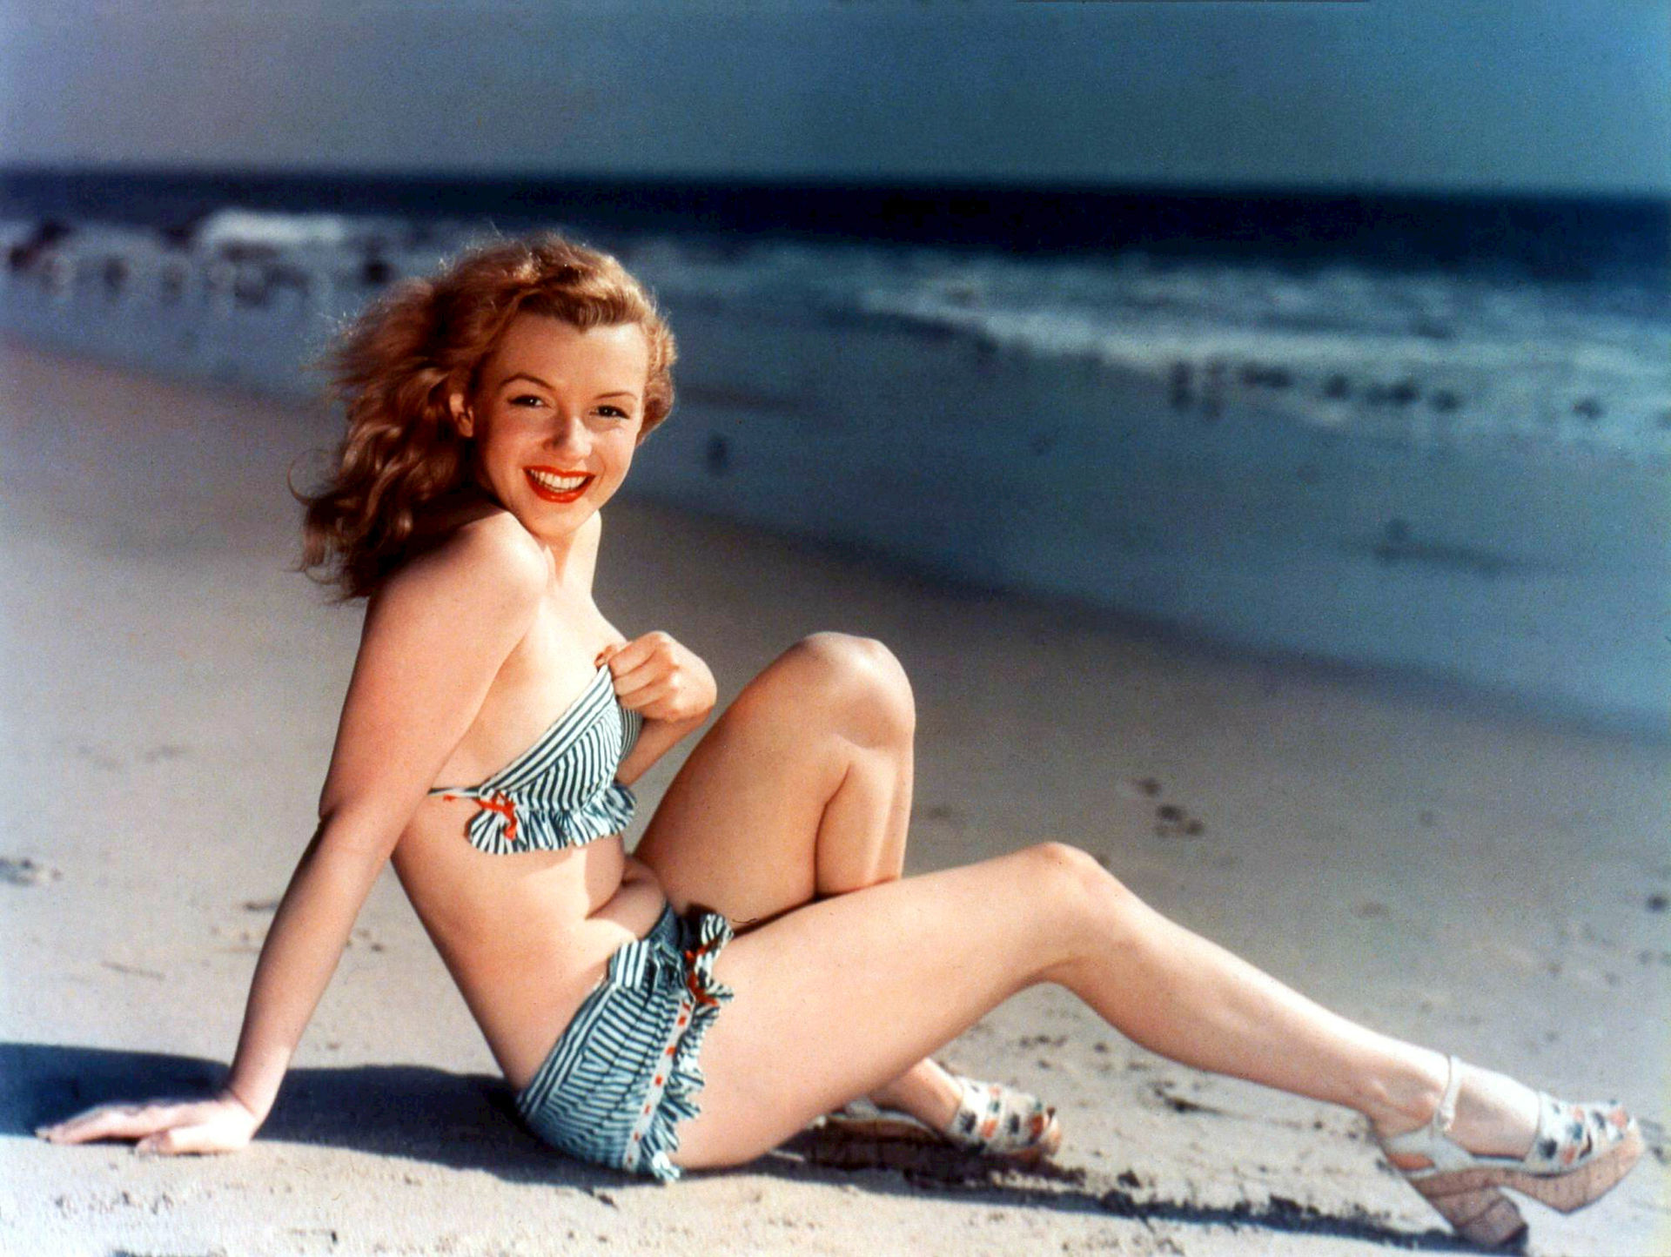
(V4_51a) The future Marilyn Monroe reclining
$include(figure-slice-vertical-end.in) $include(layout-b-end.in) $include(sheet.in) $include(layout-a.in)
I must now turn back to those extra details in Philostratos which link this picture with the final one in the cycle.
At the close of Chapter 25, the author directs our attention to the mouth of the River of Wine, and he says: ‘Dionysus also sails to the revels of Andros; his ship now moored in the harbour’.
Meanwhile, back in Chapter 15 (headed Ariadne), he had said to his young pupil:
I do not need to tell you that Theseus treated Ariadne unjustly when he abandoned her on the island of Naxos…and I do not need to point out Theseus on the ship and Dionysus on the land…nor to call attention to the woman on the rocks lying in gentle slumber…
Look at Ariadne, or rather look at her sleep, her bosom bare to the waist, her neck bent back, and her delicate breast and all her right side visible, but her left hand resting on her mantle.
How fair a sight Dionysus! (And how sweet her breath!)
$include(column-break.in) $include(figure-slice-vertical.in)
(V4_52) Detail from Titian, The Andrians
$include(figure-slice-vertical-end.in) $include(layout-a-end.in) $include(sheet.in) $include(layout-a.in)
In short, it is easy to imagine a ‘soft dissolve’ at this point, during which the island of Andros becomes the island of Naxos, and the girl is now Ariadne, exhausted by grief rather than wine, and soon to be consoled by Bacchus.
For this, precisely, is the theme of the last painting, which—as we noted earlier, was clearly intended to be hung to the left of the Andrians.
In this, the most famous painting of the cycle, Philostratos is first joined and then displaced by two Latin poets, principally Ovid again, but also with a telling contribution from Catullus.
A rhetorician’s description of timeless settings—like the apple orchard or the river of wine—give way to a poet’s recreation of several moments in a story, which Titian combines within the one frame (just as we saw in the Bellini), because the picture represents the arrival on Naxos of Bacchus and his followers, and his declaration of love to the abandoned Ariadne, and his promise to give her immortality as a constellation in the sky.
$include(column-break.in) $include(figure-slice-vertical.in)
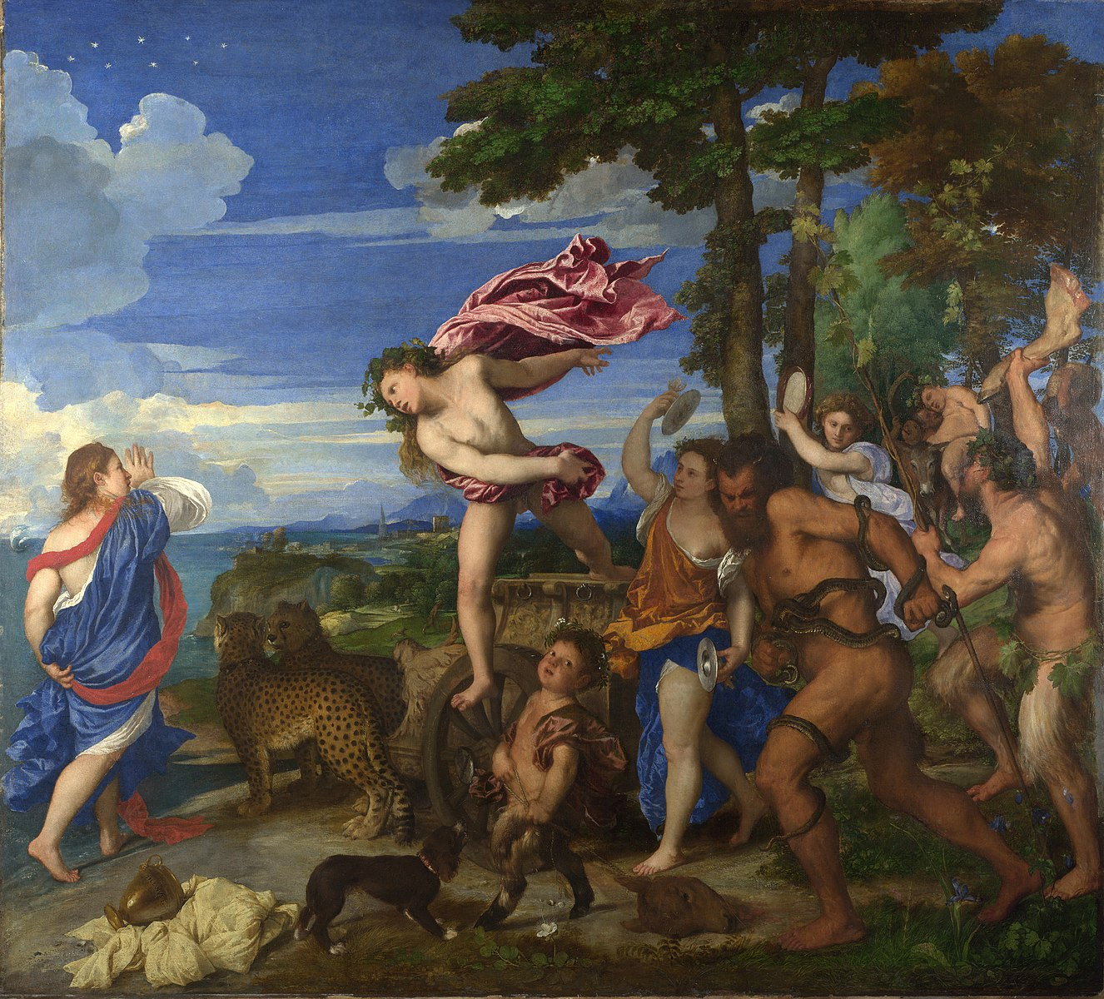
(V4_53) Titian, Bacchus and Ariadne, National Gallery
$include(figure-slice-vertical-end.in) $include(layout-a-end.in) $include(sheet.in) $include(layout-c-33.in) $include(one-column-text.in)
The episode is told in the first book of the Art of Love in a passage which finds Ovid at his most brilliant best. So, I’m going to give you the chance to read nineteen of his couplets in the original, matching the five paragraphs as far as possible with the free and spirited verse translation by Peter Green, published by Penguin Classics (a far cry from Loeb Classics!)
$include(one-column-text-end.in) $include(layout-c-33-end.in) $include(layout-a-66.in)
Ecce, suum vatem Liber vocat; hic quoque amantes
Adiuvat, et flammae, qua calet ipse, favet.
Gnosis in ignotis amens errabat harenis,
Qua brevis aequoreis Dia feritur aquis.
Utque erat e somno tunica velata reccinta,
Nuda pedem, croceas inreligata comas,
Thesea crudelem surdas clamabat ad undas,
Indigno tenereas imbre rigante genas.
Clamabat, flebatque simul, sed utrumque decebat;
Non facta est lacrimis turpior illa suis.
$include(text-column-break.in)
Bacchus too helps lovers,
as Ariadne discovered, ranging the unfamiliar
sea-strand of Naxos, crazed
out of her mind, fresh-roused from sleep, in an ungirt
robe, blonde hair streaming loose, bare-foot,
calling “Cruel Theseus!” to the deaf waves.
$include(layout-a-end.in) $include(sheet.in) $include(layout-a-50.in)
Iamque iterum tundens mollissima pectora palmis
“Perfidus ille abiit; quid mihi fiet?” ait.
“Quid mihi fiet?” ait: sonuerunt cymbala toto
Littore, et adtonita tympana pulsa manu.
Excidit illa metu, rupitque novissima verba;
Nullus in exanimi corpore sanguis erat.
Ecce Mimallonides sparsis in terga capillis:
Ecce leves satyri, praevia turba dei:
Ebrius, ecce, senex pando Silenus asello
Vix sedet, et pressas continet ante iubas.
Dum sequitur Bacchas, Bacchae fugiuntque petuntque
Quadrupedem ferula dum malus urget eques,
In caput aurito cecidit delapsus asello:
Clamarunt satyri “surge age, surge, pater.”
$include(text-column-break.in)
Then, presto, the whole shore echoed
with frenzied drumming, the clash
of cymbals.
She broke off, speechless, fainted,
as wild-tressed Bacchanals, wanton
Satyrs, the god’s forerunners, appeared,
with drunken old Silenus, scarce fit to ride his sway-backed
ass, hands clutching its mane
as he chased the Maenads.
$include(layout-a-end.in) $include(layout-a-50.in)
Iam deus in curru, quem summum texerat uvis,
Tigribus adiunctis aurea lora dabat:
Et color et Theseus et vox abiere puellae:
Terque fugam petiit, terque retenta metu est.
Horruit, ut steriles agitat quas ventus aristas,
Ut levis in madida canna palude tremit.
$include(text-column-break.in)
Then came the god, his chariot grape-clustered,
paired tigers padding on as he shook
the golden reins.
Thrice she tried to run, thrice stood frozen with fear.
$include(layout-a-end.in) $include(sheet.in) $include(layout-a-50.in)
Cui deus “en, adsum tibi cura fidelior” inquit:
“Pone metum: Bacchi, Gnosias, uxor eris.
Munus habe caelum: caelo spectabere sidus;
Saepe reget dubiam Cressa Corona ratem.”
$include(text-column-break.in)
“I am here
for you,” the god told her. “My love will prove more faithful.
No need for fear. You shall be
wife to Bacchus, take the sky as your dowry, be seen there
as a star, the Cretan Crown, a familiar guide
to wandering vessels.”
$include(layout-a-end.in) $include(layout-a-50.in)
Dixit, et e curru, ne tigres illa timeret,
Desilit; inposito cessit harena pede:
Implicitamque sinu (neque enim pugnare valebat)
Abstulit; in facili est omnia posse deo.
Ovid, Ars amatoria I, 525–562
$include(text-column-break.in)
Down he sprang from his chariot,
lest the girl take fright at the tigers; set his foot
on the shore, then gathered her up in his arms—no resistance—
and bore her away.
No trouble for gods to do
whatever they please.
$include(layout-a-end.in) $include(sheet.in) $include(layout-a.in)
To these spirited words, we must mentally add details from a famous poem by Catullus (where he pretends to be describing a tapestry of the same event), who speaks of the ‘departing vessel’ and specifies that some of the Bacchantes were waving the thyrsus (a wand tipped with vine leaves), some were bound with twisting snakes, some were clashing timbrels, some were brandishing the limbs of a dismembered steer.
$include(column-break.in) $include(figure-slice-vertical.in)
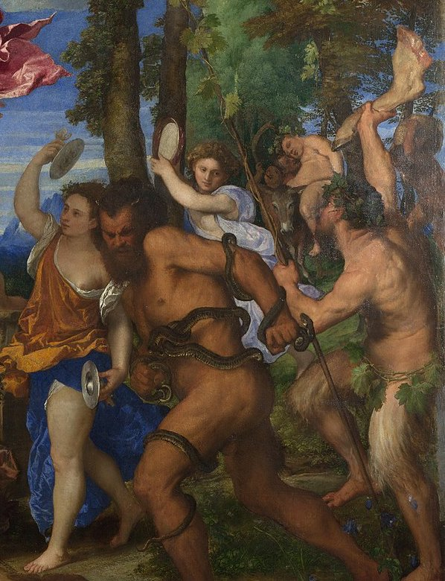
(V4_53a) Detail from Titian, Bacchus and Ariadne
$include(figure-slice-vertical-end.in) $include(layout-a-end.in) $include(sheet.in) $include(layout-a.in) $include(text-with-image.in)
We must recognise, then, another huge, almost ‘word-for-word’ (or ‘phrase-for-detail’) debt to the classical texts selected by Duke Alfonso; and we may be sure that Titian did some careful homework on surviving Roman bass-reliefs (like the one shown here) in order to discover what an ancient thyrsus and a timbrel might look like.
But what matters most is Titian’s transformation of all these elements into a High Renaissance painting, combining energetic movement, Florentine choreography and Venetian colour of a kind that would have been inconceivable before 1520.
$include(text-with-image-end-text.in)
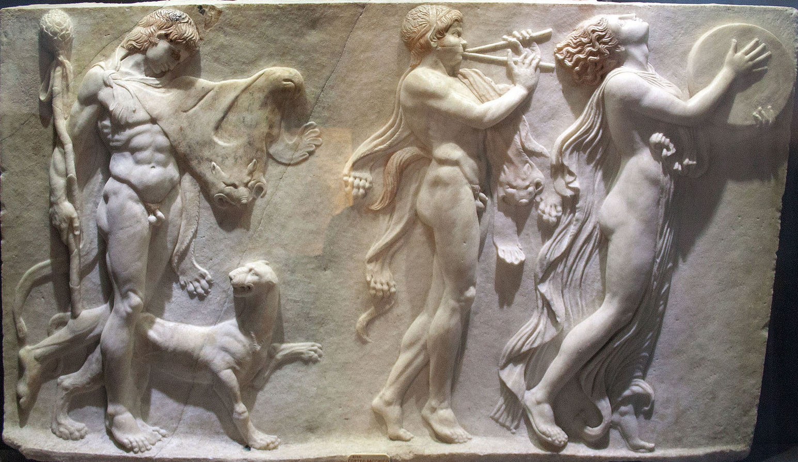
(V4_54) Roman relief of a Bacchanal, British Museum
$include(text-with-image-end.in) $include(column-break.in) $include(figure-slice-vertical.in)
(V4_53_bis) Titian, Bacchus and Ariadne, National Gallery
$include(figure-slice-vertical-end.in) $include(layout-a-end.in) $include(sheet.in) $include(layout-b.in)
By way of conclusion, let us roam over some more details.
The bronze urn is a wonderful piece of still-life painting (notice how Titian’s signature is apparently cast and glazed with the pot). There are some superb flower studies in the foreground, and the animals are splendidly observed, ranging from the mongrel (head like a spaniel, haunches like a greyhound), who is barking at the chariot, to the pair of exotic cheetahs from the Ferrara zoo, who are doing duty for Ovid’s tigers, and exchanging a calm look—relaxed, as only great cats know how.
$include(column-break.in) $include(figure-slice-vertical.in)
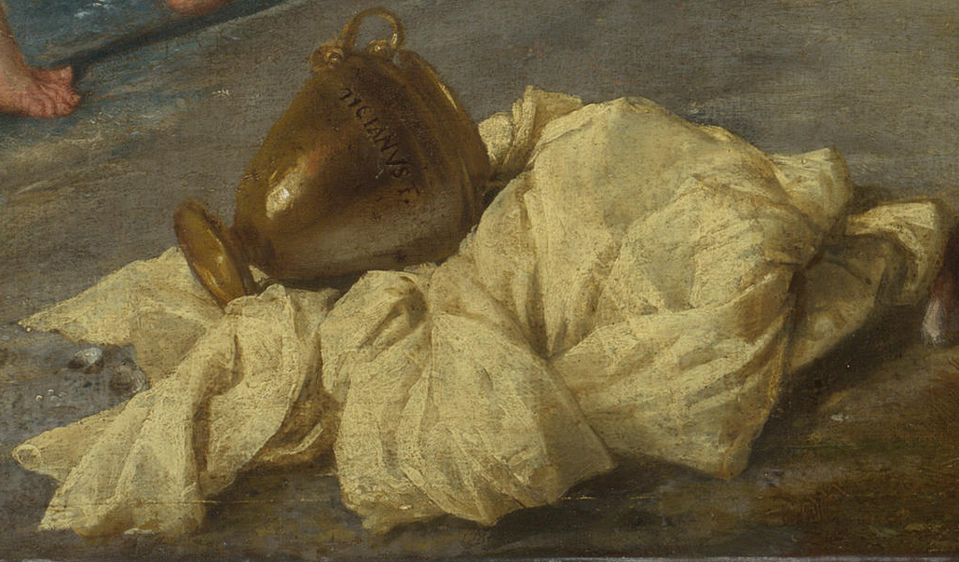
(V4_55) Detail from Titian, Bacchus and Ariadne
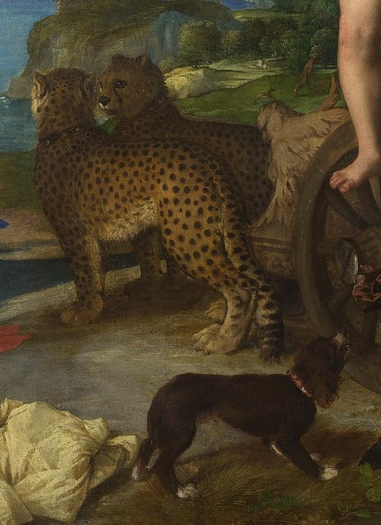
(V4_56) Detail from Titian, Bacchus and Ariadne
$include(figure-slice-vertical-end.in) $include(layout-b-end.in) $include(sheet.in) $include(layout-a.in)
I have mentioned the dismembered pieces of animals—the haunch and the head—but we must not miss the fusion of animal and human in the infant Satyr, goat-footed, dragging the donkey’s head, who is one of Titian’s most irresistible creations.
$include(column-break.in) $include(figure-slice-vertical.in)
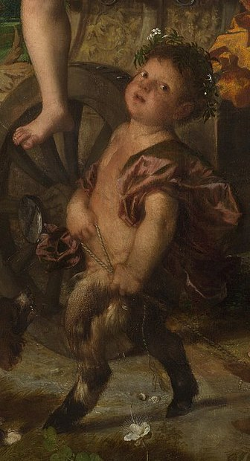
(V4_57) Detail from Titian, Bacchus and Ariadne
$include(figure-slice-vertical-end.in) $include(layout-a-end.in) $include(sheet.in) $include(layout-c.in) $include(one-column-text.in)
Dominating the right foreground is the massive, athletic body of the sunburnt and black-bearded second-row forward, where Catullus’s reference to ‘entwining snakes’ seems to have reminded Titian of the main figure in the Laocöon group, discovered only fifteen years earlier.
$include(one-column-text-end.in) $include(figure-slice.in)
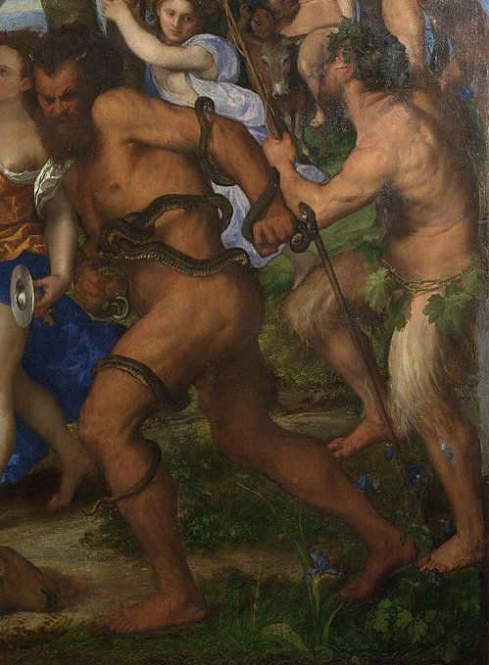
(V4_53b) Detail from Titian, Bacchus and Ariadne
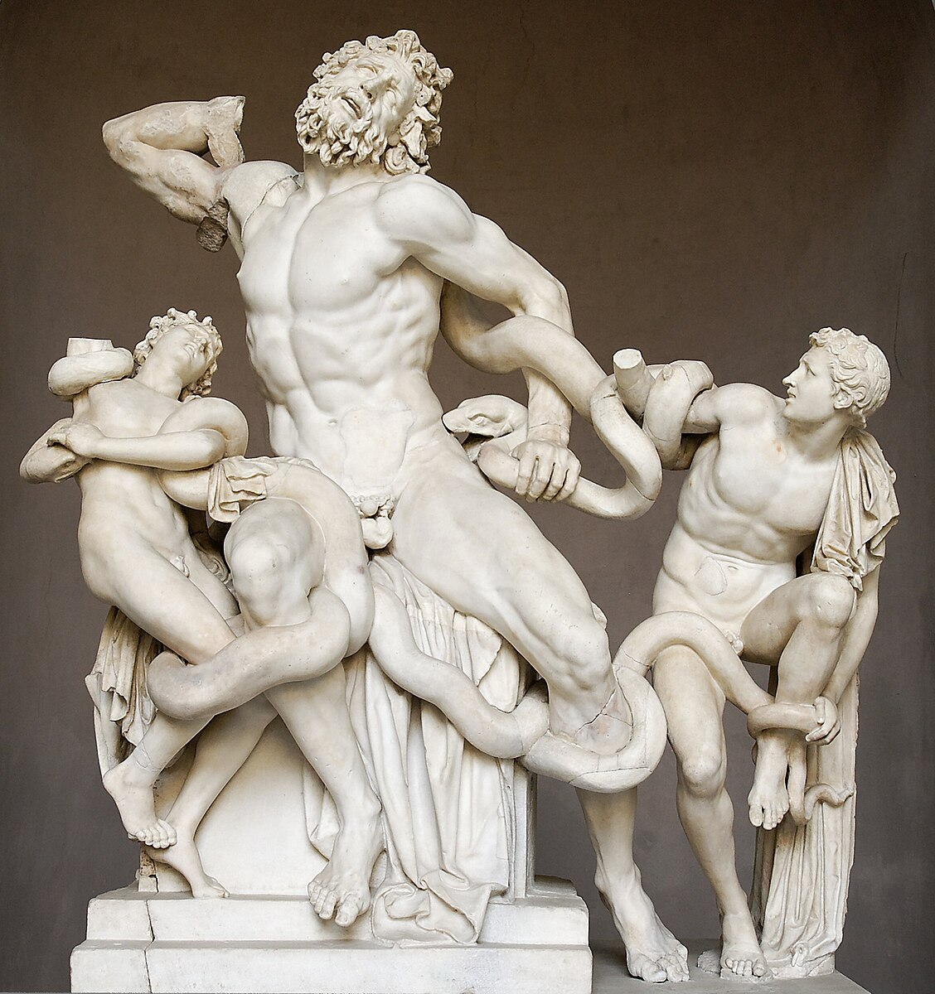
(V4_59) Laocoön, Museo Pio Clementino
$include(figure-slice-end.in) $include(layout-c-end.in) $include(sheet.in) $include(layout-c.in) $include(two-column-text.in)
Finally, focus on the two protagonists—the princess and the god.
Ariadne is extraordinary in the combination of her upwardly spiralling pose, which became a favourite among the Mannerists, and her generous, Junoesque proportions, which are decidedly un-Manneristic—just look at the massive left arm, clutching the robe around her hips, and the colossal right hand, raised in fear or alarm.
Last not least, marvel at the irruption of Bacchus, leaping from his chariot as Ovid had described him (e curru… desilit), twisting in flight, left arm swept back, right arm swinging round, the cloak blown back and up to suggest the movement forward and down.
Titian, we might say, is painting like a god—he makes it all look so easy. (In facili est omnia posse deo—‘no trouble for gods to do whatever they please’).
$include(two-column-text-end.in) $include(figure-slice.in)
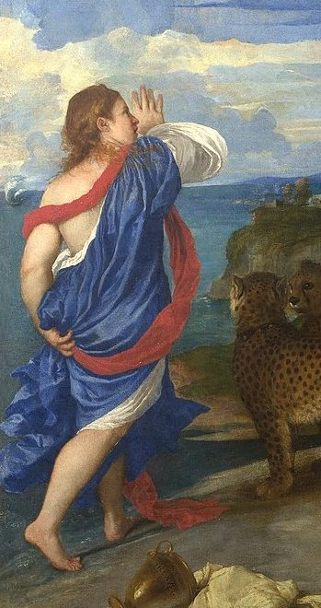
(V4_60a) Detail from Titian, Bacchus and Ariadne
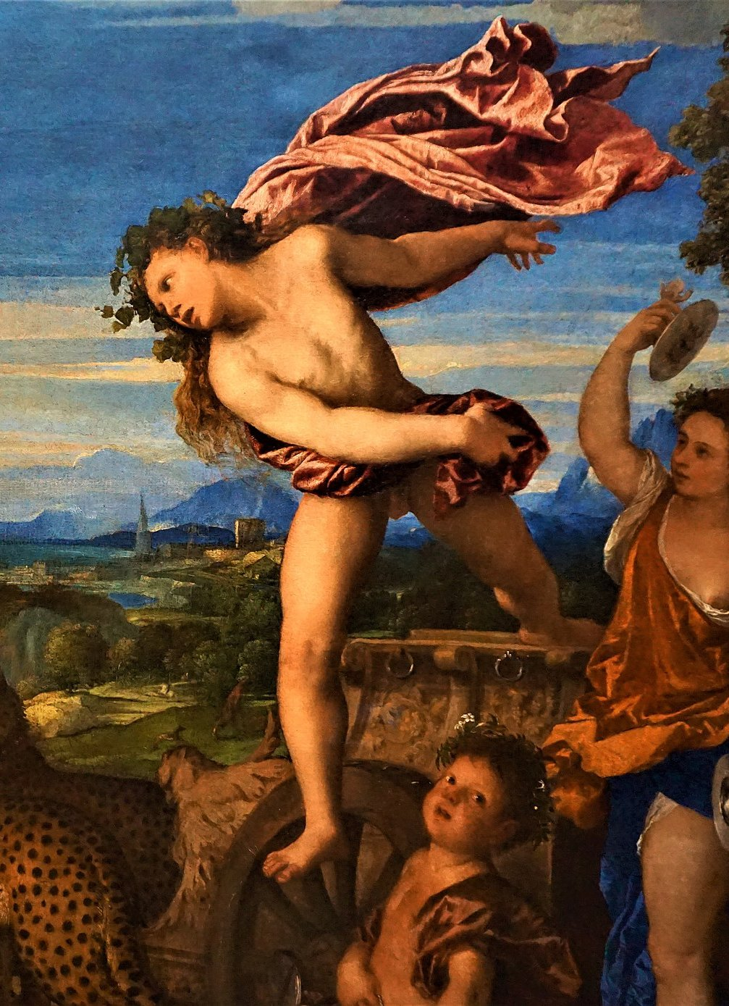
(V4_60) Detail from Titian, Bacchus and Ariadne
$include(figure-slice-end.in) $include(layout-c-end.in)

