Patrick Boyde
$include(title-layout-b.in)

Tiepolo: Angels and Patriarchs, Udine
$include(figure-slice-vertical.in)
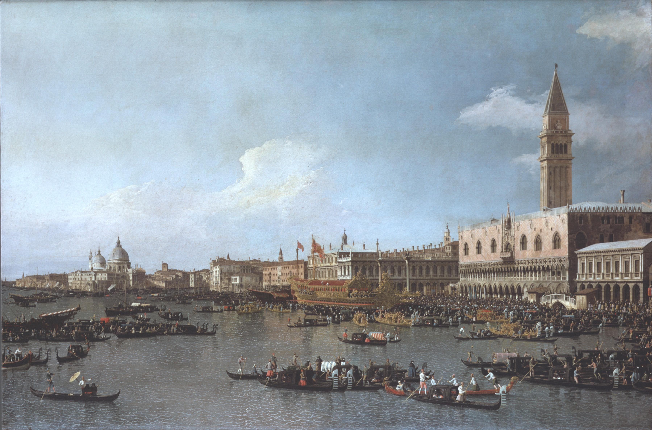
(V7_1) Canaletto, The Basin of San Marco on Ascension Day, National Gallery
$include(figure-slice-vertical-end.in) $include(layout-b-end.in) $include(sheet.in) $include(layout-c.in) $include(two-column-text.in)
The opening pair of images show annual festivals in Venice in the eighteenth century—Ascension Day in front of the Doge’s Palace, and the Regatta on the Grand Canal.
Both were painted by Canaletto in the later 1730s; and I show them to remind you that although the economic and political historians of today know that the republic of Venice suffered a major decline in the 150 years after the time of Veronese, this was by no means obvious to the Venetian ruling class, nor to the aristocratic travellers from England who commissioned paintings like these and took them home as souvenirs of the Grand Tour (which is why they are now in our National Gallery).
$include(two-column-text-end.in) $include(figure-slice-vertical.in)
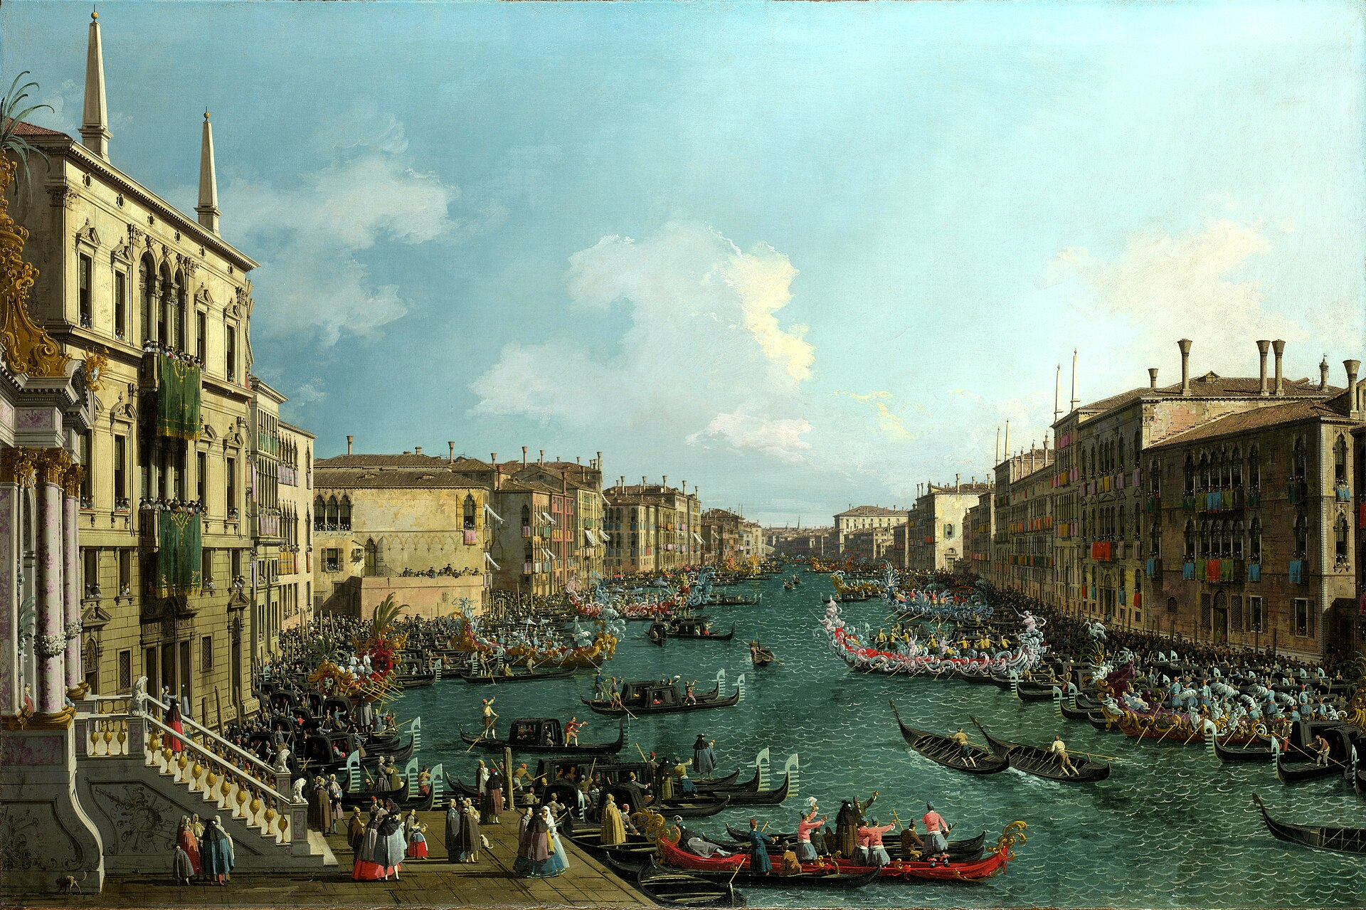
(V7_1a) Canaletto, A Regatta on the Grand Canal, National Gallery
$include(figure-slice-vertical-end.in) $include(layout-c-end.in) $include(sheet.in) $include(layout-a.in)
The Wars of the Spanish Succession, concluded by the Peace of Utrecht in 1713, and then the wars of the Polish and Austrian Successions in the 1730s and 1740s, made very little difference to Venice (whose territory in 1740 is coloured in red on this map), except that Austria now controlled all the lands shown in green, including Lombardy and Mantua, and that the new grand Duke of Tuscany was a son-in-law of the Hapsburg emperor.
$include(column-break.in) $include(figure-slice-vertical.in)
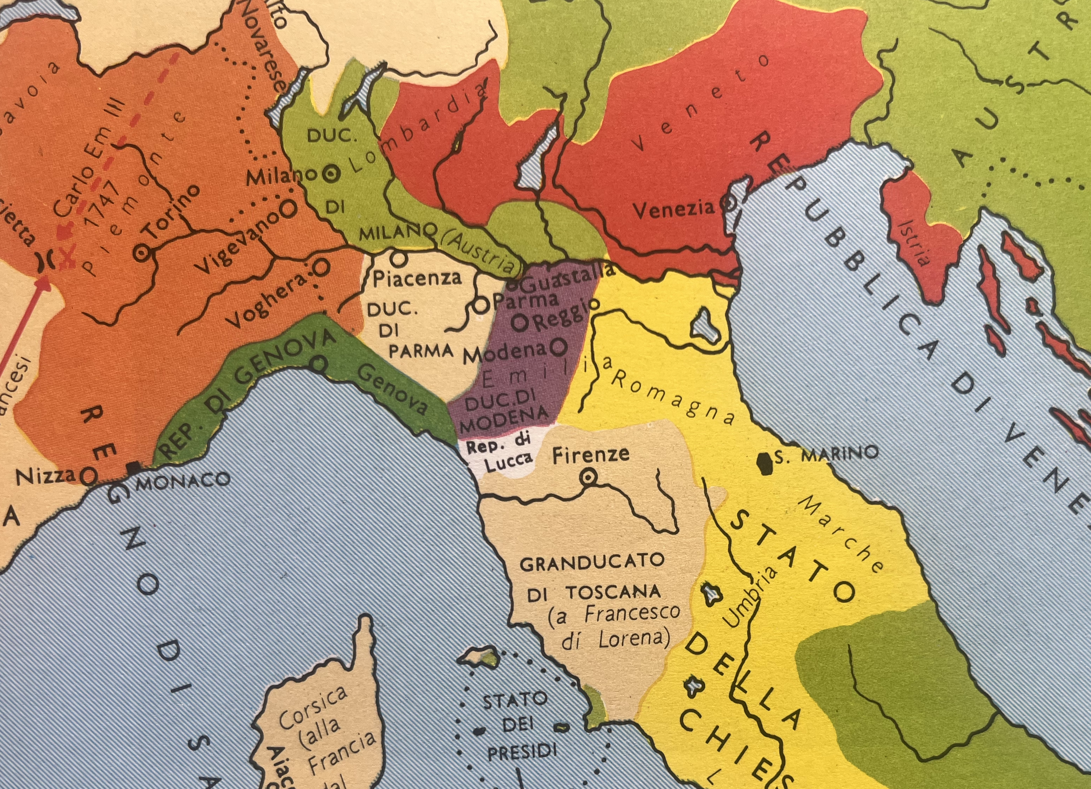
(V7_2) Political map of northern Italy, 1740
$include(figure-slice-vertical-end.in) $include(layout-a-end.in) $include(sheet.in) $include(layout-a.in)
Venice’s borders remained more or less where they had been back in 1450; and money was still available to be ‘spent conspicuously’, so that the building of new palaces and churches gave plenty of opportunities for architects and painters.
It was into this city, which (thanks to Canaletto) we feel we know so well, that Tiepolo was born in 1696—a date which makes him about ten to fifteen years younger than Vivaldi (1680) and Handel (1685), the composers who seem to share his sensibility, or a poet like Alexander Pope (1688), whose name I single out advisedly. Among his fellow-painters, he is more or less exactly the same age as Canaletto and Hogarth (both 1697), and a fraction older than Chardin (1699) and Boucher (1703).
$include(column-break.in) $include(figure-slice-vertical.in)
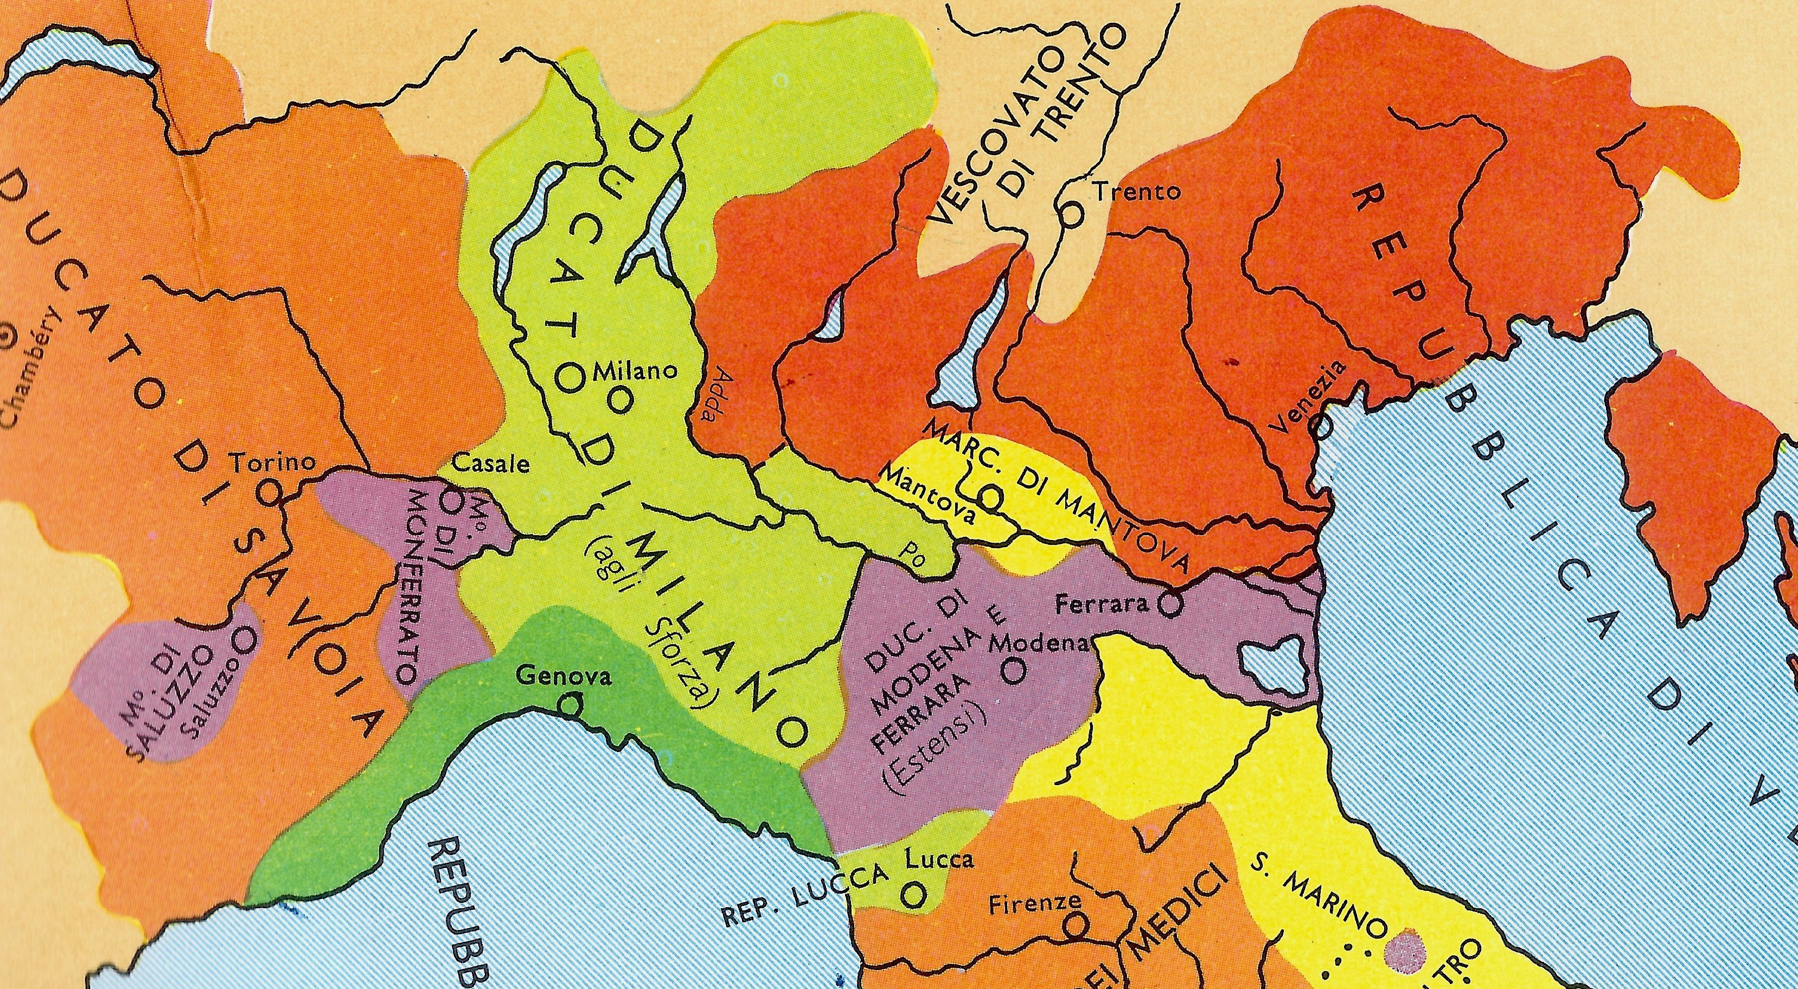
(V7_3) Detail from Political map of northern Italy, c. 1500
$include(figure-slice-vertical-end.in) $include(layout-a-end.in) $include(sheet.in) $include(layout-b.in)
It would be a hopeless task to sketch the shifts in taste and the developments in the art of painting that had taken place between 1580 and 1720; but it will be worth getting our bearings briefly by establishing a few important ‘trig points’.
The first point of reference is none other than Paolo Veronese, whose huge canvasses had yet to be stolen by Napoleon. (The Wedding at Cana was still in the refectory of the convent attached to the church of San Giorgio Maggiore, on the island opposite the Doge’s Palace.)
His colours, costumes and compositions had been enjoying a revival in the later seventeenth and the early eighteenth centuries, as you can see in the large altarpiece painted in 1691 by Gregorio Lazzarini , the master to whom Tiepolo was apprenticed.
$include(column-break.in) $include(figure-slice-vertical.in)
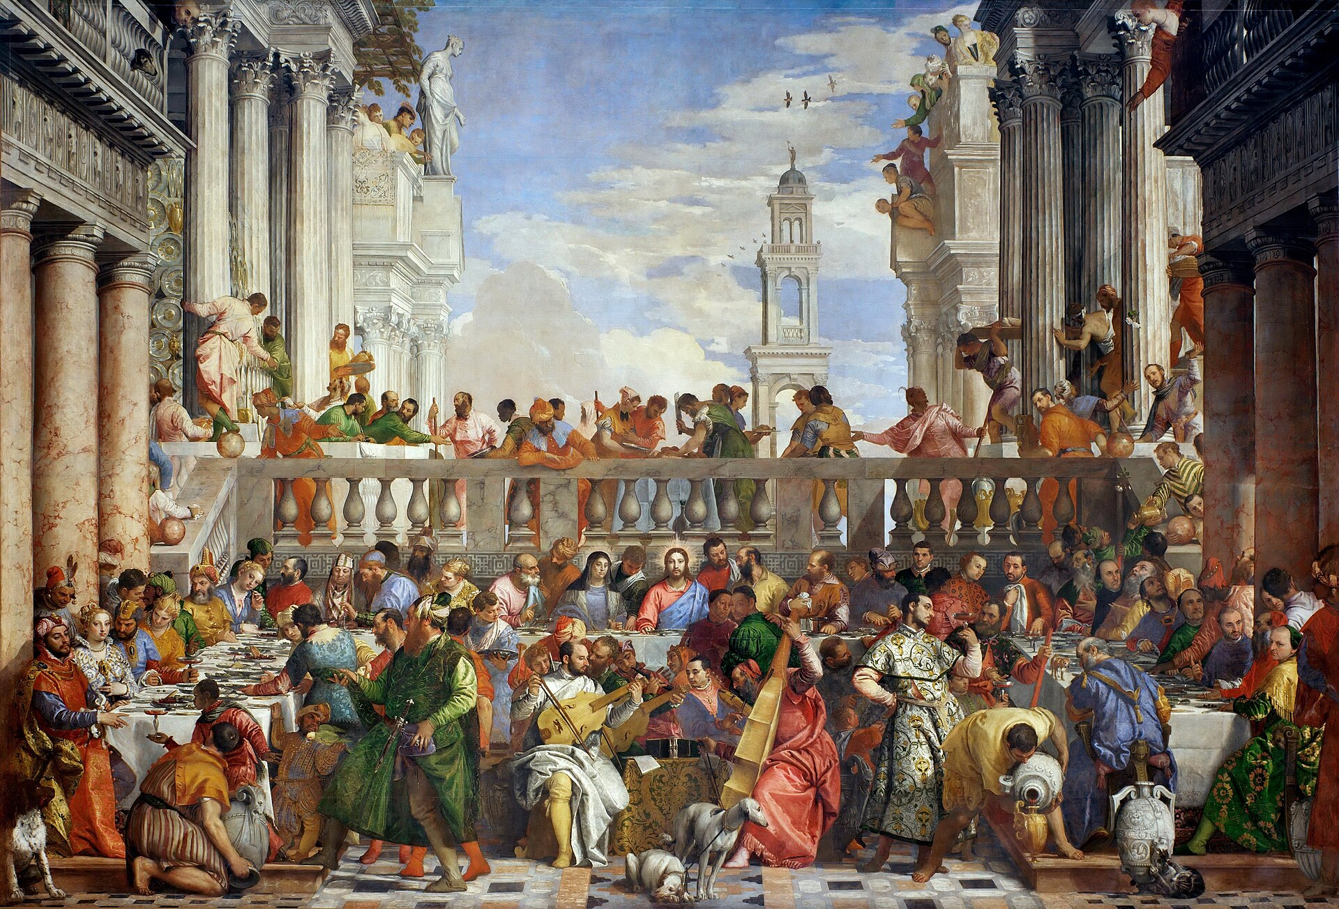
(V7_4) Veronese, The Wedding at Cana, Musée du Louvre
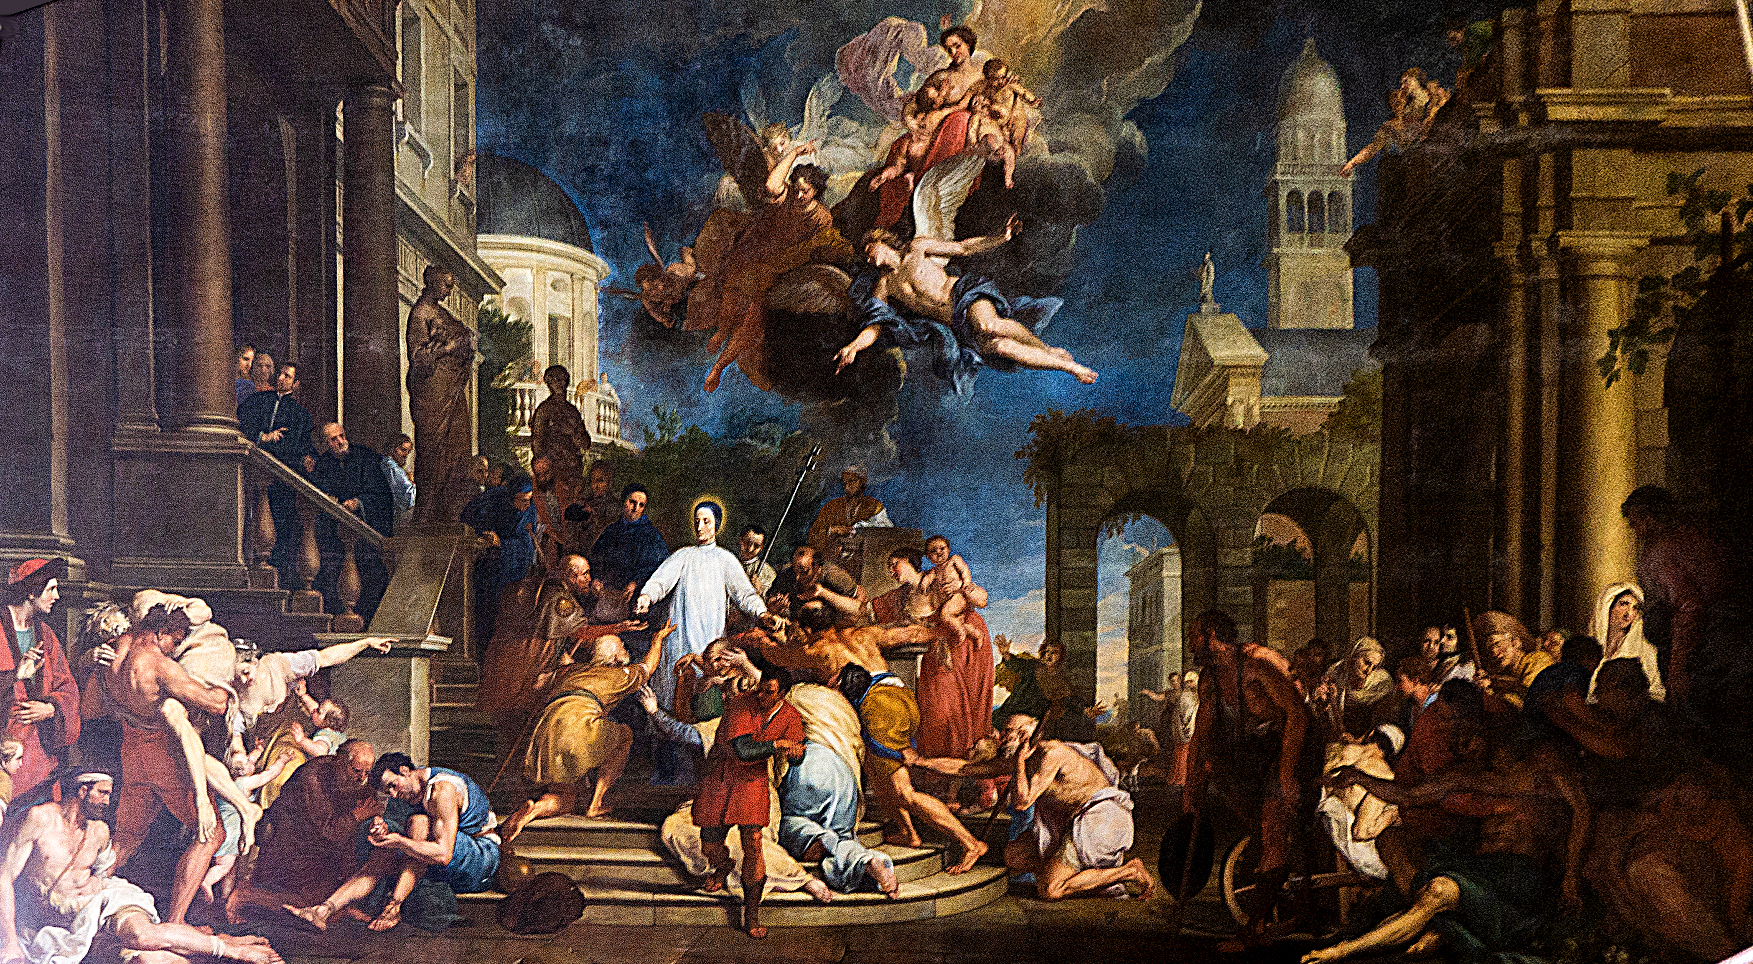
(V7_5) Gregorio Lazzarini, Charity of St Lorenzo Giustinian, San Pietro di Castello
$include(figure-slice-vertical-end.in) $include(layout-b-end.in) $include(sheet.in) $include(layout-a.in)
There was also a recognisable contemporary Venetian style embodied in the work of three artists: Sebastiano Ricci (1659–1734), Giovanni Antonio Pellegrini (1675–1741) and Jacopo Amigoni (1682–1752). It was a style much appreciated in courts and noble villas throughout Europe from Madrid to St Petersburg. (All three artists travelled widely, and all of them spent some time in England.)
Ricci was the acknowledged master; and what you see here is a highly relevant example of his grand style. It is an altarpiece, oil on canvas, thirteen feet high, dated 1708, and it was painted for the church of San Giorgio, where it is still in position.
The Virgin looks like a society bride, whilst the Christ-child, with his bright red cheeks, is simply a cousin to the little amorini who are fluttering in the sky or tuning up on the altar-step.
The composition is complex but seemingly effortless in the arrangement and interaction of the figures. (St Peter talks to the bishop, the nun adores the child, the bald man ponders the words in the book.) And the whole canvas is typical of Ricci in its vivid palette, with a predominance of cream, yellow, blue and ochre, relieved by splashes of scarlet and crimson.
$include(column-break.in) $include(figure-slice-vertical.in)
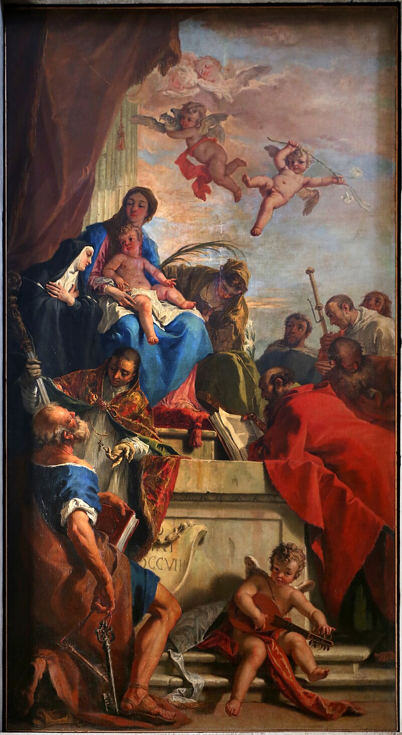
(V7_6) Sebastiano Ricci, Madonna with the Child, Church of San Giorgio Maggiore
$include(figure-slice-vertical-end.in) $include(layout-a-end.in) $include(sheet.in) $include(layout-a.in)
Ricci’s pupil, Jacopo Amigoni, was to spend much of the 1730s in England, after a ten year stay in Bavaria where he painted this elegant scene in fresco on a ceiling.
(The bearded Ulysses has just trapped the youthful Achilles into betraying his identity by raising a false alarm and thus provoking him to draw his sword. Achilles, you remember, had been concealed by his mother at the court of King Lycomedes, disguised as one of the King’s daughters, in order to save him from ‘call up’ to the Trojan War. He was secretly married to Deidamia, who is raising her bare arm.)
Notice again the brightness of the colours; the virtuosity of the perspective di sotto in su (‘from the bottom upwards’); the evanescence of the figures on the skyline who seem to be dissolving into thin air; and the theatrical movements of all the actresses and the actor ‘in drag’.
It is sublimely ‘operatic’ and reminds me of Dr Johnson’s famous definition of Italian opera: ‘an exotic…entertainment’; ‘a poetical tale or fiction, represented by…music, adorned with scenes, machines, and dancing’.
MICHELA: THERE WAS A MOMENT OF CONFUSION. (YOUR IMAGE HAD NOTHING TO DO WITH THE CASE). I’VE FOUND WHAT I WANTED ONLINE: https://www.granger.com/0022673-amigoni-achilles-jacopo-amigoni-achilles-amidst-the-daughte-image.html Looks like they might offer educational terms.
$include(column-break.in) $include(figure-slice-vertical.in)
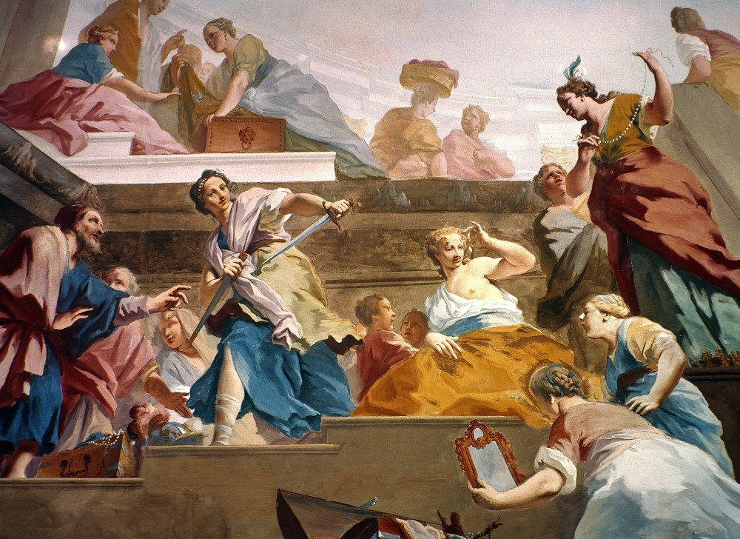
(V7_8) Detail from Jacopo Amigoni, Achilles among the Daughters of Lycomedes, Schleissheim Castle
$include(figure-slice-vertical-end.in) $include(layout-a-end.in) $include(sheet.in) $include(layout-a.in)
My third example of the contemporary Venetian style is much smaller, an easel painting, no more than four feet high, by Giovanni Antonio Pellegrini (who was about twenty years older than Tiepolo).
It was painted, in all probability, during the artist’s five-year stay in England between 1708 and 1713 and is now in the National Gallery.
The subject is taken from the book of Genesis—Rebecca welcomes Abraham’s servant-cum-emissary, who has arrived by camel and is displaying his gifts at the Well—and it is treated in just the same light-hearted spirit, with the same theatrical costumes, the same facial types, and the same ravishing colours that we shall find in Tiepolo’s cycle of frescos at Udine ten years later.
So much, then, for internationally popular Venetian art in about 1710.
$include(column-break.in) $include(figure-slice-vertical.in)
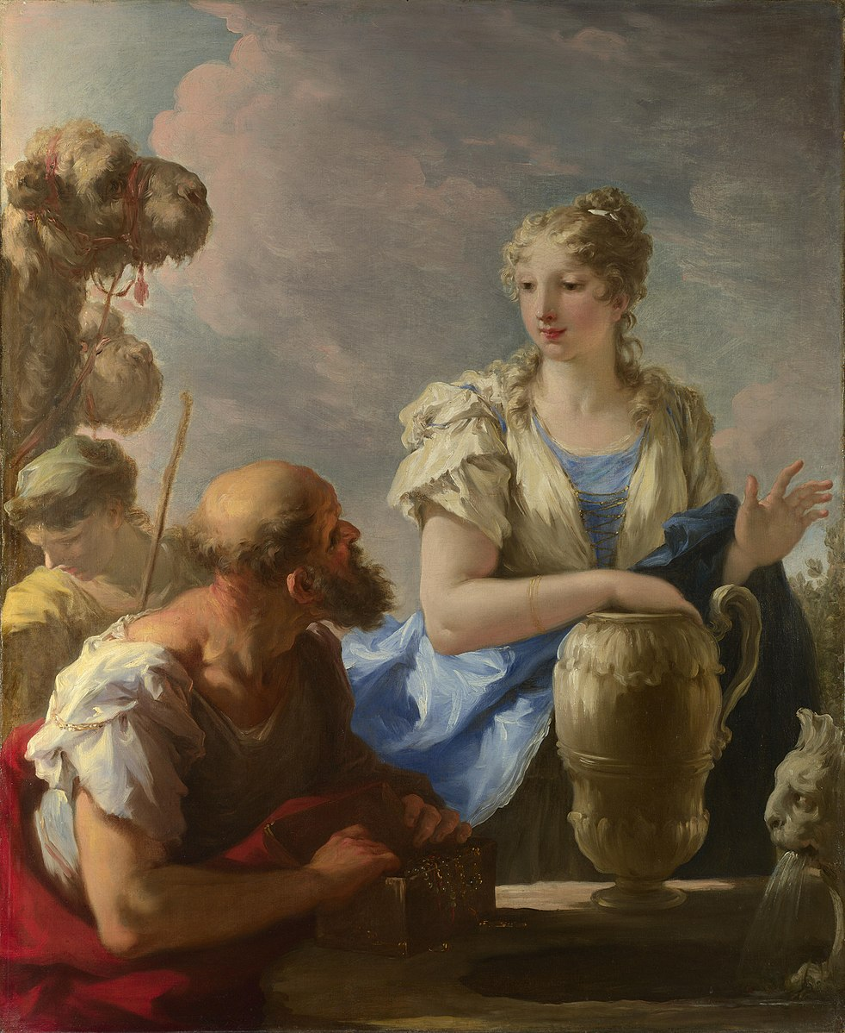
(V7_9) Giovanni Antonio Pellegrini, Rebecca at the Well, National Gallery
$include(figure-slice-vertical-end.in) $include(layout-a-end.in) $include(sheet.in) $include(layout-b.in)
A good many of Tiepolo’s own paintings survive from the first decade in his career—that is, from 1716 to 1726, the year when he travelled to Udine.
He certainly came under the influence of Piazzetta (1683–1754), thirteen years his senior, whose art sometimes looks backwards to Annibale Carracci in Bologna; and I give you just one example of how Tiepolo’s art might have developed, if he had gone further down that path.
The canvas shows St James being dragged to his execution (as in the fresco by Mantegna, in Padua). It is one of a set of twelve (each measuring a little over five feet by four, each depicting one of the apostles) which were commissioned in the early 1720s from a number of artists (including Ricci, Pellegrini and Tiepolo) for the church of the oddly named Santo Stae in Venice.
Piazzetta’s palette here is limited to browns and yellows. The scene is dramatically lit from above with splashes of light and patches of deep shadow. It depicts violence (in extreme close-up and with anatomical exactitude), done by, and done to, relatively unidealised members of the working-class—all of which is reminiscent of the art of Caravaggio and his followers a hundred years earlier.
Just how far Tiepolo could assimilate his style to that of Piazzetta is evident from his contribution to the series, the Martyrdom of Saint Bartholomew. (Notice the same low viewpoint; the same violent contrast of light and shade; the same physical types. The two figures are again almost unbearably close to the picture plane.)
$include(column-break.in) $include(figure-slice-vertical.in)
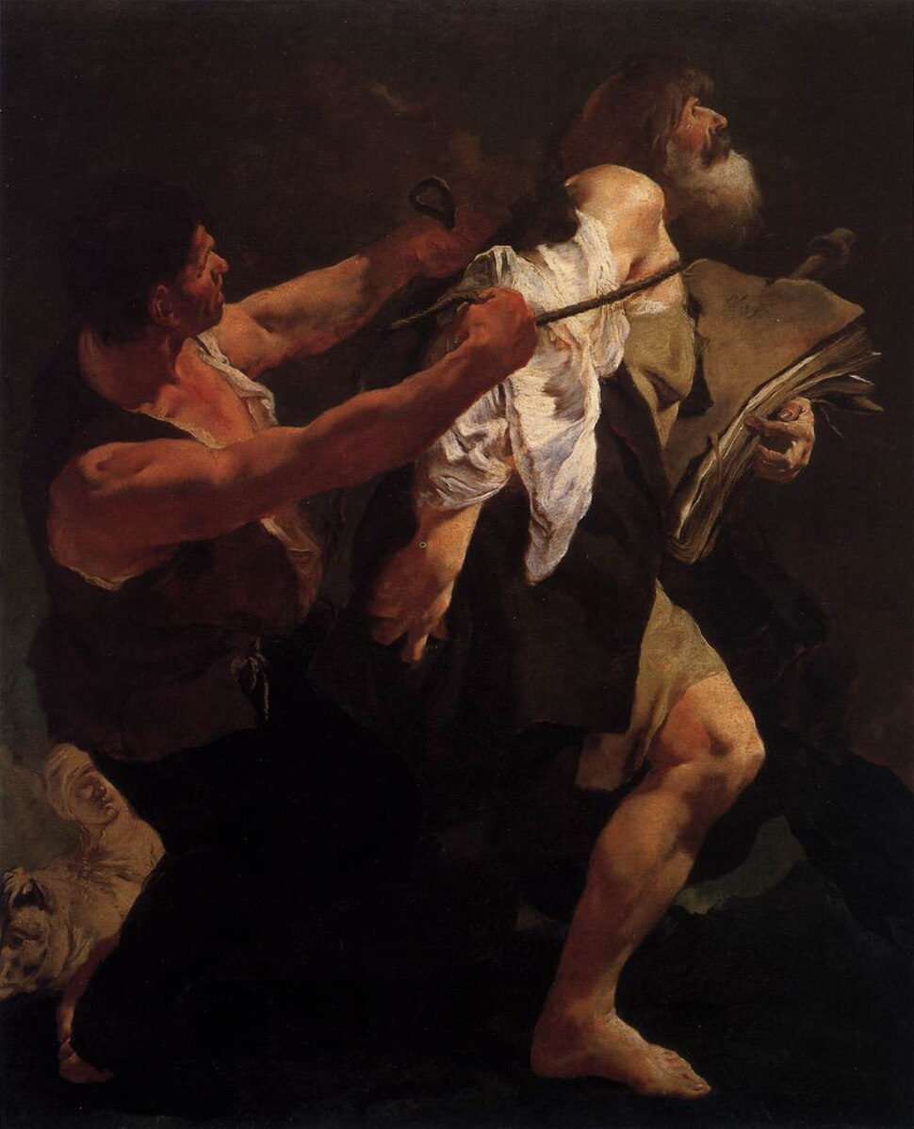
(V7_12) Giovanni Battista Piazzetta, Martyrdom of St James, Church of San Stae
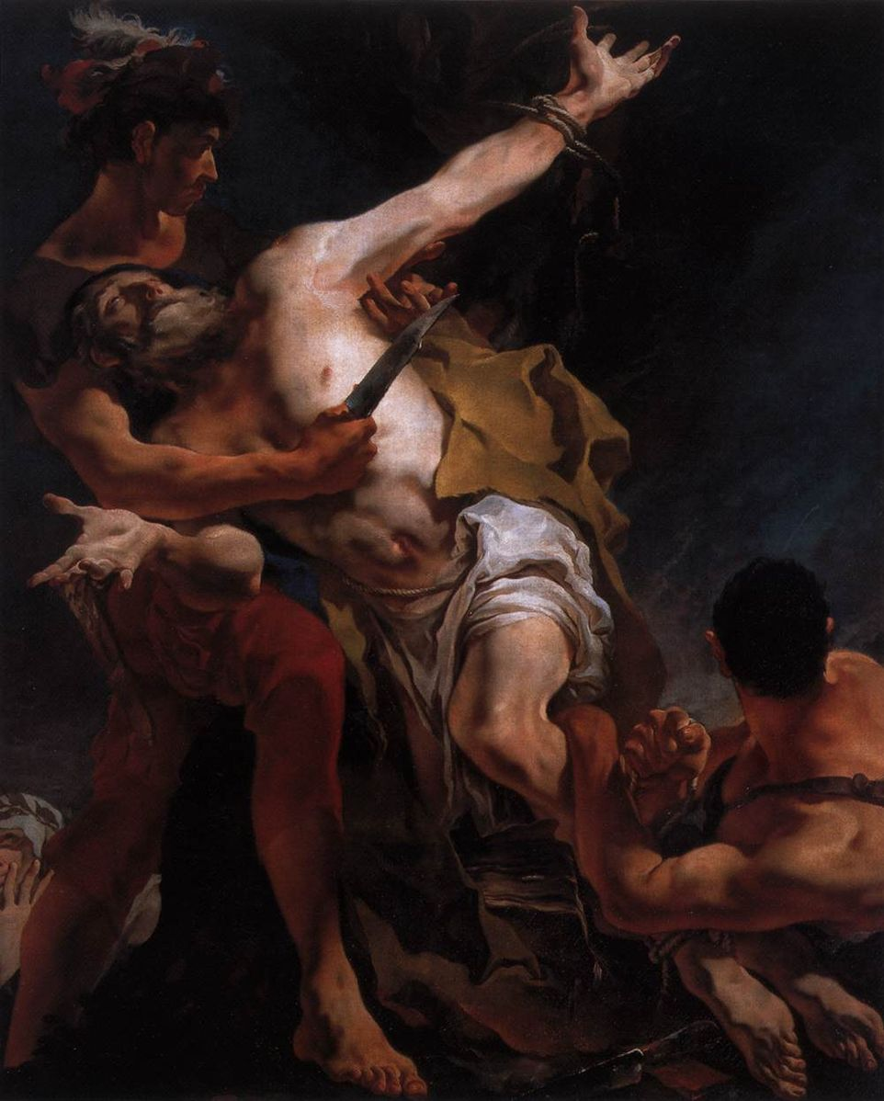
(V7_13) Tiepolo, The Martyrdom of St Bartholomew, Church of San Stae
$include(figure-slice-vertical-end.in) $include(layout-b-end.in) $include(sheet.in) $include(layout-a.in)
It will be relevant to glance at two more paintings by Tiepolo from his first decade—more intimate in scale—because they both contain characteristic features which will come as a surprise if you only know his later work.
The first measures just over three feet by four and was painted either in 1717 or in 1719 (the date is hard to read).
It shows a bearded patriarch, bending forward over the figure of a prostrate girl and clearly indicating with his left arm that she must be cast out. It is probable that he is Abraham, and she Hagar (the Egyptian slave, whom we shall again meet on the ceiling of the Galleria in Udine).
At the insistence of Sarah, his old and barren wife, the aged Abraham took Hagar as his concubine in order that she might bear him a son. Inevitably, Sarah became jealous and forced the pregnant Hagar to run away into the wilderness before her son was born (Genesis 16. 1-12). Hagar later returned with Ishmael; but after the miraculous birth of Isaac, Sarah insisted that Abraham ‘should cast out this slave-woman with her son’; a command that was ‘very displeasing to Abraham’ Nevertheless: ‘he rose early in the morning, took bread and a skin of water, and gave it to Hagar, and sent her away, in the wilderness of Beersheba’ (Genesis 21. 9–11, 14)
The tragic mood created by the expressive drawing of the despairing girl and the reluctant patriarch is reinforced by the deep shadows to the left and the right. But there is also a significant contrast between the darkness of banishment and a supernatural light of hope (making the bas-reliefs on the monument glow with an orange radiance), which anticipates the promise soon to be made to Hagar by an angel: ‘Fear not, for God has heard the voice of the lad… and will make him a great nation’ (21. 17-19).
$include(column-break.in) $include(figure-slice-vertical.in)
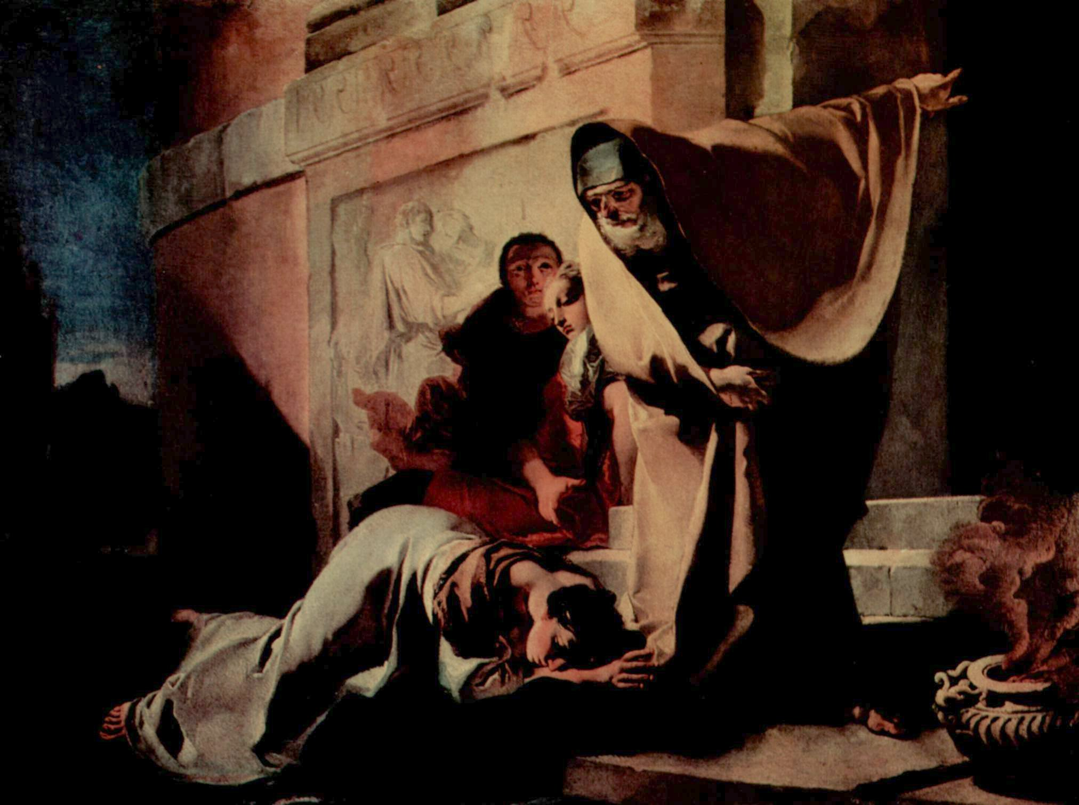
(V7_14) Tiepolo, Abraham Banishing Hagar, Rasini Collection, Milan
$include(figure-slice-vertical-end.in) $include(layout-a-end.in) $include(sheet.in) $include(layout-a.in)
If there is more than a hint of Piazzetta’ influence in the mood and handling of Abraham and Hagar, there is also a clear and delightful debt to Ricci and Pellegrini in the light-hearted scene of Alexander and Campaspe (c. 1725), which I offer as a final example of Tiepolo’s formative years. The medium is oil on canvas, and the picture is very small indeed (twenty inches by twenty-six); but there is a contrast of colours within the one picture and an element of playfulness which prepare us for the frescos to come.
On the left, we have a light blue sky, a creamy segment of a classical wall, a marble statue of Hercules, and a laurel-wreathed conqueror, picked out by the bright splash of scarlet used for his robe. He is Alexander the Great, and the lady is his imperial mistress, Campaspe, who is having her portrait painted in an uncomfortable, but very revealing pose (I think the helmeted aide-de-camp is plucking the dress just a little further off her breast).
To the right, we see the interior of the artist’s studio (the pilasters being made from a dark, volcanic rock), where there are some very dark canvasses, half finished (the nearer one showing Moses and the Brazen Serpent). The artist—in contemporary clothes—is seen at work on the portrait, his brush poised between very elongated fingers, his head and eyes screwed right round in frank admiration as he tries to capture and memorise the soft fullness of Campaspe’s breast, unaware that he is allowing a splash of paint to drip from his brush.
$include(column-break.in) $include(figure-slice-vertical.in)
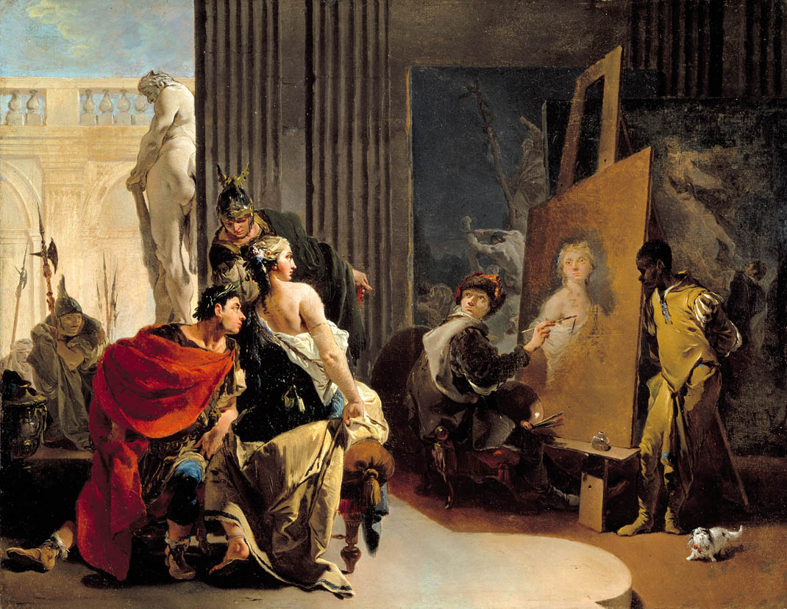
(V7_15) Tiepolo, Alexander the Great and Campaspe in the Studio of Apelles, Montreal Museum of Fine Arts
$include(figure-slice-vertical-end.in) $include(layout-a-end.in) $include(sheet.in) $include(layout-a.in)
In the story, the artist is Apelles, the greatest painter of antiquity, who fell in love with Campaspe as he painted her and became her lover—with Alexander’s gracious consent.
But this is also a self-portrait of Tiepolo in his mid-twenties, not afraid to laugh at his own pop-eyes and his own prominent nose, or at the drollness of his hypnotised expression.
In short, we have a combination of the classical and the biblical, a contrast between the palettes of Ricci and Piazzetta, in the service of a chaste sexuality and a gleam of humour—these being the elements that we are about to find reassembled in a rather different compound.
$include(column-break.in) $include(figure-slice-vertical.in)
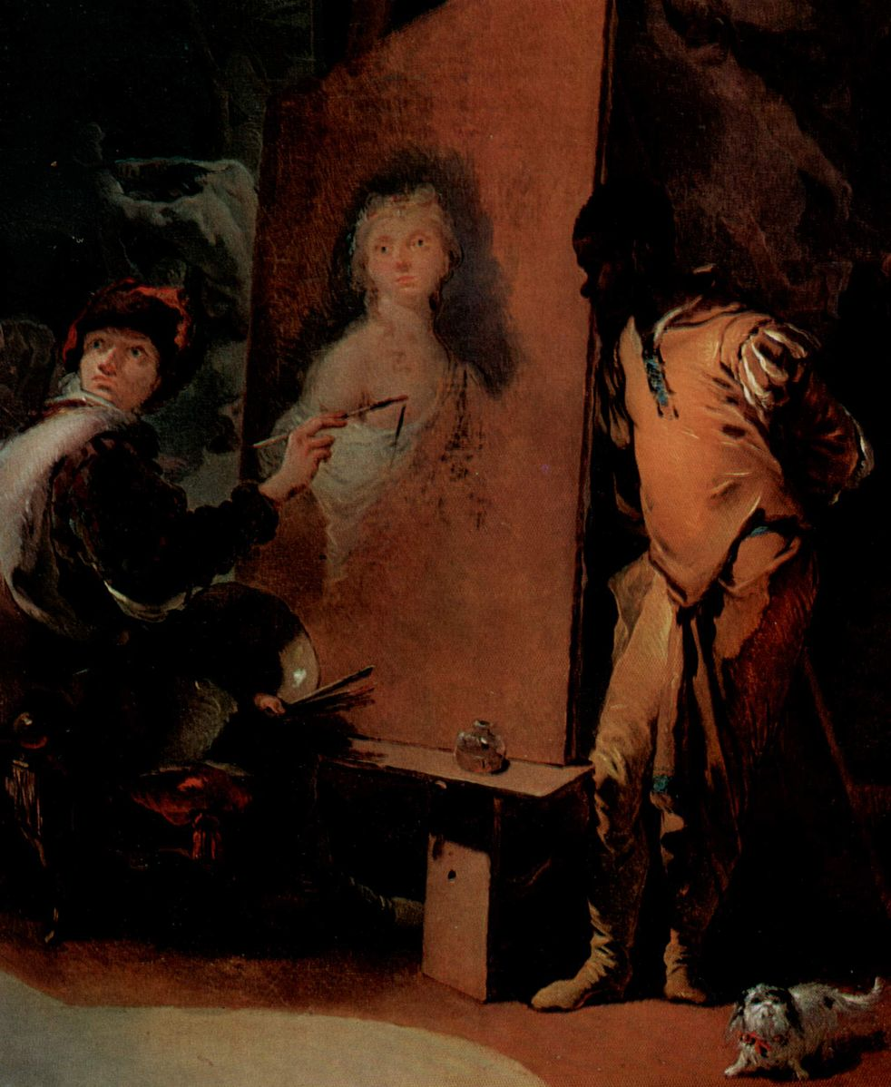
(V7_16a) Detail from Tiepolo, Alexander the Great and Campaspe in the Studio of Apelles
$include(figure-slice-vertical-end.in) $include(layout-a-end.in) $include(sheet.in) $include(layout-b.in) $include(text-with-image.in)
In 1726 Tiepolo was summoned to the city of Udine where he would work as a fresco painter in the appropriate seasons during the next three years. He was thirty years old and already cited in the documents as ‘un pittore celebre e chiaro’.
As you can see from the map and postcard, Udine lies about 60 miles to the northeast of Venice, still in the alluvial plain, but within sight of the foothills of the Alps. At that time (as the perspective map of c. 1700 reminds us), it was a compact, walled city similar to many others in northern and central Italy; and, as so often elsewhere, the streetplan of the centro storico and the principal buildings have remained much the same to this day. It is an ideal destination for a daytrip during a Venetian holiday.
$include(text-with-image-end-text.in)
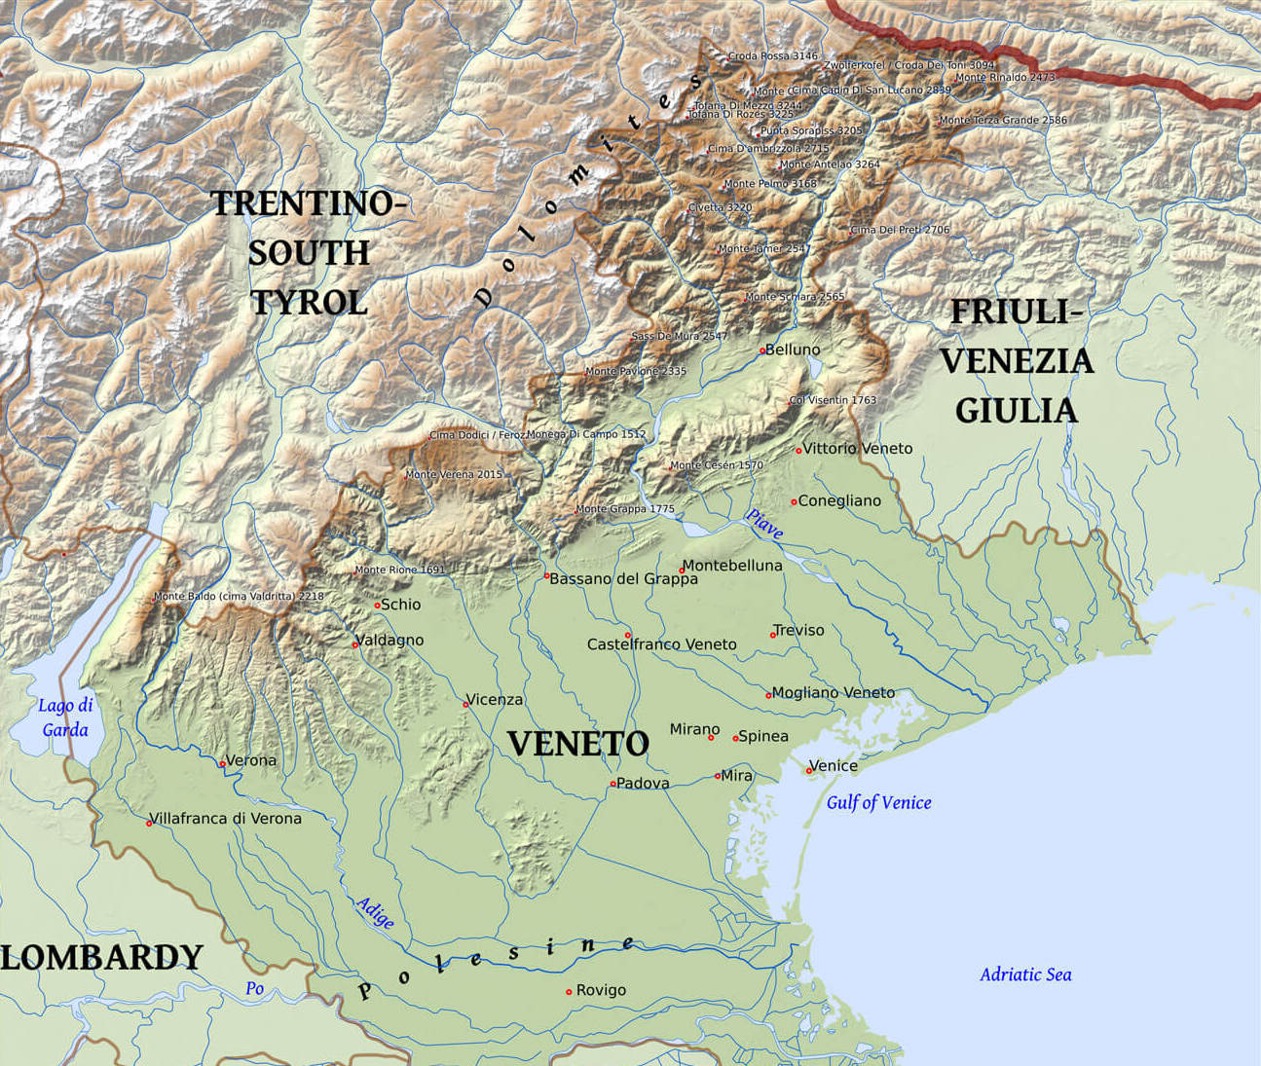
(V7_16b) Relief Map of the Veneto and Friuli–Venezia Giulia
MICHELA: I’VE CROPPED THE MODERN MAP ON THREE SIDES (TO SHOW HOW MUCH I WANT TO SEE TO THE NORTH, WEST AND SOUTH), BUT WE’VE GOT TO FIND A MAP THAT GOES AS FAR TO THE EAST AS UDINE!!! A RELIEF MAP WOULD HELP THE EXPOSITION, BUT ISN’T ESSENTIAL.
$include(text-with-image-end.in) $include(column-break.in) $include(figure-slice-vertical.in)
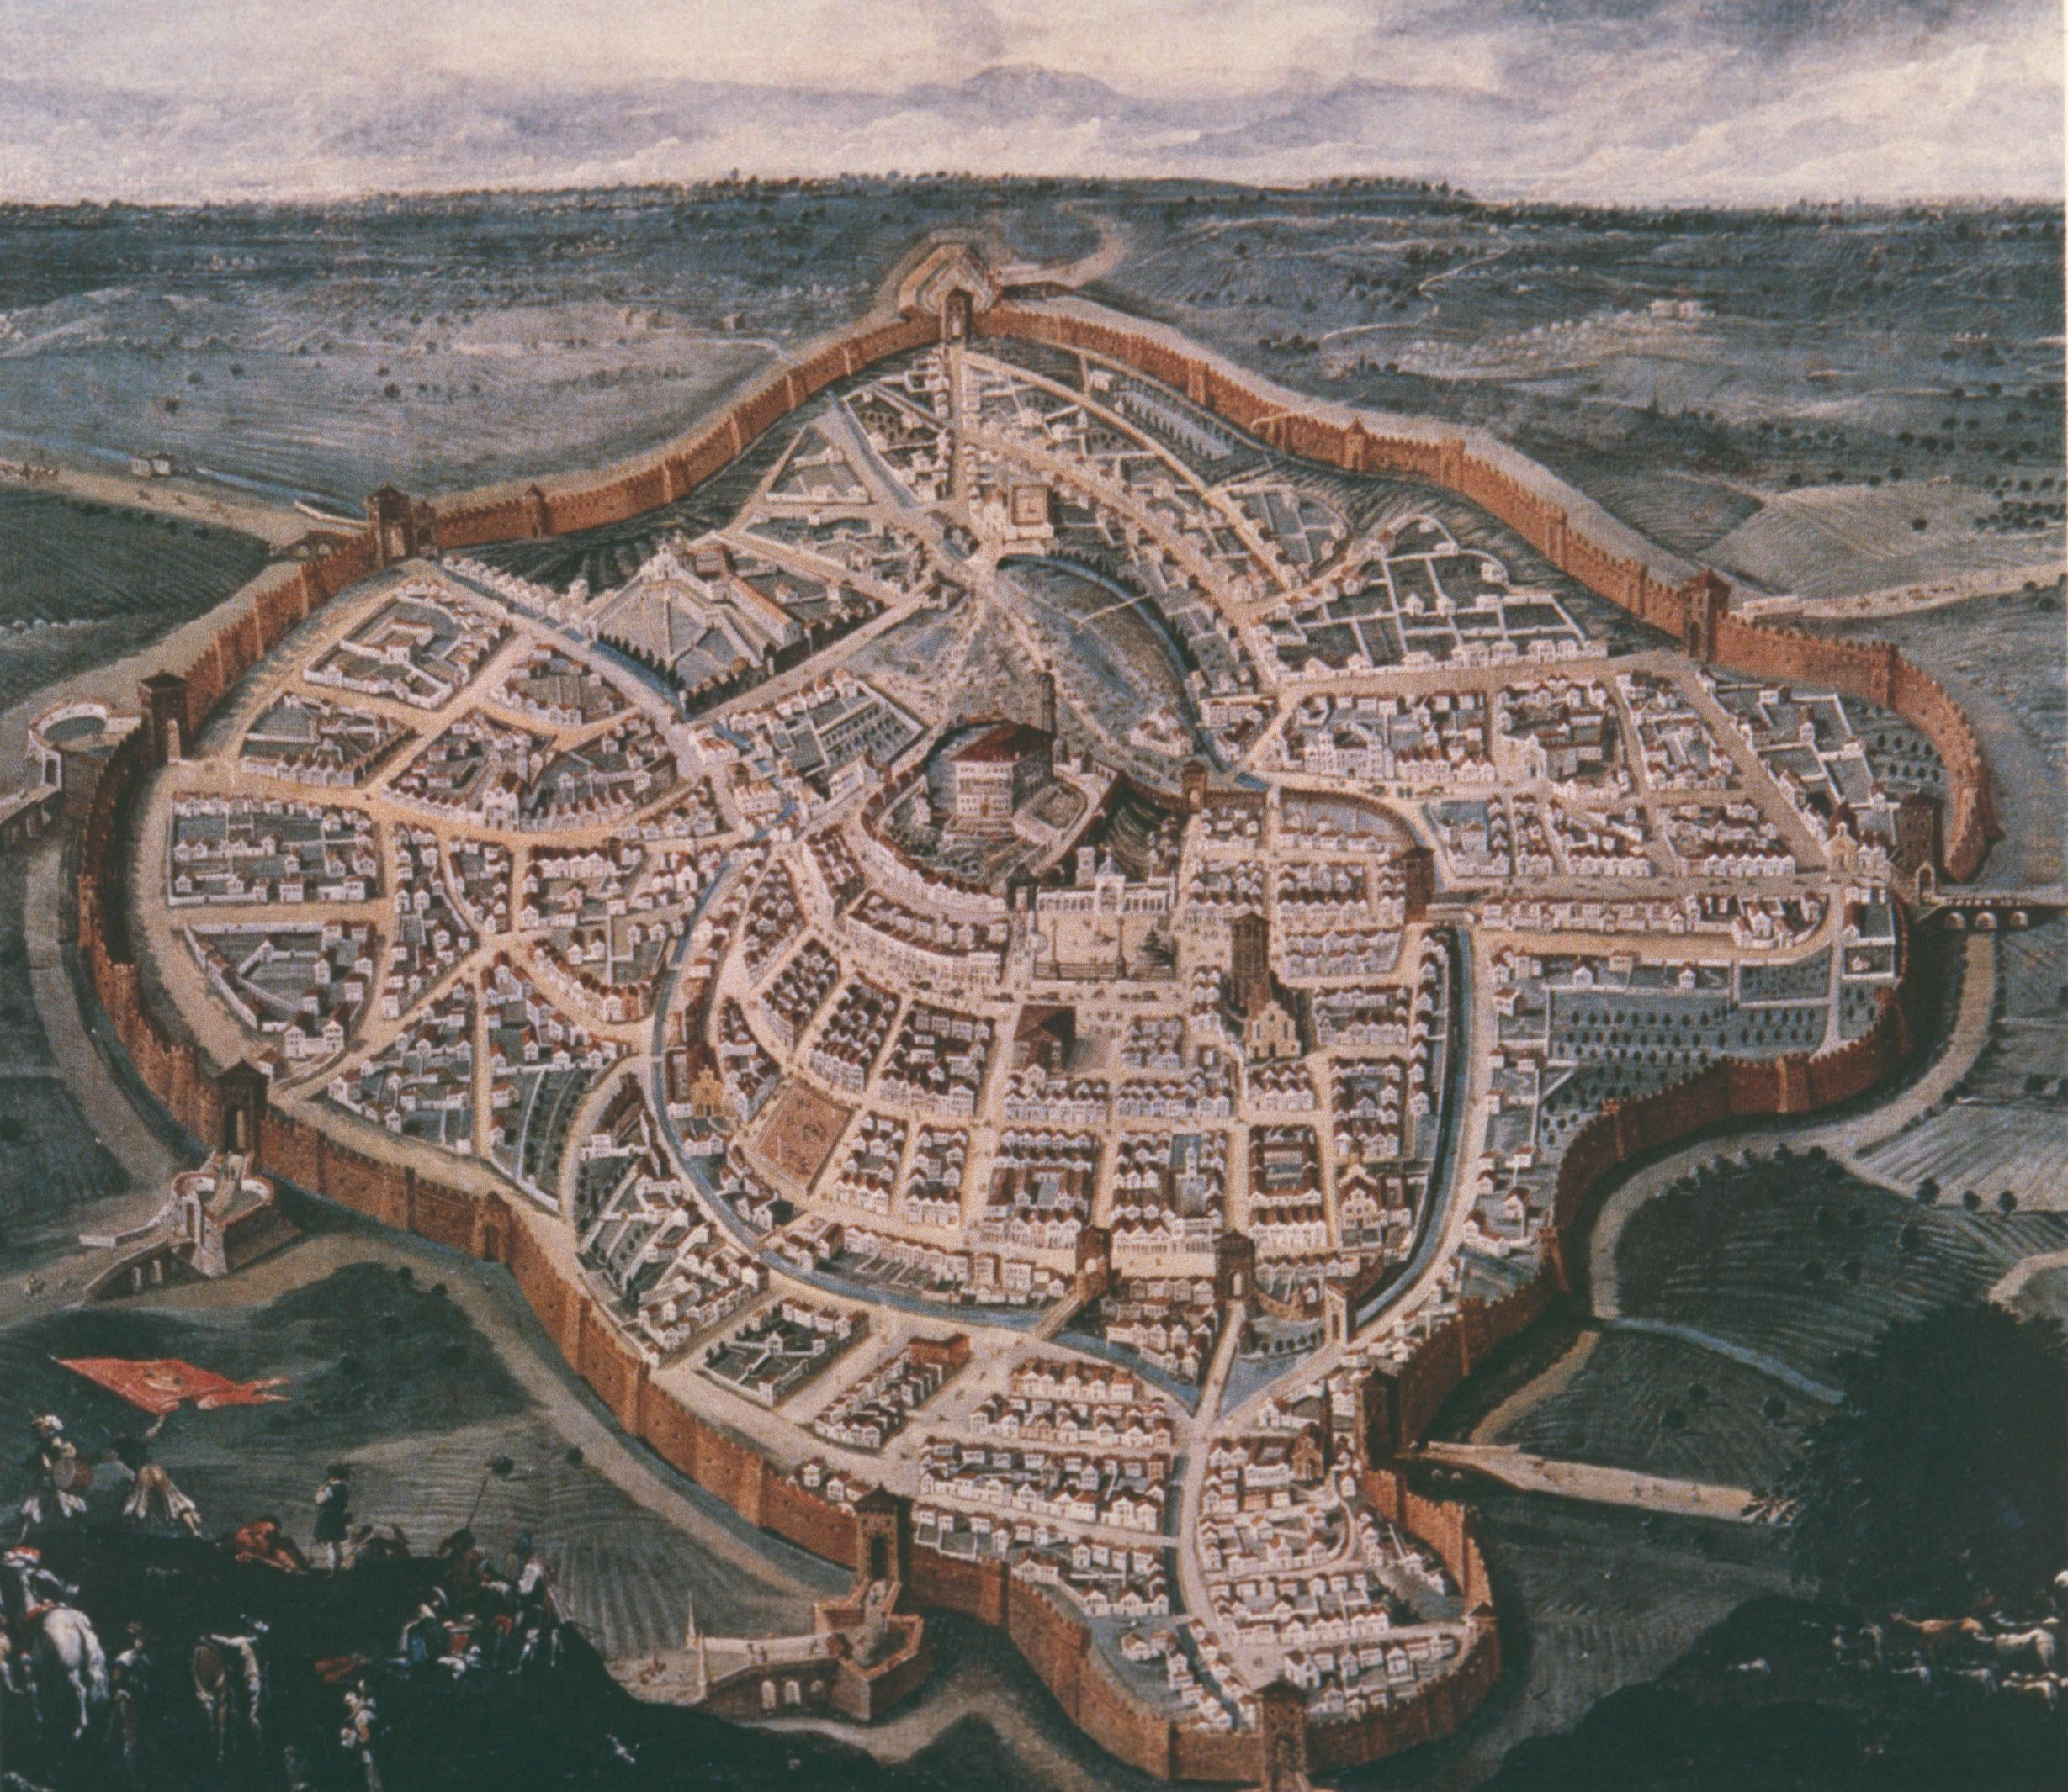
(V7_21) Luca Carlevaris, Perspective Map Of Udine, Musei Civici, Udine
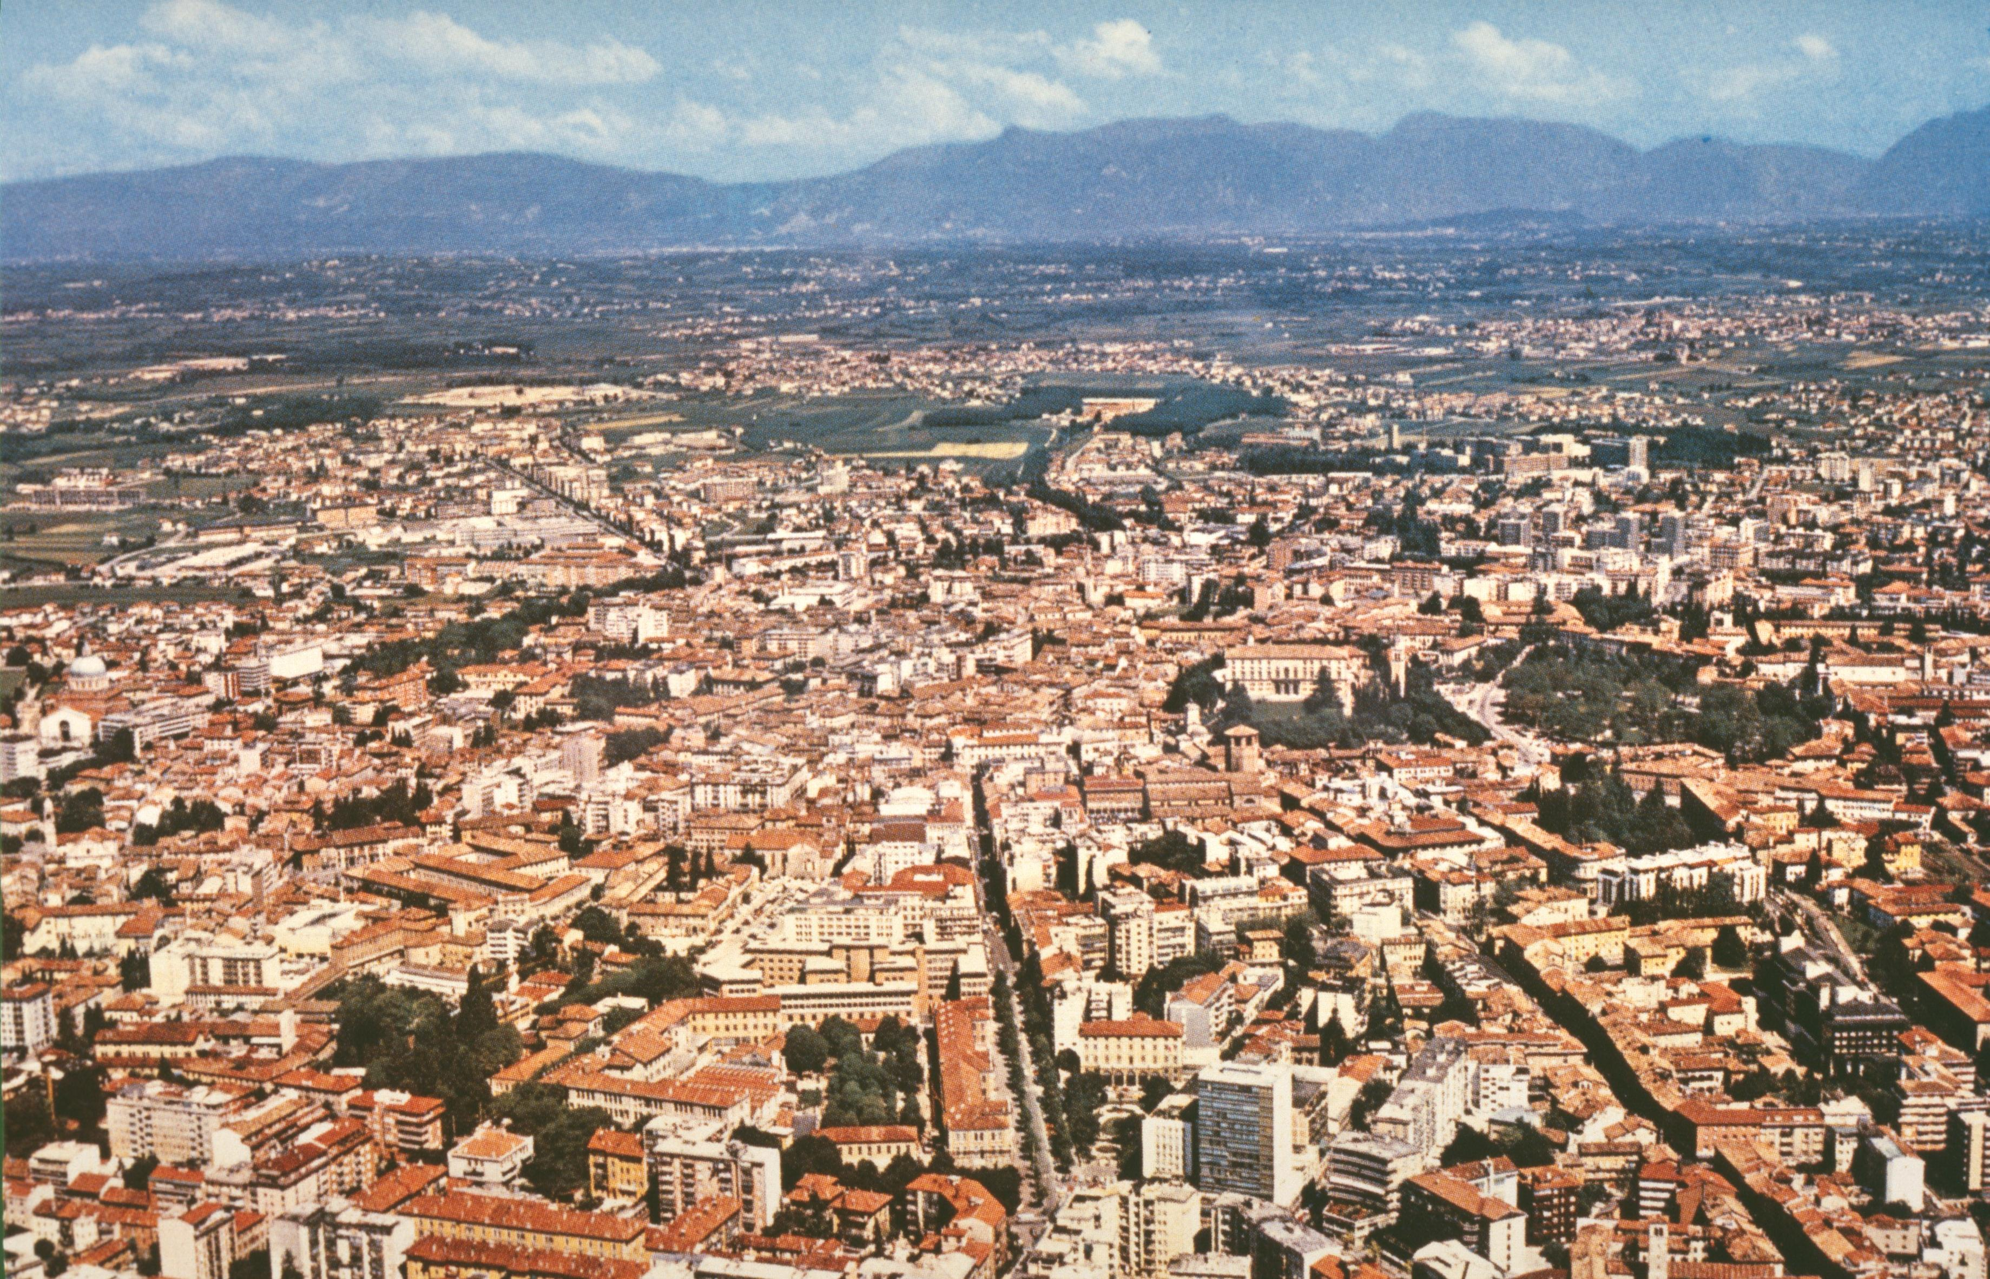
(V7_17) View from Udine to the Alps
$include(figure-slice-vertical-end.in) $include(layout-b-end.in) $include(sheet.in) $include(layout-b.in) $include(text-with-image.in)
The centre of town is graced by the slender Gothic arches of the early fifteenth-century Palazzo della Ragione (deliberately echoing the Doge’s Palace in Venice to mark the beginning of Venetian rule), known as the Loggia of Lionello, and by the rounded arches of the early sixteenth-century Loggia of St John.
Behind the elegant clock tower, a plain, box-like building dominates the city from the mound where the medieval castle used to be. The cathedral and the octagonal tower of the Baptistry stand close by (clearly visible in the detail from an earlier perspective map of 1650).
MICHELA: V7_19a IS A NEW IMAGE FROM A TRAWL. PLEASE FIX THE CAPTION IN HOUSE-STYLE.
$include(text-with-image-end-text.in)
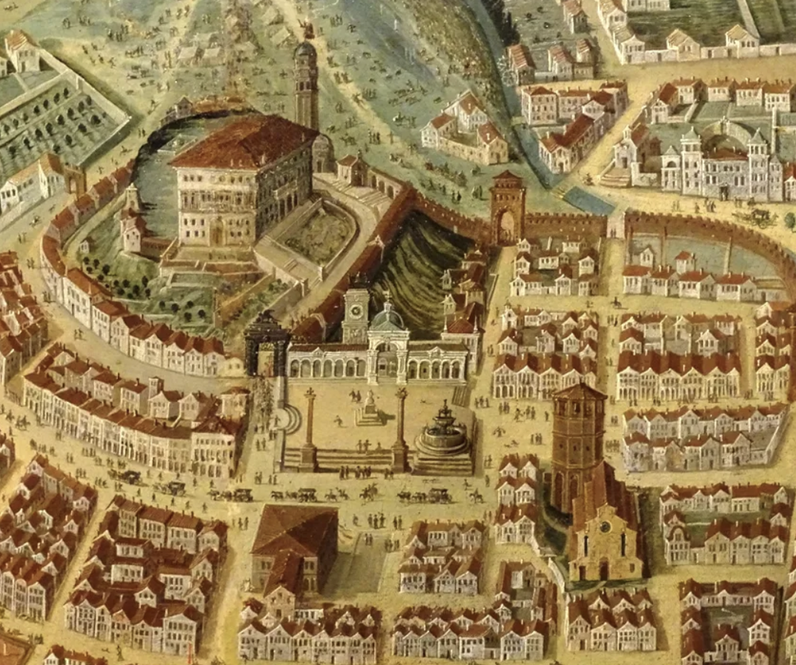
(V7_19a) FIXME: Caption needed
$include(text-with-image-end.in) $include(column-break.in) $include(figure-slice-vertical.in)
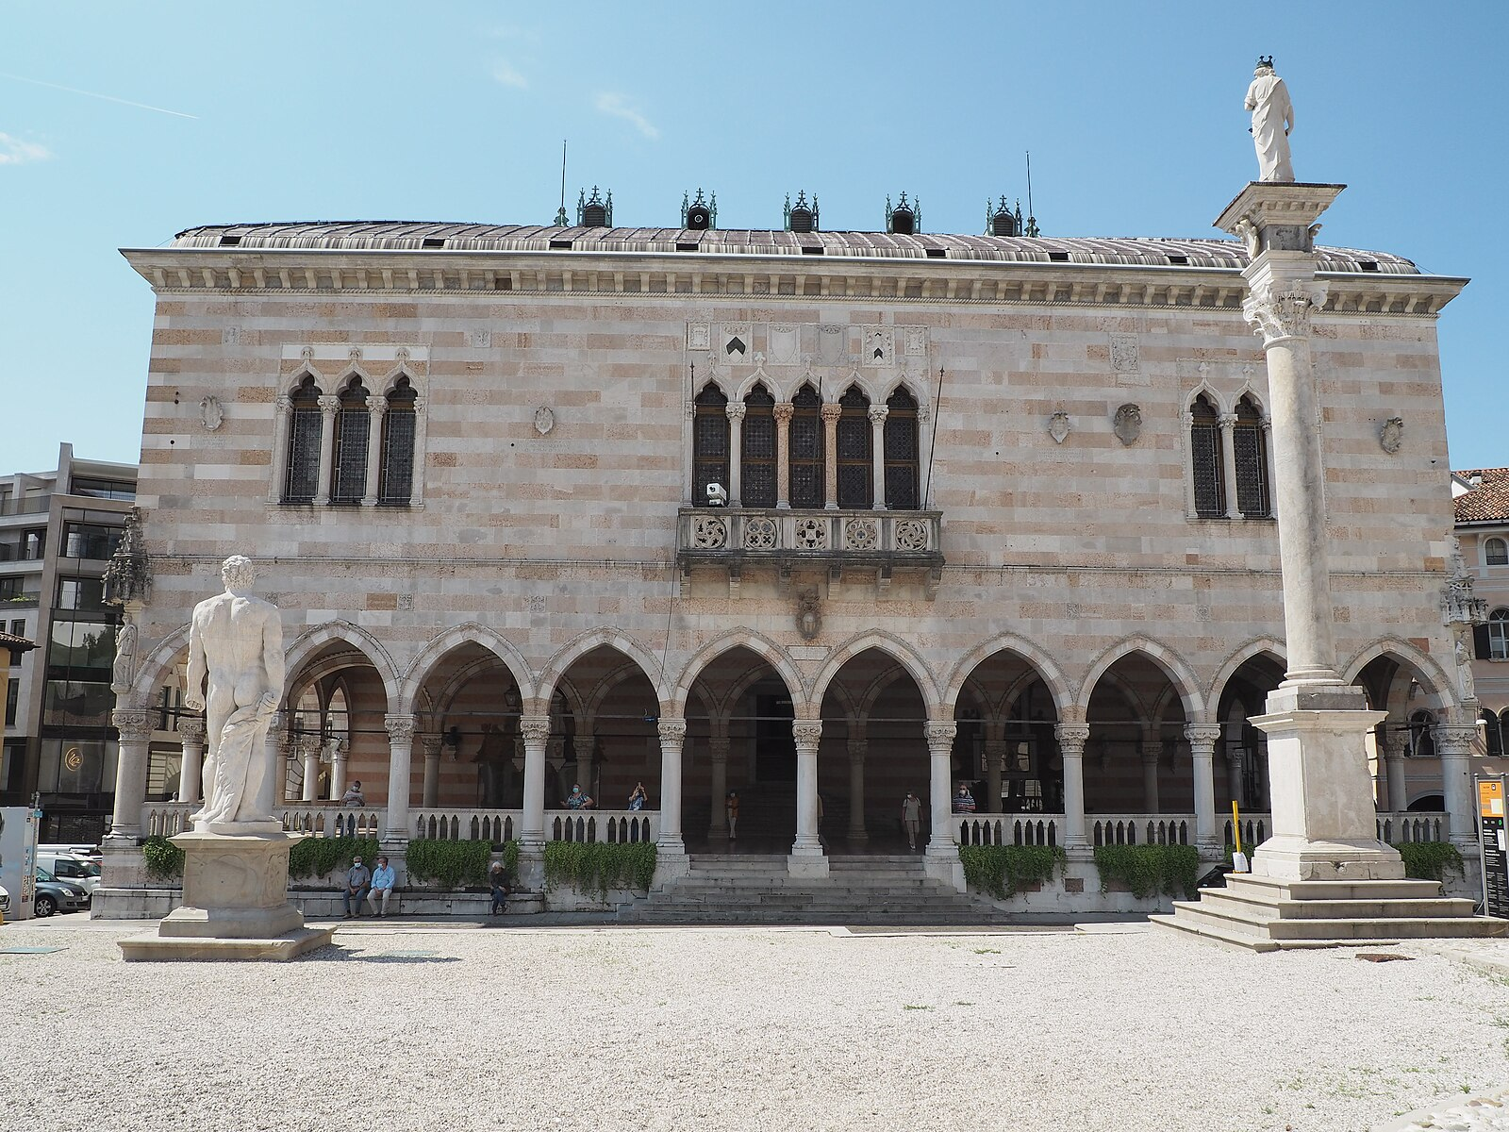
(V7_18) Loggia del Lionello, Udine
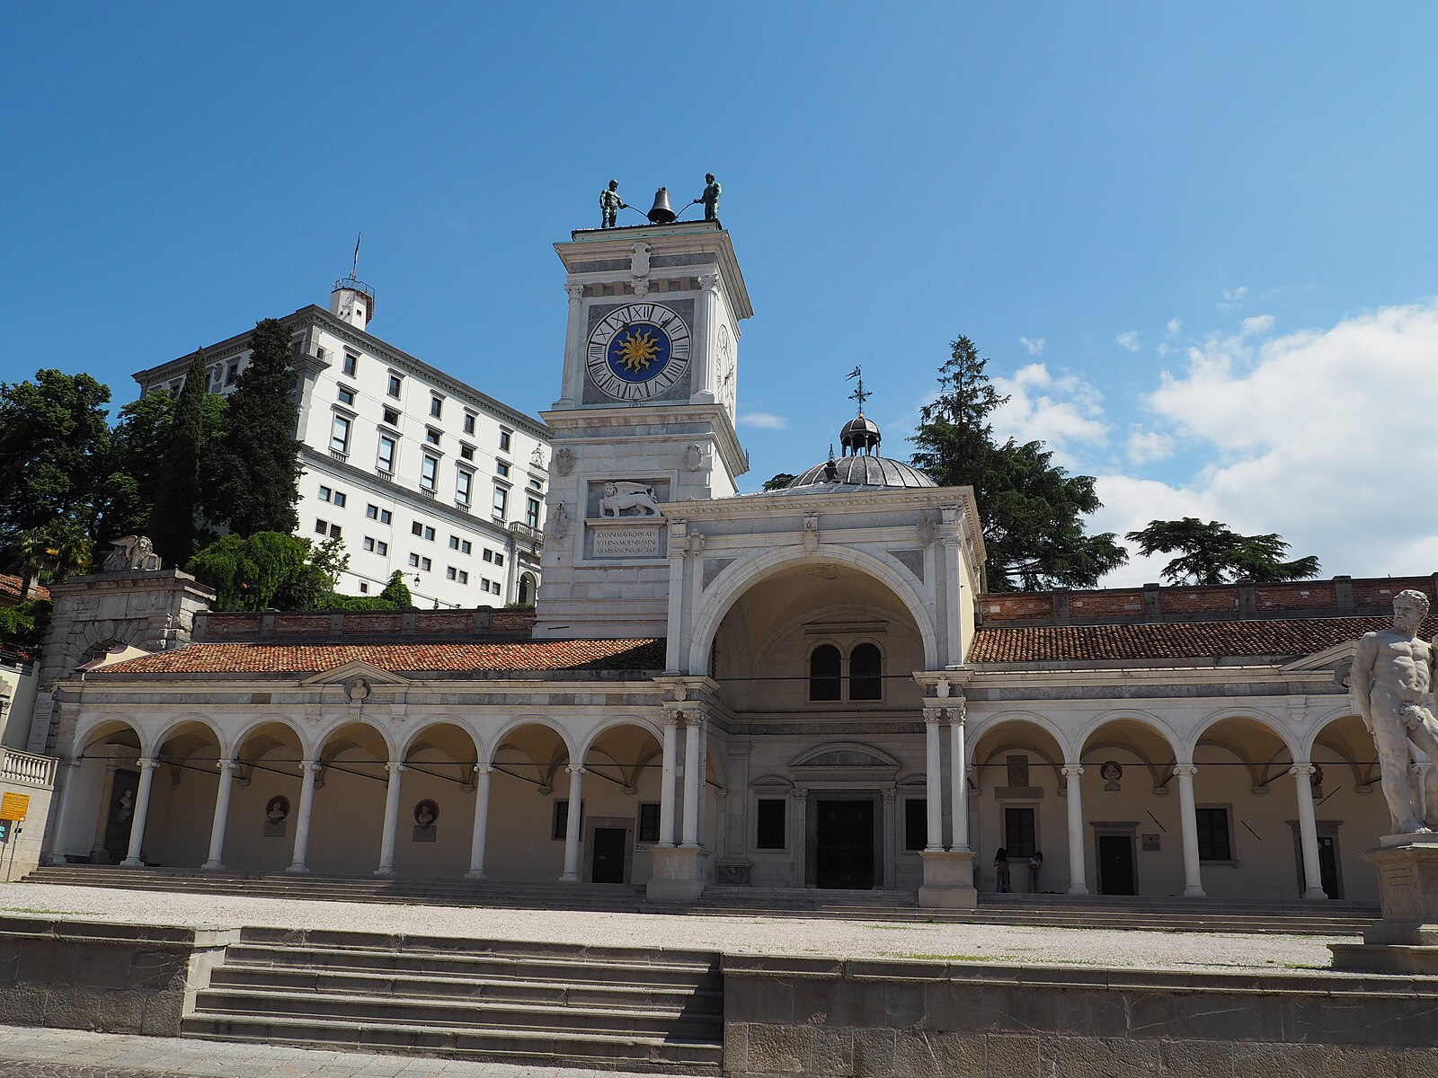
(V7_19) Loggia di San Giovanni and Castello, Udine
$include(figure-slice-vertical-end.in) $include(layout-b-end.in) $include(sheet.in) $include(layout-b.in)
The medieval façade of the cathedral is simple and unadorned; and nothing prepares you for the zing of the rococo frescos in a narrow side-chapel (the Chapel of the Eucharist).
There are no prizes for guessing that this is the fruit of Tiepolo’s first summer in Udine; and we must pause to examine the first of the three groups, if only because angels are going to be as important as patriarchs in the narrative cycle which brings us to the city.
$include(column-break.in) $include(figure-slice-vertical.in)
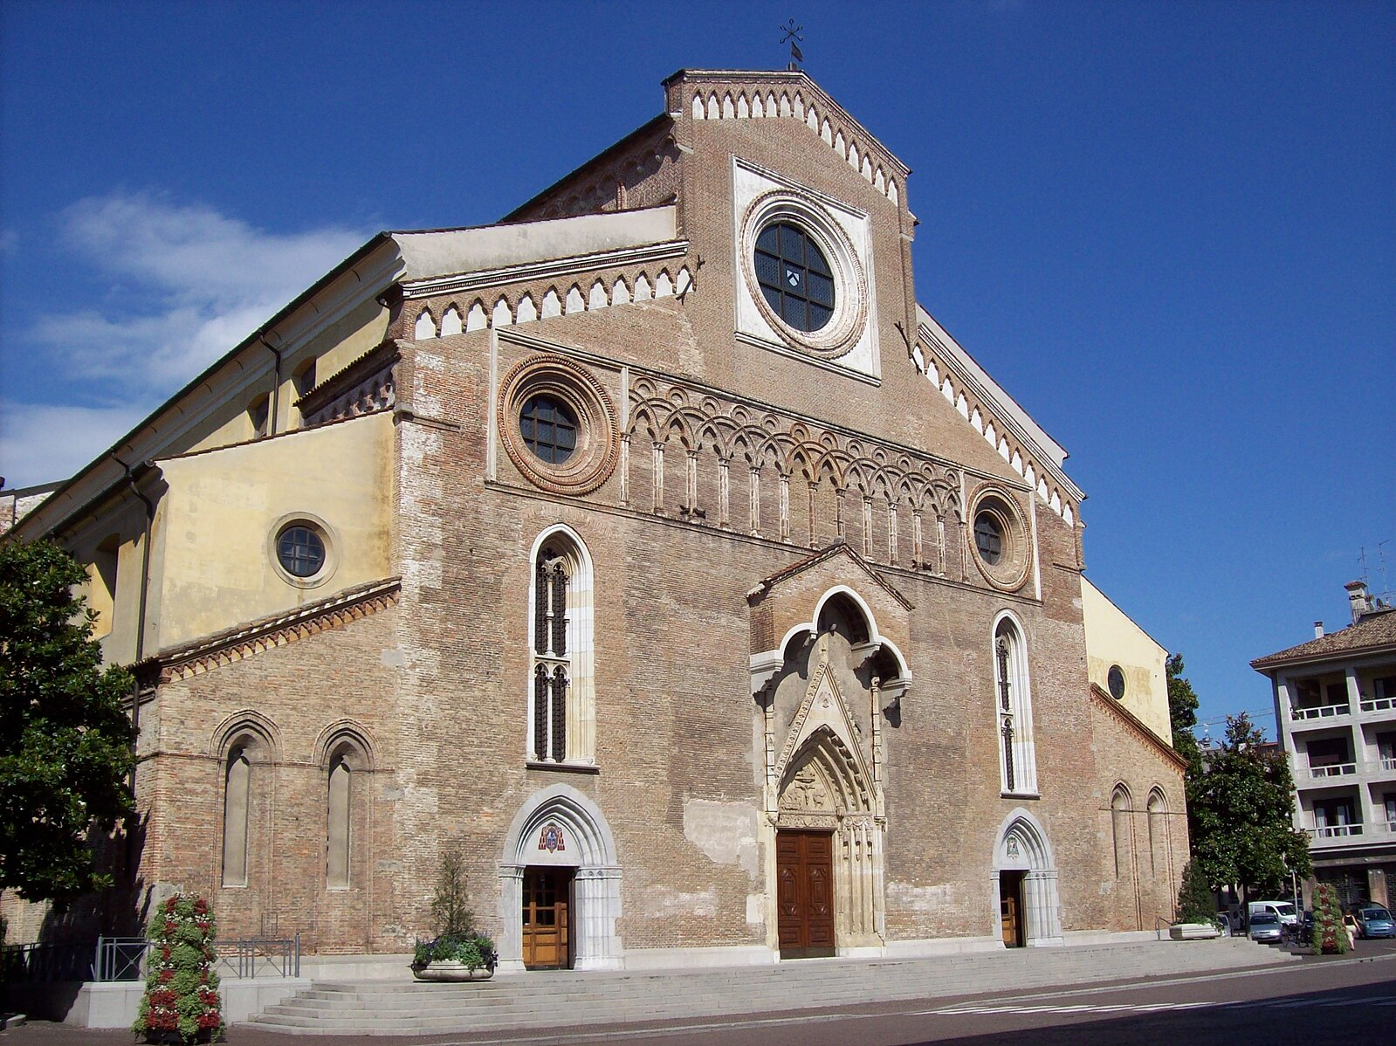
(V7_22) Duomo of Udine
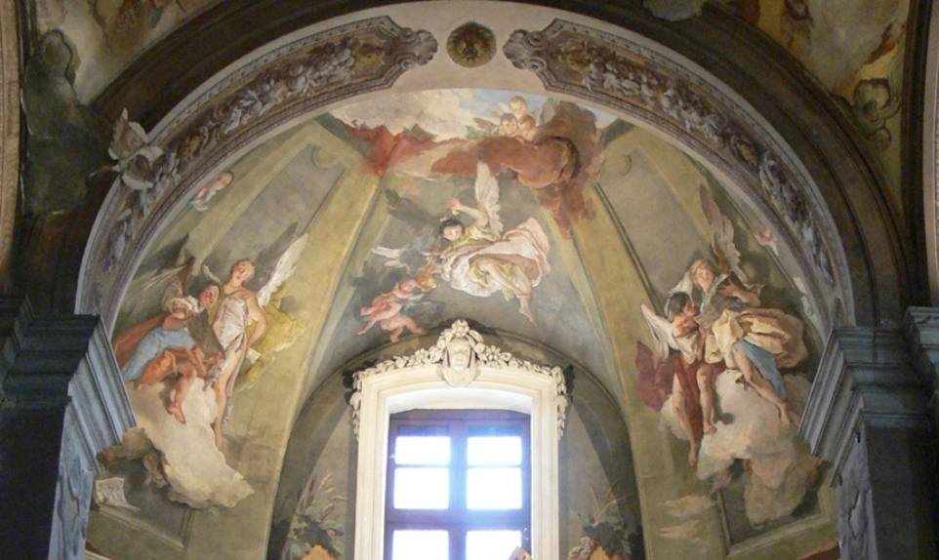
(V7_22a) Chapel of Eucharist, detail
$include(figure-slice-vertical-end.in) $include(layout-b-end.in) $include(sheet.in) $include(layout-b.in)
Angels ‘from the realms of glory’ are resting on a white cloud which seems to be floating in our space. Their bodies and their wings are solid enough for them to cast distinct shadows on the curve of the vault.
Two singers are performing what might well be an antiphonal motet (there are two other singing angels on the other side of the window), apparently supported by treble voices emanating from a small choir of infant cherubim. On this side of the window, the soprano is clearly female and is the more confident of the two. She sings from memory (holding her music behind her and thus exposing both her arm and shapely leg), while ensuring her companion does not lose the beat in a tricky passage by resting her right arm on his shoulder (as singers do). The tenor has a rather anxious expression as he tries to keep his balance on the cloud, twisting his left foot at an uncomfortable angle. He is also less well co-ordinated, clutching the second sheet of his music (but not looking at the notes), having let the first one fall onto the ledge below. (On the other side, the pair of soloists sing from the same hymnbook.)
Everything you see—colours, draftmanship, composition, wit and charm—is almost shouting the name of Tiepolo, ‘showing their birth and where they did proceed’.
$include(column-break.in) $include(figure-slice-vertical.in)
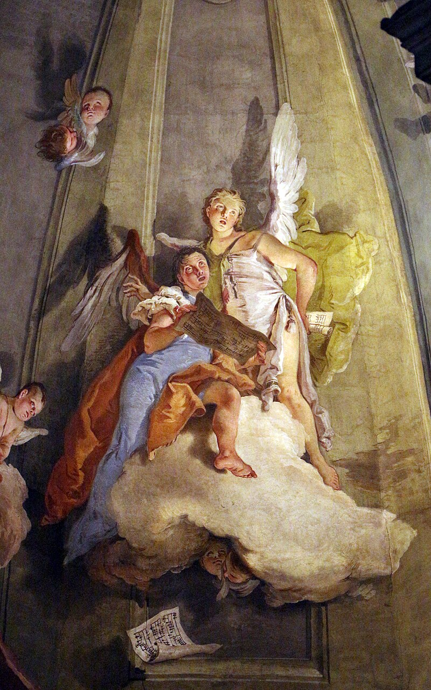
(V7_23) Tiepolo, Detail from fresco in the Eucharist chapel, Duomo of Udine
$include(figure-slice-vertical-end.in) $include(layout-b-end.in) $include(sheet.in) $include(layout-b.in)
The building which concerns us in this lecture lies close to the cathedral; and once again its façade gives no clue to the kind of treasure it contains.
It is now the palace of the Archbishop.
In Tiepolo’s time, however, it was the Palazzo of the Patriarch of Aquileia.
MICHELA: NB Ive corrected to give the ITALIAN SPELLING WITHOUT THE H (IT SEEMS FINE ELSEWHERE, BUT PLEASE DO A CHECK IN THIS AREA FOR OTHER POSSIBLE SLIPS IN TEXT AND CAPTIONS. SEPARATE TASK: PLEASE CHECK USE OF CAPITAL LETTER IN arcivescovale, WHICH RECURS IN SCORES OF LATER IMAGES. I’M HAPPY TO CONFORM TO ENGLISH CONVENTIONS IN TITLES, IF THAT IS WHAT ART HISTORIANS DO. But I don’t think Italians do. PLEASE DO A SEARCH AND CHECK.
$include(column-break.in) $include(figure-slice-vertical.in)
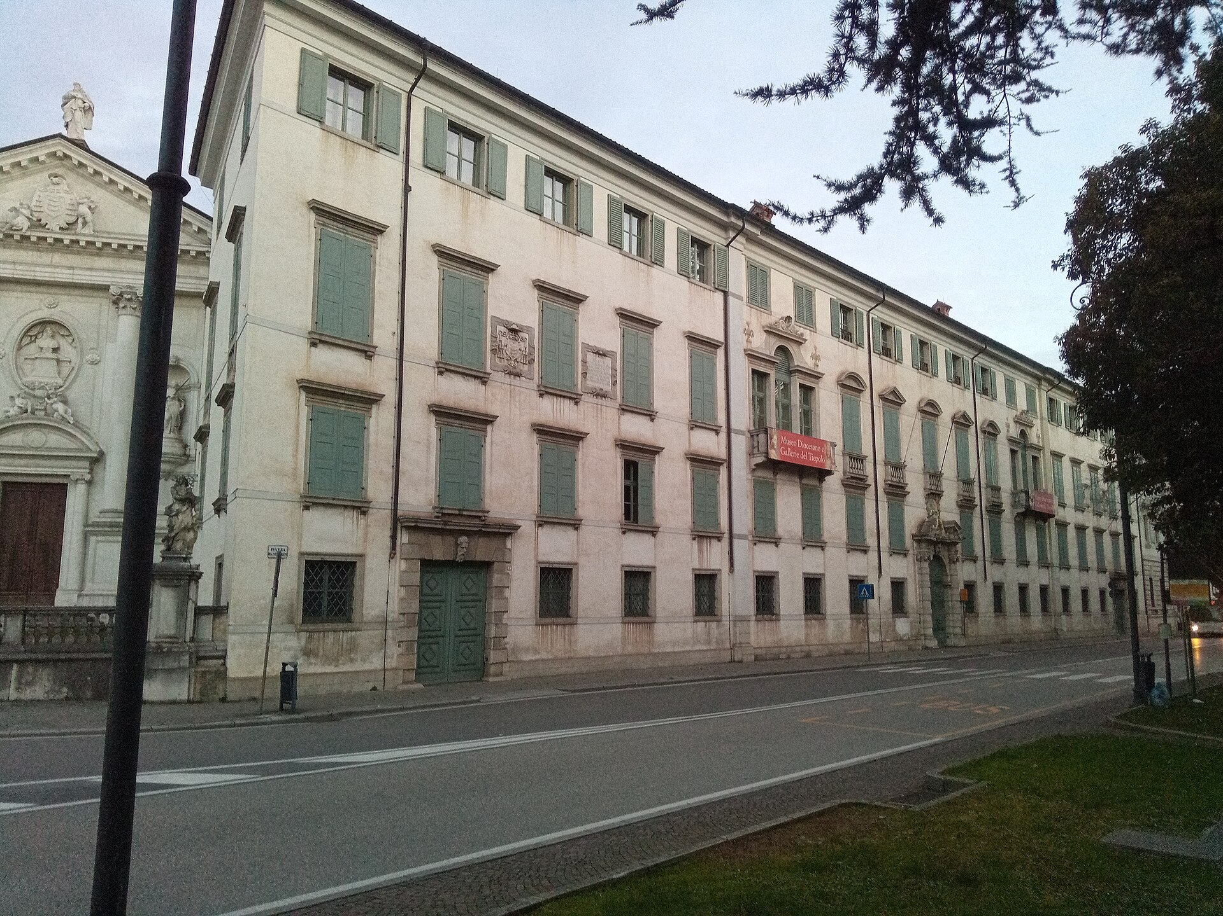
(V7_24) Palazzo Arcivescovile, Udine
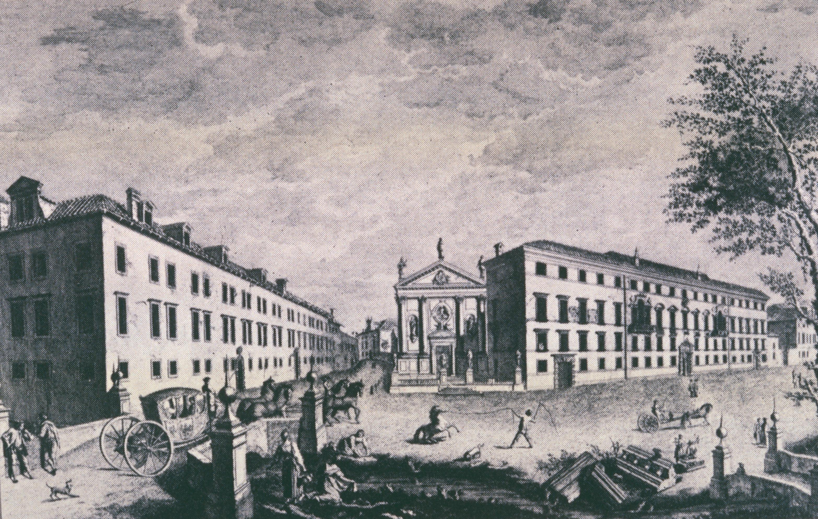
(V7_24a) 18th-century engraving of the Palazzo Arcivescovile
$include(figure-slice-vertical-end.in) $include(layout-b-end.in) $include(sheet.in) $include(layout-a.in)
Who, or what, you may well ask, was the Patriarch of Aquileia?
In Roman times, Aquileia was an important port on the Adriatic; and in the fourth century it had become the seat of a ‘Patriarchate’ which could bear comparison with those of Antioch or Jerusalem—or with what was then the mere ‘Bishopric’ of Rome.
With the passing of time, the port silted up, the city declined, and the Patriarch moved his actual seat inland—first to Cividale, in the eighth century, and then to Udine in the thirteenth, where he occupied the castle in the centre of the town and ruled the area of modern Venezia-Giulia as a feudal overlord, just like the great feudal archbishops in medieval Germany.
In 1420, however, the whole area was ‘annexed’ by the Republic of Venice. The Patriarch lost his temporal power; he was not allowed to reside in the city, in case he became the focus of local dissent; and he was appointed from one of the major noble families in Venice. (Veronese’s patron, Daniele Barbaro, had been Patriarch-Elect of Aquileia, although he never took up that office.)
$include(column-break.in) $include(figure-slice-vertical.in)
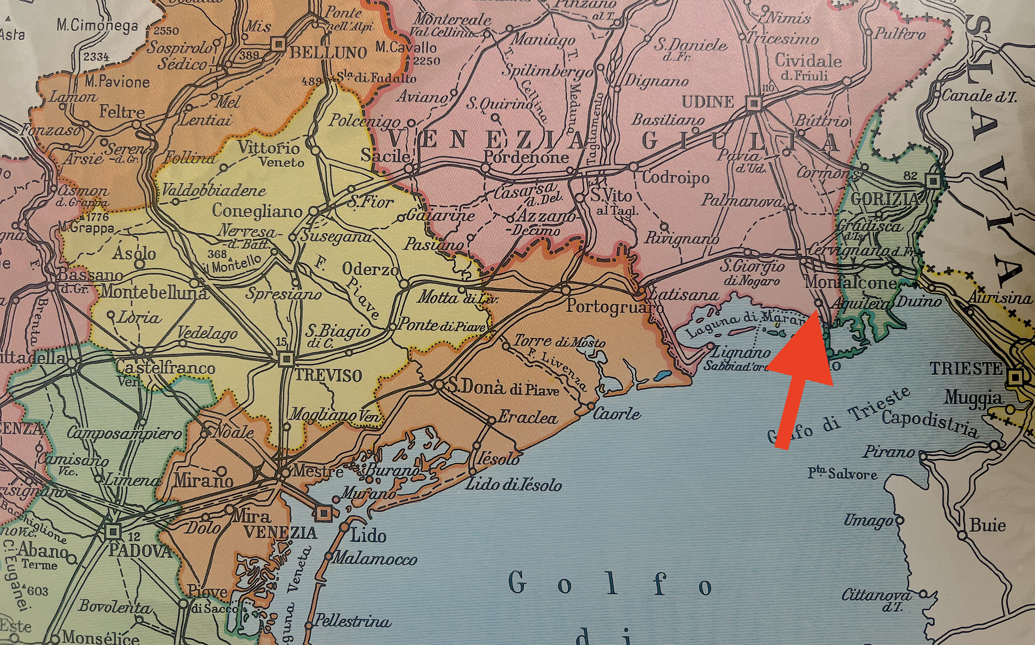
(V7_25) Map of the Veneto highlighting Aquileia
$include(figure-slice-vertical-end.in) $include(layout-a-end.in) $include(sheet.in) $include(layout-a.in)
The religious prestige and the political influence of the ancient Patriarchate survived, however, and we know that in the first half of the eighteenth century the Emperor of Austria and Venice were pressuring the Pope to abolish the institution and its prerogatives.
It is against this background that we must understand the activities of Patriarchs from the Grimani family and the Dolfin family, who extended and refashioned their curia on the site that concerns us until, by 1725, it had become the imposing edifice, shown in the nineteenth-century engraving.
I hope I have told you just enough for you to understand that the decision to have two of the major public rooms decorated with frescos by an up-and-coming artist, Tiepolo, as well as the choice of the subject matter of the frescos, was part of a power struggle and a battle for men’s minds.
MICHELA: CAPTION, PLEASE, FOR NEW IMAGE V7_25a. Nineteenth-century engraving ETC. (I found on line, Musei civici site, I think)
$include(column-break.in) $include(figure-slice-vertical.in)
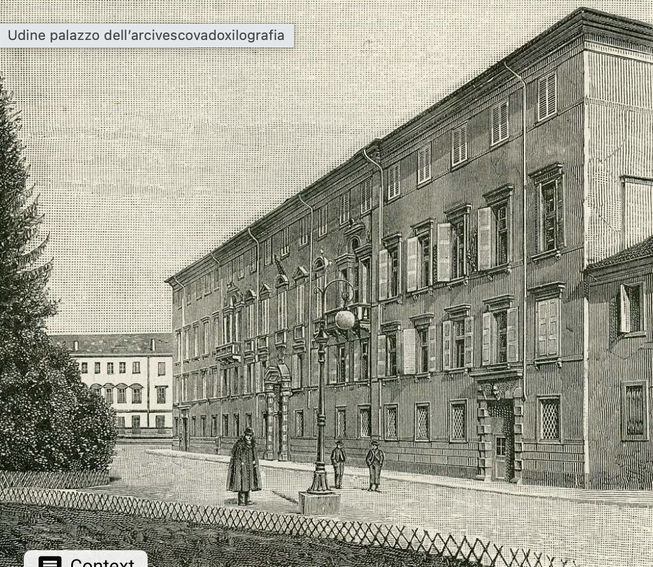
(V7_25a) 19th-century engraving etc.
$include(figure-slice-vertical-end.in) $include(layout-a-end.in) $include(sheet.in) $include(layout-a.in)
As you go into the Palazzo, you find yourself in the well of a magnificently ornate staircase—the Scalone d’onore. And if you look up, you will catch your first glimpse of a Tiepolo angel in flight—or rather, as will become clearer as you climb, of a Tiepolo archangel.
MICHELA: PLEASE CHECK FOR CONSISTENCY IN USE OF CAPITALS (onore or Onore?, as in: arcivescovile or Arcivescovile?)
$include(column-break.in) $include(figure-slice-vertical.in)
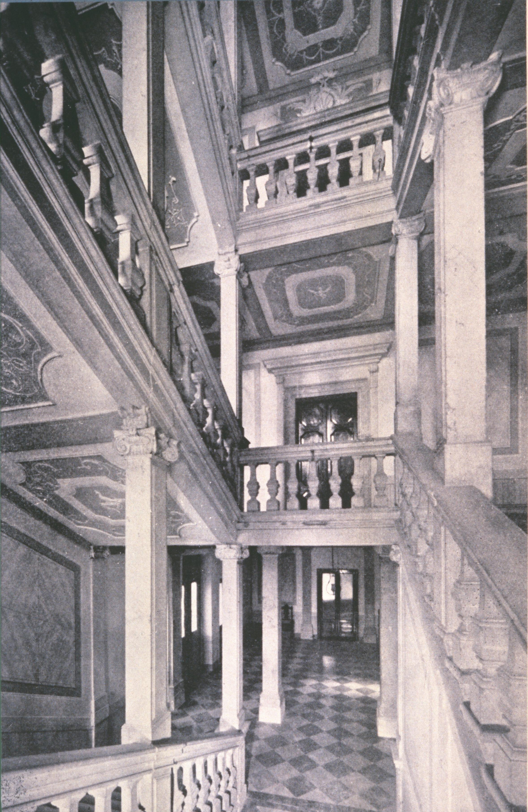
(V7_26) Scalone d’Onore, Palazzo Arcivescovile
$include(figure-slice-vertical-end.in) $include(layout-a-end.in) $include(sheet.in) $include(layout-c.in) $include(two-column-text.in)
He is St Michael—not only an archangel, but the most prominent of the only three angels in all the nine Orders who are ever referred as ‘saints’ (St Gabriel and St Raphael are possible locutions but rarely used in art history).
In Christian Art, he is most familiar in paintings of the Last Judgement at the end of time, when, according to legend, he will weigh the souls of the Resurrected (those few whose fate ‘hangs in the balance’) and drive the Damned down to Hell with his drawn sword. But he had played a similar (legendary) role at the beginning of time, when he led the celestial armies to crush the revolt of Lucifer and the Fallen Angels.
In 1725, the Patriach of Aquileiea probably chose both the subject and its dominant position as a warning of the fate that would befall the upstarts who were daring to menace the survival of the ancient Patriarchate.
However, it is unlikely you will remember the political context as you crane your neck and focus your binoculars to enjoy Tiepolo’s fresco within its highly elaborate frame.
MICHELA, PLEASE SUPPLY CAPTION FOR V7_27b, FOUND ON LINE. It shd mention Colonna by name, I think, (…in Colonna’s stucco frame… ??)
$include(two-column-text-end.in) $include(figure-slice.in)
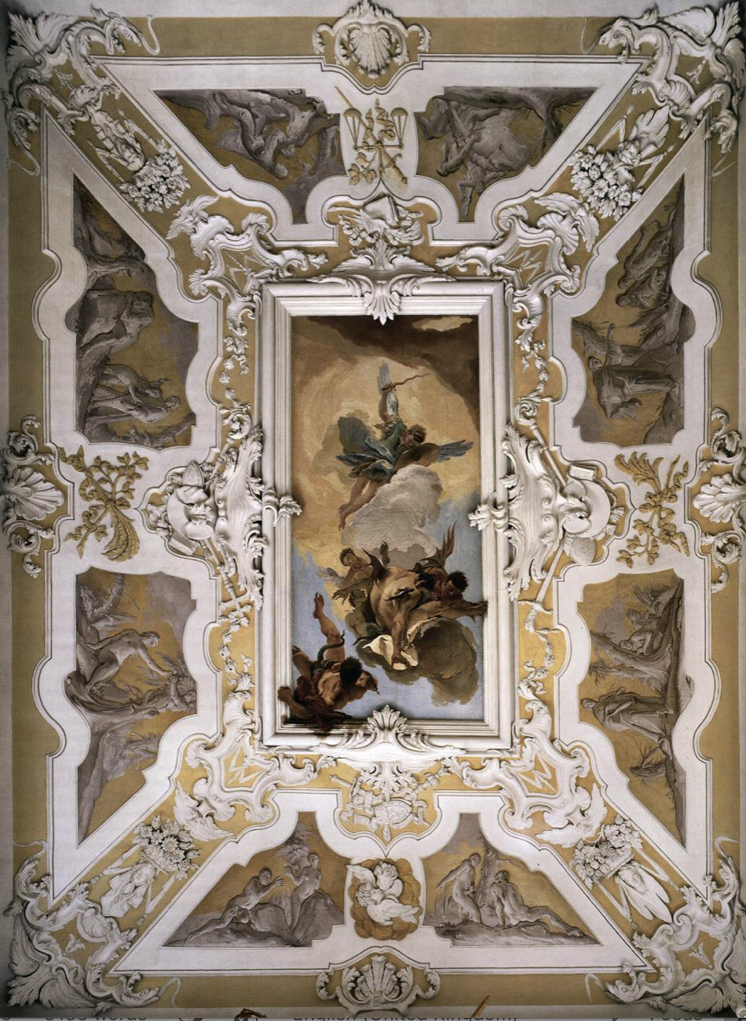
(V7_27b) FIXME: Caption needed
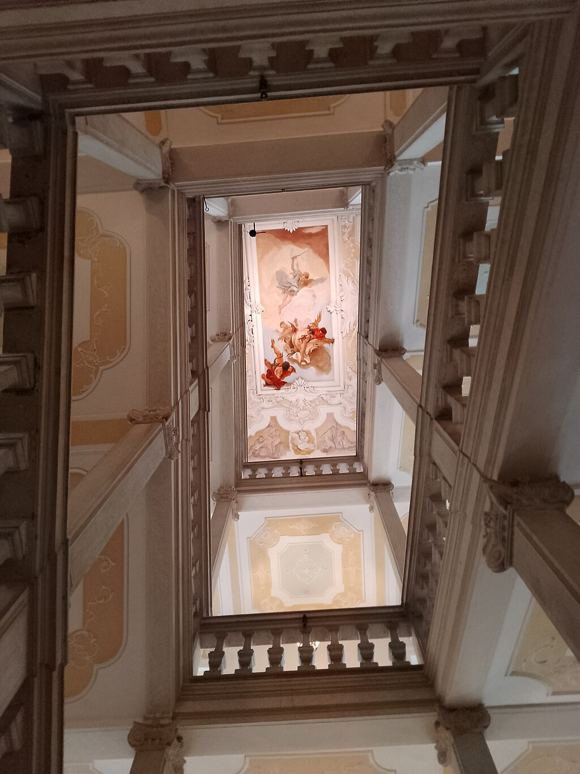
(V7_27) Stairwell of the Scalone d’Onore, Palazzo Arcivescovile
$include(figure-slice-end.in) $include(layout-c-end.in) $include(sheet.in) $include(layout-a.in)
Michael’s wings and costume are light-blue, and his sword is shaped like a cork-screw, as he swoops down on a group of four rebel angels (already demonised with batwings and corkscrew tails) to cast them down from heaven into the ‘pit’.
The most striking figure (presumably Lucifer) is shown in the most difficult foreshortening—his left arm projects beyond the frame and is actually modelled in plaster, in the round.
$include(column-break.in) $include(figure-slice-vertical.in)
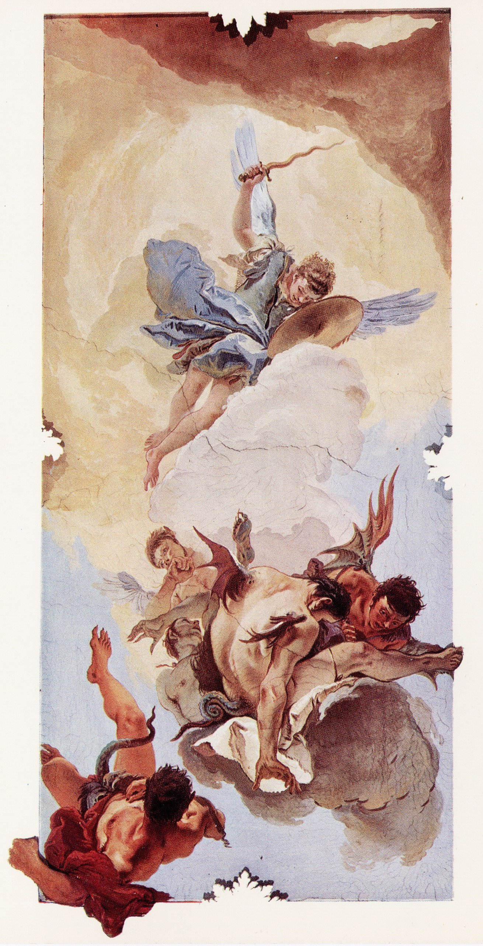
(V7_27a) Tiepolo, Fall of the Rebel Angels, Stairway of the Palazzo Arcivescovile
$include(figure-slice-vertical-end.in) $include(layout-a-end.in) $include(sheet.in) $include(layout-a-50.in)
Continue your climb to the first floor, the piano nobile, which is laid out as you can see in the plan.
(Its various irregularities remind you that the uniform façade of the eighteenth-century building conceals many separate accretions around an earlier core, on an awkwardly shaped inner-city site.)
Without pausing, proceed straight through the room ahead of you (marked 2 on the plan) and turn right into the ‘Gallery’ (marked 3), where no less than five windows on the south wall illuminate what has been called ‘a miracle of rococo decoration’ in a space measuring just 100 feet long, by 25 feet wide, under a vault about 30 feet high.
$include(column-break.in) $include(figure-slice-vertical.in)
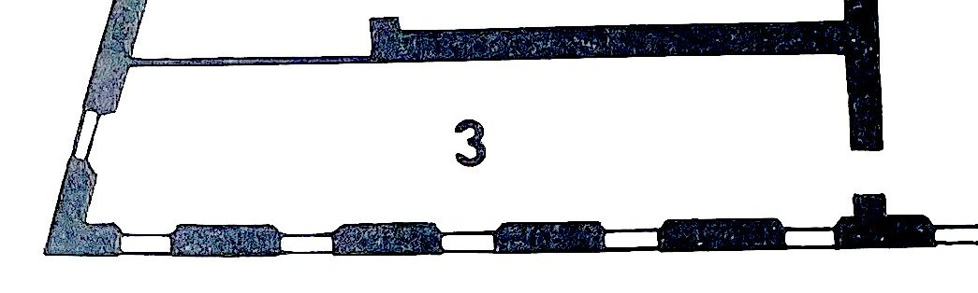
(V7_28a) Detail from Plan of first floor, Palazzo Arcivescovile
$include(figure-slice-vertical-end.in) $include(layout-a-end.in) $include(layout-c-50.in) $include(figure-slice.in)
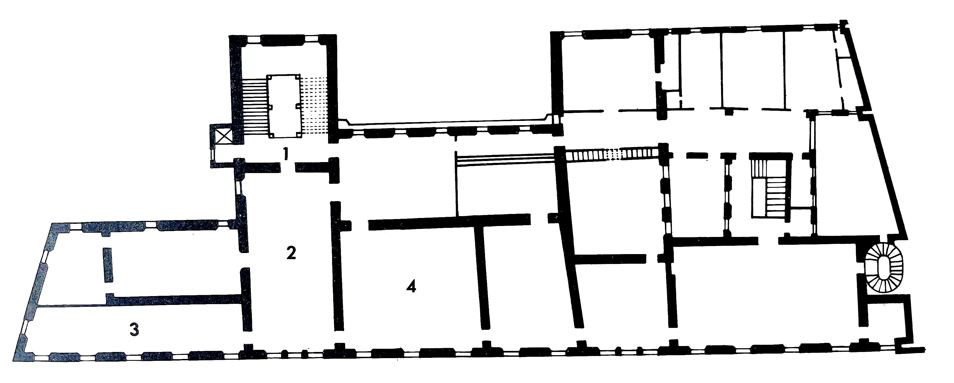
(V7_28) Plan of first floor, Palazzo Arcivescovile
$include(figure-slice-end.in) $include(layout-c-50-end.in) $include(sheet.in) $include(layout-c.in) $include(one-column-text.in)
Take a moment now to enjoy the total effect, looking first to the east and then to the west.
$include(one-column-text-end.in) $include(figure-slice.in)
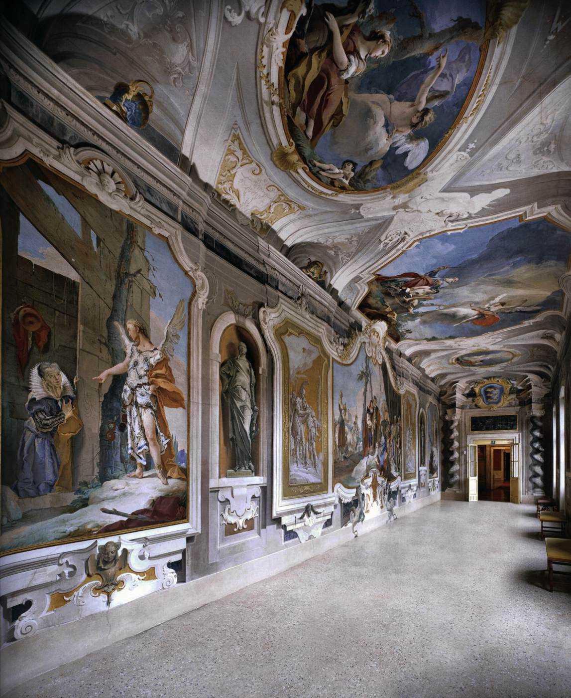
(V7_30) View of the Galleria, Palazzo Arcivescovile
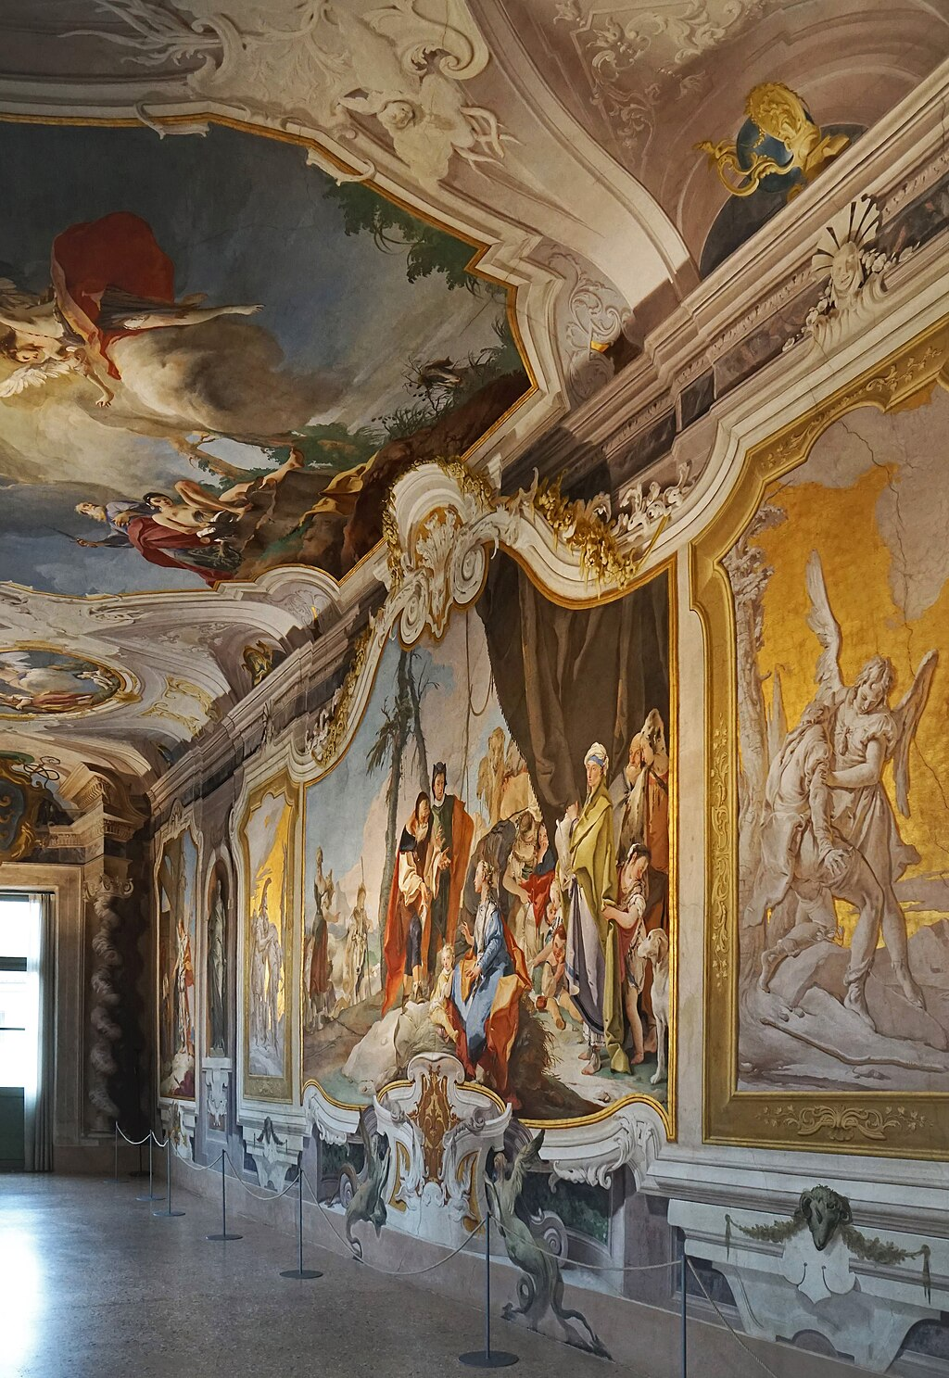
(V7_29) View of the Galleria, Palazzo Arcivescovile
$include(figure-slice-end.in) $include(layout-c-end.in) $include(sheet.in) $include(layout-c.in) $include(two-column-text.in)
As you see, the narratives that bring us to Udine are set in the most exquisitely elegant plaster surrounds, the work of Gerolamo Mengozzi Colonna (b. 1688) who would become Tiepolo’s frequent collaborator for the rest of his long career.
Not one of these cornices is rectangular, but their curvilinear shapes are repeated and arranged to achieve visual harmony.
They are laid out with three narratives on the ceiling (a large one in the centre and two smaller, symmetrical ones at each end), and five narratives on the wall (a large one in the centre, again, flanked by two symmetrical ones in grisaille and gold—simulating bas-reliefs—and there are two further narratives in symmetrical frames at either end.
MICHELA: I FOUND THIS NEW SLIDE ONLINE. I’D BE PREPARED TO PAY FOR THE FULL HEIGHT AND WIDTH.
$include(two-column-text-end.in) $include(figure-slice.in)
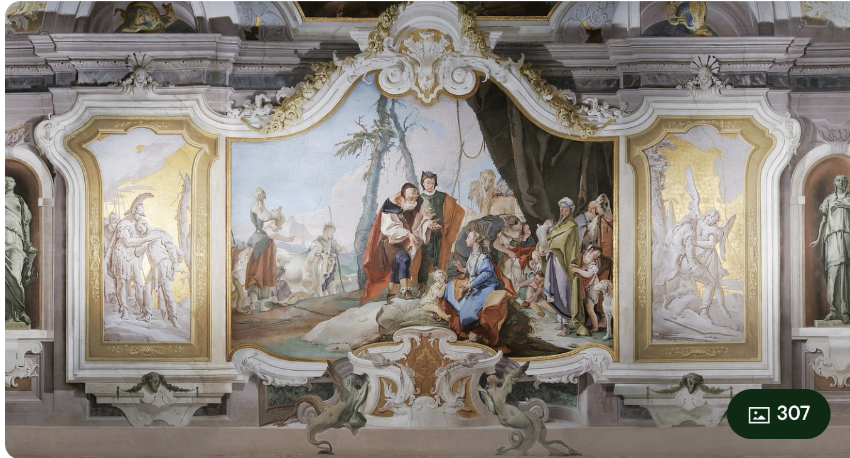
(V7_30a) View of the Galleria, Palazzo Arcivescovile
$include(figure-slice-end.in) $include(layout-c-end.in) $include(sheet.in) $include(layout-a.in)
Between the grisailles and the outlying narratives, which are in full colour, there are simulated bronze statues of female figures, apparently in deep niches, representing women prophets mentioned in the Bible; and the scheme is completed by four more of these prophetesses, all duly labelled, between the windows on the street wall.
(They were clearly painted by assistants and I cannnot show you an example; but Tiepolo’s rapid sketch for one of them gives the general idea and demonstrates his fluency as a draftsman. Notice the cast shadow even in the drawing.)
Quite how the prophetesses were meant to fit into the argument of the Gallery is not perfectly clear. They include well-known names, like Deborah and Anna, as well as two complete obscurities. But they serve to emphasise, perhaps, the important role played by the Matriarchs in the three chosen scenes from the Book of Genesis—Sarah, Rebecca, Rachel.
$include(column-break.in) $include(figure-slice-vertical.in)
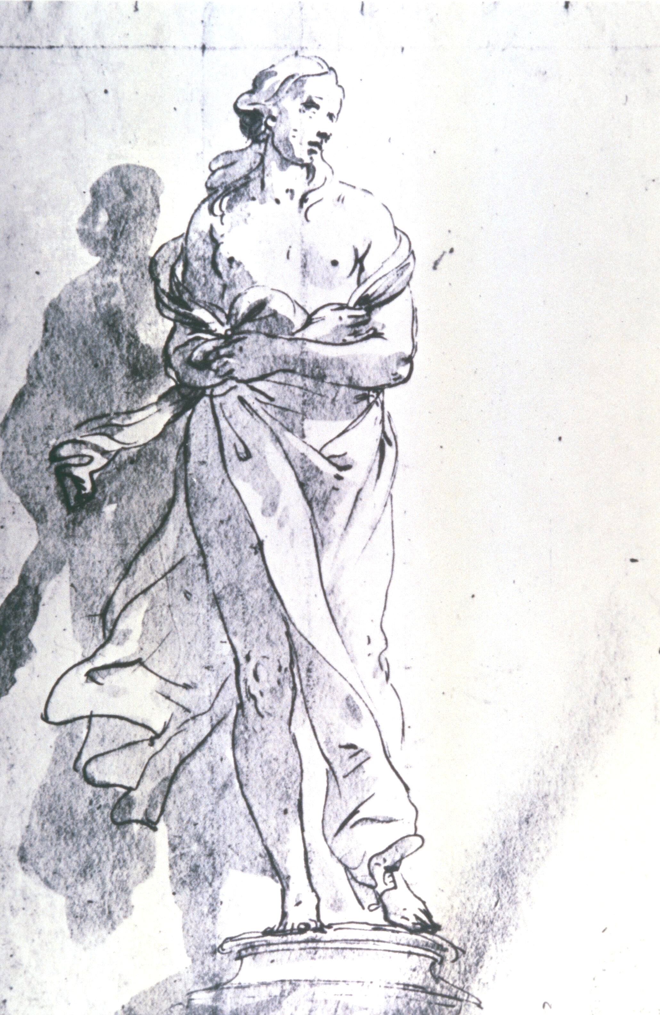
(V7_31) Tiepolo, Drawing for prophetess, Civico Museo Sartorio, Trieste
$include(figure-slice-vertical-end.in) $include(layout-a-end.in) $include(sheet.in) $include(layout-a.in)
The reasoning behind the choice of the narratives, on the other hand, is perfectly straightforward.
The Gallery was the antechamber or waiting room for those who had business with the Patriarch of Aquileia—at this period, Dionisio Dolfin—and he wanted to link his political role to the original Patriarchs—Abraham, Isaac and Jacob—showing them as assisted or guided to success in moments of trial by ‘messengers’ from heaven, angeli (άγγελος, in Greek meant no more than ‘messenger’ or ‘herald’), exactly as he, the present patriarch, hoped to receive divine aid in the defence of his prerogatives.
The only incongruity, or absurdity, is that Tiepolo and Colonna chose to treat their themes in a light-hearted way, in curvilinear frames, in bright colours, and with a good deal of innocent charm and humour.
MICHELA: PLEASE SUPPLY STANDARDISED CAPTION (I FOUND THE IMAGE BY GOOGLING ‘Dionisio Dolfin’)
$include(column-break.in) $include(figure-slice-vertical.in)
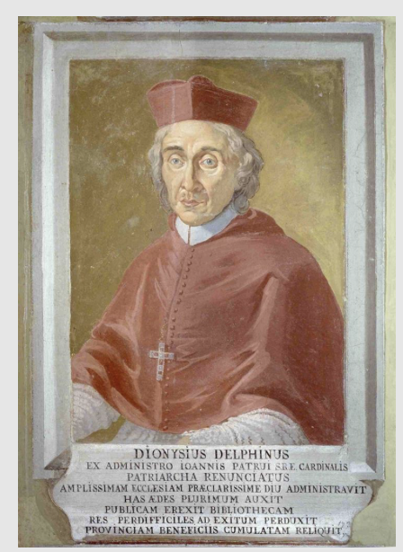
(V7_31a) Dionisio Dolfin
$include(figure-slice-vertical-end.in) $include(layout-a-end.in) $include(sheet.in) $include(layout-a.in)
The narrative sequence does not unfold simply from left to right, nor from top to bottom, because of the different sizes of the frames to be filled and the need to achieve pictorial symmetry. Hence, I will dodge about the inner wall and the ceiling, showing the frescos and reminding you about the stories in the sequence in which they occur in the Book of Genesis.
The first episode lies on the extreme right of the inner wall, and therefore happens to be the first you meet on entering the room:
It is about thirteen feet high.
The kneeling Patriarch is Abraham, now aged ninety-nine, married to Sarah, now aged ninety, in a childless marriage.
The episode is narrated in Genesis, Chapter 18; but you cannot really understand the force of the story unless you realise that the couple were first introduced at the end of Chapter 11 (when Abraham was already 75), and that the Lord has brought them out of Ur of the Chaldees, through Egypt, to a place called Mamre—not far from Sodom and Gomorah, where their nephew Lot has gone to live—promising them, time and time again, that they shall have, even at their age, a multitude of descendants who shall be ‘as numberless as the stars in the sky’, and shall dwell in the land of Canaan, which is where Abraham himself is travelling.
$include(column-break.in) $include(figure-slice-vertical.in)
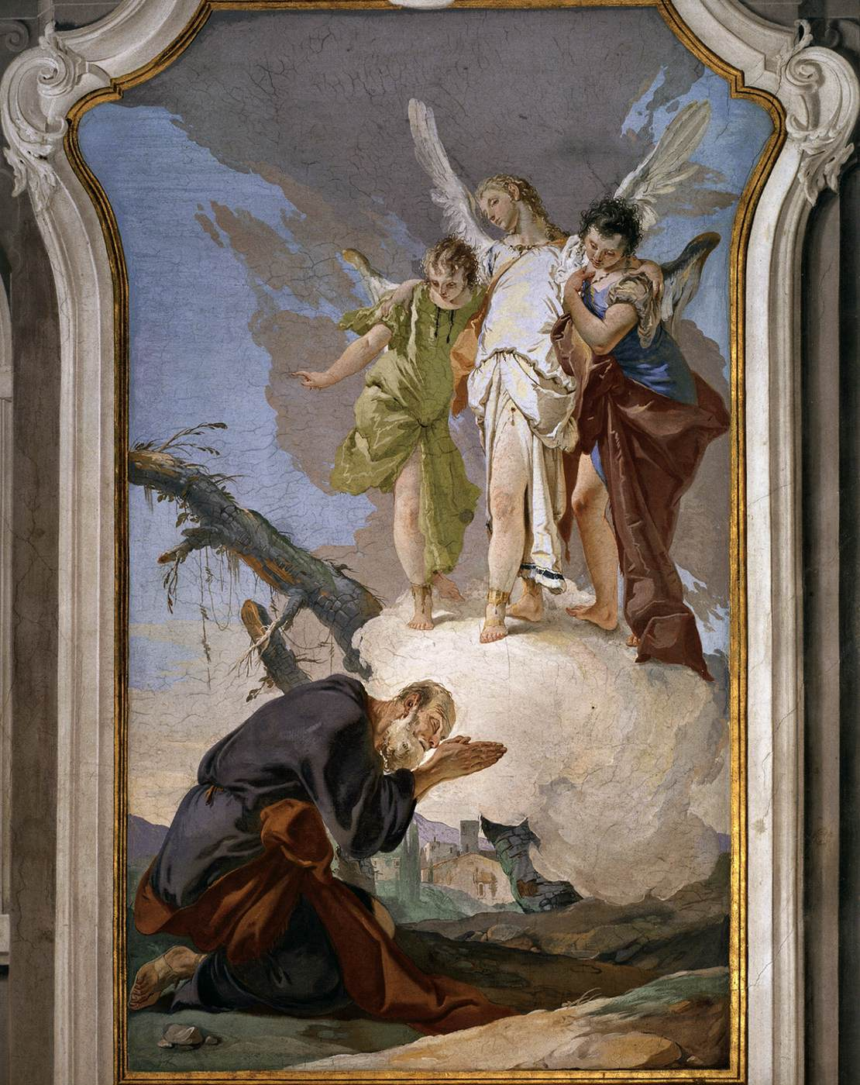
(V7_32) Tiepolo, The Three Angels Appearing to Abraham, Palazzo Arcivescovile, Udine
$include(figure-slice-vertical-end.in) $include(layout-a-end.in) $include(sheet.in) $include(layout-a.in)
Sarah was particularly sceptical about the repeated promise, hence her solution—described in Chapter 16—of persuading her husband to father a son with the Egyptian slave-girl, Hagar (which happened when Abraham was eighty-six!). And in Chapter 17, which takes place fully thirteen years later, Abraham falls on his face and laughs when the Lord tells him that his wife is about to conceive a son. This is why God insists that the boy should be called Isaac, meaning ‘he who laughs’.
We have reached Chapter 18, which begins like this: ‘The Lord appeared to Abraham by the oaks of Mamre in the heat of the day. He lifted up his eyes, and beheld three men stood in front of him’.
(There will be repeated shifts in the narrative, by the way, from one Lord to three men: and Christian theologians were to interpret the shifts as a sign that the three Persons of the Trinity had appeared to Abraham: Christian artists, however, always showed the three men as winged angels—as ‘messengers’.)
‘When [Abraham] saw them, he ran to meet them and bowed himself to the earth’. He then prevailed upon them to rest under the tree, and to take refreshment—including cakes—which were hastily baked by Sarah.
You will have noticed the tree in the fresco (although it is more like a pine than an oak, and it does not offer much shade); and you will also have registered that the buildings are suspiciously like farms in the Veneto.
Notice how old Abraham is; and how he turns his head and closes his eyes, unable to endure the radiance of the angels, while holding up his huge hands in entreaty.
$include(column-break.in) $include(figure-slice-vertical.in)
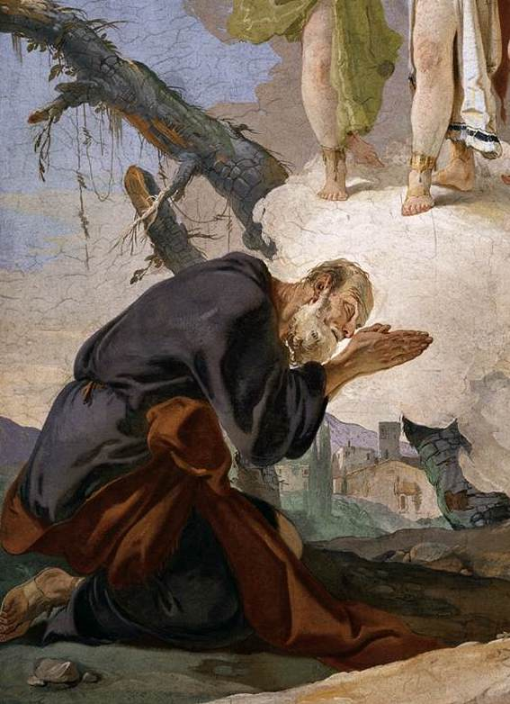
(V7_33) Detail from Tiepolo, The Three Angels Appearing to Abraham
$include(figure-slice-vertical-end.in) $include(layout-a-end.in) $include(sheet.in) $include(layout-a.in)
As for the angels—well, you must forget Rilke’s famous assertion that ‘ein jeder Engel ist schrecklich’ (‘each and every angel inspires fear), and enjoy the affectionate way the central angel is embracing his young companions, or admire the way in which their loose-fitting, theatrical costumes are caught at the waist to produce complex folds and to expose their legs (two of them having very short, bulging calves).
Enjoy the colours, too. The angels are standing on a white-pink cumulus, against a convenient, grey-bluey-pink nimbus; and the white robe and wings of the central angel contrast with the light-green and the deep blue and brown of his companions’ robes (that particular combination being, for me at least, one of Tiepolo’s trademarks).
$include(column-break.in) $include(figure-slice-vertical.in)
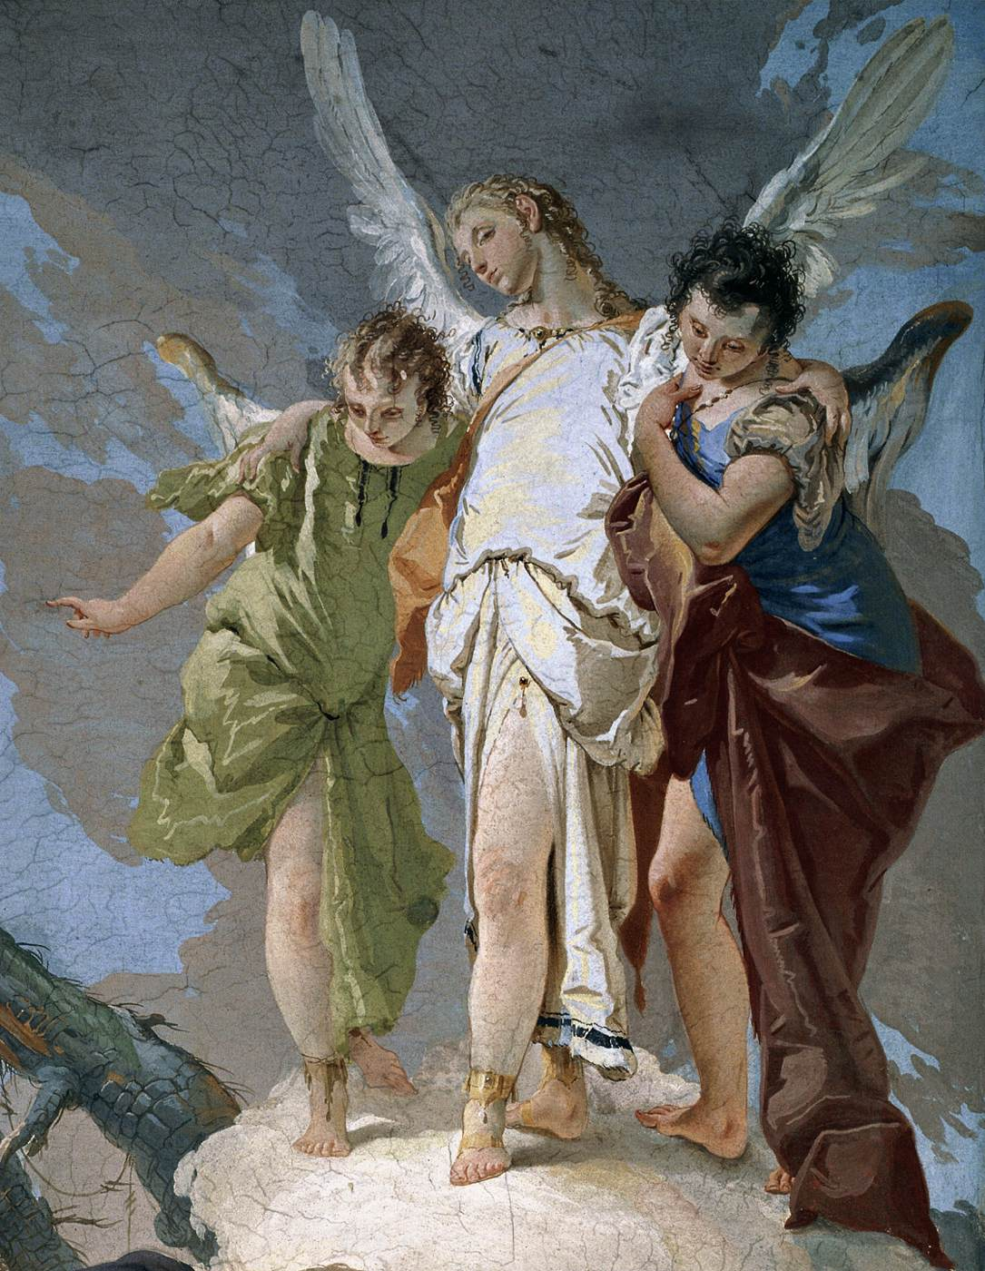
(V7_34) Detail from Tiepolo, The Three Angels Appearing to Abraham
$include(figure-slice-vertical-end.in) $include(layout-a-end.in) $include(sheet.in) $include(layout-a.in)
The Biblical story continues without a break at the far end of the gallery.
Sarah was eavesdropping, and she overheard the angels say that she should have a son in the spring, although the menopause was long behind her (or, if you prefer the more dignified words of the Bible, ‘it having ceased to be with her after the manner of women’). And ‘she laughed to herself, saying: “after we have grown old, shall I have pleasure?”’—only to deny having laughed immediately afterwards, when the Lord reproached her (at this point in the narrative, the three men have indeed become the singular Lord) with the words: “Is anything too hard for the Lord?”.
The Bible speaks of a ‘tent’, but Tiepolo gives us an improvised wooden shelter, with a nail for the shawl and for the water-bottle—the shelter being made of rough planks of pine wood (look at the knots and the grain), cut from a tree like the one which helps to support the shack.
(Do enjoy the colours here, and the fissures in the texture of the bark, and the fungus growing on it.)
$include(column-break.in) $include(figure-slice-vertical.in)
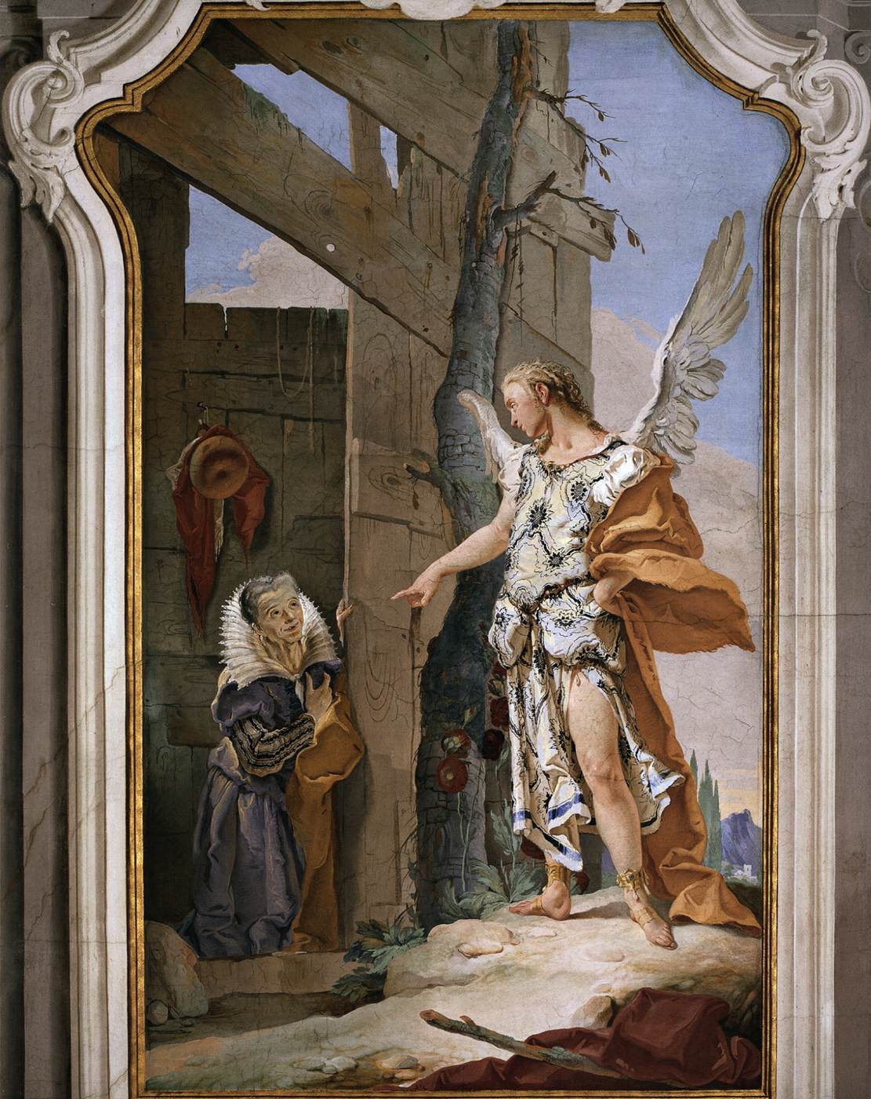
(V7_35) Tiepolo, Sarah and the Angel, Palazzo Arcivescovile, Udine
$include(figure-slice-vertical-end.in) $include(layout-a-end.in) $include(sheet.in) $include(layout-a.in)
In this image, then, the three angels have become one Lord; and the angel is clearly the central one of the first three, having the same set of his head on the long neck, the same wing feathers, and the same rather shapely thigh, even though he has rapidly changed costume and is now wearing an ochre robe, cast negligently over a beautiful, brocaded tunic with a blue hem.
$include(column-break.in) $include(figure-slice-vertical.in)
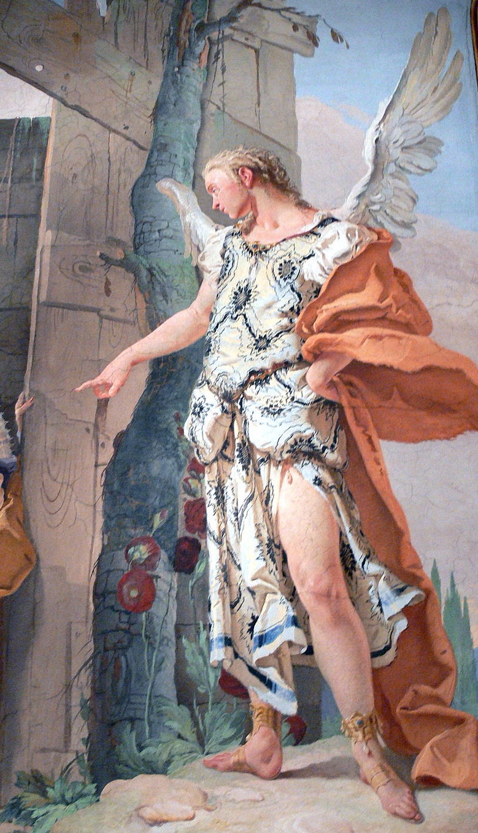
(V7_36) Detail from Tiepolo, Sarah and the Angel
$include(figure-slice-vertical-end.in) $include(layout-a-end.in) $include(sheet.in) $include(layout-a.in)
Sarah kneels like the Virgin Mary in the presence of Gabriel (the composition being very like one of Tiepolo’s drawings for an Annunciation in reverse), but she is treated with that realism, humour and hint of caricature which we are coming to expect.
Her wide-eyed expression is somewhere between laughing and denying she had laughed.
She is wrinkled, scrawny necked, and she has just two teeth; but she still lacquers her long fingernails and is dressed like a ‘grande dame’. Take in the striped sleeves of her chemise, the blue of her dress (highlighted in yellow), the ochre of her robe, and the superb whale-boned collar.
(There is a delightful double anachronism in her costume, which is neither vaguely biblical, nor eighteenth-century, but copied from sixteenth-century fashions in the paintings of Paolo Veronese).
$include(column-break.in) $include(figure-slice-vertical.in)
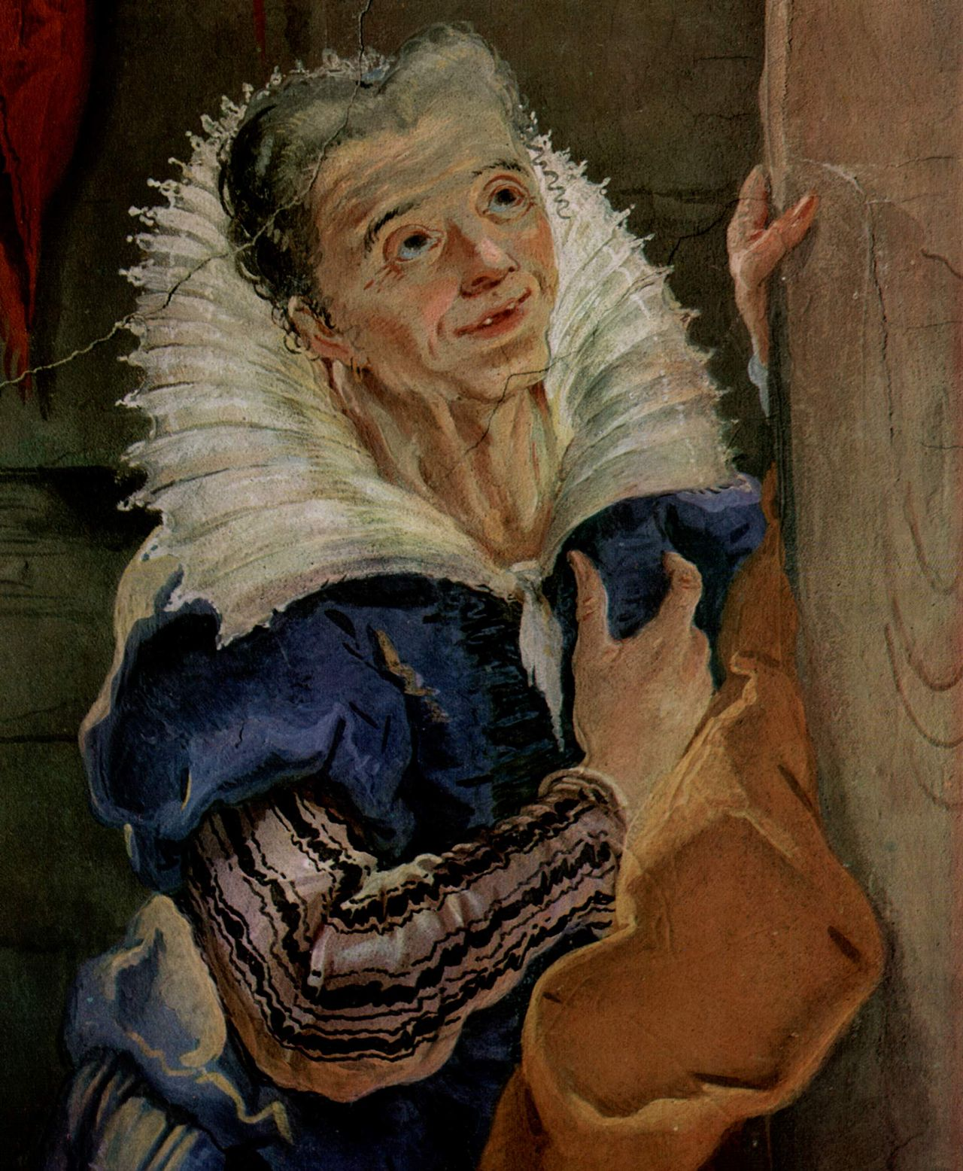
(V7_37) Detail from Tiepolo, Sarah and the Angel
$include(figure-slice-vertical-end.in) $include(layout-a-end.in) $include(sheet.in) $include(layout-a.in)
Chapters 19 and 20 of Genesis deal with Sodom and Gomorrah and with Sarah’s abduction by Abimelech. Then, in Chapter 21, Isaac, ‘he who laughs’, is born to the parents, who had each laughed at the idea of their having children at their advanced age.
No sooner is Isaac weaned, however, than Sarah grows jealous of Hagar and her son Ishmael; and (as noted earlier) she insists that Abraham ‘cast them both out into the Wilderness of Beersheba, with bread and a skin of water’.
Mercifully, the Lord was a good deal more merciful than Sarah—as we discover in the next scene, which is up on the ceiling, near the door, again in an elaborate oval moulding.
$include(column-break.in) $include(figure-slice-vertical.in)
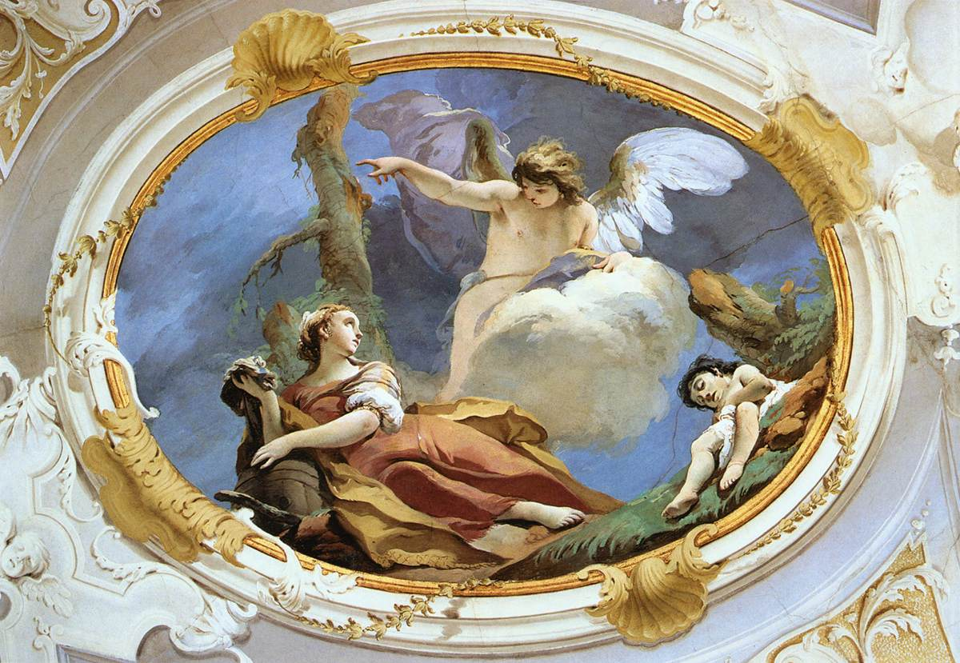
(V7_38) Tiepolo, Hagar and Ishmael in the Wilderness, Palazzo Arcivescovile, Udine
$include(figure-slice-vertical-end.in) $include(layout-a-end.in) $include(sheet.in) $include(layout-c.in) $include(two-column-text.in)
Here we discover Hagar at the foot of yet another pine, clutching a barrel (instead of the skin, from which ‘all the water had now gone’ (21. 15.)
In accordance with the text of Genesis, she is represented as ‘a good way off’ from the exhausted Ishmael, whom she has ‘cast off under a bush’ (or a pine-stump), saying: “Let me not look at the death of the child”’.
But the Lord hears the voice of the boy crying, ‘and the angel of God called to Hagar from Heaven, saying: “Fear not, arise, lift the lad, hold him fast with your hand, for I shall make him a great nation”. Then God opened her eyes, and she saw a well, and she filled the skin with water’.
(You can mentally supply the happy ending to the story, if you imagine the barrel to be full.)
$include(two-column-text-end.in) $include(figure-slice.in)
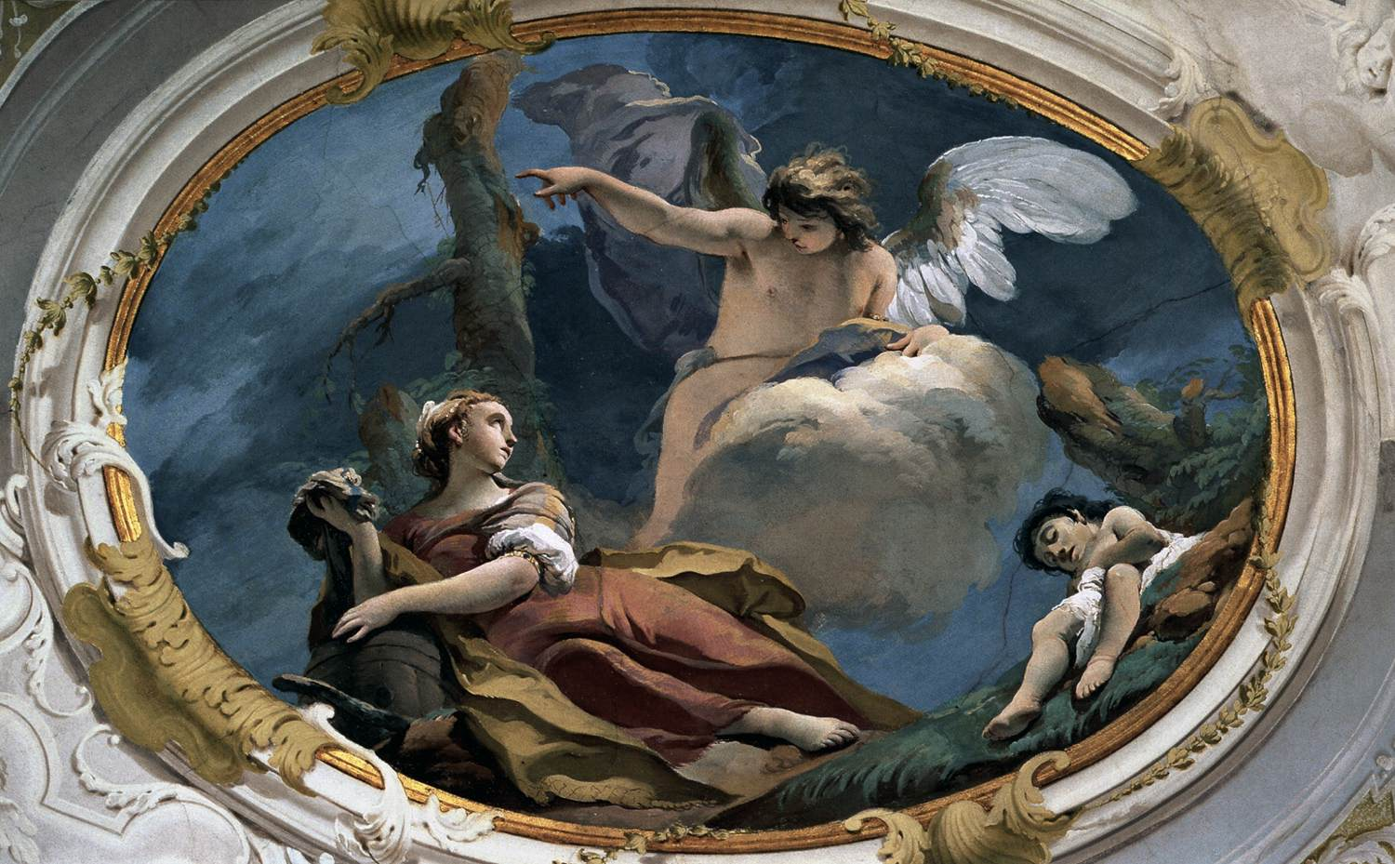
(V7_38a) Tiepolo, Hagar and Ishmael in the Wilderness, Palazzo Arcivescovile, Udine
$include(figure-slice-end.in) $include(layout-c-end.in) $include(sheet.in) $include(layout-c.in) $include(two-column-text.in)
Before we move to the next chapter in Genesis and the next fresco, please take time to enjoy the painted surface. In particular, I would like you to focus on the way in which the angel’s calf and foot seem to ‘melt’ into the white cloud; or how his right wing has ‘merged’ into the cloak, while his hair dissolves into his left wing—for this will give me the chance to quote some lines from Alexander Pope’s Rape of the Lock, which seem to me to be describing an archetypical Tiepolo ceiling, even though the poem was written back in the year 1714.
The essence of Tiepolo’s art is captured in these twelve lines (and phrase after phrase seems to be inspired by close attention to characteristic pictorial details).
He summons straight his Denizens of air;
The lucid squadrons round the sails repair;
…
Some to the sun their insect-wings unfold,
Waft on the breeze, or sink in clouds of gold:
Transparent forms, too fine for mortal sight,
Their fluid bodies half dissolv’d in light.
Loose to the wind their airy garments flew,
Thin glitt’ring textures of the filmy dew,
Dipt in the richest tincture of the skies,
Where light disports in ever-mingling dyes;
While ev’ry beam new transient colours flings,
Colours that change whene’er they wave their wings.
$include(two-column-text-end.in) $include(figure-slice.in)
(V7_38a_bis) Tiepolo, Hagar and Ishmael in the Wilderness, Palazzo Arcivescovile, Udine
$include(figure-slice-end.in) $include(layout-c-end.in) $include(sheet.in) $include(layout-c.in) $include(two-column-text.in)
We move along now to the central fresco on the ceiling, rejoicing, again, in the curves of the moulding.
It is bigger than the other ceiling frescos (thirteen feet by sixteen and a half), and it represents the single most important episode in the relationship between the patriarch and the son of his old age, when the Lord puts Abraham ‘to the test’, saying (Genesis 22. 11): ‘Take your son, your only son Isaac, whom you love, and offer him as a burnt sacrifice’.
As almost always in Christian art, we are shown the climactic moment in the story, when Isaac is already ‘bound on the altar, upon the wood’; and, as so often, Tiepolo suggests that the wood is laid to form a cross, because the episode was interpreted as a prefiguration of the Crucifixion.
$include(two-column-text-end.in) $include(figure-slice-vertical.in)
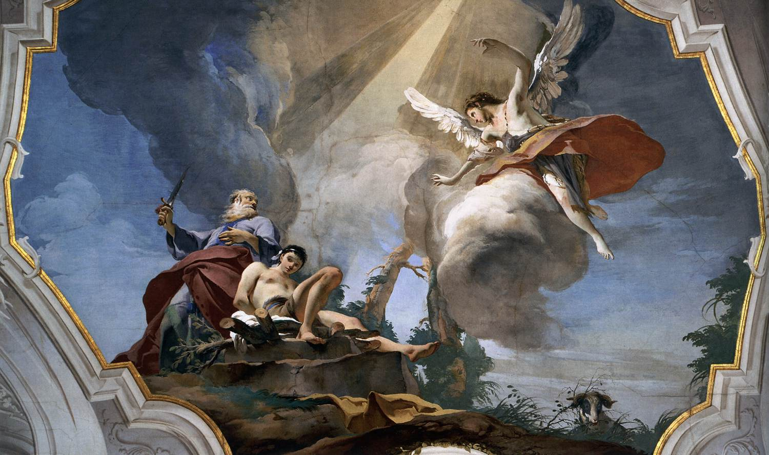
(V7_40) Tiepolo, The Sacrifice of Isaac, Palazzo Arcivescovile, Udine
$include(figure-slice-vertical-end.in) $include(layout-c-end.in) $include(sheet.in) $include(layout-c.in) $include(two-column-text.in)
You will remember that Abraham had ‘put forth his hand, and taken the knife to slay his son’, but ‘the Angel of the Lord called to him from Heaven, commanding him: “Do not lay your hand upon the lad, for now I know you fear God, seeing you have not withheld your son, your only son, from me”’.
You will remember, too, that Abraham catches sight of a ram, ‘caught in a thicket by his horns’, and offers the ram instead.
So, there is faithfulness to the narrative (the irruption of the angel, the raised knife, the altar, the wood, Isaac and the ram are all there) and a glorious feat of composition, exploiting the extraordinary curves of the surround. Nothing remotely tragic, admittedly (this is not Rembrandt in the seventeenth century), but another opportunity to relish the eighteenth-century aesthetic of Alexander Pope in Tiepolo’s vision of a ‘denizen of air’, ‘wafting on the breeze’, with ‘airy garments’ flying ‘loose to the wind’, and ‘light…disporting in ever mingling dyes’.
$include(two-column-text-end.in) $include(figure-slice-vertical.in)
(V7_40_bis) Tiepolo, The Sacrifice of Isaac, Palazzo Arcivescovile, Udine
$include(figure-slice-vertical-end.in) $include(layout-c-end.in) $include(sheet.in) $include(layout-b.in) $include(text-with-image.in)
At this point, I must remind you of the shape of the Gallery with this long shot, which will guide your eye along the length of the ceiling to the point nearest the entry door, for it is there we shall find the first of four episodes dealing with Isaac’s son, Jacob, the younger of the twins, who had fought with his elder twin Esau (the ‘hunter’ and ‘hairy man’) even while he was in the womb (this story is told in Genesis, Chapter 25).
$include(text-with-image-end-text.in)
(V7_30_bis) View of the Galleria, Palazzo Arcivescovile
$include(text-with-image-end.in) $include(column-break.in) $include(figure-slice-vertical.in)
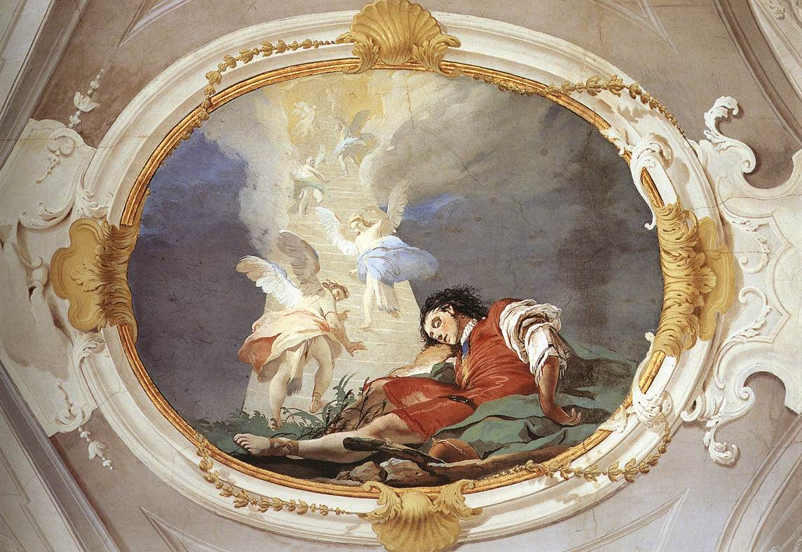
(V7_41) Tiepolo, Jacob’s Dream
$include(figure-slice-vertical-end.in) $include(layout-b-end.in) $include(sheet.in) $include(layout-c.in) $include(two-column-text.in)
Tiepolo was not required to paint the scandalous story of how Jacob persuaded Esau to sell his birthright and cheated him of his father’s blessing; but he takes up the narrative immediately afterwards when Jacob has set off on a journey to his uncle, Laban (notice the staff and his water-bottle in the foreground), with a view to marrying one of his cousins.
‘He came to a certain place, and he stayed there that night because the sun had set. Taking out one of the stones, he put it under his head, and he laid down in that place to sleep.
And he dreamt that there was a ladder set upon the earth, and the top of it reached to Heaven, and, behold, the angels of God were ascending and descending on it’. (Genesis 28, 10–12).
At this point the Lord appeared and renewed the promises made to his father and grandfather—Abraham and Isaac—about the number and the glory of his descendants.
Here, I need only remind you that you are looking at a ceiling painting, and that the ladder really does seem to climb up and up—and that the relevant lines from The Rape of the Lock are even more pertinent…
‘Transparent forms, too fine for mortal sight,
Their fluid bodies half dissolv’d in light.
…
Thin glitt’ring textures of the filmy dew,
Dipt in the richest tincture of the skies’.
$include(two-column-text-end.in) $include(figure-slice-vertical.in)
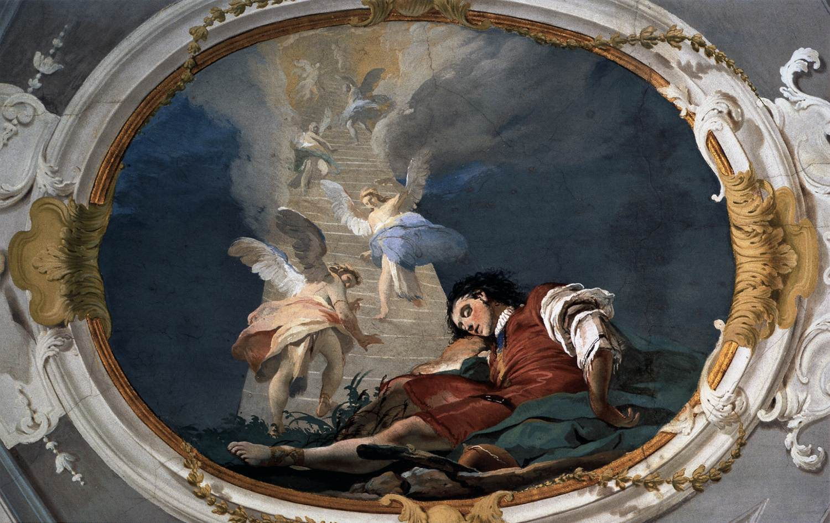
(V7_41a) Tiepolo, Jacob’s Dream
$include(figure-slice-vertical-end.in) $include(layout-c-end.in) $include(sheet.in) $include(layout-a.in)
Laban was a pretty tough customer—uncle or no uncle—and he made Jacob serve for a total of fourteen years before he let him marry the cousin he loved, Rachel, having first fobbed him off with the ‘rheumy-eyed’ elder sister, Leah.
So perhaps Laban got no more than his due in the next scene which occupies the place of honour in the centre of the wall of the Gallery.
(As you can see, it has the same dimensions as the Sacrifice of Isaac, immediately above.)
$include(column-break.in) $include(figure-slice-vertical.in)
(V7_42) Tiepolo, Rachel Hiding the Idols from Her Father Laban in context, Palazzo Arcivescovile, Udine
$include(figure-slice-vertical-end.in) $include(layout-a-end.in) $include(sheet.in) $include(layout-a.in)
The story is told in Genesis, Chapter 31.
Having eventually married both sisters, Jacob struck a bargain with his father-in-law by which he would become the owner of any sheep and goats to be born with a speckled fleece.
This bargain has made him ‘exceedingly rich’ (30. 43), because, thanks to a little sympathetic magic (as the anthropologists call it), and thanks to the help of the Lord, all the lambs and kids were born ‘striped, spotted and mottled’.
That summer, Jacob waited for Laban to depart for sheep-shearing, then he ‘arose, and set his sons and his wives on camels; and he drove away all his cattle, and all his livestock which he had gained, to go to the land of Canaan to his father Isaac’ (31.17).
Laban did not discover their flight for three whole days, and he then took a week to catch them up (this happened immediately before the episode shown here).
$include(column-break.in) $include(figure-slice-vertical.in)
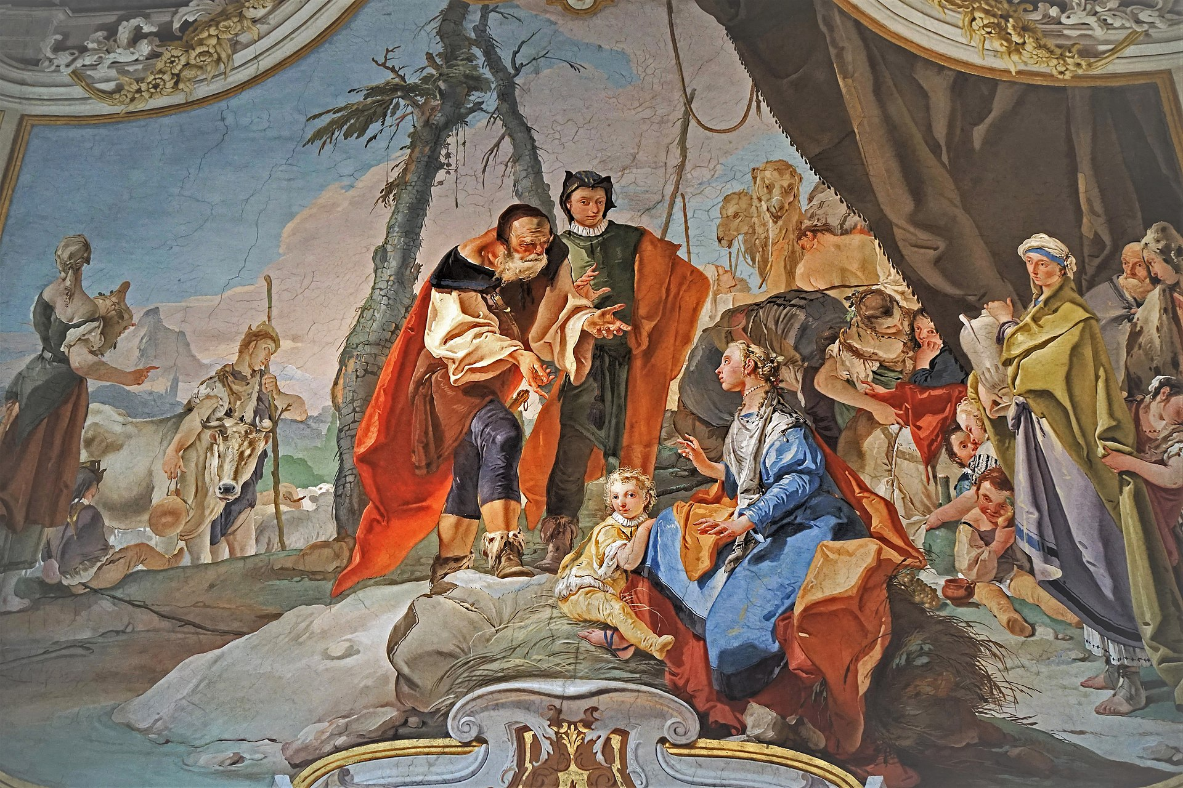
(V7_43) Tiepolo, Rachel Hiding the Idols from Her Father Laban, Palazzo Arcivescovile, Udine
$include(figure-slice-vertical-end.in) $include(layout-a-end.in) $include(sheet.in) $include(layout-a.in)
Before I remind you of what father is saying to his daughter, let us take note of the characters and the setting.
The sky and the clouds in the background could not be simpler. (Teasingly, they allow a hazy glimpse of the Alps as seen from Udine, with a campanile in the foot-hills.)
In the centre, there are two pines, which is Tiepolo’s way of reminding you that, like the earlier parts of the story, this episode takes place in the desert. The setting is emphasised— to the right of centre— by the presence of two camels (or their heads) with two attendants.
On the left, you can see a suggestion of sheep and goats, and a cow which is being escorted by an affectionate and rather dreamy cow-herd, who is carrying his indispensable staff and water-bottle, while a tall maid-servant, carrying an even bigger water-jar, turns her shapely back towards us and gestures to unseen followers, off-stage.
$include(column-break.in) $include(figure-slice-vertical.in)
(V7_43_bis) Tiepolo, Rachel Hiding the Idols from Her Father Laban, Palazzo Arcivescovile, Udine
$include(figure-slice-vertical-end.in) $include(layout-a-end.in) $include(sheet.in) $include(layout-a.in)
On the right, the vast flap of a tent forms a backdrop for the elder sister and first wife, Leah; she too has an amphora, and pyjama trousers underneath her ‘slatey’ dress.
Leah is surrounded by some of the seven children that she has already born to Jacob—one drying his eyes on her dress, and another clinging to her skirts (although he or she is really rather big to be frightened of such a soft-mouthed retriever), while a much older girl comforts a rather glum-looking Reuben.
$include(column-break.in) $include(figure-slice-vertical.in)
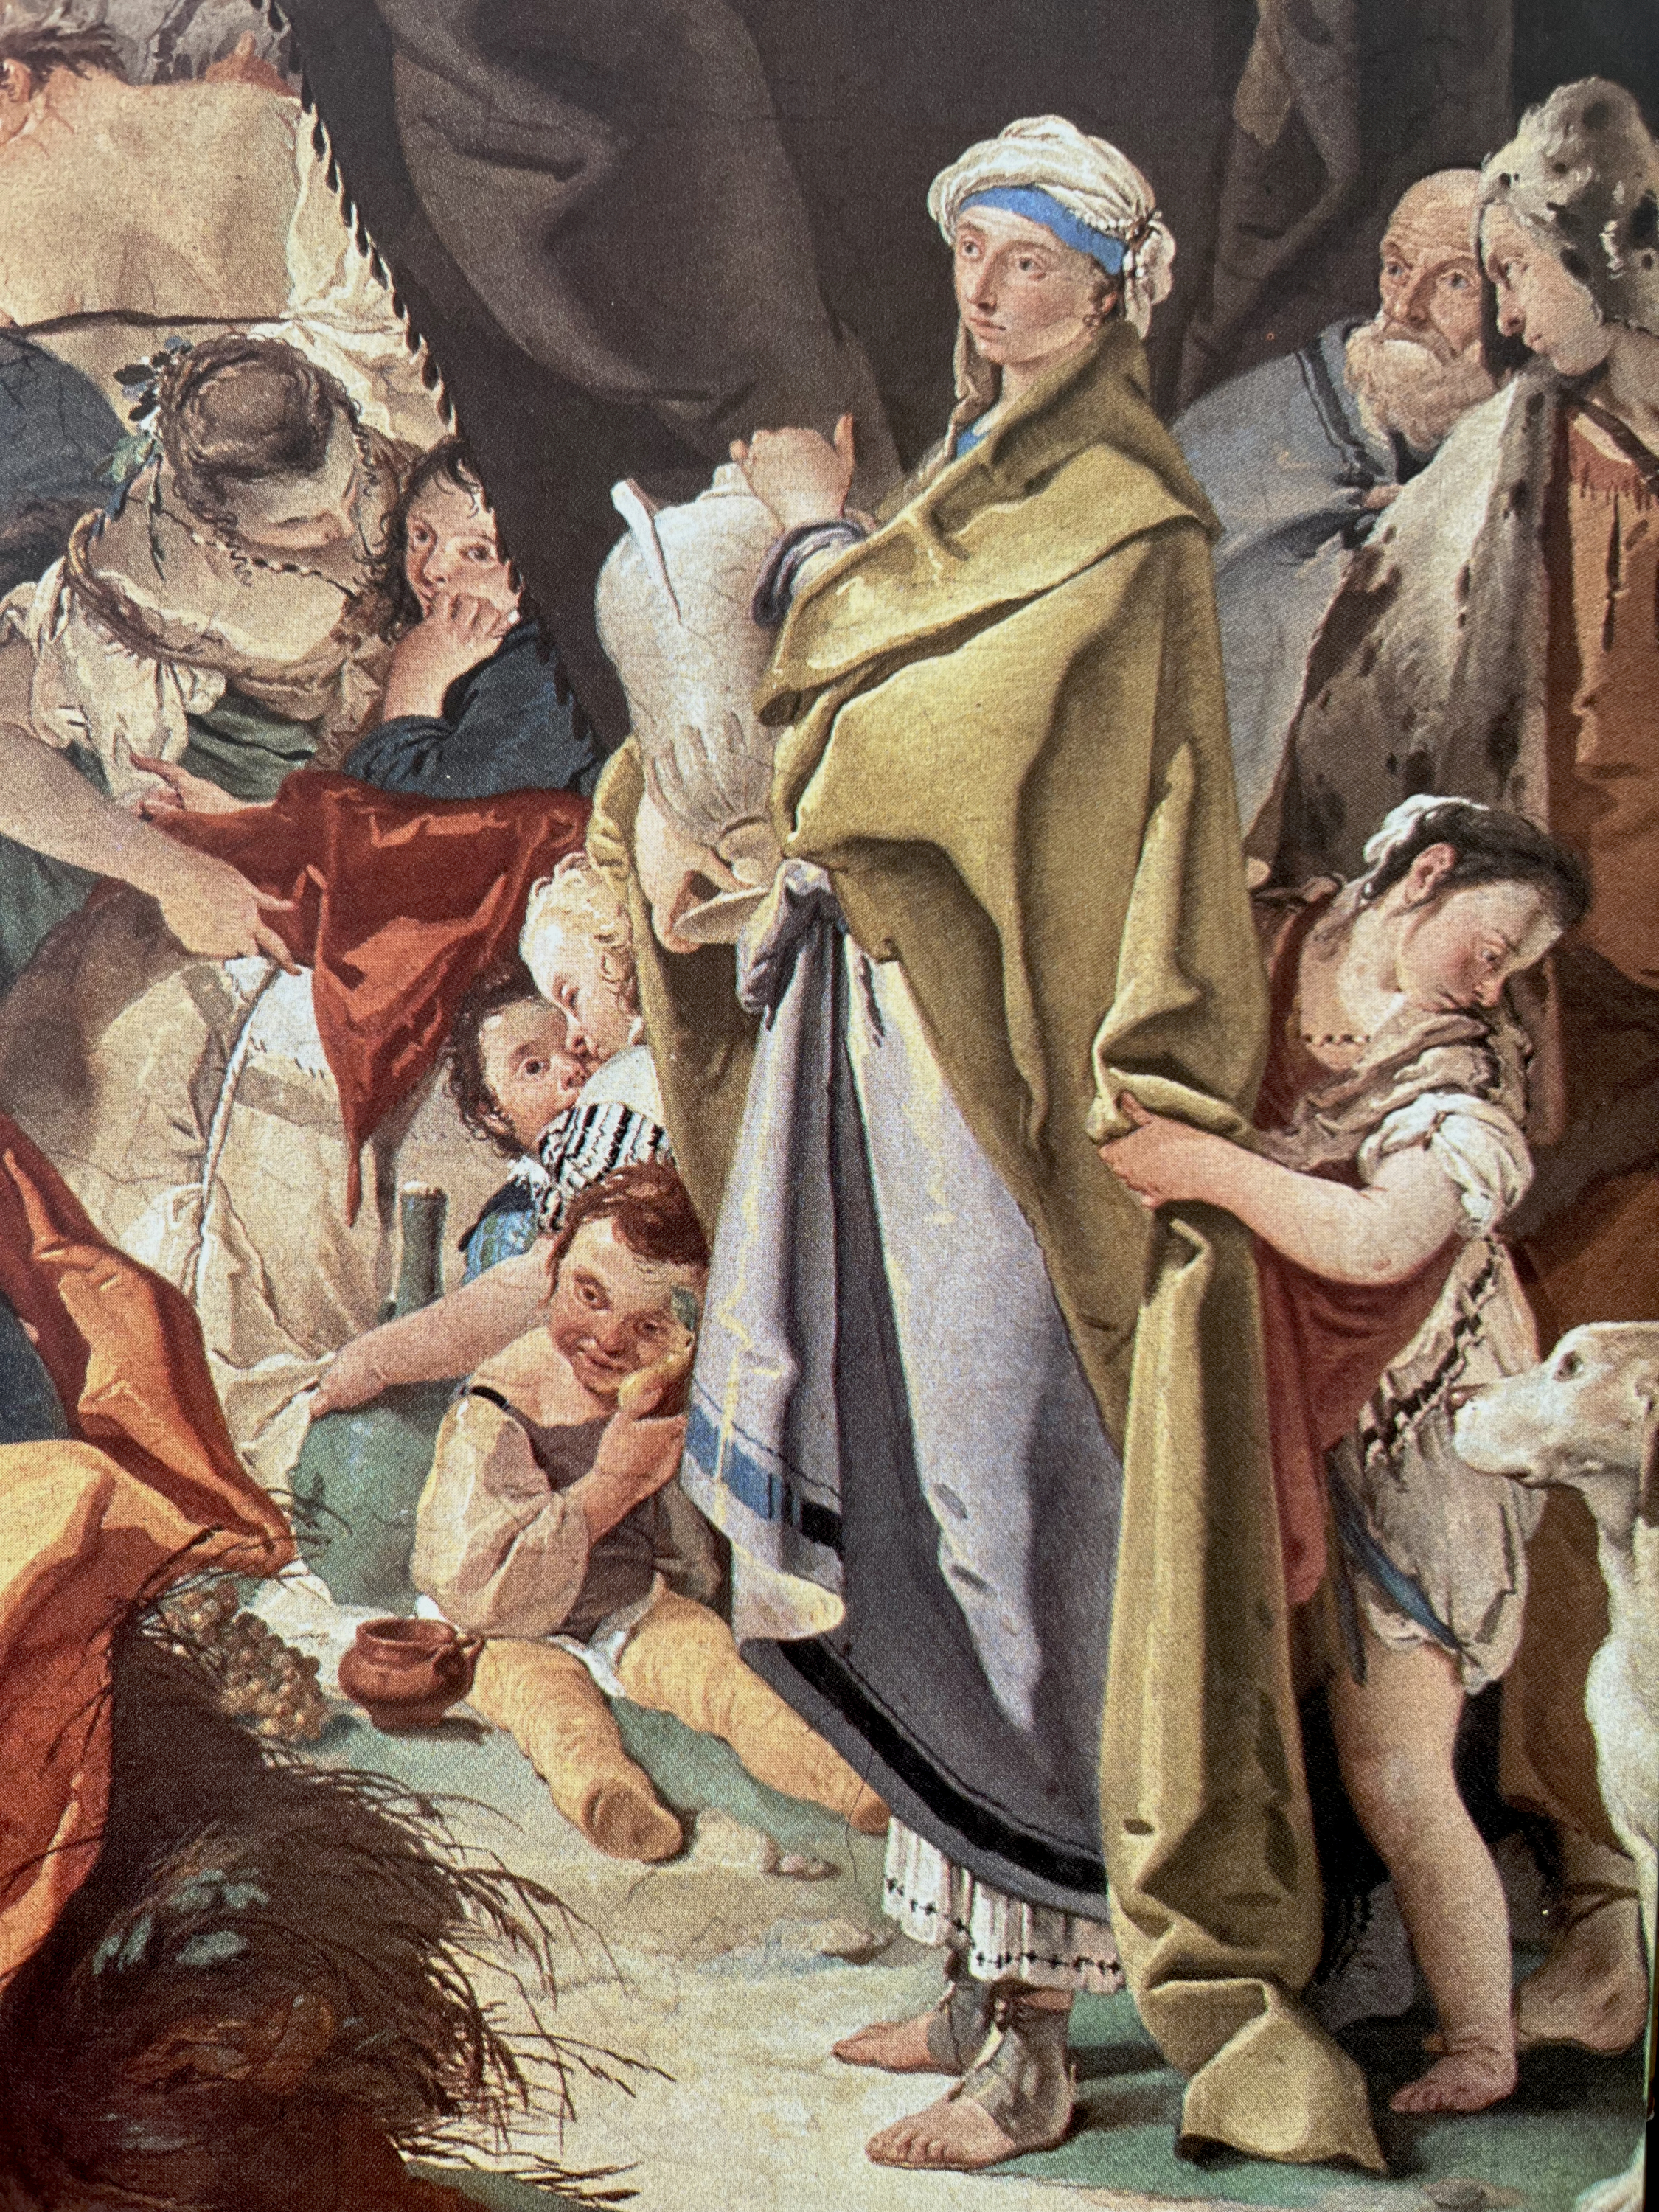
(V7_44) Detail from Tiepolo, Rachel Hiding the Idols from Her Father Laban
$include(figure-slice-vertical-end.in) $include(layout-a-end.in) $include(sheet.in) $include(layout-a.in)
The three characters in the centre are Laban, every inch the patriarch, leaning forward, with puckered brow; Jacob, looking rather ‘sheepish’; and Rachel, with her first-born at her knee.
We must go back to Genesis to discover the precise cause of the confrontation.
Laban is not only the insulted father, reproaching his daughter and son-in-law for having run away; he is the injured father, who has discovered that his household gods have been stolen. (These are called idola, ‘idols’, in the Latin Bible; and we must think of them as sacred figurines, easily transportable by a nomadic community).
We have in fact been told that it was Rachel who stole these household gods, without saying anything about the theft to her husband.
He, Jacob, a picture of righteous innocence, has invited his father-in-law to search all his possessions. Laban, having found nothing in Leah’s tent, comes to Rachel’s…
We pick the story up at Chapter 31, verse 34.
‘Now Rachel had taken the household gods and put them in the camel’s saddle, and sat upon them. Laban felt all about the tent, but did not find them. And she said to her father: “Let not my Lord be angry that I cannot rise before you, for the way of women is upon me”’.
And so, the theft was not discovered.
$include(column-break.in) $include(figure-slice-vertical.in)
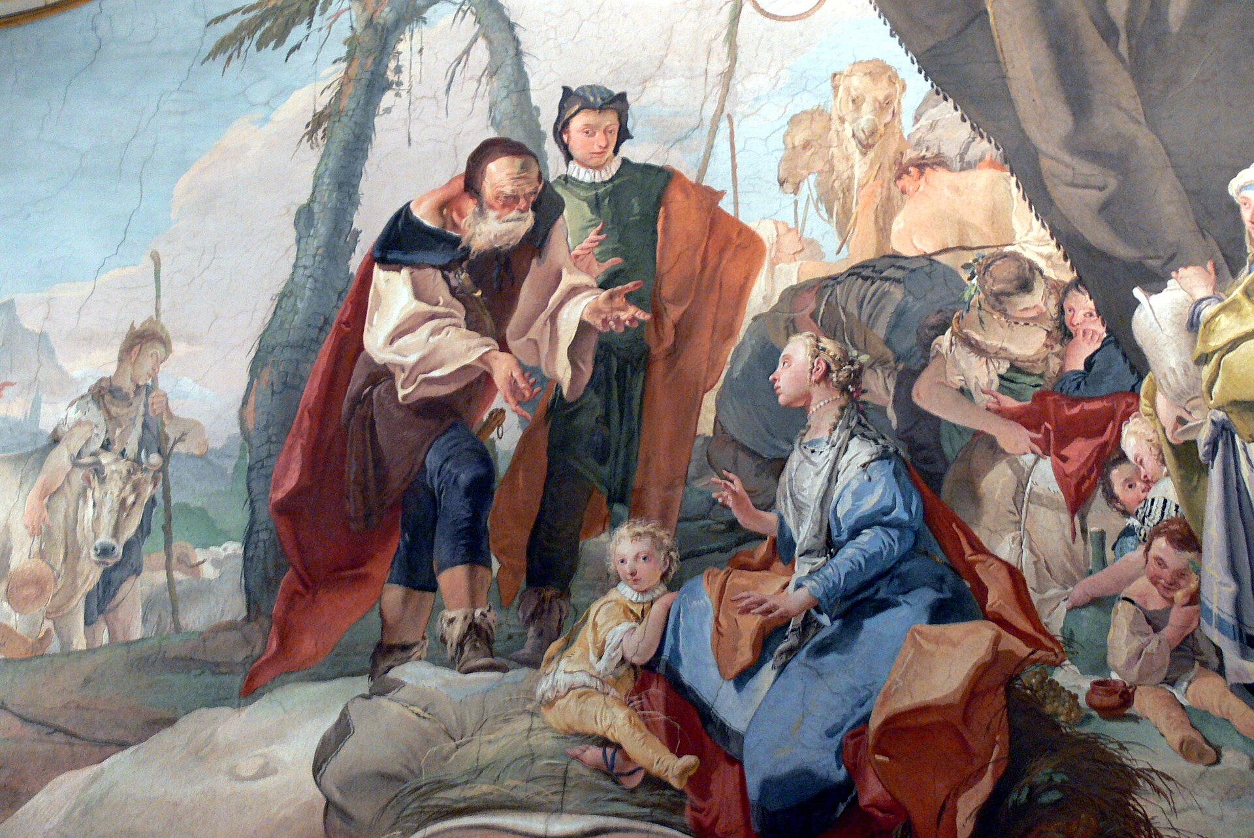
(V7_45) Detail from Tiepolo, Rachel Hiding the Idols from Her Father Laban
$include(figure-slice-vertical-end.in) $include(layout-a-end.in) $include(sheet.in) $include(layout-b.in) $include(text-with-image.in)
The episode ends with the kind of uneasy settlement that follows a major family row.
Jacob will return to Canaan after being warily reconciled with his twin-brother Esau (this is the scene, represented in simulated bas-relief—grisaille on a gold ground—to the left of centre on the same wall), and after wrestling all night with an angel (which is the subject of the parallel scene to the right).
$include(text-with-image-end-text.in)
(V7_30a_bis) View of the Galleria, Palazzo Arcivescovile
$include(text-with-image-end.in) $include(column-break.in) $include(figure-slice-vertical.in)
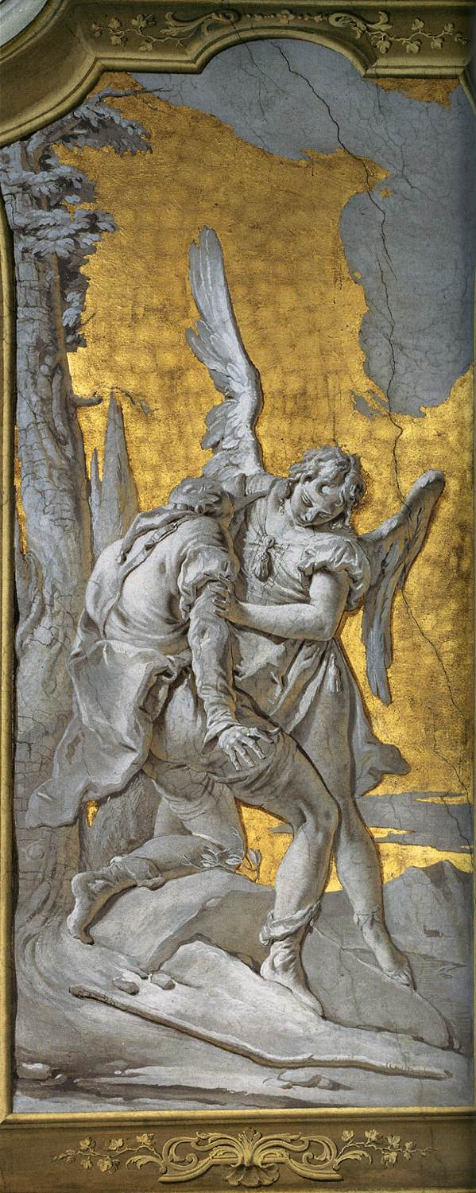
(V7_46) Tiepolo, Jacob Wrestling with the Angel, Palazzo Arcivescovile, Udine
$include(figure-slice-vertical-end.in) $include(layout-b-end.in) $include(sheet.in) $include(layout-a.in)
I think we ought to end our visit, though, with a closer look at the principal actors in the central scene.
So, look at Laban’s expressive hands, emerging from the loose sleeves of his chemise under the brown doublet, with its shoulder-strap to support the sword; or at his sunburnt neck, and puckered brow, beneath the close-fitting skullcap above the flowing beard.
Look closely too at Jacob’s puzzlement—but dawning understanding. And if you focus on the pop-eyes staring out at us, and at the large shiny nose, you may be reminded of the painter Apelles in Alexander and Campaspe, and accept that this too is intended as a self-portrait of Tiepolo at the age f (he having married very early after overcoming much resistance from his future father-in-law…).
$include(column-break.in) $include(figure-slice-vertical.in)
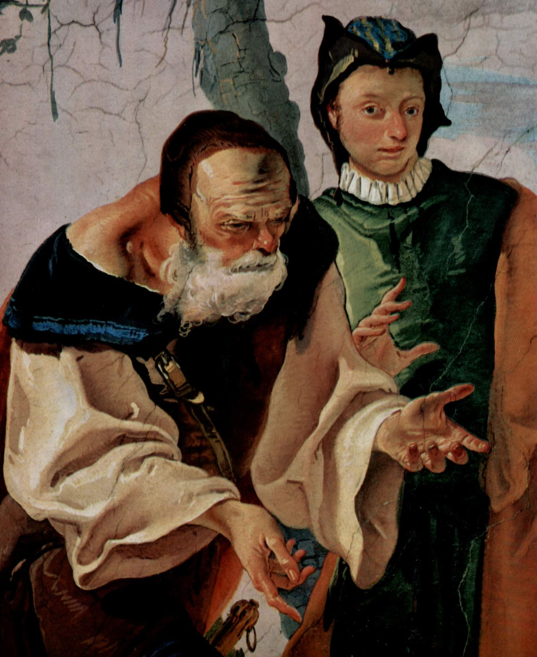
(V7_47) Detail from Tiepolo, Rachel Hiding the Idols from Her Father Laban
$include(figure-slice-vertical-end.in) $include(layout-a-end.in) $include(sheet.in) $include(layout-a.in)
If indeed this is a self-portrait, it would seem intrinsically likely that Rachel is a portrait of Tiepolo’s young wife, Cecilia, sister of the painter Francesco Guardi.
She is a Venetian beauty, blonde and blue-eyed, wearing the most ravishingly painted blue dress, with pearls in her ears, and pearls about her neck and in her hair. (Her son, incidentally, has his father’s nose and rather knowing expression.)
$include(column-break.in) $include(figure-slice-vertical.in)
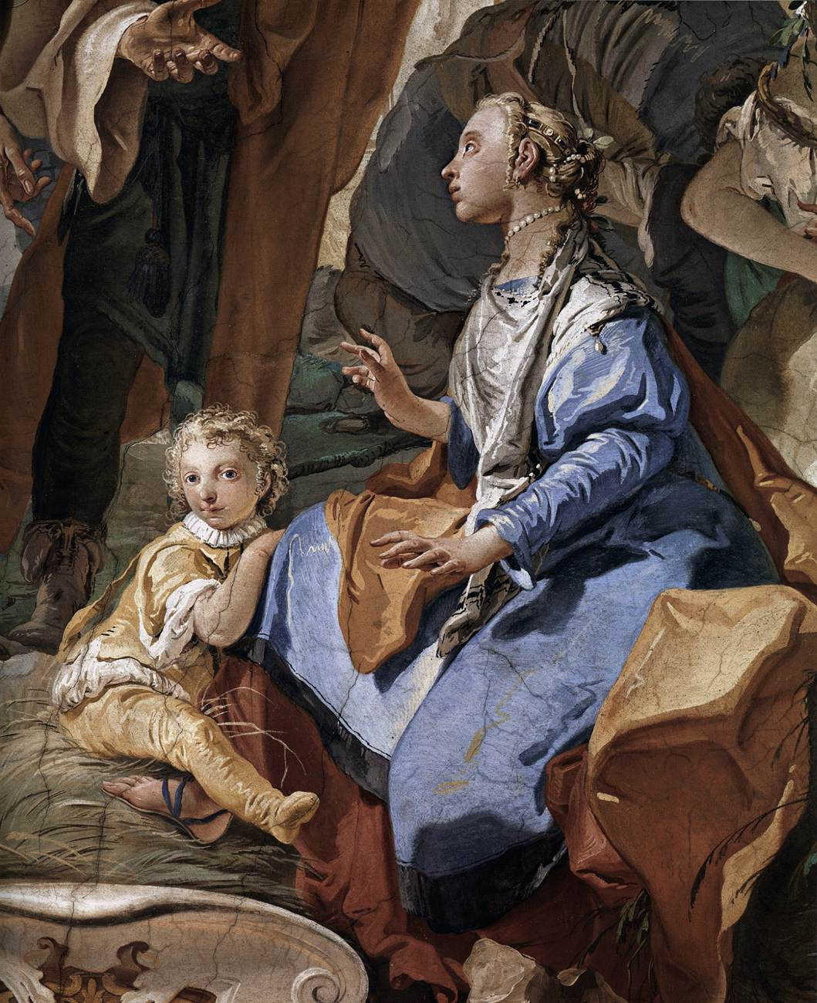
(V7_48) Detail from Tiepolo, Rachel Hiding the Idols from Her Father Laban
$include(figure-slice-vertical-end.in) $include(layout-a-end.in) $include(sheet.in) $include(layout-b.in)
Rachel is in a sense prophetic, because if the two men make us think of the earlier Tiepolo, she points forward to his later masterpieces—to a whole series of gorgeously dressed princesses and queens from the mythical Orient, each of them as self-possessed and as calculating as Rachel, who always seem to bring out the very best in Tiepolo.
He painted Tasso’s enchantress, Armida, many times, but perhaps never more seductively than in the version you see here.
He kept returning also to the story of Anthony and Cleopatra, as in this swiftly painted modello for a fresco.
$include(column-break.in) $include(figure-slice-vertical.in)
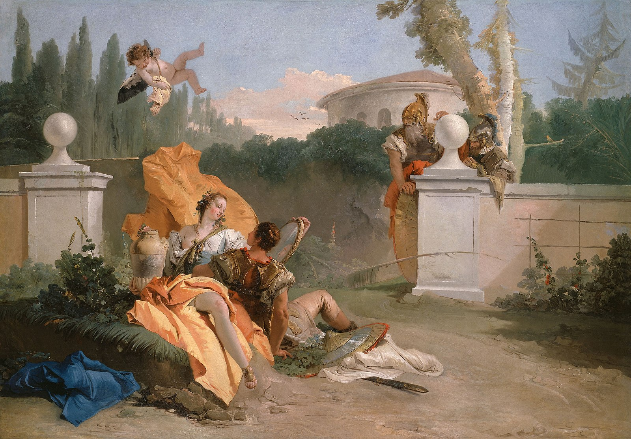
(V7_49) Tiepolo, Rinaldo and Armida in her Garden, The Art Institute of Chicago
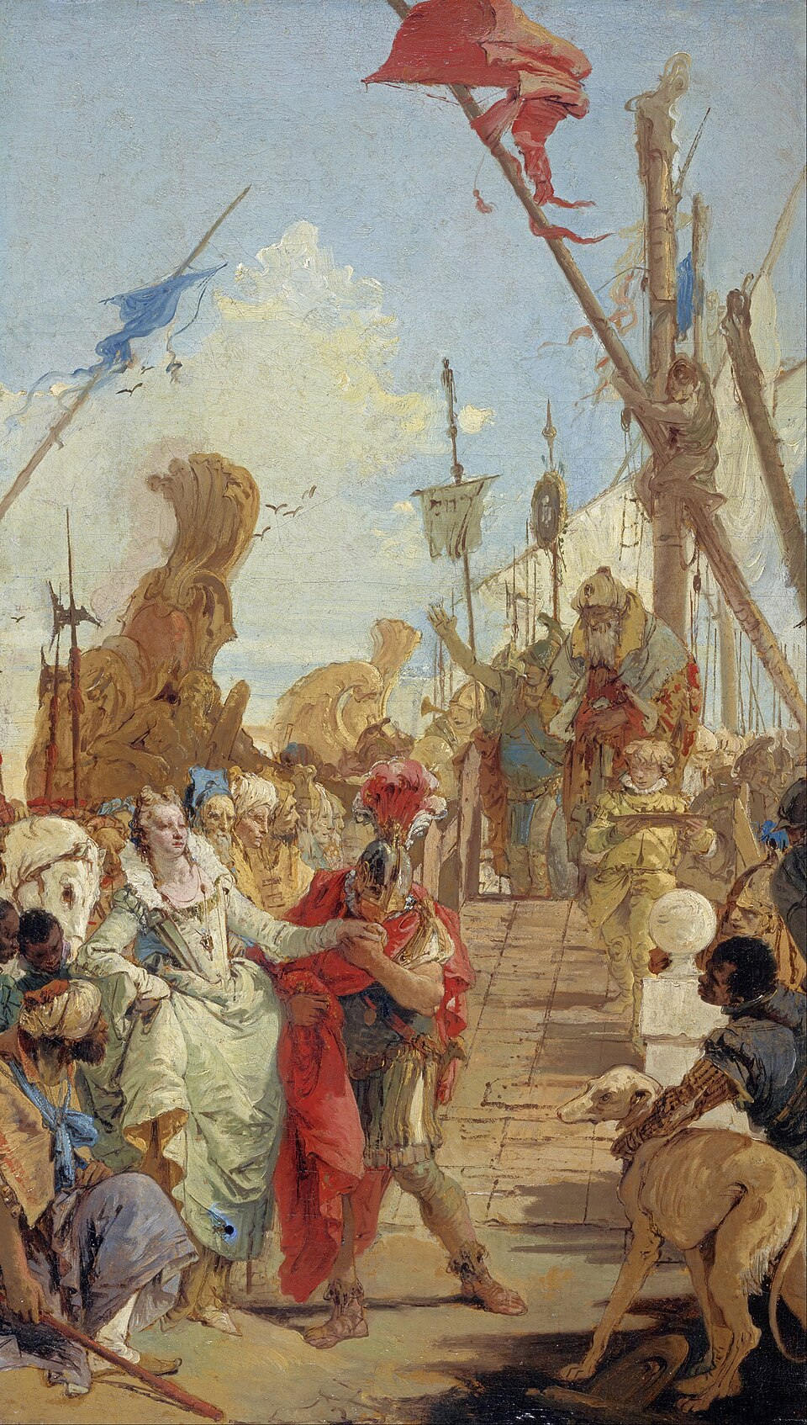
(V7_50) Tiepolo, The Meeting of Anthony and Cleopatra, National Gallery of Scotland
$include(figure-slice-vertical-end.in) $include(layout-b-end.in) $include(sheet.in) $include(layout-a.in)
He surpassed himself in this vein with Pharoah’s ‘lovely daughter’, who ‘had a most betwitching smile / and found a little baby in the waters of the Nile’; and it is with this painting (now in Edinburgh, in the Scottish National Gallery) that I would like to bring this lecture— and the whole series— to a fitting close.
Manum de tabula.
$include(column-break.in) $include(figure-slice-vertical.in)
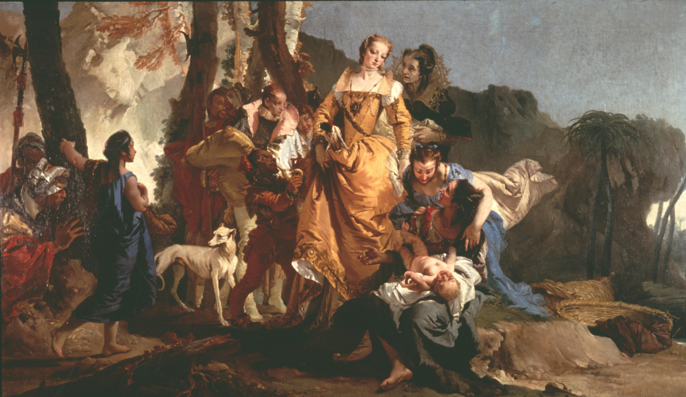
(V7_51) Tiepolo, The Finding of Moses, National Gallery of Scotland
$include(figure-slice-vertical-end.in) $include(layout-a-end.in)

